Promotion And Reappointment Dossier

Diana Dabby

November 15, 2019

Table of Contents

Executive Summary, Part I: Backstory 6

Executive Summary, Part II: Overview 8

Curriculum Vitae 11

I. Introduction: Three Maps to Orient the Reader 43

Map 1: Developing Olin Students, External Impact, Building & Sustaining the College 44

Map 2: A Creative Umbrella of Disciplinary and Interdisciplinary Work 45

Map 3: Three Overarching Themes Found in all my Work 46

II. Developing Students and Building & Sustaining the College (Map 1)—encompassing both Disciplinary and Interdisciplinary Subjects (Map 2)—incorporating Three Overarching Themes (Map 3) 49

Project A. AHS Curriculum Development (Music) 50

i. The Olin Conductorless Orchestra: offered every semester, 2002 - present 51

ii. The Wired Ensemble: Instruments, Voices, Players (offered every fall term, 2003 - present) 54

Project B. ECE Curriculum Development 56

i. Digital Signal Processing: 2009, 2010, 2011, 2012, (on leave Spring 13), 2014, 2015, 2016 Spring and Fall, (on leave Spring 18) 57

ii. Signals and Systems: 2003, 2004, 2005, 2006, 2007, (on leave Spring 2008), 2012, 2019 59

iii. Coming Soon: Engineering System Analysis—a new course for Spring 2020 60

Project C. Integrated Engineering and Music/AHS Curriculum Development 60

i. Harvard School of Engineering and Applied Science (SEAS) “Engineering the Acoustical World”: Invited guest instructor for math+music module comprising two 1.5-hour classes, 2018 61

ii. Engineering the Orchestra, part I: Acoustics, Waves, Vibration (with Prof. Chris Lee), 2007 62

iii. Engineering the Orchestra, part II: Theory, Orchestration, Composition (2008) 62

iv. Heroes for the Renaissance Engineer: Leonardo, Nabokov, Bach, and Borodin (2004, 2005, 2006, 2007) 63

Project D. The First Year: Helping Build Olin College and the Student Body (2000-2001) 64

Creating the Renaissance Engineer: Scientifically Astute, Artistic, Entrepreneurial 64

III. External Impact pertaining to Research and Intellectual Vitality (Map 1)—encompassing both Disciplinary and Interdisciplinary Work (Map 2)—incorporating Three Overarching Themes (Map 3) 67

Project E. Publication in *Science* (Music and ECE IV Portfolio) 67

Project F. Patents and Trademarks Arising from the CantoVario Project, issued by the USPTO (ECE and Music IV Portfolio) 69

Project G. Musical works: Commissions and World Premières (Music IV Portfolio) 70

IV. Intellectual Vitality uniting External Impact, Developing Students, and Building & Sustaining the College (Map 1)—encompassing both Disciplinary and Interdisciplinary Work (Map 2)—embodying Three Overarching Themes (Map 3) 75

Project H. CantoVario—Harnessing Chaotic System Variablity for Musical Variation (ECE and Music IV Portfolio) 76

Project J. The Engineers’ Conductorless Orchestra (Music and Engineering IV Portfolio) 80

i. “The Engineers’ Orchestra: a conductorless orchestra for our time” 80

ii. The Engineers’ Conductorless Orchestra website Hub: Exporting the Olin Conductorless Orchestra Model 81

Project K. 100+ Orchestral Arrangements for 12-22 Players (Music and Engineering IV Portfolio) 84

Project L. Building a Music Program at Olin from Scratch—and Sustaining it: 272 concerts from Fall 2002 - Spring 2019 (Music and Engineering IV Portfolio) 88

V. Looking Forward 91

VI. Concluding Remarks 94

VII. Supplementary Materials: Evidence 99

Supplementary Materials: Executive Summary, part 1—A Sampling of Live Recordings from Diana Dabby’s New York Concerts 99

Supplementary Materials: Executive Summary, part 2—Live recording of *Islamorada* with the composer as pianist 99

Supplementary Materials II-A-1: OCO Performance Clips showing growth of the orchestra 99

Supplementary Materials II-A-2: Wired Ensemble Performances 100

Supplementary Materials II-B-1a: DSP Course Schedule 101

Supplementary Materials II-B-1b: DSP Example of Developed Course Material 103

Supplementary Materials II-B-1c: DSP Developed Course Materials’ Topics 108

Supplementary Materials II-B-2a: Signals and Systems Course Schedule, Spring 2019 109

Supplementary Materials II-B-2b: Signals and Systems Example of Developed Course Material, Spring 2019 110

Supplementary Materials II-B-2c: Signals and Systems Developed Course Materials’ Topics, Spring 2019 119

Supplementary Materials II-C-3: Engineering the Orchestra, part II—Composition Example 120

Supplementary Materials II-D: “Creating the Renaissance Engineer”, a white paper presenting a vision for our new college, January 2001 120

Supplementary Materials III-E: Publication in *Science*: “Creating Musical Variation”, April 4, 2008 126

Supplementary Materials III-F. Recent Patents and Trademarks Issued by the United States Patent and Trademark Office (USPTO) 128

Supplementary Materials III-G: YouTube Videos of Recent Compositions 128

Supplementary Materials IV-H-1: CantoVario’s MIT VMS Demo Day presentation 129

Supplementary Materials IV-H-2: NSF I-Corps “Lessons Learned” Video 129

Supplementary Materials IV-H-3: CantoVario and NSF I-Corps Backstory 129

Supplementary Materials IV-H-4: CantoVario’s Three Current Projects 130

Supplementary Materials IV-J-1: Results of a Four-Year Study on the Effectiveness of OCO for Building Leadership, Teamwork, and Communication Skills 134

Supplementary Materials IV-J-2: The Engineers’ Conductorless Orchestra website Hub 136

Supplementary Materials IV-J-3: Example Performances by the Olin Conductorless Orchestra (2008 – 2019) 136

Supplementary Materials IV-L-1: A Recipe for Making Music or How to Bake a Music Program from Scratch (Fall 2001 – Spring 2009) 138

Supplementary Materials IV-L-2: What happened next—stories from ‘behind the scenes’ (Development of the Music Program, Fall 2009 – Spring 2019) 144

Supplementary Materials IV-L-3: Short Videos conveying the Scope and Impact of the Music Program 162

VIII. Appendices: Evidence 163

Appendix II-A-2. Examples of Wired Ensemble Assignments and Student Work 163

Appendix II-B-1. DSP: Example Assignments, Labs, and Student Work 164

Appendix II-B-2. Signals and Systems: Example Assignments and Student Work 165

Appendix II-C-1. Uniting AHS with Engineering: Module linking music and engineering developed for a new course—“Engineering the Acoustical World”, Harvard School of Engineering and Applied Sciences (SEAS) 166

Appendix III-G. Musical Scores of Commissions and World Premières 167

Appendix IV-H-1: Boston Sunday Globe Article on CantoVario (2013) 168

Appendix IV-H-2: *ArtScience* by David Edwards, Harvard University Press 2008: Chapter 2 (“Process”) on my Musical Variations Project 169

Appendix IV-H-3: NSF I-Corps Grant (funded 2019) 170

Appendix IV-J-1: “The Engineers’ Orchestra”, published by Springer Nature 171

Appendix IV-J-2: “The Engineers’ Orchestra: a conductorless orchestra for developing 21st century professional skills”, accepted for publication in the Proceedings of the ASEE Zone I International Conference, Niagara Falls, NY, April 12-14, 2019 172

Appendix IV-K-1: A Sampling of my Orchestral Arrangements 173

Appendix IV-K-2: Scores of the Sample Orchestral Arrangements 183

Appendix IV-K-3. Arrangements of Orchestral Works for 12-22 players 184

Appendix IV-K-3: 18-19 184

Appendix IV-K-3: 17-18 185

Appendix IV-K-3: 16-17 186

Appendix IV-K-3: 15-16 187

Appendix IV-K-3: 14-15 188

Appendix IV-K-3: 13-14 189

Appendix IV-K-3: 12-13 190

Appendix IV-K-3: 11-12 191

Appendix IV-K-3: 10-11 192

Appendix IV-K-3: 09-10 193

Appendix IV-K-3: 08-09 194

Appendix IV-K-3: 07-08 195

Appendix IV-K-3: 06-07 196

Appendix IV-L: Concerts at Olin (Fall 2002 - Spring 2019) that I Rehearsed and Produced 197

# Executive Summary, Part I: Backstory

**Three-part Invention**

The composers of the Baroque, Classic and Romantic periods provided many of those indelible impressions of childhood that inspired and motivated the directions I would take throughout my life. As a public performer since the age of fourteen, having won the first of a series of Young Artists’ Auditions followed by a nationally competitive scholarship to Interlochen, I spent the next decades performing myriad solo and chamber music concerts on both coasts, including concerts in New York’s Weill (Carnegie) Recital Hall and Merkin Concert Hall,Boston's Symphony Hall, Jordan Hall, and Tanglewood, as well as the Marczibanyi Teri Cultural Center in Budapest.[1]

Then in 1990, after years of performing and studying the music of others, I composed a single movement piano concerto. Shortly thereafter, the work was performed at a contemporary music event in Boston with the composer as pianist. If in the past I had felt a keen sense of exhilaration weaving the musical lines of other composers, it was now an altogether fuller sensation, captivating a throng of people with a piece that belonged to the present, and in fact, belonged to me. This performance led to my debut, as both pianist and composer, at the 1990 Tanglewood Festival of Contemporary Music.

After Tanglewood, my thoughts revolved around the next pieces I wanted to write, and in particular, the expressive voice I found within. This undertaking entailed another current in my life—electrical engineering—an odyssey that began when, out of curiosity, I picked up a copy of a journal devoted to music of the future, published by the Massachusetts Institute of Technology. I did not understand a word of what was written since the articles were quite technical. However, struck by the fact that the authors were primarily electrical engineers, I asked two questions destined to augment my life: *What would happen if a professional musician acquired the tools of the engineer? Might a breakthrough for contemporary music emanate more naturally from the artist who became scientifically astute rather than the scientist with a musical avocation?* This quest fired my imagination, motivating a return to school for a Bachelor's degree in electrical engineering, while earning my living as a pianist in New York.

Music had taught me how to plunge deeply into something and emerge with discovery. This happened repeatedly, whether I was preparing for concerts, writing a piece, or analyzing a score. In engineering school, I found myself studying for exams the same way I worked musically. There were tremendous similarities. So it was natural for me to *want* to pursue the scientific language in more than a cursory way—to speak it with a strong foundation. While at The City College of New York, I was one of two students selected nationally to receive the Society of Women Engineers/Bell Labs Scholarship in Electrical Engineering. After graduating Summa Cum Laude in electrical engineering, I received the CCNY Engineering Alumni Award for Excellence in Electrical Engineering. In the fall of 1987, I entered the graduate program in Electrical Engineering and Computer Science at MIT. At the time, I planned to work on the development of a system able to follow a performer much the same way an orchestra with conductor had followed me in the past.

Shortly after arriving at MIT, I read that something similar had already been done. So I began to articulate a more primary goal: namely, to create a contemporary voice from the merger of music with a topic I had become intimately connected with at MIT—*chaos science.* I believed that this science, already fuel for my musical imagination, could engender an elegant tool for artistic expression.

While at MIT, I received several fellowships awarded by the Department of Electrical Engineering and Computer Science: the Vinton Hayes Fellowship in Communications, the Clarence LeBel Fellowship in Acoustics, and the Barbara and Frederick Cronin Fellowship. Jerry Wiesner, President Emeritus of MIT, secured unsponsored research funds that supported my work for the period 1993-1995. I also taught recitations and tutorials for various electrical engineering courses over the span of seven semesters, including Acoustics, Signals and Systems, Circuits and Electronics.

Then, steeping myself in the intricacies of systems that exhibit chaos, I designed and built an original circuit manifesting chaotic behavior and strange attractors not previously cited in the scientific literature. The new circuit became the result of my Master's thesis, completed at MIT in 1991. The thesis was strictly technical in content. This was on purpose. I was trying to immerse myself in chaotic dynamics so as to think in mathematics almost as intuitively as in music. It was crucial since I would be combining the two in my doctoral thesis.

During the summer of 1993, I came up with the design for musical variation that became my PhD thesis. As I had sensed years earlier, the science of chaos held the key. It was by delving more deeply into the mathematics behind it that I was able to grapple with the door. In trying to understand a definition and its consequences, I realized a natural mechanism for variability inherent in chaos could be tempered via a mathematical mapping.

By January 1994, I had musical results. At the end of the year, the chaos writer for *Science News,* lvars Peterson, wrote a two-page article about my work entitled “Bach to Chaos.” This led to a series of six concert/lectures entitled “Musical Variations from a Chaotic Mapping” in Chicago and Hong Kong. At the 1995 International SIAM (Society for Industrial and Applied Mathematics) Conference on Applications of Dynamical Systems, “Musical variations from a chaotic mapping” was the unanimous choice for Best Poster Prize. A few months later, the *Encyclopedia Britannica* invited me to contribute an article for their *Yearbook of Science and the Future.* In April 1996, *Islamorada* for piano and percussion, written for the New England Conservatory Percussion Ensemble, was performed in Jordan Hall by the Ensemble with the composer as pianist (DS Dabby, 1996). This was followed by *Trio Sonata* (1997) and *Invention for Two Hands* (1997), with world premieres in 1997 and 1998, respectively.

In 1995, after defending my thesis *Musical Variations from a Chaotic Mapping,* I received my doctorate in Electrical Engineering and Computer Science from MIT. At that moment I could look back on the recent past—from matriculation at MIT to graduation—as a synthesis of my work as composer, pianist, and inventor. I had done everything I said I would do—up to a point. The thesis was really part of a larger vision for variation that I have articulated over the years. Recognizing this, MIT continued to support my work. In September 1995, I received a grant from the Dean of the School of Engineering and an equipment grant from the Dean of Humanities. Funding was renewed the following year by the Provost and the Provost for the Arts. Thus, I became a Postdoctoral Associate (1995-97) and Artist-in-Residence (Spring 1997) in the Department of Electrical Engineering and Computer Science. A nationally competitive fellowship sponsored by Tufts University (1997) resulted in my teaching a course in their EECS Department (Nonlinear Dynamics and Chaos with Applications in the Arts and Sciences). Invited concert/lectures sponsored by the departments of Music and Electrical Engineering at Princeton (1998), the Center for Applied Mathematics at Cornell University (1998), the Math and Music Seminar at Cornell (1998), the Mathematics and Music Departments at Middlebury College (1998), the International Symposium on Information Theory (1998), the Electrical Engineering and Computer Science Colloquium at MIT (1998), the 36th Annual *New Horizons in Science Briefing* International Conference for Science Writers (1998), the Arts in Science Series presented by FIRST Place of New Hampshire (1998), the Honors Colloquium at UMass Dartmouth (1999), the Women in Music Series at Tufts University (1999), and the Department of Music at Dartmouth College (1999), provided opportunities to present and discuss my work. For five of the above concert/lectures I performed the piece written for the New England Conservatory Percussion Ensemble (*Islamorada*) and then played two different variations of a “fughetta” which bifurcates the piece, thus showing how a contemporary composer might use the variation technique I’d invented.[2]

Then in January 2000, I saw an ad for a college that didn’t exist yet: Olin College of Engineering. Olin was hiring faculty to help design a school that would offer four-year tuition scholarships to all admitted students, including room and board. Such a generous gesture inspired me: I imagined a good student from modest means reading about this new college, becoming motivated to reach for it, and thus access all Olin had to offer, regardless of ability to finance such an education. Realizing this was a once in two lifetimes’ opportunity and that Olin would attract excellent students, I applied. Despite receiving offers from several colleges and universities in Spring 2000, I chose Olin, a decision I’ve never regretted. Yet when I signed that first five-year contract, I had no idea what the future would hold. In a sense, that was part of its appeal. Perhaps the biggest surprise has been the addition of another ‘hat’, an entrepreneurial ‘hat’ to those I already wear: musician (composer, pianist, orchestrator), educator, and electrical engineer. Many of my heroes—all those dead composers—also had entrepreneurial streaks. They were able to take an idea from inception to full realization, an undertaking that defines entrepreneurship. My musical variation projects now span music, electrical engineering, and entrepreneurial thinking, resulting in a “three-part invention.”

# Executive Summary, Part II: Overview

This dossier covers my work over the past 19 years at Olin College of Engineering, Fall 2000 – Spring 2019. In so doing, it offers a singular perspective on the early years of the college. As a founding faculty member, I’ve had a thrilling ride. In looking back on this time, I realize that three overarching themes have guided both my teaching and intellectual vitality at Olin, where intellectual vitality encompasses research, patents, papers, commissions, grants, performances, orchestral arrangements, among other creative efforts—and their tangible applications.

These three themes—lifelong learning, intrinsic motivation, and the creative process—evolved as a result of being in a remarkable environment, an Olin community that encouraged risk-taking and bold endeavors. Accustomed to a “long rope” from my doctoral work at MIT, I enjoyed the freedom to run with it again at Olin, creating eleven new courses between 2002 and 2009, all of them “firsts” at Olin, including core Electrical & Computer Engineering courses (required for the major) and Arts, Humanities, and Social Sciences courses (degree requirement); a music program from scratch for which I rehearsed/produced 272 concerts, including 137 by the only college conductorless orchestra composed of engineers—in the world; over 100 arrangements of symphonic repertoire that have allowed a small college like ours to house an orchestra comprising an eclectic array of instruments; seminal publications and YouTube videos that have resulted in the first performance by a student conductorless orchestra at the Great Hall of the Cooper Union (where Lincoln spoke) and the first time an orchestra composed of engineering students was invited to perform for an ASEE (American Society for Engineering Education) international conference; world premières for soloists, as well as for large instrumental/vocal ensembles, all informed by my work with musical variation, including the first ever “variation concert” where seat location determined what variation path a listener heard through a given piece. My musical variations project (CantoVario) has resulted in patents issued and pending, as well as web applications stemming from the myriad algorithms I’ve devised for musical variation. The CantoVario project brought Olin its first publication in *Science*, its first National Science Foundation (NSF) National Innovation Corps Team Award (“I-Corps: Harnessing Chaotic System Variability”), and Olin’s first MIT Venture Mentoring Service (VMS) Demo Day venture.

All the above achievements have helped define Olin College of Engineering and present it to the rest of the world, as described in the major sections of this dossier: Sections II, III, and IV. Section V looks forward to what the future holds for my work, followed by concluding remarks in Section VI. The Supplementary Materials offered in Section VII provide evidence for the achievements described in major sections II, III, and IV, respectively, i.e., the evidence given in each sub-section enumerated in Section VII applies directly to that specific section of the dossier to which the evidence speaks. For example, Supplementary Materials II-A-1 provides OCO performance clips showing growth of the Olin Conductorless Orchestra, corresponding to Section II-A-1 which addresses my course, the Olin Conductorless Orchestra. Similarly, the titles for the Appendices of Section VIII correspond to the specific sections of the main document to which they contribute evidence. For instance, Appendix III-G provides scores of recent world premières discussed in Section III-G.

In producing this dossier, I’ve sought to provide a clear roadmap to my work. This necessarily includes defining Olin’s criteria for promotion to Full Professor. According to the current version of Olin’s Faculty Manual (“V20 Faculty Manual - May 2014”), promotion to Full Professor is based on an affirmative answer to the question:

Is this person demonstrating leadership and impact, across the three overlapping activity areas, in a way that is consistent with the Olin mission and aspiration?

The Faculty Manual defines the three overlapping activity areas—Developing Students, External Impact, and Building & Sustaining the College—as follows:

*Developing Olin students* aligns directly with the Olin mission. Teaching courses clearly serves this purpose in an important way, and is of course a central activity for faculty at a student-centered institution like Olin. However, faculty members at Olin also develop students through a variety of other activities, such as mentoring individual students, developing new courses or curricula, academic advising, advising student clubs, involving students in research, running co-curriculars, supervising passionate pursuits, and working with students on College policies or programs.

Olin is a small institution, and is committed to continuous improvement and innovation in its processes as well as its educational program. Faculty members *build and sustain the College* through activities that both enable the College’s current programs and processes, and activities that improve on or create new programs and processes. While committee service within the faculty can serve this purpose, many other activities can as well. A few possible examples include working with other parts of the College (e.g., development), working with a partner institution through the Collaboratory [dedicated to co-designing transformational education experiences with other institutions], developing new innovative and effective courses, or running existing College-wide activities.

*Achieving external impact* involves pursuit of professional activities that make a difference to constituencies outside of the Olin community, and is important both for the professional growth of faculty and to serve the College’s aspiration to effect change in engineering education more broadly. Research, entrepreneurial activities, working to facilitate educational change at another institution, development of inventions, and dissemination of educational materials all are a few examples of possible activities that can achieve substantive impact outside of Olin.

These purposes are not mutually exclusive, and in many cases may be synergistic: it is possible that a given activity might address all three purposes simultaneously. For example, developing, delivering, and disseminating an educational innovation clearly could address the purposes of Developing Students, building the College, and achieving external impact; a research program that involves students could both develop students and have impact outside Olin.

Olin’s statements of Mission and Aspiration are posted on the Olin website and read as follows:

Olin’s Mission: Olin College prepares students to become exemplary engineering innovators who recognize needs, design solutions, and engage in creative enterprises for the good of the world. Olin is dedicated to continual discovery and development of effective learning approaches and environments, and to co-developing educational transformation with collaborators around the globe.

Olin’s Aspiration: Olin College seeks to redefine engineering as a profession of innovation encompassing 1) the consideration of human and societal needs; 2) the creative design of engineering systems; and 3) the creation of value through entrepreneurial effort and philanthropy. The college is dedicated to the discovery and development of the most effective educational approaches and aspires to serve as a model for others.

This dossier will demonstrate my leadership and impact across Olin’s three faculty goals of Developing Students, External Impact, and Building & Sustaining the College, in ways consistent with Olin’s mission and aspiration by means of the projects presented in Sections II, III, and IV, supported by evidence captured in Section VI (Supplementary Materials: Evidence) and Section VII (Appendices: Evidence). The Supplementary Materials present short format evidence such as links, whereas the Appendices contain evidence in longer documents such as musical scores.

To help convey my work and goals, I’ll present three approaches for understanding all I’ve accomplished and still plan to achieve. One approach focuses on Olin’s three faculty goals of Developing Students, External Impact, and Building & Sustaining the College. A second approach uses both disciplinary and interdisciplinary lenses through which to view my work. A third approach emphasizes three overarching themes—lifelong learning, intrinsic motivation, and the creative process—that pervade all I do.

The ensuing Introduction (Section I) presents each of these avenues to my work by way of pictorial maps. These maps reference my projects—denoted by capital letters A-L—showing them from the perspective of Olin’s faculty goals (Map 1), from the perspective of disciplinary and interdisciplinary work (Map 2), and from the perspective of my three overarching themes (Map 3). The maps encompass eleven different projects, but from three different vantage points. Just as a map guides an explorer through unknown lands, it’s my hope these maps will help guide and orient you through all I’ve created.

# Curriculum Vitae

**Diana S. Dabby**

Associate Professor

Electrical Engineering and Music

Music Program Director

Olin College of Engineering

**Professional Preparation**

|  |
| --- |
| Ph.D. 1995 MIT Electrical Engineering and Computer Science  S.M. MIT Electrical Engineering and Computer Science  M.F.A. Mills College Music  B.Eng. City College of New York Electrical Engineering  A.B. Vassar College Music |

**Appointments**

|  |  |
| --- | --- |
| 2010 – present | Music Program Director, Olin College of Engineering |
| 2005 – present | Associate Professor of Electrical Engineering and Music, Olin College of Engineering |
| 2000 – present | Research Affiliate, MIT Lab for Information and Decision Systems |
| 2000 – 2005 | (Founding Faculty) and Assistant Professor of Electrical Engineering and Music, Olin College of Engineering |
| Jan – May 2002 | Adjunct Graduate Faculty, The Juilliard School |
| Jan – Dec 2000 | University Fellow in Electrical Engineering and Computer Science, Tufts University |
| 1999 | Visiting Lecturer in Electrical Engineering and Computer Science, Tufts University |
| 1999 | Visiting Lecturer in Music, Tufts University |
| 1998 | Visiting Lecturer in Electrical Engineering and Computer Science, MIT |
| 1998 | Visiting Lecturer in Electrical Engineering and Computer Science, Tufts University |
| 1997 – 1998 | Visiting Assistant Professor of Music, Middlebury College |
| 1997 | Artist in Residence, MIT |
| 1997 | Summer Teaching Fellow, Tufts University |
| 1995 – 1997 | Postdoctoral Associate in Electrical Engineering and Computer Science, MIT |

**Intellectual Vitality: Research—Patents**

Dabby, D.S. (2018). Method and Apparatus for Computer-Aided Mash-up Variations of Music and other Sequences, Including Mash-up Variation by Chaotic Mapping. Utility patent application 16/144521, filed United States Patent and Trademark Office 26 September 2018, pending.

Dabby, D.S. (2017). Method and Apparatus for Computer-Aided Mash-up Variations of Music and other Sequences, Including Mash-up Variation by Chaotic Mapping. Provisional patent application 62/563669, filed United States Patent and Trademark Office 26 September 2017, pending.

Dabby, D.S. (2016). Method and Apparatus for Computer-aided Variation of Music and other Sequences, including Variation by Chaotic Mapping. US 9286877 United States Patent and Trademark Office, issued 15 March 2016. Continuation in Part to cover applications, filed April 2014.

Dabby, D.S. (2016). Method and Apparatus for Computer-aided Variation of Music and other Sequences, including Variation by Chaotic Mapping. US 9286876 United States Patent and Trademark Office, issued 15 March 2016. Provisional filed July 2010, Utility and updated Provisional filed July 2011. Preliminary amendment filed January 2012.

Dabby, D.S. (2015). EnginArtTM. Computer software for processing digital music files; computer software for creating and editing music and sounds; music-composition software. Registration No. 4698653 United States Patent and Trademark Office, registered trademark 10 March 2015.

Dabby, D.S. (2014). CantoVarioTM. Computer software for processing digital music files; computer software for creating and editing music and sounds; music-composition software. Registration No. 4656199 United States Patent and Trademark Office, registered trademark 16 December, 2014.

Dabby, D.S. (1997). Method of and apparatus for computer-aided generation of variations of a sequence of symbols, such as a musical piece, and other data, character or image sequences. US 5606144 United States Patent and Trademark Office, issued 25 February 1997.

**Intellectual Vitality: Research—Publications**

Dabby, D.S. (2019). The Engineers’ Orchestra: a conductorless orchestra for developing 21st century professional skills. Peer-reviewed and accepted for publication in the Proceedings of the 2019 ASEE Zone 1 International Conference, Niagara Falls, New York.

Dabby, D.S. (2017). The Engineers’ Orchestra—a conductorless orchestra for our time*.* Book chapter in D. Baraiktarova & M. Eodice (Eds.), *Creative ways of knowing in engineering* (pp. 23-58). Cham, Switzerland: Springer Nature. Peer-reviewed book chapter. (450 purchased downloads from Springer Nature).

Dabby, D.S. (2008). Creating Musical Variation. *Science*. 320 (5872), 62-3. Invited *Perspectives* article.

Dabby, D.S. (2003).  En Route To Engineering: Nabokov, Lepidoptera, Dynamics. In *ASEE Conference Proceedings*, *22-25 June 2003*. Nashville, TN: ASEE. pp. 8.482.1 - 8.482.9. Peer-reviewed conference paper.

Dabby, D. (2002).  Leonardo as Artist, Scientist, Engineer. In *ASEE Conference Proceedings*, *16-19 June 2002*. Montreal, Canada: ASEE. pp. 7.810.1 - 7.810.11. Peer-reviewed conference paper.

Dabby, D.S. (2001).  Heroes for the Renaissance Engineer: Leonardo, Nabokov, Bach and Borodin. In *ASEE Conference Proceedings*, *24-27 June 2001*. Albuquerque, NM: ASEE. pp. 6.539.1 - 6.539.13. Peer-reviewed conference paper.

Dabby, D.S. (1998). A Chaotic Mapping for Music and Image Variation. In *Proceedings of the Fourth Experimental Chaos Conference, 6-8 August 1997.* Boca Raton, FL: World Scientific.

Dabby, D.S. (1996). Musical Variations from a Chaotic Mapping. *Chaos: A Journal of Nonlinear Science* (American Institute of Physics), *6*, 95-107. Peer-reviewed journal paper.

**Intellectual Vitality: Research—Grants**

NSF Partnerships for Innovation—Technology Translation Grant Proposal. Proposal No. 1941526. Title: CantoVario: Uniting Chaotic System Variability, Musical Variation, and Sound-focusing Technology for Technology Translation. Diana Dabby, Principal Investigator (PI). Submitted July 2019. 250K.

Olin Integrated Project Fund. Diana Dabby. The Engineers’ Conductorless Orchestra website Hub. Award date: March 2019. 4K.

NSF Innovation Corps (I-Corps) Teams. Managing Division Abbreviation: IIP. “I-Corps: Harnessing Chaotic System Variability.” Diana Dabby, PI. Proposal no. 1924305. Award No. (FAIN): 1924305. Award date: April 4, 2019. 50K

Travel grant for further Customer Discovery by CantoVario, administered by MIT I-Corps and funded by NSF. Award date: November 2018. 1.5K.

Olin Summer Innovation and Research Grants, Summers 2014-17 and 2005-09. 4K/summer for a student programmer to code algorithms disclosed in the above patents.

“Mix and Stir: musicians, composers, poets in concert.” Babson, Olin, Wellesley (BOW) Presidential Innovation Grant. Mix and Stir featured BOW student and faculty musicians, composers, and poets in two cross-disciplinary musical/literary events, enabling them to collaborate in a new venue, as part of a new Olin concert series. Awarded 2015. 6K.

**Intellectual Vitality: Research—Web Applications**

Dabby, D.S. (2017-2019). Web Application [www.cantovario.com](http://www.cantovario.com): CantoVario incorporates a number of algorithms based on the above patents that create musical variations of original works. Web app 2017 – 2019 coded by Jacob Kingery ‘16. New web app for MIDI song variations in beta at <http://cantovario.com/summer2019/>, 2017 – 2019. Coded by Justin Kunimune ’19.

Dabby, D.S. (2019). The Engineers’ Conductorless Orchestra website Hub. Provides resources such as blueprints, videos, and scores of orchestral arrangements for engineering schools wishing to create their own conductorless orchestras that builds leadership, teamwork, and communication skills in engineering students. <https://pages.olin.edu/eco-summer2019> Coded by Luis Zuniga ’21.

Dabby, D.S. (2011-2014). CantoVario Web Application based on technology disclosed in the above patents to create musical variations of both audio and MIDI songs. Coded by James Rising.

**Intellectual Vitality: Music—Premières, Commissions, Performances, and Recordings**

(YouTube links provided where available.)

Dabby, D.S. (2018). *Parallel Lives—Distant Mirrors* for piano, bass and alto flutes, voice, and soundtrack. World première, Wellesley College Concert Series. Performed by Yong Su Clark (flutes), P. Lucy McVeigh (mezzo-soprano), and Jongsun Lee (piano). The fifth movement presents a concert of “Variations and Shadows” where seat location determines what the audience hears. The world première performance utilized sound-focusing technology developed by Kevin Brown of Brown Innovations. November 2018. <https://www.youtube.com/watch?v=xSqE22X4I8U&feature=youtu.be>

Dabby, D.S. (2017). *Who was Wissam Eid?* for violin, cello, and piano. World première, Ann Schaffner Concert Series, Olin College of Engineering. One of 14 faculty and student commissions from a Presidential Innovation Grant (Babson, Olin, Wellesley) performed by Gabriela Diaz (violin), David Russell (cello), and Lois Shapiro (piano). April 2017. <https://youtu.be/Ra_AoA8SUsY>

Dabby, D.S. (2013). *Fuente y Variación* (source and variation) for piano. World première, Youngsan Art Hall, Seoul, Korea. Commissioned by pianist Jongsun Lee for her invited artist concert sponsored by Youngsan Art Hall. May 2013.

Dabby, D.S. (2013). *Tre Studi di Colore*, three études for solo piano. Asian première, Youngsan Art Hall, Seoul, Korea. Performed by Jongsun Lee for her invited artist concert sponsored by Youngsan Art Hall. May 2013.

Dabby, D.S. (2013). *Fuente y Variación* (source and variation) for solo piano. Recorded by pianist Jongsun Lee at Mozart Hall, Seoul, Korea. December 2013. <https://www.youtube.com/watch?v=3vVeYwW1VNY>

Dabby, D.S. (2013). *Tre Studi di Colore*, three études for solo piano. Recorded by pianist Jongsun Lee at Mozart Hall, Seoul, Korea. December 2013. <https://www.youtube.com/watch?v=mRrJhR4OmEQ>

Dabby, D.S. (2012). *Tre Studi di Colore*, three études for solo piano. World première, Wellesley College Concert Series. Commissioned by the Jubilee Trio for their Houghton Chapel concert, Wellesley College. November 2012.

Dabby, D.S. (2011). *September Quartet*, a five-movement work for chorus, winds, brass, percussion, violin and piano. World première on the Tenth Anniversary of 9/11 at Distler Performance Hall, Granoff Music Center, Tufts University. Commissioned by Tufts University for the New Music Ensemble, John McDonald, Director, in commemoration of the Tufts Sesquicentennial. In the process of establishing this new link, the previous 500 views and comments were lost. September 2011. <https://www.youtube.com/watch?v=UQj2EmfFgAg>

Dabby, D.S. (2009). *11*, part of a larger Tufts University commission. Distler Performance Hall, Granoff Music Center, Tufts University. Performed by Joanna Kurkowicz, violin, and John McDonald, piano. April 2009.

Dabby, D.S. (2008). *A Fire’s Tale* for piano. World première, Boyer Hall, Temple University. Commissioned by pianist Martha Schrempel on the occasion of her Temple University Final Doctoral Recital. March 2008.

Dabby NPR radio Interview/Performance (2007). “New Space Promotes Intersection of Art and Science.” *Weekend Edition* piece highlighting, in part, the combination of engineering and music to produce a new technique for musical variation. *Invention for Two Hands* (Diana Dabby, pianist and composer) aired as excerpt. Taped Nov. 13, 2007; broadcast December 29, 2007.

Capps, D. and Bradley, L. (2007). *Con/cantation: (chaotic variations)*, a computer-assisted theme and variations performance project. Based on the chaotic variation technique presented in “Musical Variations from a Chaotic Mapping” (Dabby 1996). Sponsored by the Radcliffe Institute for Advanced Study. April 2007.

Dabby, D.S. (2006). *Aerial Silk* for solo piano to accompany ‘aerial silk’ performer Matthew Brouillard. Sorenson Theater, Babson College, on behalf of the Sharing Foundation. December 2006.

Dabby NPR member station WBUR Interview/Performance (2004), “Variations on Chaos – Math and Music of Diana Dabby.” Taped April 23, 2004; broadcast July 9, 2004.

Dabby, D.S. (1999). *Trio Sonata* for flute and piano. Foy Concert Hall, Moravian College, Bethlehem, PA. Performed by the Kani-Schrempel Duo. February 1999.

Dabby, D.S. (1998). *Invention for Two Hands* for piano. World première (composer as pianist), Center for the Arts, Middlebury College. May 1998.

Dabby, D.S. (1997). *Trio Sonata* for flute and piano. World première, 14th Annual Musicfest, Bethlehem, PA. Commissioned and performed by the Kani-Schrempel Duo. August 1997.

Dabby, D.S. (1996). *Islamorada* for percussion ensemble and piano. World premiére (composer as pianist), Jordan Hall at New England Conservatory of Music. Commissioned by the New England Conservatory Percussion Ensemble. April 1996.

Dabby, D.S. (1993). *Manhattan EightSixSix* for piano and tape. World première (composer as pianist), The Cube, MIT. May 1993.

Dabby, D.S. (1990). *Lopez* for piano and tape. World première (composer as pianist), The Cube, MIT. May 1990. Tanglewood première (composer as pianist), Tanglewoord Festival for Contemporary Music. August 1990.

**Intellectual Vitality: Music—Orchestral Arrangements**

Orchestral arrangements for the 12-22 players of the Olin Conductorless Orchestra (OCO) are available on the Engineers’ Conductorless Orchestra website Hub <https://pages.olin.edu/eco-summer2019>

As a self-directed orchestra, OCO selects its own repertoire, often voting for symphonic works written for orchestras four times its size. Since Olin is a small school (350 students), OCO has always had an eclectic array of instruments. This nonstandard instrumentation—coupled with unbalanced wind, brass, and string sections—necessitate the orchestral arrangements I’ve created.

Links to sample recordings can be accessed in this CV under the subsequent heading: “Intellectual Vitality: Music—the Olin Conductorless Orchestra.”

Dabby, D.S. (2018-2019). Nine arrangements of the following works (some of which were arranged for two different instrumentations, due to Junior semester away: Mozart *Wind Serenade in Bb major*, K. 361 (Rondo) – 2 different arrangements; Tchaikovsky “Waltz” from the *Serenade for String* Orchestra, op. 48 – 2 different arrangements; Mozart Overture to *Così fan tutte*, K. 588; Berlioz “Marche Hongroise” from *La Damnation de Faust* – 2 different arrangements; K. Badelt/T. Ricketts Medley from *Pirates of the Caribbean* – 2 different arrangements; and Arturo Marquez *Danzon No. 2*.

Dabby, D.S. (2017-2018). Six arrangements of the following works: Dvorak *Serenáda in d minor, Op. 44* (Finale); Elgar *Serenade for String Orchestra in e minor*, op. 20 (Allegro Piacevole and Allegretto); Mozart Overture to the *The Marriage of Figaro*, K. 492; Schumann *Symphony No. 1 in Bb major*, “Spring”, Op. 38 (Andante un poco maestoso—Allegro molto vivace); Puccini *Preludio Sinfonico* in A Major; and Elmer Bernstein theme song from *The Magnificent Seven.*

Dabby, D.S. (2016-2017). Six arrangements of the following works: Shostakovich “Waltz No. 2” from the *Suite for Variety Orchestra;* Mozart Overture to the *Magic Flute*; Louis Prima/Benny Goodman/O’Brien *Sing, Sing, Sing*; Gershwin *An American in Paris* (in an abridged version and a complete version, each for a different instrumentation); and J. Powell/S. O’Loughlin “This is Berk”from the movie *How to Tame Your Dragon*.

Dabby, D.S. (2015-2016). Seven arrangements of the following works: Dvorak *Serenáda in d minor, Op. 44 (Minuet in F)*; Suk *Serenáda in Eb major*, Op. 6 (Andante con moto); Beethoven Overture to the *Creatures of Prometheus*; Saint-Säens *Danse Bacchanale* from *Samson et Dalila*; A. Silvestri, G. Ballard, and J. Brubaker Suite from the *Polar Express*; Rimsky-Korsakov *Scheherazade* (The Sea and Sinbad’s Ship); Dvorak *Symphony No. 9 in e minor* “From the New World”, Op. 95 (Allegro con fuoco).

Dabby, D.S. (2014-2015). Seven arrangements of the following works: Dvorak *Serenáda in d minor*, Op. 44 (Moderato, quasi marcia); Dvorak *Serenáda in E major*, Op. 22 (Moderato); J.S. Bach/Holst *Fugue à la Gigue*; Ramin Djawadi Theme song from *Game of Thrones*; Wagner *Ride of the Valkyries*; Prokofiev Montagus and Capulets (from *Romeo and Juliet*, op. 64ter); and Bernstein *Symphonic Dances* (Prologue and Somewhere).

Dabby, D.S. (2013-2014). Six arrangements of the following works: Copland *Appalachian Spring* (in abridged and complete versions, the latter for 2 different instrumentations); Debussy *Petite Suite*; Saint-Saens *Le Carnaval des Animaux* (Introduction et Marche Royale du Lion, Le Cygne, and Fossiles); and Dvorak *Symphony No. 8 in G major*, op. 88 (Allegro, ma non troppo).

Dabby, D.S. (2012-2013). Six arrangements of the following works: Beethoven *March* *alla Turca*, op. 113; Stravinsky *Suite No. 2*; Marquez *Danzon No. 2*; Mussorgsky and Mussorgsky-Ravel *Pictures at an Exhibition* (Promenade and Old Castle); Saint-Saens *Danse Macabre*; and Mozart *Wind Serenade in Bb major,* K. 361 (Largo-Molto Allegro).

Dabby, D.S. (2011-2012). Eight arrangements of the following works: Mozart *Symphony no. 35 in D major*, K. 385, “Haffner”, (Allegro con spirito); Beethoven *Symphony no. 7 in A major*, Op. 92 (Allegretto); John Williams *Across the Stars* (from Star Wars Episode II “Attack of the Clones”); Tchaikovsky “Waltz Finale and Apotheosis” from *The Nutcracker*; Haydn *Symphony no. 45 in f# minor*, Hob. I:4; Mozart *Serenade* *in Eb major*, K. 375 (Finale: Allegro); Piazzolla *Oblivion*; and John Williams Theme from *Jurassic Park*.

Dabby, D.S. (2010-2011). Seven arrangements of the following works: J.S. Bach *Orchestral Suite No. 4* (Overture); Copland *Rodeo* (Hoe-down); Holst “Jupiter” from *The Planets*; Lee Jisu *Arirang Rhapsody*; Rimsky-Korsakov “The Sea and Sinbad’s Ship” from *Scheherazad*e; Suk *Serenade in Eb for String Orchestra*, Op. 6; and Dvorak *Symphony No. 9 in e minor*, “From the New World”, (Allegro con fuoco).

Dabby, D.S. (2009-2010). Six arrangements of the following works: Handel “Alla Hornpipe” from *Water Music*; Mozart Overture to the *Marriage of Figaro*; Beethoven *Symphony No. 4 in Bb* *major* (Adagio-Allegro vivace); Schumann *Symphony No. 2 in C major* (Adagio espressivo); Smetana *The Moldau*; and Mussorgsky *Night on Bald Mountain*.

Dabby, D.S. (2008-2009). Nine arrangements of the following works: Saint-Saens *Danse Macabre* (3 arrangements, each for a different instrumentation); Beethoven *Symphony No. 7 in A major*, Opus 92 (Allegretto) - 5 arrangements, each for a different instrumentation; and Mussorgsky-Ravel *Pictures at an Exhibition* (Promenade I, Gnomus, Promenade II, Il vecchio castello, Promenade III, Tuileries, Limoges).

Dabby, D.S. (2007-2008). Ten arrangements of the following works: Haydn *Symphony No. 48 in C major,* “Maria Theresa”, (Allegro) – 3 arrangements, each for a different instrumentation; Beethoven *Symphony No. 8 in F major, Op. 93* (Allegro vivace e con brio) – 2 arrangements, each for a different instrumentation; Beethoven *Symphony No. 8 in F major, Op. 93* (Allegretto scherzando); Bernstein Overture *to* *Candide* – 2 arrangements, each for a different instrumentation; and Smetana *Vltava*.

Dabby, D.S. (2002-2007). 25 arrangements of works by Mozart, Gershwin, Rachmaninov, Britten, Stravinsky, Tchaikovsky, Bartok, Elgar, Shostakovich, Gorecki, Copland, Fauré, Borodin, and Schubert, of which only nine survive. The others appear to be lost due to lack of an orchestral library for the arrangements (which has since been remedied).

**Intellectual Vitality: Music—Solo Piano Concerts** (ranging from Bach to Bartok) and **Contemporary Music Performances**

|  |  |
| --- | --- |
| 1998 | Center for the Arts, Middlebury College. Solo piano concert. May 1998. |
| 1996 | Jordan Hall at the New England Conservatory. Contemporary piano performance: *Islamorada* for percussion and piano by Diana Dabby (composer and pianist) with the New England Conservatory Percussion Ensemble, Frank Epstein, Director. April 1996. |
| 1993 | The Cube, MIT Media Lab. Contemporary piano performance: *Manhattan EightSixSix* for piano and tape by Diana Dabby (composer and pianist). May 1993. |
| 1991 | Boston Symphony Hall. Contemporary keyboard performance: *From Silence* for electronics with live performers (violin, viola, percussion, keyboards and soprano) by Jonathan Harvey; John Hoose, conductor. January 1991. |
| 1990 | Tanglewood Festival of Contemporary Music. Contemporary piano performance: *Lopez* for piano and tape by Diana Dabby (composer and pianist). August 1990. |
|  | The Cube, MIT Media Lab. Contemporary piano performance: *Lopez* for piano and tape by Diana Dabby (composer and pianist). May 1990. |
| 1987 | Merkin Concert Hall, New York, NY. Solo piano concert to establish the Judith Resnik Memorial Scholarship at The City College of New York. April 1987. Sold out. |
|  | Friends of Music Series, Princeton University. Solo piano concert. April 1987. |
| 1986 | American Music Week Manhattan, New York, NY. Two performances. November 1986. |
| 1983 | Jeunesse Musicale Concert Series, Marczibanyi Teri Cultural Center, Budapest, Hungary. Solo piano concert, April 1983. Sold out. |
|  | Museum of the City of New York Concert Series (encore), New York, NY. Solo piano concert. March 1983. |
|  | Donnell Library Concert Series (by audition), New York, NY. Solo piano concert. March 1983. |
|  | Hewlitt-Woodmere Library Concert Series (by audition), New York, NY. Solo piano concert. March 1983. |
| 1981 | Gallery Concerts at St. Ignatius Church (by audition), New York, NY. Solo piano concert. December 1981. |
|  | Massapequa Public Library Concert Series (by audition), Massapequa, NY. Solo piano concert. November 1981. |
|  | Bosendorfer Beethoven Festival (encore), Friends of the Arts Concert Series, Oyster Bay, NY. Solo and one piano-four hands Beethoven performances. September 1981. |
|  | Museum of the City of New York Concert Series (by audition), New York, NY. Solo piano concert. March 1981. |
| 1980 | Trinity Church Concert Series (by audition), New York, NY. Solo piano concert. November 1980. |
|  | Bosendorfer Beethoven Festival at Coe Hall (by audition), Friends of the Arts Concert Series, Oyster Bay, NY. Solo Beethoven performance. September 1980. |
|  | Lincoln Center Performing Arts Library, New York, NY. Solo piano concert. June 1980. |
|  | Carnegie (Weill) Recital Hall, New York, NY. Solo piano concert, April 1980. Sold out. |
|  | South Huntington Library Concert Series (by audition), South Huntington, NY. Solo piano concert. April 1980. |
|  | Westbury Library Concert Series (by audition), Westbury, NY. Solo piano concert. March 1980. |
|  | Brooklyn Museum, Brooklyn, NY. Solo piano concert. January 1980. |

A sampling of live recordings from my New York concerts can be heard at <https://youtu.be/CZB8NF390GU>

A live recording of a contemporary performance, *Islamorada* for percussion and piano (with the composer as pianist and the percussion part rendered on tape), can be heard at <https://youtu.be/UZQwi24DGBo>

**Intellectual Vitality: Music—Building a Music Program from Scratch, and Sustaining it**

|  |  |
| --- | --- |
| 2002 - present | Founder and developer of the Music Program at Olin College of Engineering (2002-present). Responsibilities include applying orchestration, composition, theory, and performance skills towards all facets of the program; organizing and rehearsing concerts for Olin events and programs (8-23concerts/year inside and outside Olin); ensuring year-to-year continuous improvement and innovation.  Rehearsed and produced 272 concerts by the Wired Ensemble, the Olin Conductorless Orchestra, and other ensembles. Of these 270 concerts, I performed as a pianist in 70 of them to help establish the program. (Programs available on request.) |
| 2002 – present | Founder and developer of the *Olin Conductorless Orchestra* (2002-present), an ensemble—minus conductor—featuring instrumentalists in leadership, communicative, and collaborative roles. The Olin Conductorless Orchestra is the only conductorless (self-directed) orchestra composed of engineers—in the world. Responsibilities include re-orchestrating symphonic works (chosen by the students) for the orchestra’s eclectic combination of instruments; providing constructive commentary on a weekly basis; coaching/rehearsing/guiding from the side or up front, as needed; bringing in Boston area musicians to provide external feedback to the orchestra 3-4 times each semester. |
| 2019 | Concert by the Olin Conductorless Orchestra at the American Society for Engineering Education Zone I International Conference, Niagara Falls, NY. 12 April 2019. |
| 2005 - 2018 | Acquisition of instruments, including alto flute, bass flute, percussion (xylophone, glockenspiel, toms, snares, cymbals, triangles, bass drum, timbales, bongos, conga, and smaller instruments), timpani (23”, 26”, 29”, and 32”), Yamaha upright B3 rehearsal piano, and Steinway A rehearsal/practice piano. |
| 2017 | Concert by the Olin Conductorless Orchestra at the Great Hall of the Cooper Union. 19 February 2017. |
| 2014 | Initiated Ann Schaffner Concert Series at Olin College with generous grant from the Schaffner family. April 2014. |
| 2013 | Acquisition of new Steinway B for Milas Hall Mezzanine (Olin’s music performance space). Wrote proposal, discussed with administration, responded to questions from all concerned, located piano technician in Connecticut to evaluate the Steinway prior to purchase, emails and phone calls with the piano technician, meetings/emails/phone calls with the seller, emails/phone calls/meetings with Facilities regarding placement of Steinway once it arrived, emails/phone calls with Steinert Pianos in Boston to install piano dolly, emails/phone calls with Olin’s piano technician to address voicing, string leveling, tuning, and regulation of the piano, and fundraising (emails/phone calls/meetings) to finance purchase. |

**Intellectual Vitality: Music—the Olin Conductorless Orchestra** (OCO)

Dedicated to playing orchestral works selected by its students, OCO forges individual participation, active listening, and group-motivation into performances that have established it as a singular ensemble. In Fall 2002, I created the Olin Conductorless Orchestra to give our new college, and its students, a bold variation on the collegiate student orchestra—one that is self-directed rather than conducted. In so doing, OCO offers engineer-musicians an experiential lab for developing leadership, teamwork, and communication skills, while doing something they love—music.

The orchestra has performed 137 concerts since inception. A representative sampling of performances is given below, in chronological order to show overall growth of the orchestra. The orchestral arrangements are identified in “Intellectual Vitality: Music—Orchestral Arrangements” given above. (Full list of concerts available on request.)

|  |  |
| --- | --- |
| Spring 2008 | Haydn *Sinfonia No. 48 in C Major*, “Maria Theresia”: first movement (Allegro). <https://youtu.be/knulC0k1r5M> |
| Spring 2011 | Composite video excerpts (Holst: Jupiter from *The Planets* and Lee Jisu: *Arirang Rhapsody*). <http://www.youtube.com/watch?v=ZFd453aYudU&feature=mfu_in_order&list=UL> |
| Spring 2013 | Arturo Marquez *Danzon No. 2*.  <https://youtu.be/yyzEQ6n6OYA> |
| Fall 2015 | Beethoven Overture to the *Creatures of Prometheus*  <https://www.youtube.com/watch?v=VlkAZG106ek> |
|  | Saint-Saens *Danse Bacchanale*  <https://youtu.be/zix7IweadvM> |
| Spring 2016 | Dvorak *Symphony No. 9 in e minor*: fourth movement (Allegro con fuoco)  <http://bit.ly/OCO_Dvorak9th> |
| Spring 2017 | Gershwin *An American in Paris*  <https://www.youtube.com/watch?v=BA5F48usRIo> |
| Spring 2019 | Mozart *Serenade in Bb major for 13 Winds*, K. 361: Finale  <https://www.youtube.com/watch?v=hTNUGRU4Pl8> |
|  | Berlioz “Marche Hongroise” from *La Damnation de Faust*  <https://www.youtube.com/watch?v=a9IkNITe1fE> |

**Invited Lectures and Presentations**

|  |  |
| --- | --- |
| 2018 | CantoVario keynote. Young Inventors’ Program Convention at Southern New Hampshire University (SNHU) sponsored by the Academy of Applied Science, Fidelity Investments, and SNHU. “Two-Part Invention.” March 2018. |
|  | Guest Lectures on the mathematics underpinning music for “Engineering the Acoustical World,” a new course at Harvard University, John A. Paulson School of Engineering and Applied Sciences. Lectures connected the wave equation, overtone series, tuning, string harmonics, and modal scales. February 2018. |
| 2017 | CantoVario presentation and demo. MIT Venture Mentoring Service annual showcase/networking event “The Entrepreneurial Edge.” October 2017. |
| 2016 | CantoVario pitch and demo. MIT Venture Mentoring Service “Snapshot Pitches.” February 2016. |
| 2015 | Seminar presentation: CantoVario. Wellesley College AFR -237 - Women, Careers, and Diversity: Mining the Landscape.  February 2015. |
| 2014 | Competition for MIT Venture Mentoring Service (VMS) 2014 Demo Day. CantoVario (EnginArt) selected as one of 20 Demo Day presentations from 70 MIT start-up applicants. April 2014. |
|  | CantoVario Workshop. Society of Composers, Berklee College of Music. February 2014. |
|  | CantoVario presentation. Society of Composers, Berklee College of Music. February 2014. |
| 2013 | Art of Science speaker series, Brandeis Women in Science Initiative, Brandeis University. “Creating Musical Variation—from Chaos.” March 2013. |
| 2012 | Dean William Parks Colloquium, Christopher Newport University. “Two-part Invention: Creating at the Interface of Art and Science.” April 2012. |
| 2010 | Tedx Olin College. “Musical Variation via Chaos.” December 2010. |
|  | Skidmore Union Network, funded by an NSF Advance PAID grant. “From Chaos: Musical Variations.” March 2010. |
| 2009 | Yale University Women in Science, “Taming Chaos for Musical Variation.” October 2009. |
|  | National Symposium for the Advancement of Women in Science (NSAWS), presented by Women in Science at Harvard-Radcliffe. “Taming Chaos for Musical Variation.” February 2009. |
| 2008 | MIT Laboratory for Information and Decision Systems *Colloquium*. “Creating Musical Variation.” April 2008. |
| 2007 | Plenary speaker, 2007 International Conference on Complex Systems. “Engineering Chaos and Musical Variation.” 28 October-2 November 2007. |
|  | Dartmouth College Thayer School of Engineering (Jones Seminar Series on Science, Technology, and Society). “Chaos Theory intersects Musical Variation.” April 2007. |
|  | Concert/lecture. The City College of New York Honors Program, Schools of Engineering and Liberal Arts/Sciences. “At the Interface of Science and Art.” March 2007. |
| 2006 | Guest Lecture. Harvard University Engineering Sciences 147: Idea Translation. “Pulling Music out of Chaos.” November 2006. |
| 2005 | Lecture presentation. National Association of Schools of Music (NASM) 81st Annual Meeting, *New Dimensions: Avant-garde Thinking in Educational Technology*. “Automatic Generation of Musical Variations.” 19-22 November 2005. |
| 2004 | Concert/lecture. Harvard University School of Engineering and Applied Sciences. “Engineering Musical Variation.” December 2004. |
| 2002 | Concert/lecture. Mills College Department of Music. “Tempering Chaos for Musical Variation.” April 2002. |
| 2001 | Concert/lecture. Boston Cyber Arts Festival, Sorenson Theater, Babson College. “Creating Musical Variation by Taming Chaos.” April 2001. |
| 1999 | Concert/lecture. Department of Music, Dartmouth College. “Art ꓵ Science: Musical Variations from a Chaotic Mapping.” March 1999. |
|  | Concert/lecture. Women in Music Series at Tufts University. “Music and Engineering—Endless Variations.” |
|  | Concert/lecture. Honors Colloquium, UMass Dartmouth. “Art ꓵ Science: Music via Chaos.” |
| 1998 | Concert/lecture. Arts in Science Series presented by FIRST Place of New Hampshire. “Art ꓵ Science: Music and Image from Chaos.” November 1998. |
|  | 36th Annual *New Horizons in Science Briefing* International Conference for Science Writers sponsored by the Council for the Advancement of Science Writing, in conjunction with Boston University. “A Chaotic Mapping for Music and Art.” 1-5 November 1998. |
|  | Concert/lecture. International Symposium on Information Theory, Kresge Auditorium, MIT. “Variations in Music and Image via Chaos.” August 1998. |
|  | Concert/lecture. Departments of Music and Electrical Engineering, Princeton University. “Art ꓵ Science: Music and Image from Chaos.” April 1998. |
|  | Concert/lecture. Electrical Engineering and Computer Science Colloquium, MIT. “Art ꓵ Science: A Chaotic Mapping for Musical Variation.” March 1998. |
|  | Math and Music Seminar, Cornell University. “At the Intersection of Math and Music: A Chaotic Mapping for Musical Variation.” March 1998. |
|  | Concert/lecture. Center for Applied Mathematics Colloquium, Cornell University. “From a Chaotic Mapping: Variations in Music and Image.” March 1998. |
|  | Concert/lecture. Center for the Arts, Middlebury College. “Where Art meets Science: Musical Variations from a Chaotic Mapping.” February 1998. |
| 1997 | Mathematics Seminar, Middlebury College. “Mappings for Music.” October 1997. |
|  | Office of Naval Research. Fourth Experimental Chaos Conference, Boca Raton, FL. “A Chaotic Mapping for Music and Image Variation.” July 1997. |
| 1996 | Mitsubishi Electric Research Lab, Cambridge, MA. “Musical Variations from Chaos.” October 1996. |
| 1995 | Concert/lecture. Departments of Music and Electrical Engineering, Hong Kong University. “Musical Variations from a Chaotic Mapping.” April 1995. |
|  | Concert/lecture. Department of Physics, Hong Kong University of Science and Technology. “Musical Variations from a Chaotic Mapping.” April 1995. |
|  | Concert/lecture. Department of Electrical Engineering, Hong Kong Polytechnic University. “Musical Variations from a Chaotic Mapping.” April 1995. |
|  | Concert/lecture. Departments of Music, Mathematics, and Physics, Hong Kong Baptist University. “Musical Variations from a Chaotic Mapping.” April 1995. |
|  | Concert/lecture. Department of Mechanical and Automation Engineering, Chinese University of Hong Kong. “Musical Variations from a Chaotic Mapping.” April 1995. |

**Conference Presentations and Symposia**

|  |  |
| --- | --- |
| 2019 | Invited Speaker and Panelist. “The Engineers Orchestra.” ASEE Cooperative & Experiential Education Division (CEED). Leveraging Experiential Learning to Integrate Liberal Arts Into Engineering Education, Tampa Convention Center, Tampa, FL. 15-19 June 2019. |
|  | Conference Presentation. “The Engineers’ Orchestra: a conductorless orchestra for developing 21st century professional skills.” ASEE Zone One International Conference, Niagara Falls, NY. 11-13 April 2019. |
| 2018 | Invited panelist. Academy of Applied Science panel presentation on Invention Education at the Massachusetts STEM Summit. Presentation with three other educators on fostering invention for K-12 students. DCU Center, Worcester, MA. 14 November 2018. |
| 2013 | Invited Panelist, Wheaton Institute for the Interdisciplinary Humanities, Inaugural Gala Event, “The Humanities Give Back: The Role of the Humanities in Professional Fields,” moderated by Anthony Grafton, Henry Putnam University Professor of History, Princeton University. April 2013. |
| 2009 | Invited Panelist, National Symposium for the Advancement of Women in Science (NSAWS), presented by Women in Science at Harvard-Radcliffe. “Interdisciplinary careers: carrying science across fields.” 7-9 February 2009. |
| 2005 | Invited Panelist, National Symposium for the Advancement of Women in Science (NSAWS), presented by Women in Science at Harvard-Radcliffe. “Interdisciplinary careers: carrying science across fields.” 8-10 April 2005. |
| 2005 | Invited consultant, Engineering Vision Workshop sponsored by the School of Engineering, University of North Florida. “Superior Engineering Education to Drive Economic Development in Northeast Florida.” 10-12 March 2005. |
| 2004 | Invited Panelist, Siemens Foundation *Beautiful Minds, Beautiful Music* symposium at Weill (Carnegie) Recital Hall. Event sponsored by the Siemens Westinghouse Science Competition to examine the connection between science and music. June 2004. |
| 2003 | Conference presentation. “En Route To Engineering: Nabokov, Lepidoptera, Dynamics.” American Society for Engineering Education Annual Conference, Nashville, TN. 22-25 June 2003. |
| 2002 | Conference presentation. “Leonardo as Artist, Scientist, Engineer.” American Society for Engineering Education Annual Conference, Montreal, Canada. 16-19 June 2002. |
| 2001 | Conference presentation. “Heroes for the Renaissance Engineer: Leonardo, Nabokov, Bach and Borodin.” American Society for Engineering Education Annual Conference, Albuquerque, NM. 24-27 June 2001. |
| 1995 | Poster presentation. “Musical Variations from a Chaotic Mapping.” SIAM (Society for Industrial and Applied Mathematics) International Conference on Applications of Dynamical Systems, Snowbird, UT. 21-24 May 1995. Best Poster Prize (unanimous). |
| 1994 | Conference presentation. “A Musical Chaotic Space.” Acoustical Society of America Conference, Cambridge, MA. 6-10 June 1994. |

**Olin Summer Intellectual Vitality (IV) Grants: Research Students (2005 – 2019)**

(In chronological order to convey the progress of my projects.)

|  |  |
| --- | --- |
| Summer 2005 | Michael Wu ’07 coded up a number of preliminary algorithms for making variations of audio recordings. Despite some promising results, this preliminary work was abandoned. In March 2006, I had an epiphany which led to the continuous- and discrete-time algorithms coded up during summers 2006, 2007, 2008, 2009. |
| Summer 2006 | Michael Wu ’07 programmed the continuous-time algorithms in Matlab. Though he had never built an interface up to that point, he created an efficient design that allowed access to a number of complex variation methods for audio. During Fall 2006, I realized all of the continuous-time algorithms also applied to making variations of discrete-time input, e.g., MIDI song files. |
| Summer 2007 | David Nelson ’09 coded up the new discrete-time algorithms, based on the above continuous-time results, in Python. Though he had never coded in Python, I took a chance on him, and I’m glad I did. He not only programmed the aforementioned discrete-time algorithms, but also created a usable interface so that I could experiment further. |
| Summer 2008 | Kevin Cheng ’11 then coded the continuous-time algorithms in Matlab. This was necessary because the beautiful interface created by Michael Wu no longer worked with my new computer. Furthermore, I wanted to re-test the results of Summer 2006 to make sure they were reproducible. Eddie Byun ’11 also worked with me. At the start of the summer, he wanted to improve his programming ability, yet realized as the summer progressed that coding was not where he wanted to put his future energies. This turned out to be a valuable realization (his words to that effect). |
| Summer 2009 | Andrew Pikler ’12 coded a number of new discrete-time algorithms that arose when I turned my attention to the problem of rhythmic variations. Again, the breakthrough for these rhythmic variation methods arose in a flash during a quiet moment in May 2009, but only after making various attempts since 2000. Andrew made an interface that I used in order to check new results against those created earlier. |
| Summer 2014 | James Jang ’17 researched and organized a number of contemporary song recordings by key and tempo so that we could test “CantoVario” (the musical variations project) with different genres. CantoVario encompasses all the continuous- and discrete-time algorithms disclosed in the above patents. |
| Summer 2015 | Jacob Kingery ’16 coded a number of web mockups, audio experiments, and new algorithms designed to satisfy copyright and trademark constraints. This work started in fall 2014 as an Undergraduate Research project (for credit), continued in Spring 2015 as paid work, and summer 2015 as part of an Olin Summer IV Grant. |
| Summer 2016 | Sungwoo Park ’19 coded a web app that included 4 of my variation algorithms for MIDI songs. Duncan Hall ’18 investigated the addition of a score feature for the web app. |
| Summer 2017, Summer 2019 | Justin Kunimune ’19 programmed a standalone desktop version of CantoVario that now includes all my variation algorithms for MIDI songs, as well as a web app featuring same (now in beta). |
| Summer 2019 | Luis Zuniga ’21 built the new Engineers’ Conductorless Orchestra website Hub. Though he had never created a website, he taught himself the necessary HTML, CSS, and JavaScript languages. The website was a complex undertaking due to the large amount of content, as well as the variety of that content (e.g., videos, musical scores, programs, etc.) |

**Courses Taught**

(In chronological order to show evolution of course development at Olin College of Engineering, while building & sustaining the College, as well as at other institutions.)

|  |  |
| --- | --- |
| 1997 Fall | *Musical Variation* seminar, Middlebury College Dept. of Music |
|  | *Music Composition I*, Middlebury College Dept. of Music |
| 1998 Spring | *Music Composition II*, Middlebury College Dept. of Music |
|  | *Music Theory I*, Middlebury College Dept. of Music |
| 1998 Fall | *Signals and Systems* (6.003), MIT Dept. of Electrical Engineering and Computer Science |
|  | *Circuits*, Tufts University Dept. of Electrical Engineering and Computer Science |
| 1999 Fall | *Musical Variation* composition seminar, Tufts University Dept. of Music |
|  | *Music, Art, Literature: Intersections with Science*. Tufts University Dept. of Music |
|  | *Circuits*, Tufts University Dept. of Electrical Engineering and Computer Science |
| 2002 Spring | *Music, Art, Literature: Intersections with Science*. The Juilliard School, Graduate Division |
|  |  |
| **2001 – 2015** | **Developed, taught, and created curricular materials for the following courses. Each different course was a ‘first’ at Olin College of Engineering** |
| 2001 Fall | *Leonardo as Artist, Scientist, Engineer*, offered during Olin’s “Partner Year” |
| 2002 Spring | *Nabokov, Butterflies, Moths*, offered during Olin’s “Partner Year” |
| 2002 Fall | *Music Performance, Music Composition* which included the Olin Conductorless Orchestra. ELE1020 |
| 2003 Spring | *Musical Design and Aesthetics*, including the Olin Conductorless Orchestra. ELE1025 |
| 2003 Fall | *The Wired Ensemble: Instruments, Voices, Players*. Arts, Humanities, and Social Sciences (AHS) Foundation course. AHS1122 |
|  | *The Olin Conductorless Orchestra*, though not yet a course, running concurrently. |
| 2003 | *Signals and Systems*. Electrical and Computer Engineering (ECE) core course (required for ECE majors). FND2510 |
| 2004 Spring | *Heroes for the Renaissance Engineer: Leonardo, Nabokov, Bach, Borodin.* AHS elective. AHS1140 |
|  | *The Olin Conductorless Orchestra*, though not yet a course, running concurrently. |
|  | *Signals and Systems*. ECE core course (required for ECE majors). ENGR2410 |
| 2004 Fall | *The Wired Ensemble: Instruments, Voices, Players*. AHS Foundation. AHSE1122 |
|  | *The Olin Conductorless Orchestra*, though not yet a course, running concurrently. |
| 2005 Spring | *Signals and Systems*. ECE core course (required for ECE majors). ENGR2410 |
|  | *Heroes for the Renaissance Engineer: Leonardo, Nabokov, Bach, Borodin.* AHS elective. AHSE2120 |
|  | *The Olin Conductorless Orchestra*, though not yet a course, running concurrently. |
| 2005 Fall | *The Wired Ensemble: Instruments, Voices, Players*. AHS Foundation. AHSE1122 |
|  | *The Olin Conductorless Orchestra*. AHS elective. AHSE0112 |
| 2005 Spring | *Signals and Systems*. ECE core course (required for ECE majors). ENGR2410 |
|  | *Heroes for the Renaissance Engineer: Leonardo, Nabokov, Bach, Borodin.* AHS elective. AHSE2120 |
|  | *The Olin Conductorless Orchestra*. AHS elective. AHSE0112 |
| 2006 Fall | *The Wired Ensemble: Instruments, Voices, Players*. AHS Foundation. AHSE1122 |
|  | *The Olin Conductorless Orchestra*. AHS elective. AHSE0112 |
| 2006 Spring | *Signals and Systems*. ECE core course (required for ECE majors). ENGR2410 |
|  | *The Olin Conductorless Orchestra*. AHS elective. AHSE0112 |
| 2007 Fall | *The Wired Ensemble: Instruments, Voices, Players*. AHS Foundation. AHSE1122 |
|  | *The Olin Conductorless Orchestra*. AHS elective. AHSE0112 |
| 2007 Spring | *Signals and Systems*. ECE core course (required for ECE majors). ENGR2410 |
|  | *Heroes for the Renaissance Engineer: Leonardo, Nabokov, Bach, Borodin.* AHS elective. AHSE2120 |
|  | *The Olin Conductorless Orchestra*. AHS elective. AHSE0112 |
| 2007 Fall | *The Engineers’ Orchestra, part I: Acoustics, Waves, Vibrations.* Engineering elective. Co-taught with Prof. Chris Lee. ENGR2125 |
|  | *The Engineers’ Orchestra, part II: Theory, Orchestration, Composition*. AHS elective. AHSE2125 |
|  | *The Wired Ensemble: Instruments, Voices, Players*. AHS Foundation. AHSE1122 |
|  | *The Olin Conductorless Orchestra*. AHS elective. AHSE0112 |
| 2008 Spring (on developmental leave) | *The Olin Conductorless Orchestra*. AHS elective. AHSE0112 |
| 2008 Fall | *The Wired Ensemble: Instruments, Voices, Players*. AHS Foundation. AHSE1122 |
|  | *The Olin Conductorless Orchestra*. AHS elective. AHSE0112 |
| 2009 Spring | *Digital Signal Processing.* ECE elective. ENGR3499 |
|  | *The Olin Conductorless Orchestra*. AHS elective. AHSE0112 |
| 2009 Fall | *The Wired Ensemble: Instruments, Voices, Players*. AHS Foundation. AHSE1122 |
|  | *The Olin Conductorless Orchestra*. AHS elective. AHSE0112 |
| 2010 Spring | *Digital Signal Processing.* ECE elective. ENGR3415 |
|  | *The Olin Conductorless Orchestra*. AHS elective. AHSE0112 |
| 2010 Fall | *The Wired Ensemble: Instruments, Voices, Players*. AHS Foundation. AHSE1122 |
|  | *The Olin Conductorless Orchestra*. AHS elective. AHSE0112 |
| 2011 Spring | *The Olin Conductorless Orchestra*. AHS elective. AHSE0112 |
| 2011 Fall | *Digital Signal Processing.* ECE either/or requirement that satisfies either a core requirement or an ECE elective requirement. ENGR3415 |
|  | *The Wired Ensemble: Instruments, Voices, Players*. AHS Foundation. AHSE1122 |
|  | *The Olin Conductorless Orchestra*. AHS elective. AHSE0112 |
| 2012 Spring | *Signals and Systems*, new approach to this core course (required for ECE majors, including new text book, lab work, and written reports based on a writing rubric developed in conjunction with Olin Writing Consultant Dr. Gillian Epstein. |
|  | *The Olin Conductorless Orchestra*. AHS elective. AHSE0112 |
|  | Created and prepared curricular materials for Olin’s 2012 institutional evaluations by the Accreditation Board for Engineering and Technology (ABET) for 3 courses: Digital Signal Processing, the Wired Ensemble, Signals and Systems. |
| 2012 Fall | *Digital Signal Processing.* ECE either/or requirement that satisfies either a core requirement or an ECE elective requirement. ENGR3415 |
|  | *The Wired Ensemble: Instruments, Voices, Players*. AHS Foundation. AHSE1122 |
|  | *The Olin Conductorless Orchestra*. AHS elective. AHSE0112 |
| 2013 Spring (on developmental leave) | *The Olin Conductorless Orchestra*. AHS elective. AHSE0112 |
| 2013 Fall | *The Wired Ensemble: Instruments, Voices, Players*. AHS Foundation. AHSE1122 |
|  | *The Olin Conductorless Orchestra*. AHS elective. AHSE0112 |
| 2014 Spring | *Digital Signal Processing.* ECE either/or requirement that satisfies either a core requirement or an ECE elective requirement. ENGR3415 |
|  | *The Olin Conductorless Orchestra*. AHS elective. AHSE0112 |
| 2014 Fall | *The Wired Ensemble: Instruments, Voices, Players*. AHS Foundation. AHSE1122 |
|  | *The Olin Conductorless Orchestra*. AHS elective. AHSE0112 |
| 2015 Spring | *Digital Signal Processing.* ECE either/or requirement that satisfies either a core requirement or an ECE elective requirement. ENGR3415 |
|  | *The Olin Conductorless Orchestra*. AHS elective. AHSE0112 |
| 2015 Fall | *The Wired Ensemble: Instruments, Voices, Players*. AHS Foundation. AHSE1122 |
|  | *The Olin Conductorless Orchestra*. AHS elective. AHSE0112 |
| 2016 Spring | *Digital Signal Processing.* ECE either/or requirement that satisfies either a core requirement or an ECE elective requirement. ENGR3415 |
|  | *The Olin Conductorless Orchestra*. AHS elective. AHSE0112 |
| 2016 Fall | *The Wired Ensemble: Instruments, Voices, Players*. AHS Foundation. AHSE1122  *Digital Signal Processing.* ECE either/or requirement that satisfies either a core requirement or an ECE elective requirement. ENGR3415  *The Olin Conductorless Orchestra.* AHS elective. AHSE0112 |
| 2017 Spring | *The Olin Conductorless Orchestra*. AHS elective. AHSE0112 |
| 2017 Fall | *The Wired Ensemble: Instruments, Voices, Players.* AHS Foundation. AHSE1122 |
|  | *The Olin Conductorless Orchestra.* AHS elective*.* AHSE0112 |
| 2018 Spring (on developmental leave) | *The Olin Conductorless Orchestra.* AHS elective. AHSE0112 |
| 2018 Fall | *The Wired Ensemble: Instruments, Voices, Players*. AHS Foundation. AHSE1122 |
|  | *The Olin Conductorless Orchestra.* AHS elective. AHSE0112 |
| 2019 Spring | *Signals and Systems* |
|  | *The Olin Conductorless Orchestra*. AHS elective. AHSE0112 |

**Independent Studies (IS) and Olin Self-Studies (OSS)**

(In chonological order to convey the growth and variety of the Music Program.)

|  |  |
| --- | --- |
| 2003 Spring | Musical Concepts (Etosha Cave) IS |
| 2004 Fall | Music Composition (Amanda Blackwood) IS |
|  | Music Composition (Jake Graham) IS |
| 2006 Spring | Jazz Theory (Steve Shannon) IS |
|  | Music Theory: Tonal Harmony (Matt Tesch) IS |
|  | Musical Performance (Steve Shannon) IS |
|  | Digital Audio Synthesis (Grant Hutchins) OSS |
|  | Alexander Borodin: The Relationships that Influenced his Pursuit of Music (Christopher McCabe) Babson College Honors Thesis |
| 2006 Fall | Harmonic Practice (Michael Wu) IS |
| 2007 Spring | A Quick-Entry Musical Interface for Notation Software (Ben Fisher) IS |
|  | Country and Blues in America: 1920-1960 (Brian Shih) IS |
| 2007 Fall | Music Composition (Leif Jentoft) IS |
| 2008 Fall | Music Composition (Jeff Gluckstein) IS |
| 2009 Spring | Progressive Rock composition (James Whong and Dan Cody) OSS |
| 2010 Spring | Tonal Harmony (Noura Howell) IS |
|  | Directing the Olin PowerChords (Dan Elg) OSS |
| 2011 Spring | Exploring DnB (Shannon Taylor) OSS |
|  | Music Theory and Ear Training (Scott Carlson) IS |
|  | Theory and Piano (Sandra Lam) IS |
|  | Digital Music (Jessica Noglows and Aaron Greenberg) IS |
|  | Live Mixing (4 students including Shannon Taylor) IS |
|  | Acoustics (Anton Frolenkov) OSS |
| 2012 Spring | A Twelve-tone Analysis of Schoenberg’s Praeludium (Jea Young Park) IS |
| 2015 Fall  2016 Fall | Music Synthesis Composition (Gray Thomas) IS  Diwali Vocal Performance (Subhash Gubba) IS  Music Production (Jee Hyun Kim) IS |
| 2018 Fall | Markov Chains and Music (Junwon Lee) IS |

**Arts, Humanities, and Social Sciences (AHS) Capstones in Music—Supervised and/or Mentored**

(In chronological order to show the trajectory of the AHS Capstone in Music.)

|  |  |
| --- | --- |
| 2005 Fall | House Music Composition (Grant Hutchins: annotation + two original house music compositions mixed to CD) |
|  | Computer Music Composition (Katie Rivard: monograph + CD of original compositions) |
|  | A Cappella Arranging (Amanda Blackwood: annotation + original a cappella arrangements of two current mixed instrumental/vocal popular songs by LeeAnn Womack and Aerosmith) |
| 2006 Spring | Bassoon Performance (Janet Tsai: annotation + live performance of 5 works in Sorenson Theater, including two for bassoon and orchestra) |
|  | Vocal Conducting (Jake Graham: annotation + demo mini disk of three a cappella works brought to performance level by a student conductor working with an amateur group of singers) |
|  | Spanish/Sephardic Music and Composition (Ben Donaldson: annotation + 3-movement work) |
|  | Hearing cf. Hearing-Impaired Perceptions of Music (Jay Gantz: monograph + 10 transcripts of interviews) |
|  | Percussion Performance and Composition (Steve Shannon: annotation + live performance of original compositions in Sorenson Theater for the Performing Arts + CD of 7 original ‘drum-featured’ pieces) |
| 2007 Spring | The Internet and the Printing Press: parallels through Western music history (Kristin Dorsey: written disciplinary deliverable) |
|  | Bass Trombone Performance (Matt Tesch: solo concert in the Glavin Chapel, Babson College) |
|  | Jazz Singing in the Swing Era (Laura Stupin: solo recital in the Glavin Chapel, Babson College) |
|  | Viola Performance (Kat Kim: solo recital in the Glavin Chapel, Babson College) |
| 2009 Spring | Chicago and Delta Blues (Kevin Sihlanick: paper + demo recital at Olin College of Engineering) |
|  | Theory as Performer’s Tool: Musical Interpretation and Audience Engagement (Sylvia Schwartz: paper + demo recital at Olin College of Engineering) |
|  | Emotional Evocation through Music (Erin Schumacher: paper) |
|  | Electronic Music Composition (Jonathan Pechan: paper + composition + recording) |
|  | Religious Tradition in American Popular Song (Bonnie Charles: paper + demo recital at Olin College of Engineering) |
|  | Tango Research and Composition (Kelly Butcher: paper + compositions + demo recital at Olin College of Engineering) |
| 2010 Spring | Violin Performance (Erika Boeing: program notes + violin recital at Olin College of Engineering) |
|  | Music Composition based on Early Music Influences (Ben Fisher: original compositions + performance at Olin College of Engineering) |
| 2010 Fall | Analysis and arrangement of “One Man Wrecking Machine” (Dan Grieneisen: paper + arrangement + recording) |
|  | Music Production: a Portfolio of Musical Works (Scott Carlson: recordings + program notes + live performance at Olin College of Engineering) |
| 2012 Spring | Vocal Percussion (Jason Curtis: vocal percussion created and performed for 3 songs—Take on Me, Grace Kelly, and S Catapult—with recordings and live performances at Olin College of Engineering) |
| 2012 Fall | Approaches to Performing and Understanding Classical Music (Elsa Culler: paper + piano recital at Olin College of Engineering) |
| 2014 Spring | Schubert Study (Liz Fitzpatrick: program notes + lessons) |
| 2014 Fall | Phoenix Flight (Kevin O’Toole: composition for OCO based on the children’s story “The Phoenix and the Carpet” by Edith Nesbit. Program notes + OCO World première at Olin College of Engineering) |
| 2015 Spring | A Look into Schubert and Schumann (Philicia Chow: program notes + lessons + May concert (cancelled due to pneumonia)) |
| 2016 Spring | Music Composition: EP (Michael Resnick: extended play collection of songs and performance at Olin College of Engineering) |
| 2017 Spring | Music Production (Riley Chapman: arrangements and recordings of “Girl in the Hi-Tops” by Peter Mulvey, “Snow is Gone” by Josh Ritter, “Easter Sunday” by John Craigie, and “Death Row” by Jimi Charles Moody) |
| 2017 Fall | Video Game Music Composition (Joseph Sutker: composition tracks to back a video game project)  Film Music Composition (William Lu: composition tracks to back a film project) |
| 2018 Spring | Dream of the Butterfly (Jee Hyun Kim: composition for piano) |
| 2019 | Journey (Joseph Lee: composition for OCO. Program notes + OCO World première, Olin College of Engineering) |

**Passionate Pursuits (Music) Supervised**

Responsibilities include helping student instrumentalists and vocalists find appropriate private instruction; evaluating end-of-term performances & deliverables; accompanying student performances on piano; and coaching, as needed.

(In chronological order to demonstrate growth of the Passionate Pursuit Program in Music.)

|  |  |
| --- | --- |
| 2002 – 2003 | Violin – Etosha Cave |
| 2003 Spring | Flute – Clara Cho |
|  | Bassoon – Janet Tsai |
|  | Clarinet – Jerzy Wieczorek |
|  | Jacob Graham – Silver Harmony (Olin’s first A Cappella group) |
| 2003 – 2004 | Trombone – Dan Bufford |
|  | Voice – Will Clayton |
|  | Trombone – Chris Doyle |
|  | Flute – Johanna Itescu |
|  | Voice – Laura Stupin |
|  | Bassoon – Janet Tsai |
| 2004 – 2005 | Flute – Johanna Itescu |
| 2005 – 2006 | Voice – Jo Itescu, Lauren Glanville, George Jemmott, Elizabeth Kneen, Paul Mandel, Karen Levi, Erin Schumacher. These 7 passionate pursuits culminated in an end-of-term musical theater revue. Worked with voice teacher to present and evaluate the student performances. |
|  | Viola – Angela Sharer  Viola Study – Kat Kim  Olin String Quartet |
| 2006 Fall | Voice Lessons – Bonnie Charles, Ben Fisher, Lauren Glanville, Karen Levi, Chujiao Ma, Paul Mandel, Jessica Murray, Amanda Pratt, Ben Small, Laura Stupin, Alexandra Wheeler, Nikolaus Wittenstein. These 12 passionate pursuits culminated in a vocal concert. Worked with voice teacher to present and evaluate the student performances. |
|  | Piano Study – Stephanie Gulbrandsen |
|  | Piano Study – Michael Boutelle |
|  | Guitar Study – Leif Jentoft |
|  | Viola Study – Kat Kim |
| 2007 Spring | Group Pursuit in “Musical Theater Performance” – Chujiao Ma, Karen Levi, Paul Mandel, Amanda Pratt, Lauren Glanville, Bonnie Charles, Ben Small. Worked with voice teacher to present and evaluate the 7 student performances. |
|  | Private Voice Study – Bryn Hollen |
|  | Voice Jazz – Laura Stupin |
|  | Viola Performance – Kat Kim |
|  | Advanced Piano Technique and Performance – Elizabeth Kneen |
| 2007 Fall | Group Pursuit in Voice Lessons – Dan Elg, Derek Thurmer, Karen Levi, Lauren Glanville, Ben Small, Paul Mandel, and Bonnie Charles. Worked with voice teacher to present and evaluate the 7 student performances. |
|  | Piano Study – Tess Edmonds |
|  | Voice Study – Bryn Hollen |
|  | Jazz Violin Study – Erika Boeing |
|  | Piano Study – Peter Massari |
| 2008 Spring | Voice Lessons in French - Liana Austin, Dan Elg, Lauren Glanville, Karen Levi, Paul Mandel, and Bonnie Charles. Worked with voice teacher to present and evaluate the 6 student performances. |
|  | Violin Study – Jonathan Reed |
|  | Piano and Music Theory – Amanda Blackwood |
|  | Solo and Four-handed Piano Peformance – Tess Edmonds |
|  | Voice Study – Bryn Hollen |
| 2009 Spring | Piano Lessons and Performance – Tess Edmonds |
|  | Violin Study and Performance – Steven Zhang |
|  | Clarinet Study – Noura Howell |
|  | A Cappella Singing – Rachita Navara |
| 2009 Fall | Clarinet Lessons – Noura Howell |
|  | Brandeis-Wellesley Orchestra – Thomas Dugger |
|  | Violin Study and Performance – Steven Zhang |
|  | Professional Singing Instruction – Rachita Navara |
|  | Gu Zheng (Chinese zither) Study and Performance – Mandy Korpusik |
|  | Gu Zheng Study and Performance – Lillian Tseng |
| 2010 Spring | Classical Vocal Techniques – Ilana Walder-Biesanz |
|  | Learning to Play the Banjo – Emily Shakleton |
|  | Lutherie in order to Make a Soprano Ukelele – Jessica Noglows |
|  | Professional Singing Instruction – Rachita Navara |
|  | Disc-jockeying – Arjun Iyer |
|  | Brandeis-Wellesley Orchestra – Thomas Dugger |
|  | Jazz Piano – Molly Farison |
| 2010 Fall | Clarinet Lessons – Noura Howell |
|  | Classical Piano Lessons – Jea Young Park |
|  | Brandeis-Wellesley Orchestra – Thomas Dugger |
|  | Classical Vocal Techniques – Ilana Walder-Biesanz |
|  | Private vocal instruction/vocal technique – Helen Wang |
|  | Viola Private Lessons – Josh Furnish |
|  | Live Mixing of Music – Mark Muraoka and Andrew Carmedelle |
|  | DJ-ing – Arjun Iyer |
|  | The Art of Reed Making (oboe) – Eric Westman |
| 2011 Spring | Professional Singing Instruction – Rachita Navara |
|  | Private Vocal Lessons – Helen Wang |
| 2011 Fall | Clarinet Lessons – Noura Howell |
|  | Classical Vocal Techniques – Ilana Walder-Biesanz |
|  | Performance DJ-ing – Arjun Iyer |
|  | Solo Violin Performance – Allie Duncan |
|  | The Ficus Quartet – Ian Hoover |
| 2012 Spring | Clarinet Lessons – Noura Howell |
|  | Classical Vocal Techniques – Ilana Walder-Biesanz |
|  | Concert Piano Performance – Alyssa Bawgus |
|  | Performance DJ-ing – Arjun Iyer |
|  | Piano Lessons – Andrew Pikler |
| 2012 Fall | Classical Vocal Techniques – Ilana Walder-Biesanz |
|  | Concert Piano Performance – Alyssa Bawgus |
|  | Electronics for Music – Arjun Iyer |
|  | Flute Lessons – Ambika Goel |
|  | Flute Lessons – A Young (Claire) Keum |
|  | Instrument Building – Alyssa Bawgus |
|  | Sound Systems – Charles Gwennap |
| 2013 Spring | Classical Piano – Luis Rayas |
|  | Classical Vocal Techniques – Ilana Walder-Biesanz |
|  | Flute Lessons – Claire Keum |
| 2013 Fall | Violin Classical Lessons – Pinar Demetci |
|  | Vocal Performance – Mariko Thorbecke |
|  | Ballet – Juanita DeSouza |
| 2014 Fall | Drums – Jay Woo |
| 2015 Fall | Instrument Fabrication – Jee Hyun Kim |
|  | Learning tenor banjo – Meg Lidrbauch  Music Performance (flute) – Kathryn Hite  Music Performance (violin) – Shreya Rangarajan  Opera Appreciation – Ziyi Lan |
| 2016 Fall | Improve Violin Skills – Yichen Jiang  Private Cello Lessons – Hannah Kolano  Piano Performance – Emily Yeh |
| 2017 Spring | Learning Mountain Dulcimer – Regina Walker |
| 2017 Fall | Classical Violin – Aiden Carley-Clopton |
|  | Violin Lessons – Vienna Scheyer |
| 2018 Spring | Orchestral Minimalism composition – Diego Alvarez |
| 2018 Fall | Learning to play Ukelele – Jerry Goss |
| 2019 Spring | Chamber music – Anne Ku |

**Committees**

(In chronological order to show building and sustaining the College.)

|  |  |
| --- | --- |
| 2000 – 2001 | Admission; Arts, Humanities, and Social Sciences (AHS) Search (Chair); Faculty Search |
| 2001 – 2002 | Admission, Faculty Search |
| 2002 – 2003 | Admission, Organizational Health, BBOW (Brandeis, Babson, Olin, Wellesley) including visiting committee to Wellesley, ECE Search Committee, Olin Expo, Gates, and Intellectual Vitality |
| 2003 – 2004 | Admission, Organizational Health, Electrical and Computer Engineering (ECE) Search Committee, AHS Search Committee, Writing Committee, Olin Expo, Passionate Pursuit Grant Board |
| 2004 – 2005 | Admission, Organizational Health, ECE Search Committee, AHS Program Group Committee, Passionate Pursuit Grant Board |
| 2005 – 2006 | Admission |
| 2006 – 2007 | ECE Program Group, AHS Program Group, Admission Reader, Passionate Pursuit Grant Board |
| 2007 (Fall) | ECE Program Group, AHS Program Group, Passionate Pursuit Grant Board (on leave Spring 2008) |
| 2008 – 2009 | ECE Program Group, AHS Program Group, Passionate Pursuit Grant Board, Student Experience Committee |
| 2009 – 2010 | Committee on Student Academic Performance, ECE Program Group, AHS Program Group |
| 2010 – 2011 | Committee on Student Academic Performance, ECE Program Group, AHS Program Group |
| 2011 – 2012 | Faculty Search Committee, ECE Program Group, AHS Program Group |
| 2012 (Fall) | ECE Program Group, AHS Program Group (on leave Spring 2013) |
| 2013 – 2014 | ECE Program Group, AHS Program Group, Admission |
| 2014 – 2015  2015 – 2016  2016 – 2017 | ECE Program Group, AHS Program Group, Admission  Academic Life, Committee on Academic Performance (COSAP)  Passionate Pursuit Grant Board |
| 2017 (Fall) | Intentional Student Experience Working Group (on leave Spring 2018) |
| 2018 – 2019 | Reappointment and Promotion Committee |

**Professional and Community Service**

(In chronological order to more clearly depict multi-year efforts.)

|  |  |
| --- | --- |
| 2006 – 2013 | Lesley University, member Doctoral Committee for thesis at the interface of art and science that focuses on computer scientists with strong talents in music, 2006 – 2013: Shaked, Varda. *The Meaning of Music-Making for Computer Scientists with a Serious Music-Making Avocation: A Phenomenological Case Study* (2013) |
| 2013 | “_______ for life.” Worked with SERV (Olin’s Student Community Service) and BOW (Babson, Olin Wellesley) faculty to involve Sorenson Center Spring Concert (featuring 6 BOW music groups, including OCO) in “_______ for life”: a SERV-sponsored event to raise funds for the American Cancer Society. |
| 2013 – 2017 | Lions Club Fundraiser (Olin Conductorless Orchestra and PowerChords), May 2013-17. Performance for Needham Lions Club as part of their annual fundraiser. |
| 2015 – 2016 | Needham Rotary Club Music Awards, adjudicator for student and professional awards, Jan. 2015, Jan. 2016 |
| 2018 | Musical Performance (Olin Conductorless Orchestra) for residents of Mt. Pleasant Residential Care Home, Jamaica Plain, MA. May 2018. |

**Contributions to Student Life**

(In chronological order to show growth of the “Learning Continuum” at Olin College of Engineering.)

**Co-Curricular: Olin Does the BSO.** Each year students sign up to attend three concerts offered by the Boston Symphony Orchestra. They receive co-curricular non-degree credit if they attend 2/3 concerts. The Office of Student Affairs and Resources has sponsored my co-curricular “Olin Does the BSO” since 2002, but we only have records of the students involved since Spring 2007.

|  |  |
| --- | --- |
| 2007 – 2008 | Bryn Hollen, Laura Stupin, Hermes Taylor-Weiner |
| 2008 – 2009 | Raphael Cherney, Bryn Hollen, Clark McPheeters |
| 2009 – 2010 | Ben Fisher, Sasha Sproch, Liz Threlkeld |
| 2010 – 2011 | Breauna Campbell, Molly Farison, Sasha Sproch |
| 2011 – 2012 | Andrew Carmedelle, Mandy Korpusik, Hannah Sarver |
| 2012 – 2013 | Alyssa Bawgus, Ry Horsey, Liz Fitzpatrick |
| 2013 – 2014 | Emily Engel, Liz Fitzpatrick, Daniel Dichter, Hannah Wilk |
| 2014 – 2015  2015 – 2016  2016 – 2017 | Christine Dimke, Riva Kahn-Hallock, Hannah Wilk  Christine Dimke, Meg Lidrbauch, Hannah Wilk  Christine Dimke, Claire Kincaid, Hyun Joo Lee, Hannah Wilk |
| 2017 – 2018 | Utsav Gupta, Cusai Alfred-Igbikwe, Rachel Won, Joseph Lee |
| 2018 – 2019 | Claire Kincaid, Paige Pfenninger, Regina Walker |

**Wired Ensemble Field Trips to New York City 2002 – present.** Yearly fall semester field trips to hear live performances at the Brooklyn Academy of Music and Lincoln Center, e.g., the Metropolitan Opera, New York Philharmonic, New York City Opera, The Juilliard School Concert Series, and more.

**Family Night at the Opera 2004 – present.** Yearly spring semester trips into Boston for my advisees; we have dinner out and attend an opera.

**Professional Affiliations**

The College Music Society (2005 – present)

American Society for Engineering Education (2001 – 2005; 2013 – present)

Institute of Electrical and Electronics Engineers (2005 – present)

IEEE Signal Processing Society (2005 – present)

# I. Introduction: Three Maps to Orient the Reader

Section I (Overview) presents three maps, each of which offers a different approach to the eleven professional projects (Projects A-L) comprising this dossier:

* Map 1 groups these projects according to Olin’s faculty goals of **Developing Students, External Impact**, and **Building & Sustaining the College**.
* Map 2 presents the same projects, but through the lenses of disciplinary fields (**engineering** or **music**) and interdisciplinary subjects (**music & engineering**, as well as **music, engineering, & entrepreneurial thinking**)—all under a creativity umbrella.
* Map 3 shows my eleven projects (Projects A – L) floating in a sea of **three overarching themes** (Lifelong Learning, Intrinsic Motivation, and the Creative Process)—themes that pervade my work, infusing all I do.

Maps 1, 2, and 3 also define the headings for the three main sections of this dossier—Sections II, III, and IV:

**II.** Developing Students and Building & Sustaining the College (Map 1)—encompassing both Disciplinary and Interdisciplinary Subjects (Map 2)—incorporating Three Overarching Themes (Map 3)

**III.** External Impact pertaining to Research and Intellectual Vitality (Map 1)—encompassing both Disciplinary and Interdisciplinary Work (Map 2)—incorporating Three Overarching Themes (Map 3)

**IV.** Intellectual Vitality uniting External Impact, Developing Students, and Building & Sustaining the College (Map 1)—encompassing both Disciplinary and Interdisciplinary Work (Map 2)—embodying Three Overarching Themes (Map 3)

Taken together, these maps summarize the many facets of my professional work and accomplishments as reflected by Projects A-L. Each project represents an area of focus, as defined in the boxed text below:

Project **A**: AHS Curriculum Development (Music)

Project **B**: ECE Curriculum Development

Project **C**: Integrated Engineering and Music/AHS Curriculum Development

Project **D**: The First Year (2000 – 2001)—Helping Build Olin College and the Student Body

Project **E**: Publication in *Science* (Music and ECE IV Portfolio)

Project **F**: Patents Arising from the CantoVario Project, issued by the USPTO (ECE & Music IV Portfolio)

Project **G**: Musical works: Recent Commissions and World Premières (Music IV Portfolio)

Project **H**: CantoVario—Harnessing Chaotic System Variability for Musical Variation (ECE and Music IV Portfolio)

Project **J**: The Engineers’ Conductorless Orchestra (Music and Engineering IV Portfolio)

Project **K**: 100+ Orchestral Arrangements for 12-22 Players (Music and Engineering IV Portfolio)

Project **L**: Building a Music Program at Olin from Scratch—and Sustaining It: 272 concerts from Fall 2002 – Spring 2019 (Music and Engineering IV Portfolio)

**Acronyms:**

**AHS** Arts, Humanities, and Social Sciences; **ECE** Electrical and Computer Engineering

**IV**  Intellectual Vitality (research, patents, publications, web applications, commissions/world premières/performances, grants, orchestral arrangements, and their tangible applications)

**USPTO** United States Patent and Trademark Office

## Map 1: Developing Olin Students, External Impact, Building & Sustaining the College

My eleven projects tightly couple with Olin’s faculty goals of **Developing Students**, creating **External Impact**, and **Building & Sustaining the College**. Figure 1 displays a visual summary of professional work and accomplishments 2000 – 2019 in the Arts, Humanities, and Social Sciences (AHS), as well as Electrical & Computer Engineering (ECE) that speak to these goals.

Projects A – L match the alphabetic headings in the Table of Contents and the ensuing document. For example, Section II of this dossier—Curriculum Development in AHS, ECE, and Integrated AHS/Music & Engineering, plus the First Year, i.e., (Projects A, B, C, and D)—intersects both **Developing Students** and **Building & Sustaining the College**. My ECE and Music Intellectual Vitality (IV) Portfolio (comprising a publication in *Science*, issued patents plus a pending patent), as well as my Music IV Portfolio (composed of world premières)—i.e., Projects E, F, and G, respectively—speak to **External Impact**, coveredin Section III. Section IV addresses the intersection of all three—**Developing Students**, **External Impact**, and **Building & Sustaining the College**—through intellectual vitality combining ECE and Music as represented by my musical variations project “CantoVario” (H), the Engineers’ Conductorless Orchestra projects (J), 100+ orchestral arrangements for 12-22 players (K), and building the Music Program at Olin from scratch—and sustaining it (L).

**Map I: Projects Grouped by Olin’s Faculty Goals**

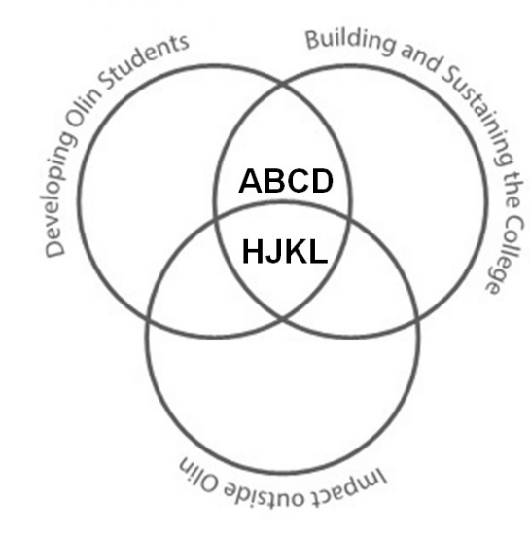Project **A**: AHS Curriculum Development (Music)

Project **B**: ECE Curriculum Development

Project **C**: Integrated Engineering and Music/AHS Curriculum Development

Project **D**: The First Year (2000 – 2001)—Helping Build Olin College and the Student Body

Project **E**: Publication in *Science* (Music and ECE IV Portfolio)

Project **F**: Patents and Trademarks arising from the CantoVario Project, issued by the USPTO (ECE and Music IV Portfolio)

**EFG**

Project **G**: Musical works: Commissions and World Premières (Music IV Portfolio)

Project **H**: CantoVario—Harnessing Chaotic System Variability for Musical Variation (ECE and Music IV Portfolio)

Project **J**: The Engineers’ Conductorless Orchestra (Music and Engineering IV Portfolio)

Project **K**: 100+ Orchestral Arrangements for 12-22 Players (Music and Engineering IV Portfolio)

Project **L**: Building a Music Program at Olin from Scratch—and Sustaining It: 272 concerts from Fall 2002 – Spring 2019 (Music and Engineering IV portfolio)

**Acronyms:**

**AHS** Arts, Humanities, and Social Sciences; **ECE** Electrical and Computer Engineering

**IV** Intellectual Vitality (research, patents, publications, web applications, commissions/world premières/performances, grants, orchestral arrangements, and their tangible applications)

**USPTO** United States Patent and Trademark Office

Figure 1. “Looking Back” Summary Map of Professional Work and Accomplishments for **Developing Students**, **Building & Sustaining the College**, and **External Impact** 2000-2019.

Map 1 differentiates the three main sections of this dossier (Sections II, III, and IV) according to Olin’s faculty goals of Developing Students, External Impact, and Building & Sustaining the College.

## Map 2: A Creative Umbrella of Disciplinary and Interdisciplinary Work

My professional work—inside and outside of Olin College of Engineering—lives in three disciplines: **Music**, **Engineering**, and more recently, **Entrepreneurial Thinking**. As shown in Figure 2 below, most of my projects lie in the interdisciplinary space spanned by music and engineering, specifically **C** (Integrated Engineering and Music/AHS Curriculum Development), **E** (Publication in *Science*), **F** (Patents and Trademarks issued by the USPTO), **J** (The Engineers’ Conductorless Orchestra), **K** (100+ Orchestral Arrangements for 12-22 Players), and **L** (Building a Music Program at Olin from Scratch—and Sustaining It).

At the intersection of all three disciplines—music, electrical engineering, and entrepreneurial thinking—lies my work as a founding faculty member of Olin College of Engineering. In that first year, we wrestled with various visions for our nascent college, including how to situate entrepreneurship within that vision, some of which is captured in **D** (The First Year (2000-2001)—Helping Build Olin College and the Student Body).

CantoVario (**H**) also lies at the intersection of these three disciplines. Perhaps the biggest surprise in my recent career has been the addition of another ‘hat’, an entrepreneurial ‘hat’, to those I already wear (musician, electrical engineer, and educator). Many of my heroes—all those dead composers—also had entrepreneurial streaks. They were able to take an idea from inception to full realization, an undertaking that defines entrepreneurship.

Thus, my musical variation projects encompassed by “CantoVario” now span music, electrical engineering, and entrepreneurial thinking. I found a way to temper and tame a natural mechanism for variability in chaotic systems by devising a chaotic mapping, resulting in musical variation. The search for funding through the MIT Venture Mentoring Service (MIT VMS) added a strong entrepreneurial component to this project.

The music space houses Projects **A** (AHS Curriculum Development (Music)) and **G** (Musical works: Recent Commissions and World Premières). Still, it can be hard to set explicit boundaries since some of my musical works were inspired by my research harnessing chaotic system variability for musical variation.

My ECE courses sit in the engineering circle. I’ve created scores of teaching materials for these courses, (please see the Supplementary Materials and Appendices of this dossier). Teaching in the electrical engineering domain has propelled my musical thinking and vice versa. The results have been interdisciplinary—on purpose. I put myself through engineering school as a pianist because I was convinced something new for music would emanate from speaking and thinking in both languages. My doctoral dissertation in the Electrical Engineering and Computer Science Department at MIT was a first step in that process.

**Map 2: Projects Grouped by Disciplinary and Interdisciplinary Areas**

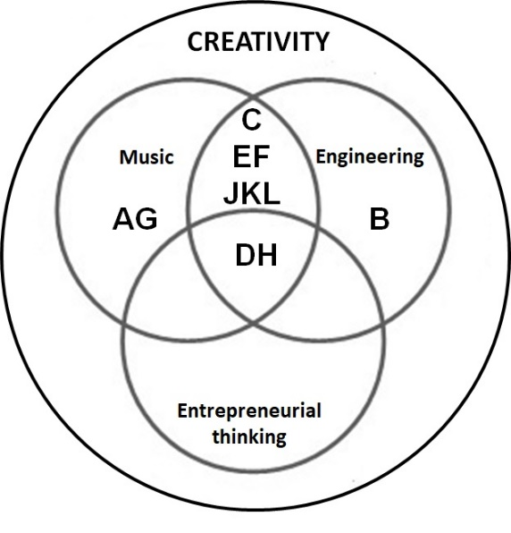Project **A**: AHS Curriculum Development (Music)

Project **B**: ECE Curriculum Development

Project **C**: Integrated Engineering and Music/AHS Curriculum Development

Project **D**: The First Year (2000 – 2001)—Helping Build Olin College and the Student Body

Project **E**: Publication in *Science* (Music and ECE IV Portfolio)

Project **F**: Patents and Trademarks Arising from the CantoVario Project, issued by the USPTO (ECE and Music IV Portfolio)

Project **G**: Musical works: Recent Commissions and World Premières (Music IV Portfolio)

Project **H**: CantoVario—Harnessing Chaotic System Variability for Musical Variation (ECE and Music IV Portfolio)

Project **J**: The Engineers’ Conductorless Orchestra (Music and Engineering IV Portfolio)

Project **K**: 100+ Orchestral Arrangements for 12-22 Players (Music and Engineering IV Portfolio)

Project **L**: Building a Music Program at Olin from Scratch—and Sustaining It: 272 concerts from Fall 2002 – Spring 2019 (Music and Engineering IV portfolio)

**Acronyms:**

**AHS** Arts, Humanities, and Social Sciences

**ECE** Electrical and Computer Engineering

**IV**  Intellectual Vitality (research, patents, publications, web applications, commissions/world premières/performances, grants, orchestral arrangements, and their tangible applications)

**USPTO** United States Patent and Trademark Office

Figure 2. “Looking Back” Summary Map of Professional Work and Accomplishments lying in disciplinary fields (**engineering** or **music**) and interdisciplinary spaces (**music & engineering**, as well as **music, engineering, & entrepreneurial thinking**)—all under an umbrella of creativity.

Disciplinary and interdisciplinary projects involving engineering, music, and entrepreneurial thinking occur in every main section of this dossier. They pervade my professional projects and are therefore included in the titles of Sections II, III, and IV.

## Map 3: Three Overarching Themes Found in all my Work

Three overarching themes infuse my work as an educator, researcher, inventor, composer, pianist, and electrical engineer at Olin College of Engineering: **lifelong learning**, **intrinsic motivation**, and **the creative process** (comprising stimulation/impetus, preparation/scaffolding, application, feedback, revision, and effective communication). Figure 3 below maps my Projects A-L to these three themes which permeate all I do.

The following short descriptions convey how I think of these three themes.

1. **Lifelong learning** is the ability to self-teach and grasp new material from different sources, a vital skill for engineers and musicians, allowing them to stay current in their respective fields. Rapid advances in technology continue to transform musical output and engineering practice, not to mention virtually every aspect of contemporary life. I impart lifelong learning to my students because whatever I didn’t know as a creator, I taught myself. For example, when I didn’t understand something in engineering, I researched the topic to find answers to my questions. In a similar vein, though I never took a course in orchestration, I learned by doing, listening, and questioning.
2. **Intrinsic motivation** involves tapping an individual’s deep desire to do something and do it well. My courses strive to tap students’ intrinsic motivation via their innate curiosity by crafting assignments that allow them to explore their own interests. With respect to my own intellectual vitality, curiosity led me to try what hadn’t been imagined before, e.g., harnessing chaotic system variability for musical variation.
3. **The Creative Process** occurs through exposure to different modes of doing, thinking, connecting, and expressing through engagement with:

Stimulation/impetus, i.e., staying open to curiosity—whether intellectual, emotional, or both; such curiosity often inspires and motivates action. I encourage student curiosity by setting aside time in course schedules so they can more fully explore areas of interest. Stimulation/impetus through curiosity has played a large role in all I do.

Preparation/scaffolding, i.e., building upon earlier work in order to set up a more complex challenge or project. Preparation and scaffolding are key components for successful teaching. They enable stable ‘jumping off’ points for students to delve deeper. They’re also key to my own creative work.

Application, i.e., harnessing concepts and ideas to produce tangible pieces of artistic, scientific, and/or engineering design. Application is written all over music and engineering. Engineers and musicians apply fundamentals of their respective disciplines to make something for others. Students in my music and engineering classes have opportunities to apply what they learn through short projects, labs, application presentations, and final projects. All my intellectual vitality has resulted in significant applications.

Feedback, i.e., hearing and acting on constructive commentary by others, each of whom brings a perspective to the table. A key part of any creative effort is constructive feedback; it’s the engine behind the revision process. In my courses, I schedule individual meetings with students to give personal feedback on what they’ve produced. For my own intellectual vitality, I’ve always had one or more “kitchen cabinets” of trusted souls who critically comment on my projects.

Revision, i.e., iterating versions of a work to produce a final version. Revision plays a central role in any creative process, whether in science or art. Students revise their work in my courses, week-in and week-out. In my own work, every project has undergone substantive revisions. I love the revision process. It plays a huge role in all I do.

Communication, i.e., the ability to express creative intent and significance, whether through the language of music or engineering. Students learn how to communicate effectively in my classes, according to well-defined professional rubrics. As a professional skill, effective communication allows them to move their projects and ideas forward as they pursue careers. Similarly, communication—musical, oral, or written—is prized in all my research and creative endeavors. It enables my work to reach others.

**Map 3: Three Overarching Themes infuse Projects A-L**

**The Creative Process:**

* Stimulation/impetus
* Preparation/scaffolding
* Application
* Feedback
* Revision
* Effective Communication
* Communication

**Lifelong**

**Learning**

**Intrinsic**

**Motivation**

**Projects**

**A B C D E F G H J K L**

Figure 3: Map 3 shows Projects A-L floating in a sea of three overarching themes—Lifelong Learning, Intrinsic Motivation, and the Creative Process. The projects are grouped by color according to the main section in which they lie. For example, bronze projects A-D, purple projects E-G, and burgundy projects (H-L) are discussed in each of main Sections II, III, and IV, respectively.

These three overarching themes—lifelong learning, intrinsic motivation, and the creative process—appear in every main section of this dossier, as reflected in the titles of Sections II, III, and IV.

For Projects A, B, and C of Section II (**Developing Students and Building & Sustaining the College (Map 1)—encompassing Disciplinary and Interdisciplinary Courses (Map 2)—incorporating Three Overarching Themes (Map 3)**), it felt most natural to interleave the themes within the document text since I designed my courses with these themes front and center. They also inspired Project D (“Creating the Renaissance Engineer: Scientifically Astute, Artistic, Entrepreneurial”).

For Section III (**External Impact pertaining to Research and Intellectual Vitality (Map 1)—encompassing both Disciplinary and Interdisciplinary work (Map 2)—incorporating Three Overarching Themes (Map 3)**) and Section IV (**Intellectual Vitality uniting External Impact, Developing Students, and Building & Sustaining the College (Map 1)—encompassing both Disciplinary and Interdisciplinary Work (Map 2)—embodying Three Overarching Themes (Map 3)**), I took a different approach since these projects reflect my personal *modus operandi*. To convey how the themes interleaved with the projects in both Sections III and IV, I made a thematic table for each project, briefly explaining the synergy between the themes and the project at hand. Each table can be found at the end of its concomitant project description.

# II. Developing Students and Building & Sustaining the College (Map 1)—encompassing both Disciplinary and Interdisciplinary Subjects (Map 2)—incorporating Three Overarching Themes (Map 3)

Section II shows my work in curriculum development from three different perspectives, that of

* Map 1 (integration of Developing Students and Building & Sustaining the College),
* Map 2 (disciplinary and interdisciplinary work), and
* Map 3 (three overarching themes: lifelong learning, intrinsic motivation, and the creative process).

Our faculty goals of Developing Students and Building & Sustaining the College are naturally connected in my curricular work, signified by Map 1. When I’m developing students, I’m also building & sustaining the College, as evidenced by Projects A, B, and C. Conversely, work that builds and sustains Olin College also figures into developing students, e.g., Project D. All my courses were “first” courses at Olin, contributing to the curriculum without which we would have no college. From 2001 to 2009, I developed, taught, and created curricular materials for eleven different courses at Olin:

1. *Leonardo as Artist, Scientist, Engineer*
2. *Nabokov, Butterflies, Moths*
3. *Music Performance, Music Composition*
4. *The Olin Conductorless Orchestra*
5. *Musical Design and Aesthetics*
6. *The Wired Ensemble: Instruments, Voices, Players*
7. *Signals and Systems (in two different versions, each presenting a different perspective)*
8. *Heroes for the Renaissance Engineer: Leonardo, Nabokov, Bach, Borodin*
9. *Engineering the Orchestra, part I: Acoustics, Waves, Vibration (with Prof. Chris Lee)*
10. *Engineering the Orchestra, part II: Theory, Orchestration, Composition*
11. *Digital Signal Processing*

Given the opportunity to create courses not offered elsewhere, I designed them to help develop our students in new and exciting ways, thus serving Olin’s innovative mission:

Olin College prepares students to become exemplary engineering innovators who recognize needs, design solutions and engage in creative enterprises for the good of the world. Olin is dedicated to continual discovery and development of effective learning approaches and environments, and to co-developing educational transformation with collaborators around the globe.

As shown in Map 2, my curricular approach embraces disciplinary and interdisciplinary education. In some courses, the interdisciplinary nature is implicit, while in others it’s explicit. Section II will describe both of these approaches. Map 2 shows that Project A (AHS Curriculum Development) and Project B (ECE Curriculum Development) are primarily disciplinary, whereas Project C (Integrated Engineering and Music/AHS Curriculum Development) clearly sits at the intersection of these fields. Project D, a seminal white paper (“Creating the Renaissance Engineer”), presents a vision for our nascent college that embraces three disciplines: engineering, the arts, and entrepreneurship.

My AHS (Arts, Humanities, and Social Sciences) and ECE (Electrical and Computer Engineering) courses also encompass the themes conveyed by Map 3: 1) **lifelong learning** (including just-in-time learning and self-teaching), 2) **intrinsic motivation**, e.g., giving students a long rope, thus fostering agency, and 3) the **creative** **process** encompassing stimulation/impetus (e.g., encouraging curiosity),preparation/scaffolding (preliminary deliverables and feedback that help calibrate expectations), application via initial explorations, final projects, semester and end-of-term performances, feedback (individual sessions with student and professor), revision (opportunities toreview and improve work), and effective communication (written and oral). These three themes will be **bolded in blue**—with the elements comprising the creative process denoted by blue text—as I discuss my current AHS and ECE courses, i.e., Project A, AHS Curriculum Development (Music), and Project B, ECE Curriculum Development:

* The Olin Conductorless Orchestra (OCO)
* The Wired Ensemble: Instruments, Voices, Players
* Digital Signal Processing, and
* Signals & Systems.

Projects C and D will discuss my interdisciplinary courses integrating AHS & Music with Engineering, as well as the white paper (“Creating the Renaissance Engineer”) which provided a vision for Olin and its student body before any students arrived.

All of the above helped build and then sustain the college. Each course was a “first” at Olin; each contributed to either the ECE or AHS Programs at Olin, including major and degree requirements; and all introduced innovations singular to Olin.

## Project A. AHS Curriculum Development (Music)

I have served on the AHS Committee at Olin since 2000, e.g., chairing the AHS Search Committee in 2000 when we hired our first professor (Prof. Robert Martello) whose field is History of Science and Technology. I created AHS courses—both disciplinary and interdisciplinary—specifically designed for the Olin student and helped incorporate effective written communication into our AHS Foundation Courses with particular emphasis on evidence-based analysis.

Not wanting to redefine classes already in existence at our neighboring partner institutions, I designed courses that spoke directly to the Olin student. For example, the Olin Conductorless Orchestra is the only orchestra composed entirely of student engineers in the nation—and it functions without a conductor, on purpose. The Wired Ensemble takes engineers on a tour of the orchestra, including voice; after learning about each family of instruments, they write music for these instruments and voices. In both these **disciplinary** courses, students learn by doing, supported by the **three overarching themes** that pervade my curricular development and work (Map 3).

The below music courses bring “balance”, “creative energy”, and “emotional connection” to our students (their descriptors), not only **developing the “whole person”** which Prof. Lynn Andrea Stein often spoke about in the first year of the College (AY 00-01), but also displaying these traits to prospective students and their families, as seen in the “Music Program Impact” video links given in **Supplementary Materials IV-L-3** (Short Videos conveying the Scope and Impact of the Music Program). All the above show that Olin doesn’t just talk the talk, but really walks the walk, thus **building the integrity of the college** **and helping sustain it**.

These courses have also brought musical opportunities for Babson and Wellesley students. For example, we were fortunate to have Stella Joo as a clarinetist in OCO during her four years at Babson College. She and Alex Niswander ‘12 were the best clarinets we ever had. She wrote the following letter upon graduating Babson:

Hi Diana,

I visited your office on Friday morning, but you must have stepped out for a moment when I was there. I didn't get to see you in person, but I just wanted to thank you one more time for the great experience I had with OCO. My college experience would not have been the same without OCO and your support along the way. It was a great way to explore and learn beyond the "business bubble" I had on Babson campus. I have always played music since I was young, whether it be a piano, a violin, or a clarinet, and I am so happy I had the opportunity to continue playing music in college. I am hoping to find an amateur orchestra in the Northern Virginia or DC area to join so I can continue to have music as part of my life even when I start work in September. Although I didn't get to play in an orchestra while I was in Singapore, there were so many opportunities to attend concerts throughout the semester, one of which was hosted by Singapore Symphony Orchestra with a guest pianist from Japan playing Rhapsody in Blue! Thank you so much for the past four years and I would love to keep in touch. I hope you have a wonderful summer.

Best,

Stella Joo[3]

### i. The Olin Conductorless Orchestra: offered every semester, 2002 - present

What in the life of an Engineering School makes a conductorless orchestra possible?

Firstly, a universal call throughout industry for engineering graduates who can work well in teams, assume, leadership, and communicate effectively. At Olin, these were founding precepts of the College. During the first week of meetings in Fall 2000 when Olin’s Founding Faculty of 12 sat together and started discussing possible avenues for the curriculum, these three professional skills were front and center.

They were weighted heavily because the National Academy of Engineering and industry were insisting that engineers of the 21st century be multi-dimensional, i.e., comfortable not only with working on multidisciplinary projects in large global teams but also poised to assume leadership and communicative roles. Much more would be expected and demanded of 21st century engineers than what had previously sufficed due to globalization and the exploding tech revolution.

Secondly, a well-known, if anecdotal, truism across many nations is that students gifted in math and science are often talented in music. Citing this, the Olin College Dean of Admission’s first question to a newly hired Assistant Professor of Electrical Engineering and Music during the summer of 2000 was, “Okay, where’s the Olin Orchestra?” This wasn’t on my “to do” list nor in my contract. But the new Dean, Dr. Charles Nolan, had researched Engineering Admissions, concluding that an orchestra would be essential for a college that did not exist yet because of the often-observed math/music connection. (N.B. Olin’s inaugural class of students matriculated in the fall of 2002 and graduated in 2006.) But instead of a conducted orchestra, I wondered if it made more sense for our new college to create a conductorless orchestra, given the call for engineers who can work in teams, and communicate effectively, both of which are essential for good leadership.

A conductorless orchestra is first and foremost a large team collaboration by individuals working toward a high performance goal. By design, no overarching figure exists to sculpt an interpretation and pull the performance together. Rather, the members themselves bring the concert to fruition. Such an orchestra exerts singular demands on each individual during rehearsals and performances: the musicians must actively listen to their parts within the context of a larger whole and adjust accordingly, without being told by a conductor.

So what does a conductorless orchestra offer an engineering school? In short, an experiential project-based learning lab for developing 21st century professional skills, i.e., leadership, teamwork, and effective communication. These professional skills will be discussed further in Section IV-J (The Engineers’ Conductorless Orchestra).

**How does the Olin Conductorless Orchestra develop students**? OCO is the only conductorless orchestra composed of engineers—in the world. It features engineering students in leadership, teamwork, and communicative roles. Dedicated to performing the symphonic literature in the concerted spirit of chamber music, the orchestra forges individual participation, active listening, and group-motivation into performances that have established it as a singular ensemble. With an essentially flat hierarchy that incorporates an ever-evolving sense of culture and cooperation as a working ensemble, OCO functions as an effective team of musicians—regardless of position—comprising students, faculty, and external guests, all dedicated to making the best music possible. As a result, everyone pulls their weight, especially necessary in an orchestra of 12-22 players where each instrumentalist is often carrying a line intended for many. Thus, every musician is both soloist and ensemble player.

As an academic course at Olin, OCO works on the project-based learning (PBL) model: students effectively operate the classroom, tapping their own **intrinsic motivation**, and I function as a professional guide-on-the-side. As the faculty guide, I play several roles with responsibilities similar to those described by Wilfred Drath and Charles Palus in *Making common sense: Leadership as meaning-making in a community of practice*.[4] These can be summarized as doing whatever it takes to help the ensemble reach its goals and maintain standards.

The members of the orchestra fill various roles such as ‘rehearsal leaders’, ‘navigators’, and ‘transcribers’. Each student signs up as a rehearsal leader for two rehearsals per semester. Rehearsal leaders help set the agenda for the upcoming rehearsal in conjunction with the navigators and faculty guide. Section leaders emerge by consensus from each of the string, wind, brass and percussion sections. The two navigators, elected by the full orchestra as overall leaders, work with me to ensure rehearsals run smoothly and communication lines stay open within the group (effective communication). For each new piece selected by OCO, student transcribers input the original score into Sibelius, a music notation program. I then re-orchestrate (arrange) the original score to suit OCO’s instrumentation for any given semester. Each arrangement re-designs an orchestral work for a different set of instruments. This is necessary because the students often choose works originally written for orchestras with 90+ players. Thus, these pieces have to be re-composed for much smaller ensembles of 12-22 musicians playing an eclectic array of instruments (please see **Appendices IV-K-1**and**IV-K-2**for a sampling of my orchestral arrangements). Because I’m aware of the capabilities and aspirations of each member of the orchestra, I’m able to tailor the re-orchestrations to the strengths and **motivation** of individual players and the orchestra as a whole.

Since Fall 2006, I’ve brought in external guests—musicians external to Olin who play professionally in the Boston area—so that student musicians hear additional perspectives on the music at hand. OCO musicians work together with the navigators, rehearsal leaders, transcribers, faculty guide, and external guests to create a meaningful musical experience not only for the orchestra but also for its audiences.

“Just in time learning” (**lifelong learning**) is delivered by the rehearsal leaders, orchestra members, as well as the faculty guide and external guests—all of which provide preparation/scaffolding. Students select their own repertoire before any music is learned which enhances their **motivation** to play the music well, e.g., schedule individual practice. (In conducted orchestras, the conductor often selects repertoire). Students offer feedback via effective oral communication on the rehearsal process in real time, and via email in preparation for the next rehearsal. The musicians work in one large group comprising all sections of the orchestra—winds, brass, strings, and percussion—as well as in smaller group sectionals consisting of a single instrumental family, e.g., a string sectional, wind sectional, etc. Students teach one another (**lifelong learning**) since each brings a level of expertise to the music-making process.

The following analogies can be made between the conductorless orchestra ‘lab’ and a hands-on engineering lab. As preparation for the hands-on lab (i.e., application via an upcoming performance), students take a Pre-Lab test (individual practice to learn parts), assimilate just-in-time learning (listen to recordings and analyze the music), complete a Virtual Lab (rehearse the music) and hands-on lab (concert performance).

As a final step in the hands-on lab, students take a Post-Lab test. This corresponds to the orchestra listening to the concert recording and dedicating follow-up rehearsals to addressing issues that require additional work in preparation for the next performance. In essence, this revision process guides musical growth, thus providing stimulation/impetus.

In collaborating with each other, sometimes intensely and often with humor, the orchestra has steadily risen to higher levels since its inception in fall 2002. OCO has been able to rise to these higher levels due to an appreciation for leadership, skill, compromise, dialog, and respect for others. Furthermore, the students in OCO have consistently included some of Olin’s finest engineers, mathematicians, and scientists, as observed by other faculty.

**Why is the Olin Conductorless Orchestra important for Olin College**? OCO is Olin’s oldest music ensemble and provides an enduring example of what our college represents. The orchestra has been a vehicle for talented students studying engineering since 2002, and shows the Renaissance side of their education. It has helped build & sustain Olin College by attracting many of Olin’s top students (as remarked by faculty) through its many visible performances for internal and external constituencies: 137 concerts, Fall 2002 – Spring 2019.

The changes we made to OCO for Fall 2012 (including a new Action Plan and Group Auditions) led to an esprit de corps that was contagious. OCO attracted additional instrumentalists during AY13-14, including first-years, an excellent clarinetist from Babson College, and Olin seniors. This trend continued in AY14-15 and AY 15-16, at which point I realized it was time to take OCO on the road so students could experience playing in venues outside Olin College. We started with Powers Hall at the Needham Town Hall in Fall 2016, followed by the Great Hall of the Cooper Union in New York in Spring 2017, the Mount Pleasant Retirement Home in Brookline in Spring 2018, and OCO’s first jet ride to perform at the ASEE (American Society for Engineering Education) Zone 1 International Conference in Niagara Falls in Spring 2019, captured in Figure 4 below.

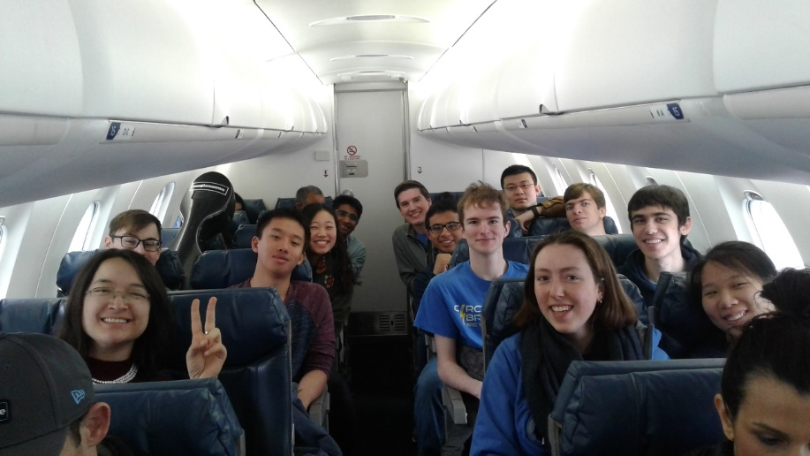

Figure 4: 2019 OCO students aboard Delta flight 5319 en route to Buffalo International Airport.

**My role in a conductorless orchestra.**  I created the Olin Conductorless Orchestra to give our new school a bold variation on the collegiate student orchestra—an orchestra that is self-directed. Its longevity and success have depended not only on a lasting commitment on my part, and that of our students, but also on the many skills I bring to its rehearsals and performances. OCO continually taps all musical parts of me: the concert pianist who knows how to craft, rehearse, and project an interpretation; the theorist who can support that interpretation by reasoning from a deep understanding of harmony and counterpoint; the orchestrator who has professionally performed all musical styles from the Baroque to modern times, applying this experience to the creation of stylistically-consistent orchestral arrangements; the composer whose imagination can conjure up novel orchestral arrangements of works written for orchestras four times our size, thus creating a coherent group sound despite an eclectic, unbalanced array of instruments; and the musician who can hear when things go awry and fix them on the spot, devising productive solutions, sometimes minutes away from performance time. As I’ve done for the past 17 years, I’m dedicated to furthering OCO’s impacts on both its students and audiences.

**Supplementary Materials II-A-1** gives two short performance clips of OCO from 2014 and 2018, as well as earlier performance clips from 2003-05 to show growth of the orchestra.

**N.B.** As will be discussed more fully in Section IV-J (The Engineers’ Conductorless Orchestra), a conductorless orchestra can serve as an experiential lab for developing leadership, teamwork, and communication skills in engineering students. Since OCO is a major vehicle for this dissemination, it’ll be referenced again in Section IV.

For more OCO YouTube performances, including complete recordings of works by Haydn, Mozart, Berlioz, Dvorak, Gershwin, Arturo Marquez, and others, please see **Supplementary Materials** **IV-J-3**(**Example Performances by the Olin Conductorless Orchestra** **2008-2019**).

### ii. The Wired Ensemble: Instruments, Voices, Players (offered every fall term, 2003 - present)

As an AHS Foundation course in music, the Wired Ensemble must meet certain criteria that we have developed as an AHS faculty. Chief among these is written communication, especially analytical writing based on close reading, thesis development, and evidential support for a given thesis. In this Foundation course, students simultaneously pursue composition with music and composition with text, including story/narrative writing.

What’s special about the Wired Ensemble? Is it the only music composition course in the nation where engineering students who have never composed music study orchestration and then compose for those instruments and voices? Probably. Is it the only music composition course in the nation where students apply analytical music composition tools—such as motivic development—not only to their pieces but also to the works of masters? I hope not!

The Wired Ensemble cycles through a new instrumental family every two weeks. There are four 100-minute classes devoted to each family or group of instruments: woodwinds, brass, strings, and percussion/voice.

For each instrument family, students provide feedback on one another’s compositions and receive feedback and other forms of scaffolding, e.g., guided learning materials that encourage self-teaching (**lifelong learning**), as well as individual sessions with me where I play their pieces at the piano, giving feedback (pro and con). For the latter, I improvise solutions to any ‘problem’ areas by first explaining what the problem is, followed by ways to solve it. Students then revise their work in preparation for a live performance class that features other student musicians as performers of their compositions. In this way, students not only hear their original compositions on live instruments but also gain firsthand experience about what works well (and perhaps not so well) based on feedback from performers, peers, professor, and their own ears. To give students useful tools for composition, we build a Composer’s Toolkit. Each week I stuff the Toolkit with new compositional tools and demonstrate these at the piano using a number of musical examples culled from the literature. These tools help students advance their own compositional and creative processes. To reinforce the Toolkit, I developed a series of “Creative Inquiries” where students apply, and gain experience with, useful compositional techniques (stimulation/impetus and application) such as motivic development. By the end of eight weeks, students are ready for a “longer rope”: they compose their “dream piece”, that piece they’ve always wanted to write, thus tapping **intrinsic motivation**. Continuing to stuff the Wired Composer’s Toolkit, I now present techniques associated with the concept of Developing Variation, e.g., linkage, thematic transformation, metrical displacement, and motivic development. These techniques find their way into students’ Final Project pieces (again, stimulation/impetus and application) which are featured in the Wired Ensemble Event concert during Olin’s December Exposition (Fall Expo). The Composer’s Toolkit pervades other aspects of the course, especially written communication. Students write short analyses of their own pieces, then a longer analysis paper on “Beethoven’s Creative Process: peering into an 1803 sketchbook.” We conclude with either written personal narratives about their connection to music or an analysis of a text written by Beethoven: the Immortal Beloved letter, perhaps the most famous love letter in all music. For this assignment, students make the connection between musical composition tools and literary composition tools. Analogies abound, e.g., musical articulations ↔ textual punctuation, non-harmonic tones ↔ diction (word choice), and so on.

**In sum**, as a disciplinary course in music, the Wired Ensemble develops students through three overarching themes of lifelong learning, intrinsic motivation, and the creative process (encompassing stimulation/impetus, preparation/scaffolding, application, feedback, revision, and effective communication). As an AHS Foundation course, it has contributed to the AHS curriculum and helped build the student body by attracting prospective students through its many performances (74 concerts, Fall 2003 – Spring 2019).

**Supplementary Materials II-A-2** provides performance clips from the Wired Ensemble composition course, 2013-2018.

As a result of my funded Babson-Olin-Wellesley Presidential Innovation Grant (“Mix and Stir”, part 2), Wired Ensemble students had the opportunity to hear their works performed live by a Wellesley College faculty trio (Gabriela Diaz, violin; David Russell, cello; and Lois Shapiro, piano) on December 5, 2017. (I had hoped to include student compositions by Wellesley music students as well, but they were at work on other projects, so only Wired Ensemble works were performed.)

**Supplementary Materials II-A-2** also includes a video of “Wired in Series”, the resulting performance of the ten short student compositions that was funded by the “Mix and Stir” grant. None of the students had composed music before taking this course.

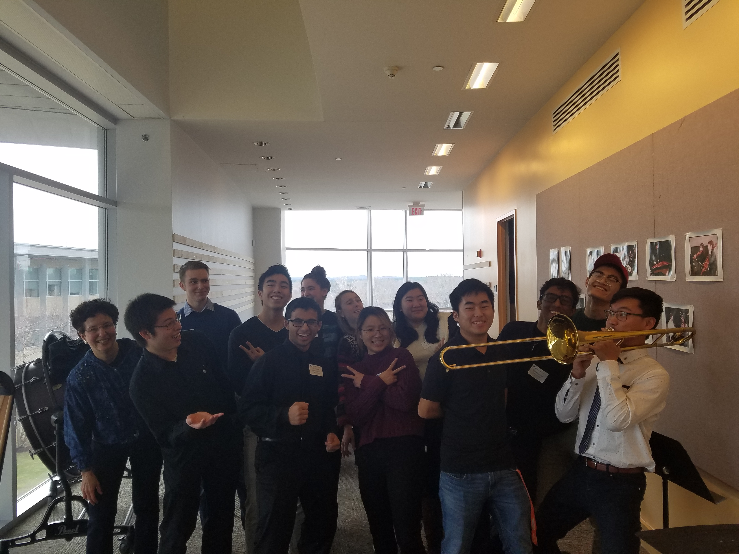

Figure 5: the 2018 Wired Ensemble after performances of their final project compositions during Olin’s December Expo.

**Appendix II-A-2** (“Examples of Wired Ensemble Assignments and Student Work”) contributes additional material, focusing on example assignments and student work. It also contains the program and student scores for the Mix and Stir concert referenced above.

## Project B. ECE Curriculum Development

I created the first versions of ECE core courses at Olin, i.e., those required for the major: Signals and Systems, Digital Signal Processing, and Engineering System Analysis (the latter currently in development with Professors Chris Lee and Siddhartan Govindasamy). My ECE courses were necessary not only to educate our students, but also to ensure accreditation for our engineering programs. They comprised the signal processing part of Olin’s ECE portfolio submitted to ABET, the Accreditation Board for Engineering and Technology. As a new college, we applied in 2006 for our first accreditation review, a process that recurs every six years after initial accreditation. For Olin’s 2012 ABET accreditation process, I prepared the ABET documentation for Signals and Systems (a required course for the ECE degree). For Olin’s 2012 and 2018 ABET accreditation reviews, I prepared the ABET documentation for Digital Signal Processing (an either/or ECE requirement that can be taken with, or instead of, Analog and Digital Communication).

The ECE courses discussed below—Digital Signal Processing (DSP) and Signals & Systems—share certain attributes with my AHS offerings. Just as I develop a Composer’s Toolkit for students in Wired Ensemble, I give my ECE students a conceptual toolbox applicable to myriad engineering areas of interest. The concepts covered in DSP and Signals & Systems not only underpin the current tech revolution, but also our natural world. My courses peer under the hood of Matlab (a high-performance computing environment for engineers) and convey the reasoning behind numerous built-in commands that allow rapid analysis, design, and prototyping. Since mistakes can occur in computation, it’s fitting for engineers to understand the concepts behind built-in commands, regardless of programming environment, to discern whether the results of such functions, e.g., conv (convolving two discrete-time signals), make sense.

DSP and Signals & Systems are disciplinary in nature (electrical engineering), as shown in Map 2. The below discussions will demonstrate not only how these courses have helped develop Olin students—while Building & Sustaining the College (Map 1)—but also how they embody my three overarching themes of lifelong learning, intrinsic motivation, and the creative process (Map 3).

### i. Digital Signal Processing: 2009, 2010, 2011, 2012, (on leave Spring 13), 2014, 2015, 2016 Spring and Fall, (on leave Spring 18)

What’s special about DSP as taught at Olin?

1. Starting the term with an advanced topic and pouring the syllabus out of it. We spend the first week examining an advanced topic (filter design) to motivate the ensuing course material. During that first week, most of the vocabulary and concepts associated with DSP are explained. Students can’t quite grasp it all, as expected, yet when they hear those terms/concepts again in weeks 2-13, their comprehension increases. Curiosity and motivation for learning perks up (**intrinsic motivation**). We use Matlab to explore filter design during that first week and throughout the term. By end of term, students understand much of what’s under the hood of Matlab’s signal processing commands.
2. Flipping the classroom. During the 2014, 2015, and 2016 iterations of the course, I used a flipped classroom approach. I created, and subsequently revised, 48 handouts that outlined the key concepts. I connected them to earlier material and gave illustrative examples that students were able to complete at their own pace. The worksheets fostered self-teaching (**lifelong learning**). I spent much of the class time circulating among the students, answering questions.

National Instruments Academic Field Engineer Leslie Yu, DSP course assistants, and I developed a series of labs over the course of the DSP iterations that allowed students to work at their own pace and receive individual help. The first two labs were modeled on the DSP First Labs by McClellan, Schafer, and Yoder. After that, we developed Lab 3 (FIR Filters and Frequency Response), Lab 4 (Filter Implementation and Coefficient Quantization), and Lab 5 (Filter Structures) specifically for our Olin course.

1. Integrating features of Wired Ensemble into DSP: **intrinsic motivation,** the **creative process**, including stimulation/impetus,preparation/scaffolding, application, feedback, revision, and effective communication. Interestingly, the Wired Ensemble influenced much of how DSP evolved. Like Wired Ensemble, DSP focuses on theory and practice, as well as building a professional vocabulary.

Preparation/scaffolding is provided not only for Final Projects but also for midterm and final exams. For example, weekly quizzes ensure students stay up-to-date with the course material.

To encourage **intrinsic** **motivation**, I give DSP students a long rope with respect to their Final Projects. But I also provide scaffolding in class and individual meetings. For example, for the first half of the term, we have weekly “Application Presentations and Reports” where students research and then prepare a DSP application of interest. Each student gives two application presentations and prepares a short written report on each. Both the presentation slides and the written reports comprise an ever-growing “Book of Apps” that students can access. In fact, many of these application presentations trigger final project ideas (stimulation/impetus).

However, because no rubric existed for either presentation or report, I decided to port over another feature of Wired Ensemble: writing according to a well-defined and professional rubric. I worked with Olin Writing Consultant Dr. Gillian Epstein to develop a rubric for the DSP “Application Presentations and Written Reports.” The rubric helped calibrate the students.

Next, I extended the Application rubric to DSP’s “Final Project Presentations and Written Reports.” In effect, the research and preparation of the Application Presentations and Written Reports provided the scaffolding for students’ Final Project deliverables which include a project proposal, revised project proposal, written final project report, and final project oral presentation (effective written and oral communication + revision). I provide written feedback on student project proposals and their revisions. I also arranged individual meetings (feedback) to help calibrate each student and allow individual questions.

**In sum**, as a disciplinary ECE course, DSP develops students through three overarching themes: lifelong learning, intrinsic motivation, and the creative process (stimulation/impetus, preparation/scaffolding, applications, feedback, revision, and effective communication). As part of the ECE core curriculum, it has helped build & sustain the college, contributing to the ABET accreditation process as well.

Please see **Supplementary Materials II-B-1a**which includes the Fall 2016 Course Schedule, **II-B-1b**for an example of my course materials, and **II-B-1c**for a listing of topics delivered by 48 course materials I developed for DSP students, based on the last iteration of this course before my developmental leave in Spring 2018.

**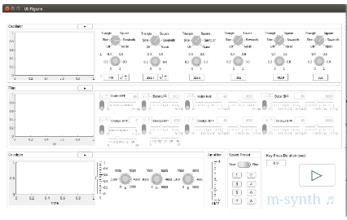****Appendix II-B-1** contains examples of DSP assignments, labs, and student work, including a student’s final project, M-synth.

Figure 6. Graphical interface built for M-synth, a final project in DSP.

### ii. Signals and Systems: 2003, 2004, 2005, 2006, 2007, (on leave Spring 2008), 2012, 2019

What’s special about the 2012 and 2019 editions of Signals and Systems? In addition to engineering content, they address written communication according to a professional rubric, require revision of written material, and encourage students to explore applications that pique their curiosity. For the 2012 version of Signals and Systems, I completely re-vamped the course to achieve a fresh perspective. Since its topics pervade contemporary applications, I offered opportunities for research and a final project (**lifelong learning,** stimulation/impetus, and application). As with DSP, I wanted to provide preparation/scaffolding for the Final Project by giving each student a chance to research and present an application that captured interest. To foster **intrinsic** **motivation**, I brought over elements of Digital Signal Processing and Wired Ensemble, such as giving students a “long rope” (**lifelong** **learning**). Thus, they had free reign to present any application that employed signals and/or systems, which meant basically everything!

Having 26 students in the class afforded opportunities to learn from one another (**lifelong learning**) about 26 different applications pertaining to our course material. Furthermore, by virtue of finding an application to present, each student researched several applications, engaging an exploratory process that included self-teaching (**lifelong** **learning**), often leading to a Final Project idea, just as it had in DSP.

Yet another feature of DSP and Wired Ensemble—writing according to well-defined and professional guidelines—informed the 2012 Signals and Systems. I prepared “Guidelines for Signals and Systems Application Presentations and Written Reports”, including rubrics for the written application report and the oral presentation, based on the earlier DSP models. This assignment demonstrated our class emphasis on (1) application, (2) written communication, and (3) preparation/scaffolding for the students’ final project deliverables, including a final project proposal, final project demo, and written final project report and oral presentation (application). As I had found with DSP, the application presentations and reports helped calibrate students: they heard/viewed their peers’ presentations, read peer application written reports (all of them accessible), and received written feedback from me. I also met individually with each presenter to give oral feedback and answer any questions.

To further calibrate the students, I gave an example presentation in class and wrote an example report that demonstrated the guidelines and rubrics (additional scaffolding).

Having gained experience and new knowledge with the Application Presentations and Reports, students were now prepared to produce their final projects. First they wrote Project Proposals according to prepared guidelines. I then provided written and oral feedback to each team of students using another feature of Wired Ensemble and DSP—individual sessions (feedback)—so that they could then revise their proposals, and if desired, their projects (revision).

The goals for the Signals and Systems final project included:

* **Lifelong learning** (students had to teach themselves material related to their projects)
* **Intrinsic motivation** (students selected their own project topics and deliverables, in consultation with me to ensure the projects were realizable in the time allocated—scaffolding)
* Effective written and oral communication
* Power of the revision process (students revised their Project Proposals, resubmitted, and received written and oral instructor feedback on their original and revised proposals via individual meetings)
* Stimulation/impetus (the joy of bringing an inventive work to fruition)
* Participation by each team member (every student on a given team had to present part of the project during the class presentations)

**In** **sum**, as a disciplinary ECE course, Signals and Systems develops students by means of three overarching themes: lifelong learning, intrinsic motivation, and the creative process (encompassing stimulation/impetus, preparation/scaffolding, application, feedback, review, and effective communication). Like the DSP course, it’s part of the ECE core curriculum requirements for the major; as such, it has helped build & sustain the college, contributing to the ABET accreditation process as well.

**Supplementary Materials II-B-2a** includes the 2019 Course Schedule; **II-B-2b**gives an example of my course materials; and**II-B-2c**contains a list by topic of course materials developed in 2012 (25 conceptual handouts) and 2019 (an additional 16 handouts) to help students grasp Signals and Systems concepts.

**Appendix II-B-2** contains examples of assignments and student work.

### iii. Coming Soon: Engineering System Analysis—a new course for Spring 2020

Currently, I’m in the process of developing a new course with Professors Chris Lee and Siddhartan Govindasamy: “Engineering System Analysis”, the follow-on course to Quantitative Engineering Analysis II. Working on the first iteration of Engineering System Analysis has been exciting. Profs. Chris Lee, Siddhartan Govindasamy, and I are conceptually and technically aligned as we develop this innovative course to be offered in Spring 2020. Here is the synopsis written by Prof. Lee for our report-out to Olin’s Integrated Project Fund from which we received Summer 2019 funding:

**A Mid-Analysis-Stream, Multidisciplinary Course**

Diana Dabby, Siddhartan Govindasamy, Chris Lee

We are creating a new multidisciplinary course that would be used by both ME and ECE majors to satisfy one of their respective core course requirements and could be included in plans of study of Engineering majors. The course focuses on building, developing, and practicing process-based quantitative analysis skills in the broad area of linear analysis of engineering systems. The first half of the course is common for all students. The second half is separated into two distinct courses. Students are required to take one of them but have the option to take both. During the summer of 2019, we defined the course structure, identified student learning goals, and outlined the course content. In the fall of 2019, we will create the specific curricular materials that will be used.

## Project C. Integrated Engineering and Music/AHS Curriculum Development

Recall that Map 2 in the Introduction (Section I) depicts the disciplinary or interdisciplinary nature of my eleven projects A-L. The curriculum development captured by Project C speaks to the explicit integration of Music with Engineering, not only in the module I developed for the Harvard School of Engineering and Applied Science (SEAS) course “Engineering the Acoustical World”, but also for Olin’s “Engineering the Orchestra”, parts I and II. Project C captures all three of these integrations, as well as a fourth course—Heroes for the Renaissance Engineer. “Heroes” melds topics in art, science, literature, entomology, music, acoustics, and chemistry, in accordance with the work done by Leonardo, Nabokov, Bach, and Borodin. Students come to realize, through readings, thinking, and discussion, that each of these individuals achieved an inimitable artistic signature by virtue of scientific knowledge and experience.

The ensuing discussion will show how these interdisciplinary classes support the faculty goals of Developing Students and Building & Sustaining the College (Map 1)—at Olin and elsewhere—as well as how they incorporate my three overarching themes of lifelong learning, intrinsic motivation, and the creative process (Map 3).

### i. Harvard School of Engineering and Applied Science (SEAS) “Engineering the Acoustical World”: Invited guest instructor for math+music module comprising two 1.5-hour classes, 2018

I designed, developed, and implemented a module connecting music theory, instrument theory, and engineering acoustics for the Harvard School of Engineering and Applied Science (SEAS) “Engineering the Acoustical World” as an invited guest instructor for a math+music module comprising two 1.5-hour classes on February 13 and 15, 2018. Prof. Rob Wood, the instructor in charge of “Engineering the Acoustical World,” a new course in SEAS at Harvard, invited me to link math and music for his course. My module—entitled “What’s so great about the overtone series?”—connected the wave equation, overtone series, tuning, string harmonics, modal scales, and orchestration, something I’ve always wanted to do! I prepared seven handouts for students, faculty, and staff that made the connections for study in and outside the classroom. [Robert Wood, Charles River Professor of Engineering and Applied Sciences, Harvard]

These modules helped **students develop** an interdisciplinary understanding of a deep connection between music and math by solving the 1-dimensional wave equation to reveal the fundamentals of standing waves and the overtone series, both topics central to science and music, respectively. These modules resulted from Olin’s Summer Institute where faculty from different educational institutions participate in a week-long immersive experience where they explore their own upcoming educational initiatives. Thus, the modules **built upon Olin’s relationship** with colleagues in SEAS at Harvard.

Students in the course came from backgrounds in engineering and/or the liberal arts. To understand the material presented in these modules, they engaged in **lifelong learning** (including self-teaching unfamiliar aspects of music or math), **intrinsic motivation** (by virtue of enrolling in the course, they indicated a curiosity about connections between engineering and the acoustic world around them which further manifested itself in the questions they asked), preparation/scaffolding (provided for them by an excellent team of instructors), application (how the harmonic series permeates engineering and music, e.g., string harmonics demonstrated live with a student cellist, wave phenomena, and my own example of how I re-orchestrated the Dvorak Eighth Symphony for a small orchestra by harnessing the overtone series to create a coherent group sound), effective communication (by providing different in-class methods for conveying the material at hand, e.g., videos, concept handouts, audio examples, and demonstrating at the piano), and stimulation/impetus (by exposing the students to different avenues for interdisciplinary connection).

**Appendix II-C-1** contains the following course materials that I prepared for these two Harvard SEAS classes on the topic “What’s so great about the overtone series?”

1. The overtone series pops out of the wave equation
2. The overtone series, standing waves, harmonics
3. A quick recap of our prior class
4. Pythagoras: scales based on proportional string lengths
5. From Pythagoras to Ptolemy to tempered tuning
6. Modal scales
7. Taking advantage of the overtone series for orchestration

During my earlier years at Olin (2001 – 2008), I gave courses that united engineering, science, art, and music. The below parts ii-iv give a short sampling.

### ii. Engineering the Orchestra, part I: Acoustics, Waves, Vibration (with Prof. Chris Lee), 2007

Prof. Chris Lee and I last offered this course in Fall 2007. Students have been asking for it ever since.

One of our projects involved students making a flute, such as that shown in Figure 7.

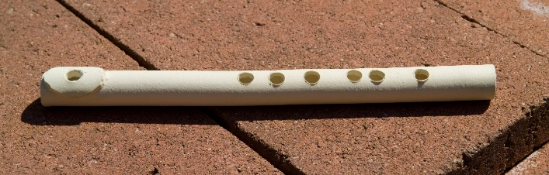

Figure 7: A clay flute engineered by an Olin student as a final project.

Many of our students are already multi-talented so Prof. Lee and I wanted to draw on that by creating a course that further **develops the multidisciplinarity of our students**. Engineering the Orchestra, part 1, also offered a tangible example of Olin’s dedication to multidisciplinary education, thus helping **build the college**.

Students engaged with themes of **lifelong learning** (through research according to their interests), **intrinsic** **motivation** (enrolled students had self-selected due to their own desire to understand, design, and make musical instruments), stimulation/impetus (different approaches to instrument production, e.g., using different materials to realize a flute), preparation/scaffolding plus application (students engineered a PVC pipe didgeridoo, PVC pipe flute, and cigar box guitar before embarking on their own final instrument design projects), feedback (from peers and professors), revision (iterative approaches to each application mentioned above), and effective communication (final project proposal and final project report).

### iii. Engineering the Orchestra, part II: Theory, Orchestration, Composition (2008)

It was neat teaching Engineering the Orchestra, parts I and II, as back-to-back half-semester courses in Fall 2007 because I made timely connections between the two, thus **developing students** through an interdisciplinary experience that also **contributed to the college’s resonance with interdisciplinary courses**.

Initially, I created part II, not only to link with part I, but also in response to student requests for a sequel to the Wired Ensemble. Thus, the course drew on their **intrinsic motivation** to make music. Part II provides ‘just-in-time’ harmonic and contrapuntal theory for the study of instrumentation with an emphasis on composing for combinations of strings, woodwinds, brass, and percussion (**lifelong learning**). Equipped with a technical understanding of orchestral instruments as a result of Part I, students connect the art of ensemble writing to the physical understanding of instruments (stimulation/impetus). As a result, they can reason from several vantage points as to why, for example, a particular harmonic voicing might be preferable to another (effective communication). Finally, while engaged in writing short studies for mixed ensembles (preparation/scaffolding) that underwent review (feedback) and revision, students looked forward to composing their Opus 1, a culminating work for multiple instruments (application).

**Supplemental Materials II-C-3** gives a final project composition from this course.

### iv. Heroes for the Renaissance Engineer: Leonardo, Nabokov, Bach, and Borodin (2004, 2005, 2006, 2007)

In times past, whenever I felt challenged or curious about life’s journey, I sought heroes. Since childhood, my heroes have included ‘all those dead composers.’ I took them along life’s journey, reading their lives, letters, and playing their works. During my graduate years at MIT, while linking engineering with music and maintaining professional lives in each, I found myself encountering issues that seemed singular to my pursuit of engineering and music. Now that I had become a ‘Two-part Invention,’ I found no lack of ideas. But the pressing issue was time. And that was only the beginning. How does one chart a productive course that does not easily fit within any one discipline? Once again, as in my childhood, I found heroes. They taught me how to navigate dual professions. They helped me accept that time would always be an issue, and they inspired me: Despite great innate gifts, Leonardo, Nabokov, Bach, and Borodin worked hard, often passionately and even obsessively. They stayed true to their creative core and stoked their intellectual curiosity.

For many years, I felt a strong compulsion to bring their example to contemporary life. As a first step, I designed “Heroes for the Renaissance Engineer” to speak directly to Olin students, many of whom have talents in music, art, science, math, and engineering, thus tapping their own interests (**intrinsic motivation**). In Heroes, students seek answers to the questions: To what extent have artists exhibited extraordinary knowledge and ability in science? Does this necessarily infuse their art, and if so, how? (stimulation/impetus)

To answer these questions, they study source documents and analyze the works of Vladimir Nabokov (writer and lepidopterist), Leonardo da Vinci (artist and engineer), J.S. Bach (composer, performer, and acoustician), and Alexander Borodin (composer and chemist), shown in Figure 8. By examining source documents and what they reveal, students develop an appreciation for primary source material that can lead to lucid evaluation of documents throughout life (**lifelong learning** and effective communication). “Just-in-time learning” gives context for answering the above questions. For example, starting with a crash course in Lepidoptera (an order of insects comprising butterflies and moths), students go on a “Lit/Lep” hunt through two of Nabokov’s works (*Speak, Memory* and *Lolita*), critical for understanding his many lepidopteral references (preparation/ scaffolding). For their final projects, students have the opportunity to integrate their artistic and engineering sides by creating works that call upon both. Each writes a proposal, receives peer and professor feedback, then submits successive versions of the project for review (revision and application)—till the final deliverable.

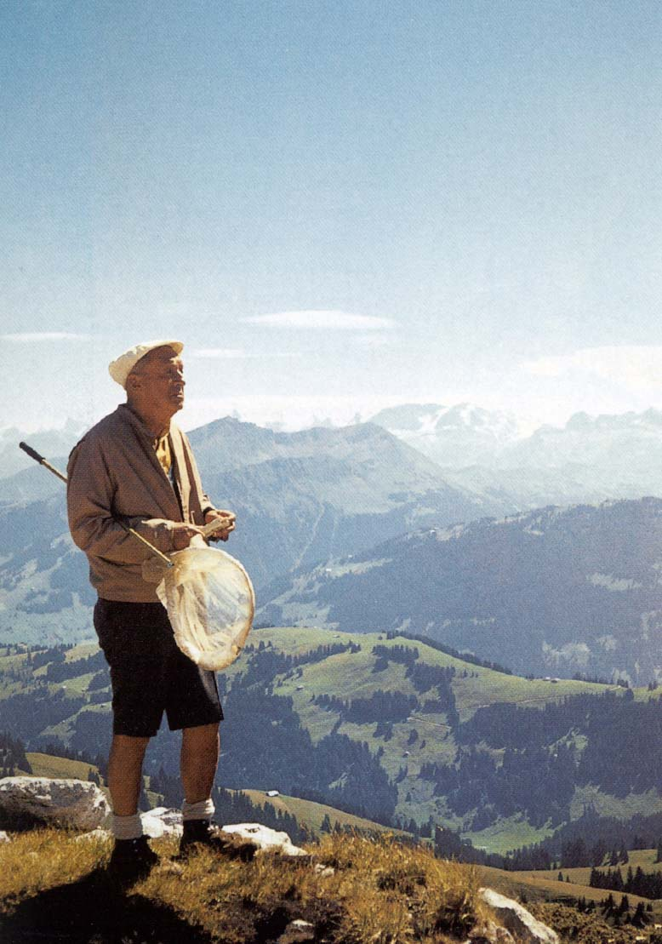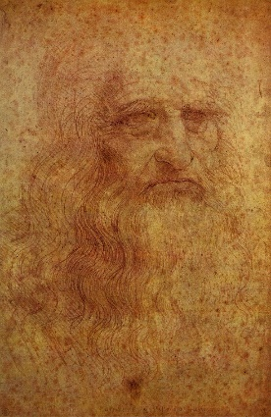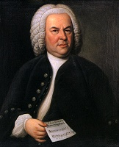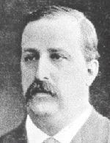

Figure 8: Nabokov with his butterfly net, Leonardo (self-portrait), Bach holding a canon that never ends (loops), and a photo of Borodin.

**In sum**, Nabokov, Leonardo, Bach, and Borodin each achieved a self-sufficiency enabling the articulation and realization of work revealing a singular vision, shaped in part by fluency in both technical and artistic disciplines. They help **develop students** of today by demonstrating the benefits of speaking two languages with depth and passion, resulting in inimitable work. They set examples that students might emulate: the predilection for invention and discovery; the chance to contribute in art, science, and maybe in both; and the almost inevitable signature that such fluency bestows on the work they undertake—all of which help **build & sustain the reputation of our College**.

## Project D. The First Year: Helping Build Olin College and the Student Body (2000-2001)

### Creating the Renaissance Engineer: Scientifically Astute, Artistic, Entrepreneurial

*“Olin’s mission does not stop after a student graduates. Rather it is carried forward, an integral part of each graduate, into creative endeavors far and wide. What assures the creativity?*

*A mind able to triangulate its corners.”*

This is how I began the white paper circulated around Olin in mid-late January, 2001, when Olin consisted of just 12 faculty, a leadership team, plus administrative support; students wouldn’t arrive till the following fall. I wrote the document because Rod Crafts, then Dean of Students, and Steve Holt (then Professor of Physics) pulled me aside in early January and said, “we believe the vision you paint for the college is the strongest so far, so why don’t you write it up.” The resulting white paper presented the following argument:

The Renaissance, a time of fluid boundaries between science and art, produced feats of engineering design, artistic mastery, and an entrepreneurial spirit that continue to inspire and motivate humankind. At [Olin College of Engineering], our students learn to speak the languages of engineering, science, mathematics, the arts, and business—not as separate subjects—but all together. We emphasize this essentially trilingual approach (engineering/science/math, arts, entrepreneurship) because we believe that a mind able to reach all its corners becomes a fully functioning intelligence capable of reaping the kind of “breakthrough” thinking that moves the human condition further [stimulation/impetus and preparation/scaffolding].

Olin students create in many fields while at the College—in engineering, mathematics, science, art/music/film/video/writing/theater/performance, and business—just as they will after graduating [application]. We believe that pursuing projects and knowledge in all of these concentrations fuels an individual’s creativity, as does the ability to communicate these pursuits to a larger audience [effective communication]. It is this synergistic creativity that is ultimately Olin’s goal—to produce and enhance the resilient, resourceful, artistic, intelligent, and technically astute individual who will take these gifts and basically go out and change the world in some way. This catalyst for change touches another of Olin’s core values: that change be beneficial to human kind. Philanthropy, ethics, and communication figure prominently in the [Olin] worldview. Towards that end, our faculty includes social scientists with specialties in past and current ethical and historical issues, as well as experts in communication so that our students have the skills to reach others with their ideas.

Given the emphasis on creating in multiple fields which, by its very nature, often necessitates “going out on a limb”, students’ participation and ever-increasing fluency in Engineering, Entrepreneurship, the Arts helps them become more confident in their abilities. Ultimately—after an undergraduate education steeped in “doing” and “thinking” both singly and collaboratively—they find themselves comfortable with risk, having spent part of their undergraduate years becoming acquainted with it [feedback and revision]. A high comfort level with risk provides a key character trait of the entrepreneur, where entrepreneur is defined broadly as an independent, active, self-sufficient individual who “can articulate a vision and bring it to fruition” [Prof. Steve Schiffman, Senior Olin Partner]. Risk-tolerance enables graduates to pursue business opportunities, inventions, innovative projects, not to mention dreams, new theories, and ideas from which others may shrink or cast as impossible [**lifelong learning** and **intrinsic motivation**]. Of course, history is awash with great ventures that were so summarily dismissed. Olin graduates are not shrinking violets and they do not take no for an answer! They are a little bit uppity (though respectfully so).

Please see **Supplementary Materials II-D** for the complete white paper.

“Creating the Renaissance Engineer” turned out to be a prescient work. I personally gave each member of our faculty and administration a copy and then met with each. The paper engendered key conversations among the Olin community. It framed useful language by giving Olin a three-cornered vision embodying Engineering, the Arts, and Entrepreneurship. These three anchors for our new college were next captured in a visual image which became known as the “Olin Triangle”, as shown in Figure 9.

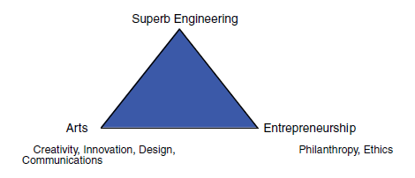

Figure 9. The Olin Triangle showing the three “major dimensions of an Olin engineering education.”[5]

By showing the three “major dimensions of an Olin engineering education”, the Olin Triangle inspired our early vision, a vision that has “stood the test of time” and “is still used to guide curricular discussions”, as remarked in highly visible publication by Olin’s President (Richard Miller) , Provost (David Kerns), and Vice President for Innovation & Research (Sherra Kerns), entitled “Designing from a Blank Slate: The Development of the Initial Olin College Curriculum”, published by the National Academies Press in 2005.3

**In sum**, by writing “Creating the Renaissance Engineer” and jumpstarting conversations among Olin stakeholders in 2001, I helped lead Olin to a cogent vision, one that had lasting impact during the critical formative years prior to ABET accreditation in 2006. Though written 18 years ago, it speaks to **developing students**,as well as **building & sustaining the College** (Map 1), before our college-to-be had students or buildings. It reflects my three overarching themes (Map 3)—**lifelong learning**, **intrinsic motivation**, and the **creative process**—to present a vision for Olin College. By encouraging the ability to triangulate Engineering, the Arts, and Entrepreneurship, while emphasizing their synergy (Map 2), the white paper’s message still resonates with students today, given their talents in engineering and the arts. Its curricular impact endures, as evidenced by the engineering, artistic, and entrepreneurship courses offered at Olin.

**҉҉҉**

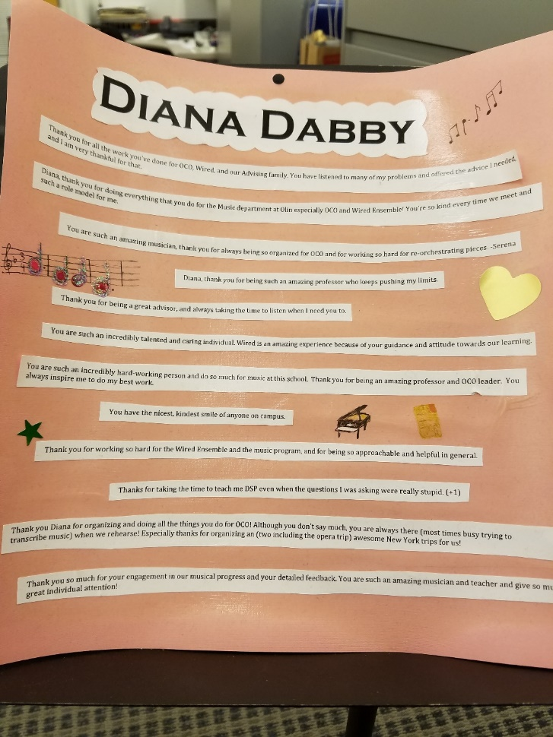**In sum**: *Leadership and Impact.* We’ve now come to the end of Section II (**Developing Students and Building & Sustaining the College (Map 1)—encompassing both Disciplinary and Interdisciplinary Subjects (Map 2)—incorporating Three Overarching Themes (Map 3)**), embodying Projects A, B, C, and D. As evidenced by Section II and its associated Supplementary Materials and Appendices II-A through II-D, these Projects A-D not only developed students, but also helped build and sustain the College, while introducing innovations singular to Olin. My initiative, commitment, and results—twelve “firsts” at Olin (comprising 11 new courses plus the white paper “Creating the Renaissance Engineer” which articulated an educational vision for the college and its students)—have demonstrated *Leadership and Impact* with respect to Olin’s faculty goals of **developing** **students** and **building & sustaining the College**. In addition, my curricular contributions helped establish Olin’s ECE, Engineering, and AHS Programs, while contributing core courses required for electrical and computing engineering majors, as well as for the Olin degree.

In closing Section II, I wanted to include the gift that keeps on giving. Two years ago, I walked into Studio 305 on Fall Expo Day to start a dress rehearsal for the Wired Ensemble Event performance and found this placard slipped under my door. Turns out a group of students prepared similar placards for every Olin faculty member—a boost for all on the final project exhibition day of the semester—Fall Expo.

Figure 10. What Olin students do for Olin faculty.

# III. External Impact pertaining to Research and Intellectual Vitality (Map 1)—encompassing both Disciplinary and Interdisciplinary Work (Map 2)—incorporating Three Overarching Themes (Map 3)

Speaking, living, and breathing two languages—one technical, the other artistic—has defined my professional life since graduating MIT in 1995. It’s been an exciting adventure, at times fast and furious. I love creating in both. Every day is different. One night an email might arrive out of the blue commissioning a new piece for a concert, the next I could be working on an innovative algorithm for musical variation, after which I might find the algorithm influencing how I’m composing a new musical work (metaphorically) and vice versa. On a daily basis, I ‘speak’ engineering and music. This is how I like it.

My professional life in music, electrical engineering, and at the interface of the two, has spanned multiple areas, including music composition, intellectual property, a longstanding musical variations project (CantoVario), the Music Program at Olin, published works on a conductorless orchestra for engineering students, and the 100+ orchestral arrangements that have enabled a small school like Olin to have an orchestra that is self-directed.

Section III addresses those projects that demonstrate Leadership and Impact with respect to Olin’s faculty goal of External Impact, specifically Projects E (Publication in *Science*), F (Patents and Trademarks Arising from the CantoVario Project), and G (Musical works: Recent Commissions and World Premières). Projects E and F, explicitly interdisciplinary, and Project G, primarily disciplinary, all interface with three overarching themes: lifelong learning, intrinsic motivation, and the creative process (involving stimulation/impetus, preparation/scaffolding, application, feedback, revision, and effective communication).

(N.B. Section IV presents Projects H-L which will demonstrate Leadership and Impact across all three Olin faculty goals: developing students, external impact, and building & sustaining the College.)

## Project E. Publication in *Science* (Music and ECE IV Portfolio)

October 28, 2007 turned out to be one of those days where in the morning, the electrical engineering side of me was giving an invited plenary for the 2007 International Conference on Complex Systems entitled “Engineering Chaos and Musical Variation” and the musical side was rushing to a dress rehearsal of the Olin Conductorless Orchestra for an afternoon performance of Haydn and Beethoven for the Fall Admissions Open House. It was a memorable day, one that also contained a surprise.

A senior editor from the journal *Science* was in the audience during the presentation I gave on my work with musical variation and chaos theory at the Complex Systems Conference. A month later, I received an email from the Perspectives editor of *Science* asking if I would write an article on creating musical variation that would set the context for my work, including audio examples. Writing that article felt like writing a piece of music: complete engagement as one thought flowed to the next.

“Creating Musical Variation” traces the development of musical variation from Mozart and Haydn to Stravinsky, Pierre Henri, and John Cage, from theorists Johann Riepel to Arnold Schönberg—all of whom provided context for my new variation technique. The article opens with a fact gleaned from primary source material: “In the 21 letters that Mozart wrote to his friend Michael Puchberg between 1788 and 1791, there exist at least 24 variants of the supplication ‘Brother, can you spare a dime?’” Mozart varies his theme of “cash needed now” in much the same way 18th century composers wove additional notes around a theme in order to create a variation. Later composers conceived different forms of musical variation, ranging from Stravinsky’s ‘matrix-like’ array of pitches to create his *Variations* for orchestra to Cage’s completely random approach in his *Variations IV* where any number of ‘players’ can show up and perform by ‘playing’ radios, noise-makers, and even instruments. However, if a composer wants to vary an entire work from one hearing to the next, and even from performance to performance, without Cage’s randomness, a different kind of variation technique can be applied—one that uses a chaotic mapping to make musical variations of the entire work. I designed this technique to harness a natural mechanism for variability found in the science of chaos: the sensitivity of chaotic trajectories to initial conditions. Though most engineers seek to avoid chaotic dynamic behavior, I tamed and tempered it for musical variation. *Science* gave me a great opportunity to set the context for my work in a highly regarded journal.

**Supplementary Materials III-E** contains the full *Science* article, “Creating Musical Variation.”

**In sum**, my invited Perspectives article, “Creating Musical Variation”, demonstrates *Leadership and Impact* with respect to Olin’s faculty goal of **External Impact** (Map 1), by virtue of its publication in *Science*. The article fuses the disciplines of music and engineering (Map 2). The table below succinctly captures the role played by each of my three overarching themes in Project E, thus elaborating on Map 3.

|  |  |
| --- | --- |
| **The Role played by each of Three Overarching Themes in**  **E:** Publication in *Science*, 2008 | |
| **Lifelong**  **Learning** | Spending days in Harvard’s Music Library, I researched aspects of musical variation, some of which were new to me. |
| **Intrinsic**  **Motivation** | Inspired to write a beautiful piece |
| **The Creative Process** | Exposure to different modes of doing, thinking, connecting, and expressing through engagement with: |
| Stimulation/impetus | A strong desire to write a compelling perspective on musical variation |
| Preparation/Scaffolding | My doctoral thesis (*Musical Variations from a Chaotic Mapping*) plus materials I developed to infuse composition courses with modules on musical variation |
| Application | Artistic flow: Writing this article felt like composing a musical work where one phrase led inexorably to the next. |
| Feedback | *Science* editors and my “kitchen cabinet” |
| Revision | Revisiting and re-working my manuscript every morning till completion, allowing a fresh approach on a daily basis, in response to the *Science* editors, colleagues, and my own inner editor. |
| Effective Communication | Producing a tangible article that led the reader from the classical theme and variation of Haydn and Mozart to contemporary times |

## Project F. Patents and Trademarks Arising from the CantoVario Project, issued by the USPTO (ECE and Music IV Portfolio)

The Intellectual Property (IP) now described arose from my work known as the CantoVario Project (later described in Section IV-H, since it unites all three Olin faculty goals of External Impact, Developing Students, and Building & Sustaining the College). This interdisciplinary work harnesses chaotic system variability to produce musical variation. In wearing an engineer’s cap and listening to the musician within, I devised chaotic mapping algorithms that provide the engine for making musical variations of an original work. Based on a natural mechanism for variability found in dissipative chaotic systems, i.e., the sensitivity of their solutions to initial conditions, this variation technique employs two chaotic trajectories that map the events of a musical work into a variation based on the original piece. The variations can be close to the original, diverge from it substantially, or achieve degrees of variability between these two extremes. The technique can serve as an idea generator or as a springboard for a dynamic music where a work changes from one hearing to the next—not in random ways—but rather by musical choice. The technique does not generate music or any other kind of data as random events; rather, it creates a rich set of variations on an already completed piece or sequence of symbols.

Despite its ability to produce variations that can be delightful—appealing to musicians and non-musicians alike—the original chaotic mapping of my earlier IP and papers has limitations. For instance, it only encompassed one algorithm, whereas the “improved chaotic mapping” described in my 2016 patents offers multiple variation techniques, and uses them to generate variations not only of a discrete-time signal representation of a source piece, e.g., MIDI file scores, prose, poetry, etc., but also variations of continuous-time signal representations of a work, e.g., audio recording, film, video, spoken word art, video games, and so on.

The patent applications (granted and pending) listed in the accompanying curriculum vitae cover my algorithms for generating musical variation. They arose from Project H (CantoVario). I have spent a number of years creating these algorithms which are specific to me and show evidence of what I do. Together they underpin the MIDI and audio sides of applications I’ve developed—known collectively as “CantoVario.” My 2010 Provisional, 2011 Utility, and 2012 Preliminary Amendment patent applications were issued by the USPTO (United States Patent and Trademark Office) in March 2016. On the advice of my team at the MIT Venture Mentoring Service (VMS), I filed trademark applications to register the marks “CantoVario” and “EnginArt” with the USPTO (granted 2014 and 2015, respectively), as well as the 2014 Continuation in Part (granted 2016).

My latest patent application (provisional + utility submitted 2017-18, pending) includes the new variation algorithms that produced the mash-ups currently on [www.cantovario.com](http://www.cantovario.com). They capture a breakthrough algorithm that occurred to me one morning in June 2017. The breakthrough algorithm enables complete mashups of songs, so that the mashups themselves constitute fully formed songs. I filed a Provisional patent application in September 2017 and a follow-up Utility patent application in September 2018. N.B: A mashup is a form of musical variation; e.g., J.S. Bach wrote a mashup for the 30th variation of his Goldberg Variations.

The CantoVario project will be discussed to a greater extent in Section IV of this dossier.

**Supplementary Materials III-F** contains my recent patents issued by the USPTO.

**In sum**, the patents (and trademarks) arising from my musical variations/chaos science projects show *Leadership and Impact* with respect to Olin’s faculty goal of **External Impact** since they underpin original and innovative work (the CantoVario Project) recognized by the National Science Foundation (NSF), the MIT Venture Mentoring Service (VMS), the USPTO, and the journal *Science*. Like the *Science* article, they fuse the disciplines of music and engineering (Map 2). The thematic table below captures the role played by each of three overarching themes in creating and writing these patents, thus providing detail for Map 3.

|  |  |
| --- | --- |
| **The Role played by each of Three Overarching Themes in**  **F:** Patents and Trademarks arising from the CantoVario Project, harnessing chaotic system variability for musical variation | |
| **Lifelong**  **Learning** | A 2014 Supreme Court decision (*Alice v. Bank*) muddied the waters for a number of  ‘algorithmic’ patent applications, including mine. Collaborating with my  patent agent, I researched and helped draft two Office Action responses (December  2014 and October 2015), the last of which was successful. |
| **Intrinsic**  **Motivation** | The patents captured the technical aspects of my work with creating musical variation. Writing them not only involved a strong sense of inner satisfaction but also satisfied my mentors at the MIT VMS (Venture Mentoring Service). |
| **The Creative Process** | Exposure to different modes of doing, thinking, connecting, and expressing through engagement with: |
| Stimulation/impetus | Cross pollination: Writing certain parts of these patents influenced other parts, as well as engendered additional algorithms for musical variation. |
| Preparation/Scaffolding | Producing all my figures and then writing the text that explained those figures |
| Application | CantoVario web and mobile applications arising from the patents |
| Feedback | Discussions with an MIT Venture Mentoring Service (VMS) IP lawyer, as well as the patent agent handling my application |
| Revision | Numerous iterations due to the large number of figures and their concomitant textual explanations |
| Effective Communication | Condensing the large provisional application (217 pages) into a more manageable utility application (~60 pages) so that both taken together covered the scope and detail of the invention and its many related parts |

## Project G. Musical works: Commissions and World Premières (Music IV Portfolio)

Musical variation has infused my creative process ever since I devised the original chaotic mapping technique for making musical variations of original works.

Now after years of working with CantoVario, I find my compositional style has become infused with thousands of variations. They have permeated my musical being, especially those works composed since 2011: *September Quartet*, a large scale work that received its world première on the tenth anniversary of 9/11; the piano compositions *Tre Studi di Colore* (2012) and *Fuente y Variación* (2013); the 2017 trio (violin, cello, piano) *Who was Wissam Eid?*, and the five-movement work *Parallel Lives—Distant Mirrors* (2018) where the variation path heard by listeners during the fifth movement depends on seat location.

***September Quartet*** (2011)

Composed for chorus, winds, brass, percussion, violin and piano, *September Quartet* was commissioned by Tufts University for the New Music Ensemble, John McDonald, Director, in commemoration of the Tufts Sesquicentennial. An integral part of the piece involves the gradual illumination of the names representing the 246 non-hijacker passengers and crew members of the four planes obliterated on September 11, 2001, hence the name *September Quartet*. Lasting approximately 30 minutes, the five movements are titled:

* Beginning
* 77—175
* 93
* 11
* End

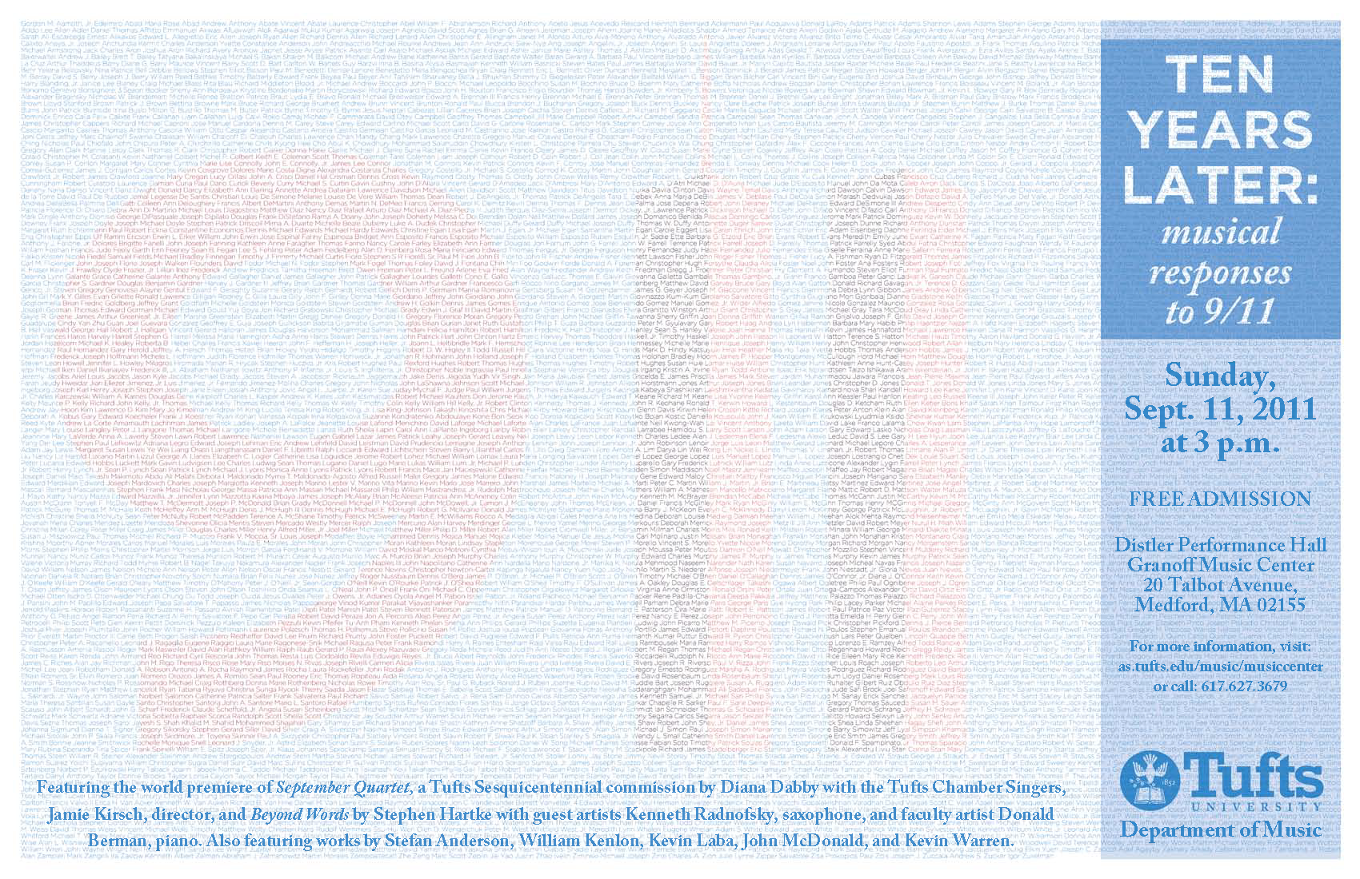

Figure 11. Poster for the “Tenth Anniversary of 9/11 Concert” at the Distler Performance Hall, Granoff Music Center, Tufts University, September 11, 2011.

***Tre Studi di Colore*** (2012)

These three études for solo piano – Azzurro (for right hand alone), Rosso (for left hand alone), and Violetto (for two hands) – offer a dramatic and athletic tour de force for the pianist. Their interpretation relies on certain interpretive slants, e.g., hearing the piano embrace different instruments of the orchestra (and at times, a military band). Commissioned by the Three-College Collaboration (Babson, Olin, Wellesley) for the Jubilee Trio’s Houghton Chapel concert, Wellesley College, Nov. 2012, these études were later performed abroad (May 30, 2013) by pianist Jongsun Lee who won an emerging artists’ competition awarding her a debut recital at Youngsan Art Hall in Seoul, Korea.

***Fuente y Variación*** (2013)

*Fuente y Variación* (source and variation) was commissioned by pianist Jongsun Lee for her invited artist concert sponsored by Youngsan Art Hall, Seoul, Korea, May 2013. The piece presents another perspective on classical variation form: first the audience hears an original piece (기원) and then a variation (변화) of it. The variation diverges in substantive ways from the original, yet the two pieces stay connected through motivic and thematic reinterpretation. In a broad sense, the music has become dynamic – it changes with time as a river might change from day to day, season to season, yet is still recognized in its essence.

***Who was Wissam Eid?***(2017)

Commissioned by the Babson, Olin, Wellesley Collaboration and scored for violin, cello, and piano, *Who was Wissam Eid?* grew out of a New York Times article “The Hezbollah Connection” by Ronen Bergman.  Bergman investigated the 2005 assassination of Rafik Hariri, the former prime minister of Lebanon who sought to unyoke Lebanon from Assad’s Syria.  Wissam Eid, a young Lebanese police detective and former engineering student, unraveled the plot—initially blamed on a 22-year old religious Sunni Muslim (Ahmad Abu Adass).  Family and friends described Adass as kind and generous; sadly, the plotters took advantage of his kindness to set him up as the fall guy for the murder of Hariri.  Eid doubted the setup, instead approaching the case with a novel idea: on his own time, he tracked records of cell phone traffic, eventually identifying five members of Hezbollah, a militant group loyal to Bashar al-Assad, as responsible for the entire plot. In reading the story, I fell in love with Wissam Eid, hoping he would somehow escape the fate of Hariri and Adass.  His car was blown up in 2008.  He was 31.

The 10-minute work for violin, cello, and piano has three movements:

1. Ahmad Abu Adass
2. Rafik Hariri
3. Wissam Eid

***Parallel Lives—Distant Mirrors*** (2018)

*Parallel Lives—Distant Mirrors* for piano, flute, voice, and soundtrack, received its world première on the Wellesley College Concert Series, November 10, 2018. The work explores parallel universes in Iraq and the United States. It offers the audience **a concert of “Variations and Shadows” where seat location determines what variation path through a piece is heard by the audience.** I’ve talked about such a “variation concert” in formal concert/lectures and informal talks since 1994. The world première performance utilized sound-focusing technology developed by Kevin Brown of Brown Innovations. To our knowledge, this is the first “variation concert” ever presented.

Five movements comprise the 30-minute work:

1. Ignition (solo piano), at minute 05:25 of the YouTube precording
2. The Last Minutes of Baghdad TV (bass and alto flutes + projection), at minute 15:28
3. An Iraqi Mother’s Lament (voice and piano), at minute 19:13
4. Quranic Verses 16:111 – 16:114 (speaker and alto flute), at minute 24:33
5. Catharsis (piano + soundtrack), at minute 26:04

The culminating movement includes a soundtrack composed of Associated Press recordings from the 2003 bombardment of Iraq, the last minutes of Iraqi TV, recorded American and Iraqi voices, among others.  Movements 2, 3, and 4, each focus on one of the Arabic voice recordings but in translation. The text for the third movement for voice and piano can be found in the YouTube description.

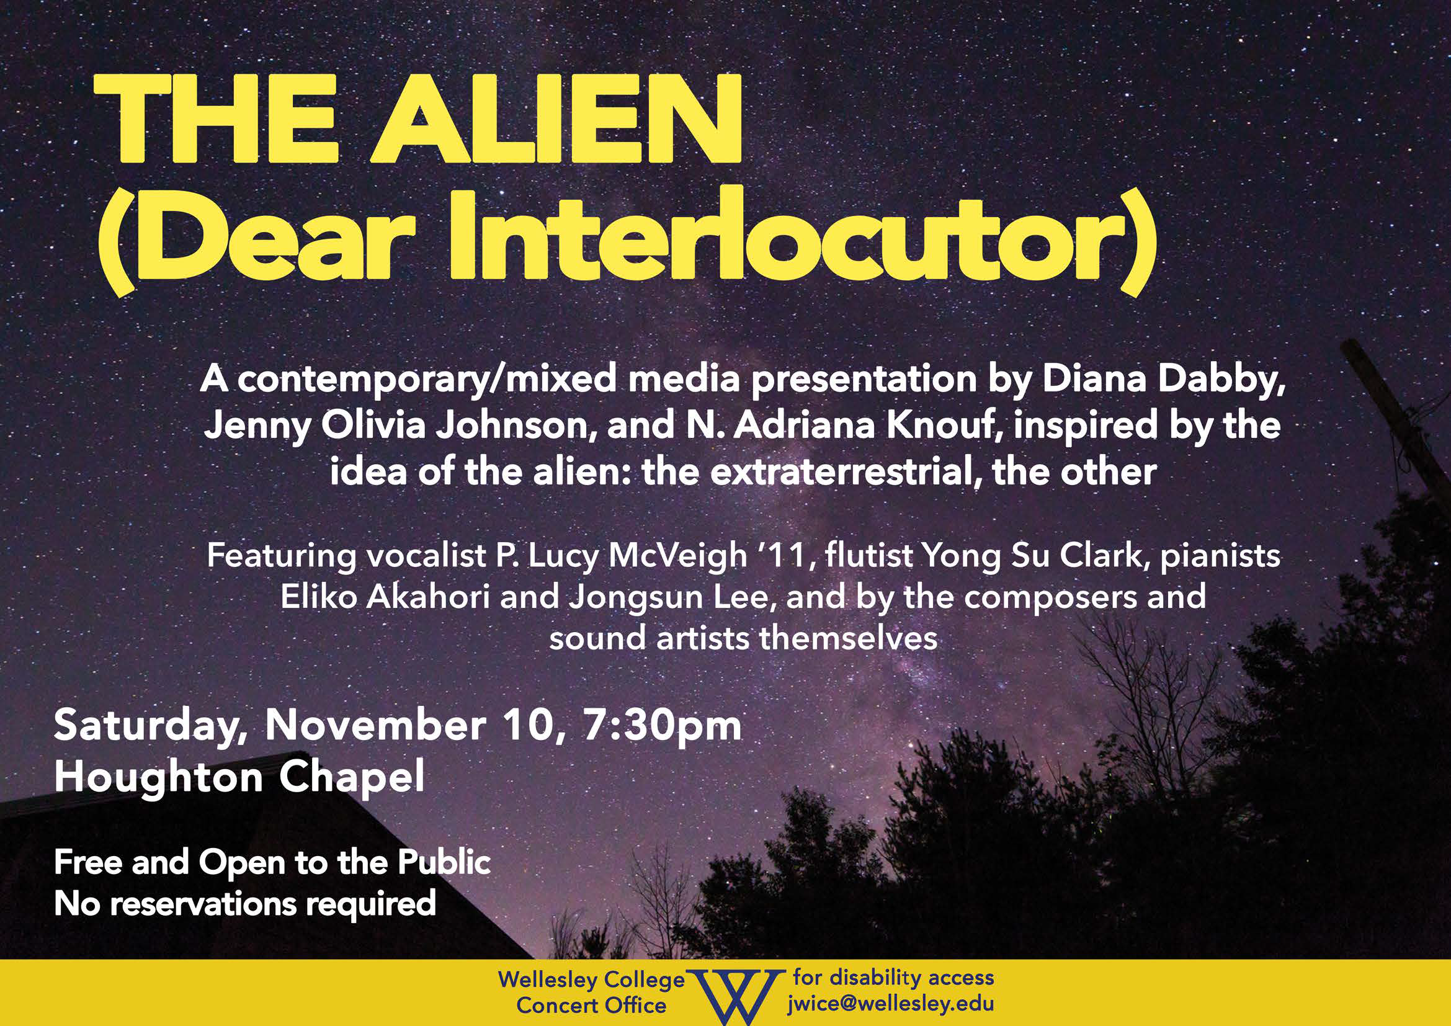

Figure 12. Wellesley College Concert Series poster for the “Alien” concert featuring works by Wellesley professors Jenny Olivia Johnson, N. Adriana Knouf, and Diana Dabby.

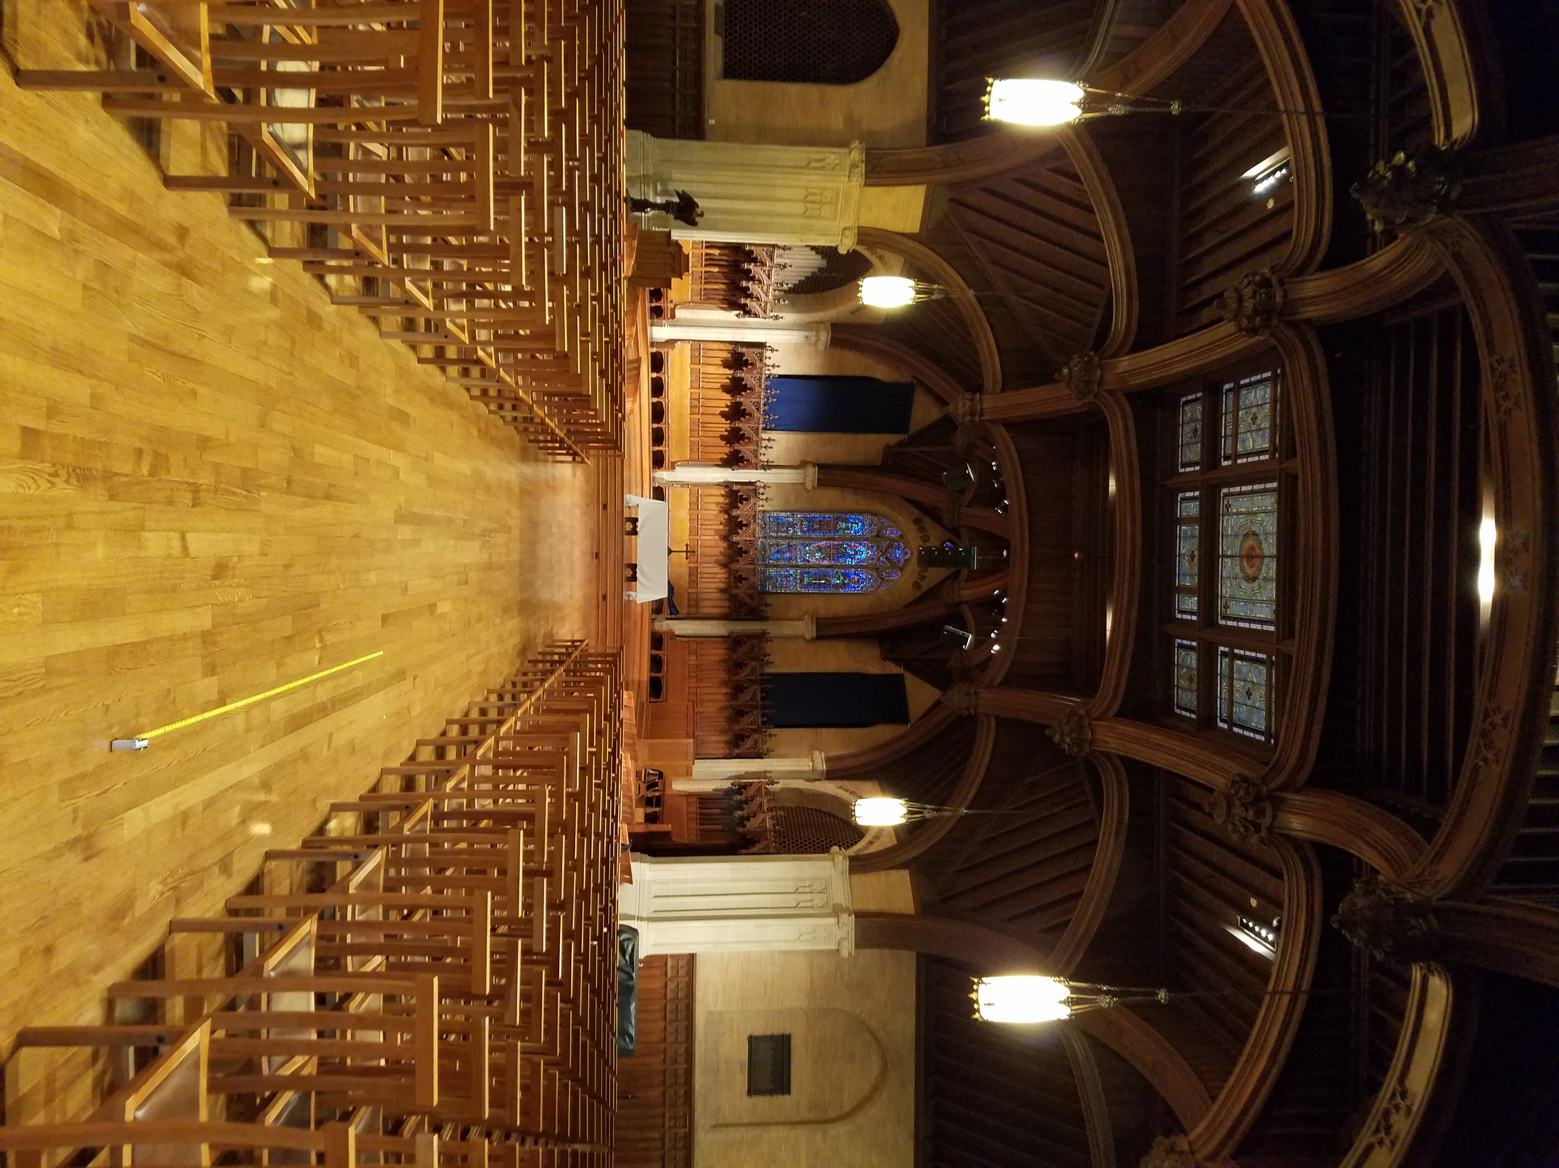

Figure 13. Houghton Memorial Chapel at Wellesley College, the acoustic space where Kevin Brown of Brown Innovations and Diana Dabby produced their “variation concert” with Dabby’s *Parallel Lives—Distant Mirrors.*

**Supplementary Materials III-G**gives performance links for these pieces. **Appendix III-G**contains the scores.

**In sum**, the above five works lie in the disciplinary space of music (Map 2), yet all were influenced by my work with musical variations from a chaotic mapping. They demonstrate *Leadership and Impact* with respect to Olin’s faculty goal of **External Impact** (Map 1) by reaching out to audiences in concert and online. All five world premières were well-attended and four occurred as part of established concert series in excellent venues: Distler Performance Hall, Perry and Marty Granoff Music Center, Tufts University Concert Series; Youngsan Art Hall Concert Series, Seoul, Korea; and Houghton Memorial Chapel, Wellesley College Concert Series. ***September Quartet***received a spontaneous standing ovation as can be seen on the YouTube video. It has been viewed 702 times from two different YouTube uploads, the first of which (500 views) was removed in favor of the second (202 since April 2014). The movements comprising the piano pieces ***Tre Studi di Colore*** (2012) and ***Fuente y Variación*** (2013) have a total of 1,706 views (since December 2013), showing some movements dominating others, e.g., ***Variación*** with 582 listens. Together with ***Who was Wissam Eid?***(383 since May 2017) and ***Parallel Lives—Distant Mirrors*** (205 since December 2018), these five works, have reached an online audience of 3000 despite requiring longer attention spans. All of the above speaks to *Impact*.

In composing these works, I demonstrated *Leadership* through an innovative approach to each: the gradual illumination of names throughout *September Quartet*, representing the 246 non-hijacker passengers and crew members of the four planes obliterated on September 11, 2001; structuring the movements of *Tre Studi di Colore* for each hand alone and then hands together; presenting another perspective on classical variation form in *Fuente y Variación* where the audience first hears an original piece and then a variation of that piece; writing *Who was Wissam Eid?* so it starts out of nowhere and out of sight, with the movements (and instrumentalists) as characters in an unfolding drama; and creating a “variation concert” for *Parallel Lives—Distant Mirrors* where seat location determines which variation path is heard during the final movement.

The thematic table below succinctly captures the role played by each of my three overarching themes in Project G, thus speaking to Map 3.

|  |  |
| --- | --- |
| **The Role played by each of Three Overarching Themes in**  **G:** Musical works—Recent Commissions and World Premières | |
| **Lifelong**  **Learning** | Whatever I didn’t know, I taught myself. For example, in writing *September Quartet*, I incorporated substantial percussion. Since I’m not a percussionist, I consulted online percussion videos, as well as dedicated texts such as Samuel Solomon’s *Percussion*. |
| **Intrinsic**  **Motivation** | Experiencing a “flow” focus while creating new works |
| **The Creative Process** | Exposure to different modes of doing, thinking, connecting, and expressing through engagement with: |
| Stimulation/impetus | The music of my heroes—all those dead composers |
| Preparation/Scaffolding | A thorough grounding in performance, harmony, counterpoint, and analysis, whose fundamental principles apply to all my music, and I believe to music of any era |
| Application | World première performances |
| Feedback | Discussions with performers, colleagues, and my “kitchen cabinet” |
| Revision | Revisiting work en route to final version: A large part of my creative process involves constant iterations of the composition at hand, then stepping back so I can return with fresh ears a day or more later. |
| Effective Communication | Moving an audience as powerfully as the stories that compelled me to write the music, enabling their protagonists to still live through remembrance … |

# IV. Intellectual Vitality uniting External Impact, Developing Students, and Building & Sustaining the College (Map 1)—encompassing both Disciplinary and Interdisciplinary Work (Map 2)—embodying Three Overarching Themes (Map 3)

Four large projects comprise this section. Each speaks to External Impact, Developing Students, and Building & Sustaining the College:

* CantoVario (my musical variations project)
* the Engineers’ Conductorless Orchestra project
* the 100+ orchestral arrangements I’ve created for nontraditional instrumentation (as occurs in the Olin Conductorless Orchestra)
* Building the Music Program at Olin from scratch—and sustaining it.

The CantoVario projects integrate my Electrical Engineering and Music IV Portfolios and demonstrate **External Impact** (recognized by external experts), **Developing Students** (knowledge and skills growth), and **Building & Sustaining the College** (external recognition for the College), as discussed in Section IV-H below.

The book chapter “The Engineers’ Orchestra: a conductorless orchestra for our time” (elaborated below in Section IV-J) shows how a conductorless orchestra **develops professional skills in engineering students**, fosters **external impact** by enabling the conductorless orchestra model to reach a larger audience, thus helping **build & sustain the college**’s reputation as an incubator for innovation in engineering education. Section IV, Project J also introduces the new Engineers’ Conductorless Orchestra Hub—a website of resources and materials exportable to other engineering schools considering a conductorless orchestra for their musician-engineers.

Section IV, Project K gives an overview of the 100+ orchestral arrangements I have created for the Olin Conductorless Orchestra (OCO), now available to other engineering schools. These orchestral arrangements have **external impact** because they remove the barrier to procuring music for orchestras with non-standard instrumentation, a likely occurrence for an engineering school wanting to start its own conductorless orchestra. Thus a conductorless orchestra for **developing engineering students** to lead, team, and effectively communicate becomes possible for other schools. Such an orchestra can help them attract prospective students, in similar ways to how OCO has helped Olin attract students, thereby helping **build & sustain their schools**, as well as ours. Just as my arrangements have enabled a small college like Olin to have an orchestra—despite nonstandard instrumentation across unbalanced wind, brass, and string sections, as has been noted by students, staff, faculty, parents, and a trustee—they can open the conductorless door to others.

The Music Program at Olin (further discussed in L below)—has shown **impact outside Olin** by virtue of its visibility to external constituents through concerts. It has continually **developed students** by offering performance opportunities inside and outside Olin. By showcasing students’ multifaceted talents, the program underscores Olin’s dedication to both technical and artistic pursuits, thus helping **build & sustain the college’s** reputation. Perhaps most importantly, it has given students “balance” in their engineering studies, or as one student put it, “No music, no life.”

The above Projects H-L are interdisciplinary in nature (uniting music and engineering) with the CantoVario project spanning engineering, music, and entrepreneurial thinking. My three overarching themes infuse all of them.

## Project H. CantoVario—Harnessing Chaotic System Variablity for Musical Variation (ECE and Music IV Portfolio)

Though my musical variation projects encompassed by “CantoVario” now span music, electrical engineering, and entrepreneurial thinking, they began by linking only two—music and engineering—by providing a means by which music combined with chaos theory produced musical variations. Specifically, I found a way to temper and tame a natural mechanism for variability in chaotic systems by devising a chaotic mapping, resulting in musical variation. This technique became the cornerstone of my doctoral thesis, *Musical Variations from a Chaotic Mapping*. After earning my doctorate, I expanded my ideas further, figuring out how to generate variations of audio songs, which in turn led to algorithms for making more sophisticated pitch and rhythmic variations of MIDI songs. Because I was now working on a number of musical variation projects, I started referring to them by the umbrella term “CantoVario.” Up to this point, CantoVario existed at the intersection of music and engineering. But funding remained a constant issue. My work didn’t neatly fit grant opportunities which tended to be discipline-specific. In short, I didn’t know where to turn or what to do with CantoVario. A colleague suggested the MIT Venture Mentoring Service (MIT VMS). I applied in Fall 2013 and with that step, I gradually put on the entrepreneurial hat. So my musical variation project (CantoVario) now combines music, engineering, and entrepreneurial thinking.

My musical variation research (CantoVario) is significant because it allows musicians and non-musicians alike to create variations of their songs, whether in MIDI (musical instrument digital interface) format or in audio formats such as mp3 and wav. The CantoVario project—underpinned by a number of algorithms based on my patents (granted and pending)—has been recognized by experts at the National Science Foundation (NSF) and MIT, thus demonstrating **external impact**. CantoVario has also been recognized in the “Ideas” section of the *Boston Sunday Globe* and in a chapter of a Harvard University Press book, each of which can be found in **Appendix IV-H-1** and **Appendix IV-H-2**, respectively.

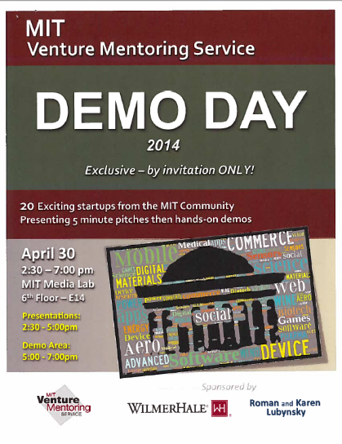The MIT Venture Mentoring Service (VMS) selected CantoVario as one of the presenters for its 2014 Demo Day.[6] Seventy startups applied and 20 were selected, including CantoVario. A video of CantoVario’s Demo Day five-minute presentation can be accessed in **Supplementary Materials IV-H-1**.

Figure 14: Poster for the 2014 MIT VMS Demo Day.

The MIT VMS subsequently invited CantoVario to participate in its Snapshot Pitches 2016, Entrepreneurial Edge Showcase 2017, and the MIT Innovation Corps (2018), a program sponsored by the National Science Foundation (NSF). In March 2019, CantoVario was selected for the National Innovation Corps (I-Corps) sponsored by NSF and awarded a 50K grant for customer discovery.[7]

As part of the NSF National Innovation Corps, the CantoVario team participated with 20 other nationally-selected teams in an intensive 7-week program. The I-Corps program embraces the Steve Blank approach to entrepreneurship: “getting out of the building” to interview potential users about their “jobs to be done”, e.g., what goes well in these “jobs to be done” and what doesn’t go so well. Our team included an Olin alum as software developer (Jacob Kingery ’16) and an industry mentor (Howard Lieberman, formerly with Bose Corporation and Apple Computer).

As the entrepreneurial lead for the CantoVario team, I completed 170 face-to-face interviews in 6½ weeks, May 6 – June 13, 2019. These interviews yielded context as well as gain/pain points, focusing mainly on musician-producers: amateur, student, and professional. Here, the term musician-producer is defined as a musician who creates music as her/his/their ‘job to be done’, e.g., a singer-songwriter. Yet many of those interviewed wear myriad musical hats: instrumentalist, singer, songwriter, recording engineer, mixer, etc., as discovered through interviews in Nashville, Miami, and the greater Boston area.

In awarding the grant to the PI (Diana Dabby) and her institution (Olin College of Engineering), NSF gave Olin College its first I-Corps National Team Award, thus helping **build & sustain the College**.

**Appendix IV-H-3**contains the full NSF grant “I-Corps: Harnessing Chaotic System Variability.”

The CantoVario project has **developed students’** programming and presentation **skills**: Students (and alumni) assisted me in preparing and demonstrating CantoVario at the 2014 MIT Venture Mentoring Service (VMS) Demo Day, the 2016 MIT VMS Snapshot Pitches, the 2017 Entrepreneurial Edge Showcase, the 2018 keynote address for the Academy of Applied Science Young Inventors Program, and the 2019 NSF National I-Corps Teams presentations. For the latter, each team had to prepare weekly webinar presentations on what was learned. For our final deliverables, I-Corps required a 2-minute video summarizing our “Lessons Learned”, i.e., what our interviewees taught us, as well as a ten-minute presentation in Nashville.

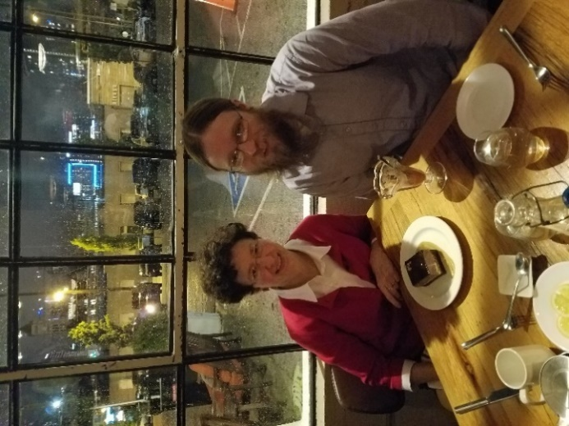Please see **Supplementary Materials IV-H-2**for the “Lessons Learned” video and **Supplementary Materials IV-H-3**for the CantoVario and NSF I-Corps Backstory.

Figure 15. Jacob Kingery ’16 and Diana Dabby having dessert at Adele’s after giving our final NSF I-Corps National Teams presentation on June 21, 2019 in Nashville.

The CantoVario web app [www.cantovario.com](http://www.cantovario.com) contains 160 mashups generated by my latest algorithms, as disclosed in “Method and Apparatus for Computer-Aided Mash-up Variations of Music and other Sequences, Including Mash-up Variation by Chaotic Mapping”, (Utility patent application 16/144521, filed USPTO Sept. 2018.) A video on the web app landing page gives an overview of the project which encompasses both MIDI and audio applications.

As a potentially disruptive audio and MIDI technology, CantoVario can alter how people interact with music on and offline. It takes “personalized music” beyond playlists and song recommendations, allowing music lovers to directly participate in the creative process. For musicians, it enables new avenues for developing and presenting original music to listeners for a more interactive user experience. Finally, no differentiator yet exists that distinguishes one digital music service from another; they all advertise the same basic products—recommendations and playlists. By offering direct interaction with songs and playlists to create new songs that can be shared with others, CantoVario offers a unique experience for music streaming service customers.

Currently, CantoVario encompasses three related projects, described in **Supplementary Materials IV-H-4**, that unite chaos science with musical variation. The first addresses a music maker’s worst pain point, while projects 2 and 3 expand the technology to wider audiences through a novel music/STEM exhibit prototype for a science museum and a new listening experience for concert-goers (the “variation concert”).

All three projects rely on CantoVario’s core technology that employs a dissipative chaotic system, e.g., the Lorenz equations, to generate musical variations. Most engineers seek ways to eliminate chaos, but I thought it could be used. In its ‘chaotic regime’, the Lorenz system possesses a natural mechanism for variability due to the sensitivity of its solutions to initial conditions. I found a way to exploit that built-in variability to produce variations of a context-dependent sequence of symbols, where the variant output can be close to the original work, mutate beyond recognition, or achieve degrees of variability in between.

**In sum**, through the CantoVario project, I have demonstrated *Leadership and Impact* across Olin’s three faculty goals. With respect to developing students, I displayed initiative, leadership, and impact in writing proposals that received funding from various Olin summer research programs, enabling students to work on CantoVario—a project they loved—while further developing their programming and presentation skills. As the PI for CantoVario’s I-Corps grant, I brought Olin College of Engineering its first I-Corps National Team Award due to a successful NSF grant that I wrote, again showing initiative, leadership, and impact for building and sustaining the College. With respect to external impact, I have demonstrated leadership by articulating an idea and bringing it to fruition. In doing so, I did not apply science to art, nor art to science. Rather, I took a fundamental concept in chaos science (sensitive dependence on initial conditions) and a fundamental concept in music (variation), then created something completely original and nonrepresentational, as evidenced by my MIT doctoral thesis and issued patents. This process was remarked upon in an article written by Science Reporter Carolyn Y. Johnson for the Ideas Section of the *Boston Sunday Globe* in 2013:

The idea that science and art have something important to teach one another has been trotted out so often that it has become a truism, yet it often falls short of the truth. More often, one field seems to borrow the jargon or aesthetics of the other without bringing over the substance. Dabby, however, wanted to bring science to bear on music directly—and eventually she found a way to do just that, by using math to generate new musical ideas. …

In fact, though, Dabby’s project touches on a much larger theme: Variation is at the heart of all kinds of creation, and she has invented a new way of generating it. Dabby sees herself following in a musical tradition that stretches from Bach to John Cage. But variation is far more pervasive than that, showing up in all kinds of art and in each of us—down to the slight tweaks in our DNA that make us all recognizably different, though identifiably human.

With respect to impact, Johnson cites other applications besides music where generating variations can play a key role. Music is a highly context-dependent application where each note or musical event is determined by the preceding notes and events, and each note or event foreshadows those to yet come. That CantoVario’s technology produces musical variations that can be analyzed, as well as used for musical means, suggests application to other sequences of context-dependent symbols, in science as well as the arts, as she notes later in her article. Furthermore, it can stimulate interest in engineering for students K-12 and beyond by linking science with something they love—music—as mentioned in the same article.

As demonstrated by the above discussion, CantoVario unites Olin’s faculty goals of External Impact, Developing Students, and Building & Sustaining the College (Map 1). Its development over the years embraces **engineering, music, and entrepreneurial thinking**, depicted in Map 2. The thematic table below succinctly captures the role played by each of my three overarching themes in Project H, thus expanding upon Map 3.

The table below captures the role played by each of my three overarching themes in creating CantoVario.

|  |  |
| --- | --- |
| **The Role played by each of Three Overarching Themes in**  **H:** CantoVario—Harnessing Chaotic System Variability for Musical Variation | |
| **Lifelong**  **Learning** | Teaching myself everything I could about nonlinear dynamics and chaos, musical variation, and entrepreneurial thinking. |
| **Intrinsic**  **Motivation** | Moving my musical variation projects out of the lab and into the wider world |
| **The Creative Process** | Exposure to different modes of doing, thinking, connecting, and expressing through engagement with: |
| Stimulation/impetus | Thinking about aliasing while driving to Olin for my Signals & Systems course, then having a flash of insight that unlocked myriad algorithms for MIDI and audio variations (captured in the 2016 issued patents). Showing up at my June 2017 annual review where Olin’s provost noticed I hadn’t written much about CantoVario in my annual report. I had hit a wall yet felt close to a breakthrough. The breakthrough invention popped out the next morning and led to the mashup variations on cantovario.com, a 2017 provisional patent application, and a 2018 utility application (now pending). |
| Preparation/Scaffolding | My mentors at the MIT VMS, participation in the NSF I-Corps SPARK Program at MIT, followed by the NSF I-Corps National Teams Program |
| Application | Audio web app (CantoVario Mashup) and MIDI web app (in beta) |
| Feedback | MIT VMS mentor meetings; monthly meetings with an MIT VMS IP expert; MIT VMS 2014 Demo Day, 2016 Snapshot Pitches, and 2017 Entrepreneurial Edge; Wellesley College |
| Revision | Continual development of the algorithms in MIDI and audio formats, which in turn led to additional algorithms, but now in the other format. For example, I discovered that the audio algorithms devised as a result of the “flash of insight” mentioned above under “stimulation/impetus”, in turn unlocked myriad algorithms, now applicable to MIDI variations of songs. |
| Effective Communication | Communicating a new artistic experience: Moving the man and woman in the street with a contemporary take on musical variation, directly tapping the human soul to “sing” in ways it never knew it could |

## Project J. The Engineers’ Conductorless Orchestra (Music and Engineering IV Portfolio)

Project J—the Engineers’ Conductorless Orchestra—covers three works, including a book chapter, peer-reviewed conference paper, and a website hub designed to share the conductorless orchestra model with other engineering schools. These interdisciplinary works combining music and engineering convey how a conductorless orchestra develops students by providing a project-based learning lab for developing leadership, teamwork, and communication skills. The roles played by my three overarching themes enabled me to conceive of a self-directed orchestra for our new college, bring it to fruition—a time-intensive process developed over many years—and more recently, to introduce the model to engineering educators at other institutions.

### i. “The Engineers’ Orchestra: a conductorless orchestra for our time”

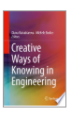 Thanks to an opportunity emailed by Prof. Caitrin Lynch to the faculty in November 2015, my monograph “The Engineers’ Orchestra” was accepted for publication by Springer Nature as a book chapter in *Creative Ways of Knowing in Engineering*, edited by Prof. Diana Baraiktarova of Virginia Tech and Prof. Michele Eodice of the University of Oklahoma at Norman. Publication as a book chapter, surrounded by those of other authors (including Prof. Zhenya Zastavker and Dr. Gillian Epstein of Olin College), has already helped plant the conductorless orchestra model in the minds of engineering educators. On the basis of the book chapter and performance videos, OCO was invited to perform for the ASEE Zone 1 International Conference on April 12, 2019, the first time an orchestra of engineering students—not to mention a conductorless orchestra—had done so.

The Engineers’ Orchestra **develops students**, namely by giving them an experiential lab for leadership, teamwork, and communication skills through their collective passion for playing music. Since its publication in January 2017, the book chapter has accumulated 450 purchased downloads, indicating significance for **external impact**, thus enabling the conductorless orchestra model to reach a larger audience, which in turn helps **build & sustain the college**’s reputation as an incubator for innovation in engineering education.

Please see **Appendix IV-J-1**for the full text of the book chapter “The Engineers’ Orchestra: a conductorless orchestra for our time.”

A follow-up paper “The Engineers’ Orchestra: a conductorless orchestra for developing 21st century professional skills” has been accepted for publication in the Proceedings of the 2019 ASEE Zone 1 International Conference held in Niagara Falls, New York, April 11-13, 2019. It can be accessed in **Appendix IV-J-2**.

This paper includes the results of a four-year study on the effectiveness of OCO for building professional skills in leadership, teamwork, and effective communication. A summary of the results show a year-to-year increase in OCO students’ understanding of leadership—including development of their own leadership ability—and student understanding of effective communication. Student development of their own communication skills ranged from 78% to 93% of respondents. Understanding of teamwork, and self-development of same, ranged from 78% to 88% of respondents. The number of respondents varied from 14 to 19, depending on the given year. Results of the full study results can be accessed in **Supplementary Materials IV-J-1**.

The Engineers’ Orchestra contributes to the Olin ecosystem in many ways. It links synergistically with Engineering Admissions since the engineering applicant pool is often strong in music. It supports the efforts of the Post-graduate Planning staff to successfully place students as interns and professionals in engineering positions: Industry has been calling for skills in leadership, teamwork, and communication for over 20 years now. The Engineers’ Orchestra supplements the Arts, Humanities, and Social Sciences programs that teach effective communication for students in engineering colleges and universities nationwide. It helps support engineering courses that have significant teaming components, as well as leadership positions manifested throughout the engineering community, from engineering clubs like Formula to top administration and management.

The Engineers’ Orchestra is a bold, new idea that can enter the engineering curriculum at home and abroad. It offers a project-based learning lab that builds upon the musical ability of student engineers to help cultivate professional skills.

But why not just teach these skills in other coursework? Why focus on engineer-musicians? Brain research suggests that musicians are already primed for leadership, teamwork, and communication. Not only do musicians exhibit linguistic advantages over non-musicians,[8] but they also have a relatively larger cerebellum and corpus callosum than non-musicians (male 2003 study). A larger cerebellum implies greater motor coordination and improved cognitive function. A larger corpus callosum suggests more interaction and transfer between the brain’s two hemispheres, since the corpus callosum connects both hemispheres.[9] It therefore makes sense for educators to nurture and support their engineer-musicians; the raw material already exists. Why not give them an orchestra to call their own—a conductorless orchestra where they practice leadership, teamwork, and effective communication in a large team environment—while doing something they love—music?

A rationale and resources for a conductorless orchestra now exist that can apply to diverse engineering schools, large and small, throughout the United States.  As a first step in exporting the Engineers’ Orchestra to other engineering schools, an Olin student and I developed the “Engineers’ Conductorless Orchestra website Hub.”

### ii. The Engineers’ Conductorless Orchestra website Hub: Exporting the Olin Conductorless Orchestra Model

Developed since 2002, the Olin Conductorless Orchestra model features core values with clear expectations, team-based organizational structures, and constructive feedback. Over the years, OCO evolved a meaning-making process of leadership—one that arises out of a group’s realization and desire to make meaning, to make sense of what they want to achieve. A leader of the meaning-making process in a community of practice shifts from the question “How can I make things happen?” to asking:

* What do we need to do to make things happen?
* How can I figure out the best ways to participate in the process of us making it happen?
* How can I help guide our activities toward the creation of significance? [10]

In successful meaning-making, the leadership process becomes more distributed. Through trial, error, and experimentation, the Olin Conductorless Orchestra evolved a distributed process of meaning-making leadership.

Effective leadership requires excellent communication and teaming skills. Research has shown that music-making confers enhanced listening comprehension, hearing, and signal discrimination.[11] OCO musicians use their instruments, eyes, and ears to communicate with each other. In doing so, they form a community of practice, i.e., a team that encourages shared and rotated leadership. Each musician accepts responsibility for team output and delivery goals. Furthermore, “each team member must develop qualities of a leader such as risk taking and receptivity to new ideas and directions, in addition to technical expertise.”[12] A conductorless orchestra offers a natural environment for collaboration among engineer-musicians, while building, sustaining, and contributing to a team.

With Summer 2019 funding from the Olin Integrated Project Fund, I took a first step towards situating the conductorless orchestra within today’s engineering curricula by working with Luis Zuniga ’21 to create a website hub. The Engineers’ Conductorless Orchestra (ECO) Hub provides useful resources for other schools wishing to start their own conductorless orchestras: blueprints, orchestral arrangements, videos, concerts, and eventually workshops. Expanding the conductorless orchestra to these institutions is a bold goal, yet the infrastructure, model, and methods—ever evolving—are all there, backed up by 17 years of sustained growth.

The ECO Hub project not only helps **develop students**, it also promises **external impact** through dissemination. It speaks to Olin’s mission: “prepare students to become exemplary engineering innovators who recognize needs, design solutions and engage in creative enterprises for the good of the world.” Yet to effectively recognize needs, design solutions and engage in creative enterprises for the good of the world, exemplary engineering innovators can benefit from experiential understanding and development of leadership, teamwork, and communication to move forward, and better situate, their ideas. By offering OCO’s resources in an easily accessible format to other engineering schools, the Engineers’ Conductorless Orchestra website Hub can help plant a project-based learning lab for professional skills in engineering curricula nationwide, and perhaps beyond. For example, one difficulty for any engineering school wishing to start a conductorless orchestra will be instrumentation, i.e., in all likelihood, there will not be the standard numbers of strings, winds, and brass that form a typical orchestra. The ECO Hub offers orchestral arrangements of works selected by students, thus having appeal to engineer-musicians 18-22 at other institutions. The arrangements I’ve created for myriad combinations of instruments, all in zipped Sibelius files, can be easily ported elsewhere.

**Supplementary Materials IV-J-2**contains additional material on the ECO Hub, including a link to it. **Supplementary Materials** **IV-J-3**provides example performances by the Olin Conductorless Orchestra, 2008-2019.

**In sum**, I have demonstrated *Leadership and Impact* across all three Olin faculty goals (Map 1) with the Engineers’ Conductorless Orchestra projects. They embody a bold, new idea that can enter engineering curricula at home and abroad by offering a project-based learning lab for cultivating leadership, teamwork, and effective communication—skills deemed necessary for 21st century engineers by the National Academy of Engineering and industry, thus impacting students inside and outside Olin College. I showed initiative and leadership by first writing a book chapter (The Engineers’ Orchestra: a conductorless orchestra for our time) that advanced a powerful thesis, supported by the engineering, music, and business literatures, as well as my own experience with the Olin Conductorless Orchestra. The book chapter, published by Springer Nature in 2017, then reached a wider audience, generating 450 purchased downloads (at $29.95/download) from the Springer website, thus demonstrating external impact. At the same time, I worked with the orchestra and then Asst. Vice President and Director of Communication Joe Hunter to videotape OCO for YouTube so that we could attract concert venues outside of Olin for our students. In January 2019, I took the initiative to write the organizers of the ASEE Zone 1 International Conference to be held in Niagara Falls, NY, in April 2019. I sent them my published book chapter and YouTube recordings of the orchestra. This resulted in the first ever orchestral performance by student engineers for engineering educators, not to mention a conductorless orchestra, again indicating leadership and impact. I showed additional initiative and leadership by writing a follow-up, peer-reviewed paper for the conference (to be published in the conference proceedings), as well as a grant proposal to the Olin Integrated Project Fund that enabled the next step: an Engineers’ Conductorless Orchestra website Hub that now provides resources to other engineering schools wishing to start their own conductorless orchestras. I’ve demonstrated impact with respect to building and sustaining Olin’s reputation for innovation in engineering education with all of the above accomplishments.

With respect to Map 2, the Engineers’ Conductorless Orchestra projects **unite music and engineering** by speaking directly to student engineer-musicians within an engineering school environment. The thematic table below captures the role played by my three overarching themes in producing the Engineers’ Conductorless Orchestra, thus addressing Map 3.

|  |  |
| --- | --- |
| **The Role played by each of Three Overarching Themes in**  **J:** The Engineers’ Conductorless Orchestra | |
| **Lifelong**  **Learning** | Continually finding ways to create a well-functioning college conductorless orchestra, despite not having a road map, since we were the only college with a self-directed orchestra. Researching what a conductorless orchestra might offer engineering students. |
| **Intrinsic**  **Motivation** | It was such an inspiring idea; I had to see it through. |
| **The Creative Process** | Exposure to different modes of doing, thinking, connecting, and expressing through engagement with: |
| Stimulation/impetus | A new mode for building leadership, teamwork, and communication skills among engineering students. |
| Preparation/Scaffolding | Researching leadership, teamwork, and communication in the engineering, business, and music literatures. |
| Application | A book chapter, peer-reviewed conference paper, invited concert at an ASEE conference, and a website hub housing resources for other engineering schools who wish to start their own conductorless orchestras |
| Feedback | Editors’ and reviewers’ critical commentary. Conference attendees’ response to the Olin Conductorless Orchestra’s concert for the Zone 1 American Society for Engineering Education (standing ovation). |
| Revision | All of the above undergoing extensive revisions (and rehearsals). |
| Effective Communication | Written and oral communication across all constituencies, ranging from editorial colleagues, faculty and staff, to students and their families. |

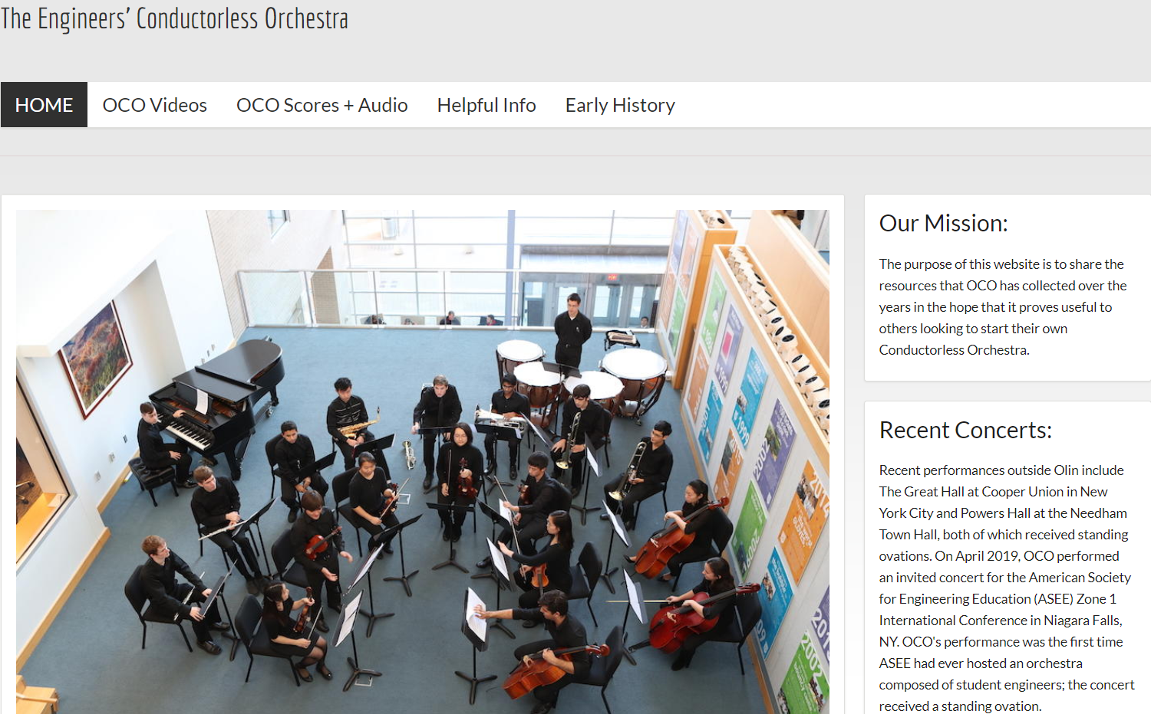

Figure 16. The homepage for The Engineers’ Conductorless Orchestra (ECO) website Hub.

## Project K. 100+ Orchestral Arrangements for 12-22 Players (Music and Engineering IV Portfolio)

Students in the Olin Conductorless Orchestra (OCO) select their own repertoire. In general, they favor big romantic pieces typically played by 70+ musicians (~50 strings and 24 wind/brass/percussion). But Olin has a small student body which has resulted in a nontraditional instrumentation since OCO’s inception. This means every piece must be re-orchestrated to suit each semester’s available instruments. For example, OCO winds and brass can outnumber the strings, and vice versa, so balance has to be achieved through often unorthodox means.

My 100+ arrangements have enabled a small school like Olin to have an orchestra, despite OCO’s eclectic instrumentation, thus contributing to student development, as well as building & sustaining the college. These arrangements can now help other engineering schools form their own orchestras since these schools will likely lack a full complement of standard instruments completing their string, wind, and brass sections. The arrangements are portable to other engineering schools via the Engineers’ Conductorless Orchestra website Hub, an externally-facing site with the mission of helping others outside the Olin community actualize the conductorless orchestra model.

**Explanatory notes for the OCO re-orchestrations (arrangements of symphonic works).** In creating these arrangements, I strive to make OCO sound as full and varied as possible, with a wide dynamic range, different colorations, strategic doublings, and effective solos/duets. Yet constraints exist, e.g., the comfort ranges of the OCO musicians. Simply substituting one instrument isn’t an option: given the eclectic instrumentation of the last 17 years, a great group sound has to be created by imaginative voice leading, unorthodox doubling (e.g., violins with glockenspiel), timbral sleight-of-hand (e.g., blending a tenor sax into an 18th century symphony), and other means.

Here is a short summary of my process for creating orchestral arrangements for the Olin Conductorless Orchestra. (The specific re-orchestrations mentioned below are elaborated further in **Appendix IV-K-1**.)

* At the start of each semester I ask students for their comfortable high and low *forte* notes and high/low *piano* notes. These often dictate what I can and cannot do, resulting in re-orchestrations particular to student instrumentalists. This is one of the reasons why my arrangements may be useful to other engineering schools wishing to start their own conductorless orchestras.

* Instrumental, sectional (strings, winds, brass, percussion), and orchestral voice leading. For example, taking a high passage written for the violins and moving it down an octave, which often necessitates moving other string and wind parts down an octave, then bringing them back into their intended ranges in a smooth manner with good voice leading.
* Stylistic intent of the composer. Having performed many Haydn, Mozart, and Beethoven piano sonatas, as well as myriad romantic works, I’ve assimilated a wide array of styles. For example, I created an arrangement of Haydn’s Symphony No. 48 (first movement) that evoked the classic style through an artful blend of three clarinets, two flutes, and a tenor sax with strings, instead of Haydn’s wind section of two oboes and a bassoon.
* Contrapuntal and harmonic practice of the composer, e.g., for a piece in E minor, replacing the low B1 dominant of the double basses with B2 (since we have no double basses), but approaching the B2 in a stylistically smooth manner, as occurs multiple times in my arrangement of the Dvorak Ninth.
* Nontraditional instrumentation, i.e., instruments typically not found in an orchestra such as piano and saxophone (e.g., my arrangement of the Berlioz “Marche Hongroise”), an over-abundance of clarinets—or none at all—as can be heard in my arrangements of Haydn’s Symphony No. 48 and Gershwin’s *An American in Paris*, respectively. Frequently I’ll compensate an over-abundance of a given instrument (such as flute) by combining each of the ‘too many flutes’ with other instruments to create hybrid instruments that hide the recognizable flute timbre (as I did with *An American in Paris*). At other times, I’ll score the non-traditional instrument (e.g., tenor sax) in a register where it will blend best with the other instruments to create a coherent group sound (as with Haydn’s Symphony No. 48).
* Non-standard ratios of violins, violas, and cellos. Strings characteristically present a homogeneous section which helps when there isn’t enough of a given instrument. But what happens when OCO has six violins and only one cello (as occurred in Spring 2019)? Depending on context, I doubled the cello with alto sax and/or brass, and even with violins, as can be heard in the Berlioz “Marche Hongroise.”
* Non-standard ratios of winds and brass. As an example, Mozart wrote his Wind Serenade, K. 361, for 2 oboes, 2 clarinets, 2 basset horns, 4 horns, 2 bassoons, and double bass. But during Spring 2019, OCO had none of these instruments; instead, we had 3 flutes, an alto sax, trumpet, euphonium, and trombone. I created an arrangement for these instruments, and wrote extra parts for our pianist and timpanist so they could join the section.
* Untenable writing for too few instruments, e.g., the Dvorak Eighth with only three violins to sustain stratospheric writing intended for a full first violin section. As another example, in his Ninth Symphony Dvorak wrote climactic passages that take the first violin section—typically 16–18 players—ever higher. But in Spring 2016, OCO only had six violins. Though some of the OCO violinists could technically play these parts, the results would have been thin and anticlimactic in comparison with the intended larger violin section of the orchestra which gave its world première (the New York Philharmonic). So to achieve these climactic passages, I scored the stratospheric lines for both glockenspiel and piano (right hand in octaves), doubled at the octave below by all six violins so that their overtones would support the glockenspiel (a high bell-like instrument) and piano.
* Giving students solos, as can be heard in all the OCO YouTube recordings. For example, in *An American in Paris*, I often re-distributed solos, originally written for one instrument, among several players. I frequently give the recapitulation of a solo to another member of the orchestra, or re-allocate who gets the top line, e.g., flute1 and flute2 customarily play the higher and lower flute parts, respectively, but I often switch them to provide more variety for the players, as can be heard in all my arrangements for OCO.
* Reduction from 90+ player orchestrations to 12-22 player arrangements (e.g., the 24 wind/brass instruments required for *An American in Paris* vs. the eight available in OCO ), or an increase in forces, as from a wind ensemble to a mixed wind/brass/percussion/piano ensemble (e.g., Mozart’s *Serenade in Bb for Winds*, K. 361).
* Balance issues, i.e., non-standard numbers of wind, brass, and strings comprising their respective sections, as have occurred and been addressed in all my arrangements, e.g., *An American in Paris* and *Danzon No. 2* by Arturo Marquez, to name but two.
* Creating the impression of large forces through changes in dynamics, color contrasts, decreasing/increasing texture, among other strategies. OCO typically likes ‘big’ works, such as *Danzon No. 2*, the *Dvorak Ninth Symphony*, and *An American in Paris*, among others.
* I try to give each student a good part that speaks to his/her/their strengths, while also challenging weaker aspects of an individual’s playing (provided the student shows a commitment to mastering an earlier part). I also try to give each at least one challenging part so they can ‘rise to the occasion’, hopefully paving the way for additional challenging parts. When material is repeated, I’ll often vary the orchestration with each repetition (e.g., the Berlioz “Marche Hongroise”) or when duets/trios allow, I switch players in and out, thereby distributing parts (e.g., Gershwin’s *American in Paris* at rehearsal 67).
* And finally, something I always try to do: everyone plays at the end of a piece—at least one note!

**Appendix IV-K-1**examines seven of my orchestral arrangements, showing how I created stylistic consistency and a coherent group sound for OCO despite eclectic instrumentation and unbalanced wind, brass, and string sections. Scores of these orchestral arrangements can be found in **Appendix IV-K-2**.

**In sum,** by creating orchestral arrangements for the Olin Conductorless Orchestra, I demonstrated *Leadership and Impact* across Olin’s faculty goals of developing students, external impact, and building & sustaining the College (Map 1). These arrangements enabled our students and community to have an orchestra for the past 17 years—despite an eclectic array of available instruments—an orchestra that has helped students grow, both as players and listeners; an orchestra that has had a positive impact on prospective students, their families, and wider communities outside Olin; an orchestra that by virtue of its being conductorless has contributed to Olin’s reputation for innovation in engineering education. Thus, though Project K lies in the music space, it also inhabits the engineering space (Map 2). The table below captures the role played by each of my three overarching themes in producing these arrangements, thus elaborating upon Map 3.

|  |  |
| --- | --- |
| **The Role played by each of Three Overarching Themes in**  **K:** 100+ Orchestral Arrangements for 12-22 Players | |
| **Lifelong**  **Learning** | My background as a concert pianist carried over to crafting compelling arrangements. Whatever I didn’t know, I taught myself. I also experimented with different ways of giving OCO a coherent group sound, e.g., at one point I took a chance using overtones to help bolster the group. It worked so I capitalized on overtones in many succeeding arrangements. |
| **Intrinsic**  **Motivation** | I found making arrangements to be a creative art. |
| **The Creative Process** | Exposure to different modes of doing, thinking, connecting, and expressing through engagement with: |
| Stimulation/impetus | Each work offering another opportunity to make music, now by re-designing the music for a different instrumentation, motivating other changes as well, e.g., writing an extra part for piano (an instrument not typically included in symphonic scores) |
| Preparation/Scaffolding | Teaching Wired Ensemble where students learn about the instruments of the orchestra, including voice, helped prepare me further. I studied Samuel Adler’s orchestration text, third edition, which I found very helpful. |
| Application | Creating 100+ arrangements of predominantly large orchestral works, for small orchestral ensemble with nonstandard instrumentation |
| Feedback | What I heard in rehearsals, students, musical colleagues, and my inner ear |
| Revision | As needed, usually when I hear a section of the orchestra having trouble projecting the thrust, line, or emotional content of a part. |
| Effective Communication | Conveying the musical intent of the original score to the players. For example, when the original score calls for a big climax, I’ll create the illusion of large forces by altering the original dynamics and/or changing its texture. I also move solos around the orchestra, often dividing a given solo between two instrumentlaists as a call and answer, to create more interest and catalyze greater focus among the players. |

## Project L. Building a Music Program at Olin from Scratch—and Sustaining it: 272 concerts from Fall 2002 - Spring 2019 (Music and Engineering IV Portfolio)

With help from many inside and outside Olin, I built the Music Program at Olin from scratch. It includes an engineers’ conductorless orchestra, a new concert series (the Ann Schaffner Concert Series, now five years old), new instruments (since 2013, a Steinway B concert piano, Yamaha B3 48” upright, bass flute, alto flute, 29” and 26” timpani), myriad student performances (272 from the Wired Ensemble, the Olin Conductorless Orchestra, and other performances I rehearsed and produced), plus a Babson-Olin-Wellesley (BOW) Presidential Innovation Grant that supported two “Mix and Stir” concerts at Olin. The first featured two world premières by BOW faculty and the second focused on student compositions.

A colorful history of the program from 2001 – 2019 can be found in the Supplementary Materials. We start with Years 1-9, entitled “A Recipe for Making Music (or how to bake a music program from scratch)”, found in **Supplementary Materials IV-L-1**. Years 10-19 are captured in a more narrative style: “What happened next: stories from ‘behind the scenes’ (Development of the Music Program, Fall 2009 – Spring 2019)”, depicted in **Supplementary Materials IV-L-2**.

Music is a vital tradition at Olin, reminding us of the multiple intelligences our students bring to the community and beyond. Every year, Olin student club groups such as PowerChords, Olin Jazz Orchestra, and the Olin Rock Orchestra, as well as course groups such as the Wired Ensemble, Olin Conductorless Orchestra, and students in the AHS Capstone perform myriad concerts. A complete listing for the latter three which arose from my courses can be found in **Appendix IV-L**: Concerts at Olin (Fall 2002 – Spring 2019).

Building the Music Program at Olin from inception to the present time required all musical parts of me: composer, arranger, concert pianist, theorist, performer, and writer. What I didn’t know, I learned on the job or I taught myself. It’s been an amazing journey, exciting and creative. There’s also been a lot of behind the scenes work to ensure its sustainability. There are many, many people to thank—something I do on the last page of every program. So here are those names from programs during 2018-19.

**William Baez** (Facilities personnel), **Ellen Bailey** (Business Manager, Administrative Services and Innovation), **Holly Bennett** (Senior Admin. Asst. for Academic Affairs), **Alanna Boyd** (Director of Development), **Susan Brisson** (Director of Admission), **Krystal Burgos** (Asst. Dir. for Admission Systems & Operations), **Rae-Anne Butera** (Dean of Students Affairs), **Jose Mendoza** (Facilities personnel), **Linda Canavan** (Associate Dean for Academic Programs, and Registrar), **Neiza Correia** (Facilities personnel), **Paul Coveney** (Admin. Asst. for Academic Affairs), Anne-Marie Dorning (Associate V.P. for Marketing and Communication), Noel Espinal (Facilities Asst. Director), Francisco Fernandez (Facilities personnel),

**Jacqueline Fernandez** (Facilities personnel), **Marcella Fornagiel** (Admin. Asst. for Academic Affairs), **Alia Georges** (Asst. Director of Admission and Financial Aid Counselor), **Jeremy Goodman** (V.P. for Administrative Services and Innovation), **Alyson Goodrow** (Director of Marketing), **Steve Hannabury** (Executive V.P. Emeritus), **Stephanie Hill** (Asst. to Dean of Admission and Financial Aid and Campus Visit Coordinator), **Joe Hunter** (Remember Productions), Beth Kramer (V.P. for Advancement), **Barbara Luciano** (Admin. Asst. for Academic Affairs), **Vin Manno** (Provost), **Katherine McDonough** (Asst. to the Provost and Dean of the Faculty), **Robinson Medrano** (Facilities personnel), **Susan Mihailidis** (Director of Academic Affairs and Sponsored Programs), **Rick Miller** (President), **Shannon Paleologos** (Director of Annual Giving and Family and Alumni Relations), **Emily Petersell** (Asst. Director of Admission), **Kathleen Rollauer** (Director of Advancement Services), **Emily Roper-Doten** (Dean of Admission and Financial Aid), **Mark Somerville** (Dean of Faculty), **John Sullivan** (Program Director, Needham Lions Club), **Nancy Sullivan** (Asst. to the President), **Ashlee Talbot** (Program Coordinator, Student Affairs and Resources), **Paul McAuley** (Facilities Director), Music Program Assistants **Joseph Lee** '19, **Brandon Zhang** '21, and **Luis Zuniga** '21.

**We gratefully acknowledge the following people who donated funds in support of OCO’s ASEE concert in Niagara Falls, NY:** Jane F. Tor, Li Fan, Susan Johanson, Brian Tor, Charles Nolan, Christopher Lee, Evan Dorsky, Daniel Rosner, Rongnong Zhou, Carol Reilly, Nancy and John Sullivan, Vincent Manno, Susan Goldstein, Linda Vanasupa, Justin P. Emmi, Janet Tsai, Molly Crowther, Rose E. Higgins, Anne Ku, Colin Takeda, Vaishali Sudhakar, Meg Lidrbauch, Charlotte Lidrbauch, Wen Fan, Gopal Borde, Suzanne Alcott, and Anonymous (3).

Finally, four short YouTube videos happened to be caught on camera during Music Program Concerts. They help convey the impact and scope of the program. Their links can be found in **Supplementary Materials IV-L-3**.

**In sum**, by building the Music Program at Olin from scratch—and sustaining it—I demonstrated *Leadership and Impact* across Olin’s three faculty goals of Developing Students, External Impact, and Building & Sustaining the College (Map 1), as discussed above and supported by evidence from Supplementary Materials IV-L-1 and IV-L-2, as well as the initiative, commitment, and musicianship necessary to produce the 272 concerts given in Appendix IV-L. I’m grateful for the many people who helped, without whom we wouldn’t have a Music Program! Yet I’m also aware that the buck stops here, and somehow the show must go on. Building and sustaining the program required a complete musician who could guide it for the benefit of the students and the Olin community. In bringing my skills to the table, I showed leadership by stepping in as composer, pianist, theorist, collaborator, and cheerleader, as needed. It required an openness to ideas, as well as a high comfort level with trust and distributed authority, all of which resulted in a cornucopia of groups and music-making on campus. In short, I followed a “meaning-making” process of leadership, as described in Section II-A-1. The impact of the program on Olin students starts as external impact, since they first hear its results as prospective students; simply stated, it attracts students to Olin, and thus impacts the long-term sustainability of the College, especially with respect to the caliber of the student body. Olin’s engineer-musicians are consistently among its best students, reflecting the excellence of the College.

Project L occupies the music space, yet it also lies in the engineering space because it has given our engineering students opportunities and venues for making music (Map 2). The table below captures the role played by each of my three overarching themes in building & sustaining the Music Program, thereby speaking to Map 3.

|  |  |
| --- | --- |
| **The Role played by each of Three Overarching Themes in**  **L:** Building a Music Program at Olin from Scratch—and Sustaining it | |
| **Lifelong**  **Learning** | Whatever I didn’t know, I researched and worked to find a solution, often with help from others (students, staff, faculty, and administration). |
| **Intrinsic**  **Motivation** | The musician in me felt compelled to make Olin welcoming to student instrumentalists and vocalists. As a founding faculty member, I envisioned students taking their instruments with them through engineering school, as opposed to placing them in long-term storage and returning 4 years later with a rusty key. |
| **The Creative Process** | Exposure to different modes of doing, thinking, connecting, and expressing through engagement with: |
| Stimulation/impetus | Music permeating the walls at Olin. It’s always happening somewhere on campus. |
| Preparation/Scaffolding | My professional experience as a concert pianist, composer, and more recently, orchestrator |
| Application | Building a music program that allows all to create and participate. For example, we have numerous club ensembles that rehearse and perform a cappella, jazz, and rock. Students take courses and private lessons at Wellesley, Brandeis, and neighboring music schools. |
| Feedback | Constructive commentary from students, colleagues, and audiences |
| Revision | Hearing student needs and suggestions. Also, initiatives that I see are necessary, e.g., purchasing additional instruments. |
| Effective Communication | Written and oral communication: all facets of concerts inside and outside Olin—ranging from equipment+logistics+collaborating with support staff to conducting rehearsals—as well as exchanges with many constituencies such as prospective students and colleagues. |

# V. Looking Forward

My work moving forward builds upon the projects described above since many are ongoing, specifically:

* Project **A**. AHS Curriculum Development (Music)
* Project **B**. ECE Curriculum Development
* Project **C**. Integrated Engineering and Music/AHS Curriculum Development
* Project **F**. Patents arising from the CantoVario Project (ECE & Music IV Portfolio)
* Project **G**. Commissions and World Premières (Music IV Portfolio)
* Project **H**. CantoVario: Harnessing Chaotic System Variability for Musical Variation (ECE and Music IV Portfolio)
* Project **J**. The Engineers’ Conductorless Orchestra (Music and Engineering IV Portfolio)
* Project **K**. Orchestral Arrangements for 12-22 Players (Music and Engineering IV Portfolio)
* Project **L**. Building a Music Program at Olin from Scratch—and Sustaining It (Music and Engineering IV Portfolio)

These projects will continue to reinforce, as well as demonstrate Leadership and Impact, across Olin’s three faculty goals of Developing Students, achieving External Impact, and Building & Sustaining the College (Map 1), by straddling disciplinary and interdisciplinary domains (Map 2), infused by my three overarching themes—lifelong learning, intrinsic motivation, and the creative process (Map 3)—in similar ways to those already discussed in Sections II, III, and IV of this document.

I expect my pending USPTO utility+provisional application “Method and Apparatus for Computer-Aided Mash-up Variations of Music and other Sequences, Including Mash-up Variation by Chaotic Mapping” to be granted: the examiner’s review requires only two minor fixes by November 16, 2019.

My work will continue to move forward because I love to learn, communicate, create something from nothing, put everything together to produce impactful projects, meet with people who know more than I do or who bring a different perspective to the table, and continue to run with a long rope (for which I am ever grateful to Olin and MIT). Music trained me well for all of the above: I called upon these traits in my years as a concert pianist in New York, though I didn’t have names for them back then. This framing document has allowed me to step back and see how these traits continue to influence my life.

An effective association with colleagues at the MIT Venture Mentoring Service and at NSF through my ongoing I-Corps grant enables the CantoVario project to receive timely guidance, thus maintaining its upward trajectory. By participating in the NSF and MIT venture ecosystems, CantoVario remains committed to transferring ideas developed in the lab to the outside world through (1) its MIDI and audio platforms, (2) science museum exhibit prototypes featuring direct interaction with music via variation, chaos theory, and the sound-focusing technology of CantoVario’s Industry Partner—Brown Innovations, and (3) new listening experiences such as the “variation concert”, where seat location determines which variation path audience members hear during a given piece. I plan to continue composing music infused by this new form.

Each additional orchestral arrangement I create for the Olin Conductorless Orchestra will become available to other engineering schools through the Engineers’ Conductorless Orchestra website Hub. Ditto for OCO’s evolving blueprints, rehearsal strategies, and videos. By meeting with other engineering school deans, professors, and students, we’ll be able to proactively add resources based on their feedback, especially with respect to getting started—and then sustaining—an engineers’ orchestra. My goal is to help situate the conductorless orchestra as a project-based learning lab in engineering curricula nationwide, not only to afford engineer-musicians everywhere experiential development of skills in leadership, teamwork, and communication, but also to offer our OCO students engagement with peers at other institutions through their affinity as musicians. These engineer-musicians are our future. As discussed in Project J, they have been blessed with innate gifts. Brain research has shown they are already primed for leadership, teamwork, and effective communication; thus they are excellent contenders for meaningful professional lives. It’ll be prescient for them to become acquainted with one another across multiple engineering schools, while still undergraduates and while doing something they love.

To help accelerate these goals, I’ll continue to publish material (papers, articles, etc.) that reaches engineering educators, as well as find opportunities for OCO students to perform outside Olin, as happened recently at the 2019 ASEE Zone I International Conference in Niagara Falls, New York. Through concerts and workshops, they’ll personify the multiple intelligences that define the Olin student, thus helping highlight and honor these intelligences in student engineer-musicians elsewhere.

Sustaining the Music Program at Olin remains a high priority. Music gives our students emotional release and balance. It’s gratifying to hear them practicing alone and in various groups when I go home at night. Part of my job is to ensure they take their instruments and voices with them through four years of engineering school. Our college has actively supported retention of talents since inception, so I convey this message to every incoming class of students. Still, Olin is a small school, and like any small school, it can get insular. So for the past 18 years I’ve found ways to get students out into the wider world, not only to perform external concerts, but also through my yearly extra-curriculars such as “Olin Does the BSO” where we hear Boston Symphony Orchestra concerts at Symphony Hall, “Family Night at the Opera” where I take the Dabby “advising family” (Olin’s terminology for a faculty member plus advisees) out for dinner and an opera in Boston, and the Wired Ensemble trips to New York City where we attend an opera at the MET or a concert. All these outside activities have been ongoing for the past 17, 15, and 17 years, respectively.

Finally, with respect to curriculum development Projects A-D, I find myself continually excited by being in the classroom and by the beauty of the topics at hand, whether in engineering, music, or both. I’m especially looking forward to rolling out our new Engineering System Analysis course with Professors Chris Lee and Siddhartan Govindasamy. These languages of music and engineering have stimulated my own creativity in ways I could not have imagined. It’s been—and continues to be—an exciting ride. I want to share that excitement with my students and encourage them in their endeavors, however bold they may be!

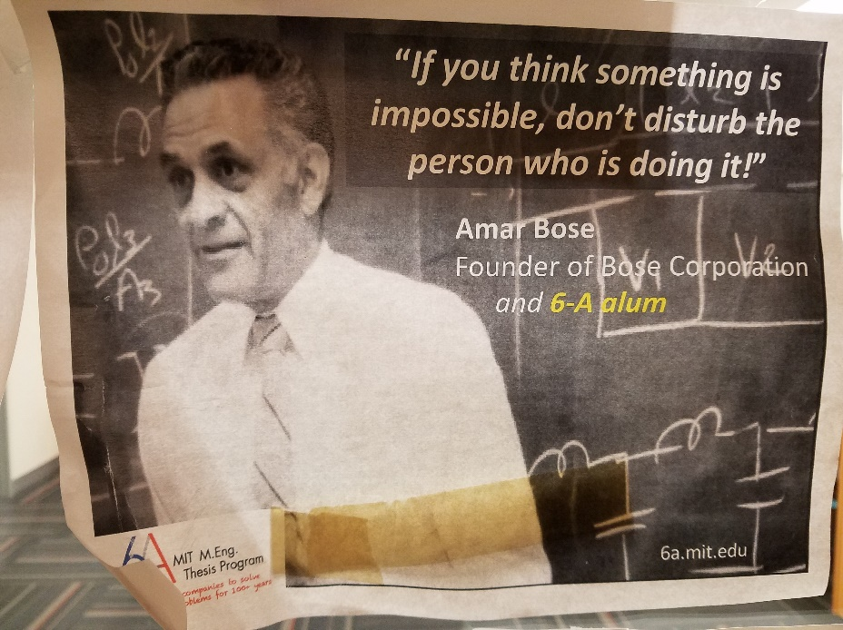

Figure 17. One of my mentors. I’ve been blessed with mentors, past and present, who continue to sit in my metaphorical “kitchen cabinet.” They have encouraged my work over many years, however bold (or full of risk) these projects may have seemed at times.

# VI. Concluding Remarks

“Hi Diana, I have some pretty bad news... I just hurt my finger and had to go to the emergency room.”

“Diana, can we talk? I need some resting time in *American*.”

“Diana, I know we have no trumpet in OCO but I can get a pocket trumpet from my brother and try to play it.”

“In his song *Love Lockdown*, Kanye West asks the question, “What’s so great about convolution?”

“Diana, thanks for taking the time to teach me DSP even though the questions I was asking were really stupid. (+1)”

“We’re going to approve this project right now. You’re being admitted to the NSF I-Corps National Teams.”

“What does writing music have to do with writing text?”

“This is a game-changer.”

“Thank you.”

When I taught at MIT (as a teaching assistant, recitation instructor, and visiting lecturer) for courses in acoustics, signals and systems, and circuits, I couldn’t help noticing the connections between standing in front of an MIT audience of bright students and performing before a New York audience of professional musicians and classical music aficionados. During and after a particularly good class, I got the same “high”—spiking, lingering, and ultimately evanescing—until the next time.

Then and now, I find myself elated when connecting with a group of people, whether on stage, in a classroom, or a small seminar. Yet the elation also derives from the material I’m conveying or creating—its elegance, mystery, and depth. Simply stated: I love what I do.

Olin has encouraged its faculty to try out new ideas, to take a chance even if it flops. I enjoy taking risks; they have helped me grow professionally. I expect I will always feel this way. Like many musicians, I am never completely satisfied; I can always hear something better. This can be a good thing, quietly nurturing me, while the bar continues to inch upwards. The process of perfecting creative work, both in and out of the classroom, captivates and sustains my daily focus. Each class I give, every new facet of my intellectual vitality, can be continually sculpted into something better, constituting a beautifully timed and organic entity, akin to a musical piece.

Whether engaged in teaching or intellectual vitality, I enjoy the process of taking something to the next level—a ‘high’ for me. I live to create and this definitely makes me tick. I also love to learn. If a love of learning pulses the ‘seconds-hand’ of my core clock, then the minute-hand meshes all that I teach myself (and what others teach me, including my students, colleagues, and friends) to my hour hand. This in turn gears my creativity and imagination, infusing all I do. For example, as I guide student projects in the Wired Ensemble, the Olin Conductorless Orchestra (OCO), and the Music Program, I find myself drawing on an entire lifetime in music to make connections for individual students and the class as a whole. For instance, to emphasize a point, I’ll sit down at the piano with the score and play a *performer’s* Schenkerian analysis of a given piece. This method allows students to hear the ‘thread’, the connective tissue, from one phrase (or section) to the next.

Such “connective tissue” also binds concepts in Digital Signal Processing (DSP) and Signals & Systems. For instance, every year, whether teaching DSP or Signals and Systems, I notice students have trouble with convolution. As a result, I’ll start one of our convolution classes by blasting a famous song, e.g., *Love Lockdown* by Kanye West. As if quoting from a ‘Far Side of the Moon’ card, I write on the board, “In his song *Love Lockdown*, Kanye West asks the question: What‘s so great about convolution?” By doing something unexpected and fun—including a ‘pretend’ conversation with West—I explain the ways convolution enhances system knowledge, and then ask: does it work for any system? To answer that question I prove the convolution theorem, using the properties of linearity and time invariance covered earlier. Now they see in a fundamental way that—given an input signal and the impulse response of a system (not just any system, but an LTI system)—convolution gives the output. Furthermore, they also understand why we spent time rigorously establishing linearity and time-invariance by connecting these concepts to convolution, i.e., providing “connective tissue.” On a higher level, they start to appreciate why proofs can be an engineer’s best friend, that knowing when and where to apply various results involves awareness of the hypotheses underlying theorems. For this reason, I include proofs when teaching DSP and Signals & Systems.

Electrical engineering and music have each inspired and motivated me to realize my dreams, as have the practicing engineers and professional musicians I have met within each field. These fields have also cross-pollinated one another. Music taught me how to approach engineering problems, and electrical engineering wired me differently for my post-New York creative work. Because the synergy of electrical engineering and music are welded into my core, I find myself making links among other disciplines as well, as evidenced by past and future courses such as our upcoming multidisciplinary Engineering System Analysis course in Spring 2020. Making connections was also front and center when I was asked to prepare a module linking music and engineering for a new course (“Engineering the Acoustical World”) in the School of Engineering and Applied Sciences (SEAS) at Harvard University. I pulled the overtone series out of the wave equation, then connected it to the tuning of instruments, the evolution of modal scales, and orchestration.

Though my professional lives keep me at times almost too busy, I would not trade any of my many hats right now. For those hats—some old, some new, many multifaceted, a few anomalous—have taught me, and continue to teach me, how to learn, grow, and create. They have engendered intellectual vitality in music that has moved audiences as seen by the response to *September* *Quartet*, captured in the performance video on YouTube. World premières of my compositions have been performed at home and abroad by exceptional musicians. My latest work, *Parallel Lives—Distant Mirror*, explores parallel universes in Iraq and the United States, while offering the audience a new listening experience: a concert of “Variations and Shadows” where seat location determines what the audience hears in the concluding fifth movement.

The book chapter “The Engineers’ Orchestra: a conductorless orchestra for our time” has spread the conductorless orchestra concept to a larger audience, while showing how it fosters leadership, teamwork, and communication among engineering students. One of its goals is to provide opportunities for OCO students to travel, perform, and conduct workshops at peer engineering schools. A follow-up paper (“The Engineers’ Orchestra: a conductorless orchestra for developing 21st century professional skills) reveals the results of a four-year study showing that 77% or more of OCO students have increased their understanding of leadership, teamwork, and effective communication, as well as developed their own leadership, teamwork, and communication skills, as a result of their work in the Olin Conductorless Orchestra.

I created the Olin Conductorless Orchestra to give our new school a bold variation on the collegiate student orchestra—an orchestra that is self-directed. Its longevity and success have depended not only on a lasting commitment on my part, and that of our students, but also on the many skills I bring to its rehearsals and performances. OCO continually taps all musical parts of me: the concert pianist who knows how to craft, rehearse, and project an interpretation; the theorist who can support that interpretation by reasoning from a deep understanding of harmony and counterpoint; the orchestrator who has professionally performed all musical styles from the Baroque to modern times, applying this experience to the creation of stylistically-consistent orchestral arrangements; the composer whose imagination can conjure up novel orchestral arrangements of works written for orchestras four times our size, thus creating a coherent group sound despite an eclectic, unbalanced array of instruments; and the musician who can hear when things go awry and fix them on the spot, devising productive solutions, sometimes minutes away from performance time. As I’ve done for the past 17 years, I’m dedicated to furthering OCO’s impacts on both its students and audiences.

To keep OCO viable and growing over these past 17 years, I’ve created over 100 arrangements of orchestral works, each tailored to the musicians in our orchestra. These arrangements have 1) helped ensure continuity of our unique orchestra which has become a signature example of what Olin is all about, and 2) allowed OCO musicians, who play an eclectic mix of instruments, to perform the music they love (typically large romantic works originally intended for orchestras four times our size). Summer funding from the 2019 Integrated Project Fund has brought forth the new Engineers’ Conductorless Orchestra website Hub, containing useful materials exportable to other engineering schools. Furthermore, it was coded by an Olin student who had never before built a website (Luis Zuniga ’21). I took a chance on him—as I have with many Olin students—watching their confidence grow as a project moves forward.

Providing leadership and musical expertise to the Music Program has resulted in its continued growth and development. Such a program is necessary for any engineering college since students talented in math, science, and engineering are often talented in music. This has been the case at Olin as well. The significance of our Music Program has been articulated by others, e.g., the remarks caught on videotape after a Candidates Weekend concert (“Music Program Impact” in Supplementary Materials IV-L-3). With the help of many in the Olin community, we’ve developed a vibrant Music Program with a performance space in Milas Hall—actually, a mezzanine—enhanced by the advent of new instruments, a burgeoning concert series thanks to the generosity of Ann Schaffner and her family, and increasing connections with our neighboring colleges.

Putting on my electrical engineering hat, I wrote the technical parts of the patents underpinning the CantoVario projects, while my musical side addressed the artistic aspects. On hearing the results of these patents, a legal expert who runs a patent research firm remarked, “This is a game-changer.” CantoVario’s significance lies in its potential to change how we listen to and interact with music—on and offline. This has been recognized by the MIT Venture Mentoring Service (VMS) when a group of experts selected CantoVario as one of 20 (from 70 ventures) for its 2014 MIT VMS Demo Day. The MIT VMS also selected CantoVario for its 2016 “Snapshot Pitches”, 2017 “Entrepreneurial Edge” showcase, and its 2018 National Science Foundation (NSF) SPARK program. In April 2019, NSF awarded CantoVario an Innovation Corps (I-Corps) National Teams grant, bringing Olin its first I-Corps National Team Award. As part of that program, I completed 170 in-person interviews for customer discovery, of which 169 interviewees welcome follow-up. Earlier recognition for the musical variations project included an invited Perspectives article for *Science* (2008), a chapter in a 2008 Harvard University Press publication (*ArtScience: Creativity in the Post-Google Generation*), exposure on NPR’s Weekend Edition (2008), and a feature article on the front page of the *Boston Sunday Globe* “Ideas” section (2013).

Future CantoVario projects have received strong letters of support from the Museum of Science and Industry in Chicago (the largest science center in the Western Hemisphere) and from The Bridge, an incubator for musician-producers in Miami, FL (funded by the Knight Foundation). By creating variations (including mash-up variations) that can be close to the original, mutate beyond recognition, or achieve degrees of variability between these two extremes, CantoVario allows musicians and non-musicians alike to go on a journey with the songs they love, to someplace new or unimagined. For aspiring musician-producers, it serves as an idea generator, presenting an array of possibilities, to be accepted or further revised by the musician. In doing so, CantoVario addresses the pain points of “stress, anxiety, and self-doubt” that can result when a songwriter hits a block. For those lacking the time, talent, or resources to acquire musical skills, it allows anyone to take favorite songs, and vary them to create something personal that can then be shared with others. In creating CantoVario, I did not apply science to art, nor art to science. Rather, I took a fundamental concept in chaos science (sensitive dependence on initial conditions) and a fundamental concept in music (variation), then created something completely original and nonrepresentational, as evidenced by my MIT doctoral thesis and issued patents.

As discussed in this dossier, the CantoVario projects catalyzed the fusion of three caps—musician, electrical engineer, and entrepreneurial thinker—into one, three-cornered hat embodying the creative space I now inhabit. Yet I first spoke of “a mind able to triangulate its corners” in my 2001 white paper “Creating the Renaissance Engineer: Scientifically Astute, Artistic, Entrepreneurial.” In presenting a vision for Olin’s curriculum and its impact on our eventual graduates, it jumpstarted necessary curricular conversations and became the basis for the “Olin Triangle”, a visual emblem encapsulating the major elements of an Olin engineering education. By encouraging the ability to triangulate the corners of Engineering, the Arts, and Entrepreneurship, while emphasizing their synergy, the white paper’s message still resonates with our students today, as does its curricular impact.

**In sum**, my work during the past 19 years at Olin College of Engineering (Fall 2000 – Spring 2019) as captured by the major sections of this dossier (Sections II, III, and IV)—each supported by evidence contained in Section VII (Supplementary Materials: Evidence) and Section VIII (Appendices: Evidence)—has shown *Leadership and Impact* across Olin’s three faculty goals: Developing Students, External Impact, and Building & Sustaining the College (first alluded to by Map 1 of Section I). The dossier has also revealed leadership and impact in my disciplinary and interdisciplinary work involving music, engineering, and entrepreneurial thinking (as introduced by Map 2, Section I), where both the disciplinary and interdisciplinary areas have been infused by three overarching themes of lifelong learning, intrinsic motivation, and the creative process (involving stimulation/impetus, preparation/scaffolding, application, feedback, revision, and effective communication), as initially presented by Map 3 in Section 1.

Each of these maps offered a different approach to my work, each providing a different lens for viewing the eleven projects through which I’ve demonstrated leadership and impact across Olin’s faculty goals (Developing Students, External Impact, and Building & Sustaining the College) by:

* developing eleven new courses between 2002 and 2009, all of them “firsts” at Olin, including core ECE courses required for the degree, interdisciplinary courses, and Arts, Humanities, and Social Sciences courses
* building a music program from scratch for which I rehearsed/produced 272 concerts, including 137 by the only college conductorless orchestra composed of engineers—in the world
* producing YouTube demo videos that enabled the first performance by a student conductorless orchestra at the Great Hall of the Cooper Union (where Lincoln spoke) and the first time an orchestra composed of engineering students was invited to perform for an ASEE (American Society for Engineering Education) international conference
* creating over 100 arrangements of symphonic repertoire that have allowed a small college like Olin to house an orchestra despite an eclectic array of instruments in unbalanced string, wind, and brass sections
* authoring a white paper that produced a curricular vision for Olin College, subsequently captured by the college-defining “Olin Triangle”: Superb Engineering, Arts (creativity, innovation, design, and communication), and Entrepreneurship (philanthropy and ethics)
* publishing Olin’s first article in *Science*
* writing seminal publications on the engineers’ conductorless orchestra model for developing professional skills in leadership, teamwork, and communication, as well as exporting the model through an Engineers’ Conductorless Orchestra website Hub that provides resources for starting additional conductorless orchestras at other engineering schools
* composing world première works for soloists, as well as for large instrumental/vocal ensembles, all informed by my work with musical variation, including the first ever “variation concert” where seat location determines what variation path one hears through a given piece
* inventing automatic generation of musical variations by taming and tempering a natural mechanism for variability found in chaos science
* capturing the inventions which underpin my musical variations project (CantoVario) in patents (issued and pending), as well as web applications stemming from the myriad algorithms I’ve devised for musical variation
* winning a competition that enabled CantoVario to be a featured venture at the annual MIT Venture Mentoring Service Demo Day, a first for Olin College
* writing the NSF grant that brought Olin its first NSF National I-Corps Team Award (“I-Corps: Harnessing Chaotic System Variability”).

All the above achievements have helped define Olin College of Engineering and present it to the rest of the world, as described in the major sections of this dossier.

A final remark, on a personal note: I’m deeply grateful to the many people at MIT, Tufts, Juilliard, and elsewhere who encouraged my work, not only with words but also with opportunities. Access and opportunity spearhead innovation. In my case, they allowed creativity to flow freely and find its many voices. Closer to home, I’m gratefully indebted to the many Olin students, staff, faculty, and administration, for giving me the “long rope”, scaffolding, just-in-time learning, sufficient infrastructure for performances and projects, opportunities to revise, the many individual meetings I’ve had with you, the faculty development modules for tooling (e.g., effective written/oral communication workshops), and the resulting creative stimulation/impetus that arises from being in this amazing educational environment. In nurturing these themes within, you have given me the joy and experience to foster them in others. I’ve greatly appreciated the support provided for my work with musical variation over many summers, as well as all the help, in ways large and small, with the Music Program—inspiring me to give back what you have so generously given. Thank you!

# VII. Supplementary Materials: Evidence

## Supplementary Materials: Executive Summary, part 1—A Sampling of Live Recordings from Diana Dabby’s New York Concerts

The following selections can be heard at <https://youtu.be/CZB8NF390GU>

1. Beethoven *Sonata in F major*, op. 10, no. 2 (3rd movement: Presto)
2. Liszt *Rigoletto Paraphrase*, at time stamp 2:53
3. Robert Helps *Trois Hommages* (Hommage à Ravel), at time stamp 11:16
4. Bach-Tausig *Toccata and Fugue in d minor*, at time stamp 15:41
5. A Liszt interlude …, at time stamp 25:36
6. Bartok *Suite op. 14* (Allegro molto; Sostenuto), at time stamp 26:34
7. Haydn *Sonata in D major*, Hob. XVI/24: 1st movement (Allegro), at time stamp 31:42; 2nd and 3rd movements (Adagio, Finale: Presto), at time stamp 35:50

All the above pieces play one after another with black screens identifying the work for the duration of the piece.

## Supplementary Materials: Executive Summary, part 2—Live recording of *Islamorada* with the composer as pianist

*Islamorada*, a ten-minute concerto for piano and percussion, captures a small town in the Florida Keys. The work opens with percussion alone, followed by the entrance of the piano, left hand alone. The pianist’s left hand plays as a solo instrument until the right hand enters approximately 2.5 minutes into the piece.

In this work, I reversed the customary roles of the piano and percussion. Much of the melodic material of the piece is carried by the pitched percussion, while the piano assumes a more drum-like character. Forty-one percussion instruments are divided among eight players.

During the spring and summer of 1998, I gave a number of concert/lectures on my new variation technique. Wanting to use *Islamorada* as a demo piece for how a composer might use a chaotic mapping for generating musical variations, yet unable to engage a percussion ensemble wherever I went, I put the percussion part on tape and then played the piano part in tandem with the tape.

This live performance recording of the original piece occurred during a concert/lecture I gave at Kresge Auditorium, MIT, in August 1998: <https://youtu.be/UZQwi24DGBo>

Though I didn’t apply my new variation technique to its composition, I did use *Islamorada* as a test piece for showing an audience how an original work could become dynamic, i.e., change from one hearing to the next much the same way a river changes from season to season yet is still recognizable in its essence.

## Supplementary Materials II-A-1: OCO Performance Clips showing growth of the orchestra

Supplementary Materials II-A-1 gives two short performance clips of OCO from 2014 and 2018, as well as earlier performance clips from 2003-05 to show growth of the orchestra.

The first clip (OCO performing Dvorak’s Eighth Symphony at the May 2014 Olin Expo) demonstrates the teamwork and communication enabling all to lock in for the exciting accelerando to the end. OCO Expo Spring 2014 performance clip <https://youtu.be/uGVKzEfd4qE>

The second clip shows the orchestra four years later performing the Schumann First Symphony in Spring 2018: <https://youtu.be/dkMaVZTSmdQ>

The 2018 recording shows how much the orchestra has grown since its formation in fall 2002 with five students and myself at the piano. In the early years of the college, OCO performances had to include sizeable piano parts, as can be heard in the below 2003-05 performance clips. These large piano parts were necessary: they provided the glue bridging drastically unbalanced orchestral sections. For example, in fall 2003 we had four trombones and only one violin!

Rachmaninov Rhapsody on a Theme of Paganini Fall 2003: <https://youtu.be/Y0L6LMzZKVk>

Gershwin Rhapsody in Blue Spring 2004: <https://youtu.be/xVPgU-288eA>

Britten Diversions for orchestra and piano (left hand alone) Fall 2005: <https://youtu.be/y7DrRH0VZ5s>

Please see **Supplementary Materials IV-J-3** for more OCO YouTube performances, including complete recordings of works by Haydn, Mozart, Berlioz, Dvorak, Gershwin, Arturo Marquez, and others.

## Supplementary Materials II-A-2: Wired Ensemble Performances

An overview of performance clips from the Wired Ensemble composition course, 2013-2018, can be heard at <https://youtu.be/Itx2s73QVnQ>

A YouTube video <https://youtu.be/2NhlqJxwcX0>captures the student works comprising *Wired in Series*, a performance of ten short student compositions resulting from my “Mix and Stir” grant, a Babson-Olin-Wellesley (BOW) Presidential Innovation Grant Award. None of the students had composed music before taking this course.

1. A Fresh Start (violin, cello, piano) by Madi Wyatt
2. Up and Over (violin, cello) by Luis Zuniga
3. Reunited (piano) by Naomi Chiu
4. Saferoom 2 (violin, cello, piano) by Mika Notermann
5. Noire (violin, cello, piano) by Cusai Alfred-Igbokwe
6. May I? (cello, piano) by Junwon Lee
7. Circus (violin, cello) by Jonathan Zerez
8. Drifting Away (violin, cello, piano) by Kyle Emmi
9. I Thought of You Today (piano) by Braden Oh
10. The Warmth of Winter (violin, cello, piano) by Vienna Scheyer

Scores and the Program can be found in **Appendix II-A-2**.

## Supplementary Materials II-B-1a: DSP Course Schedule

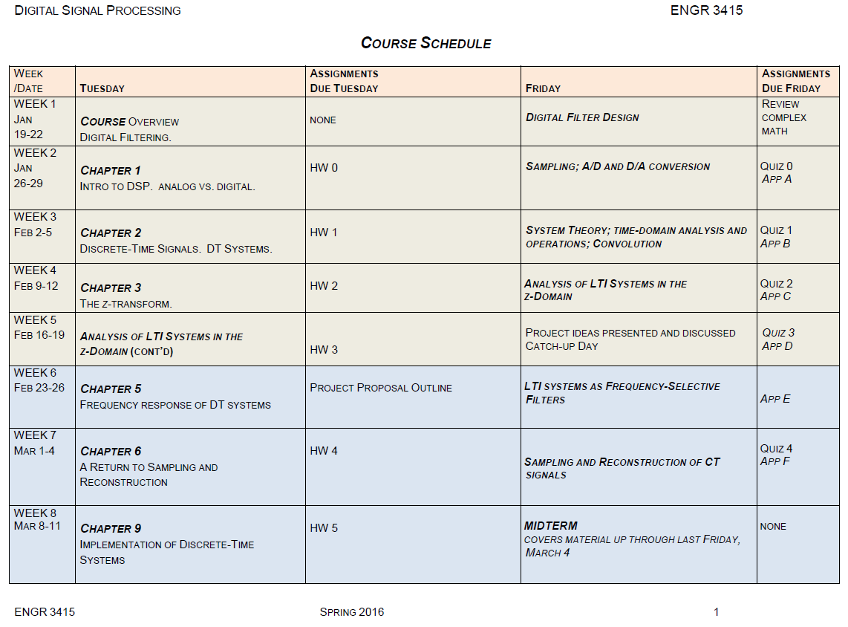

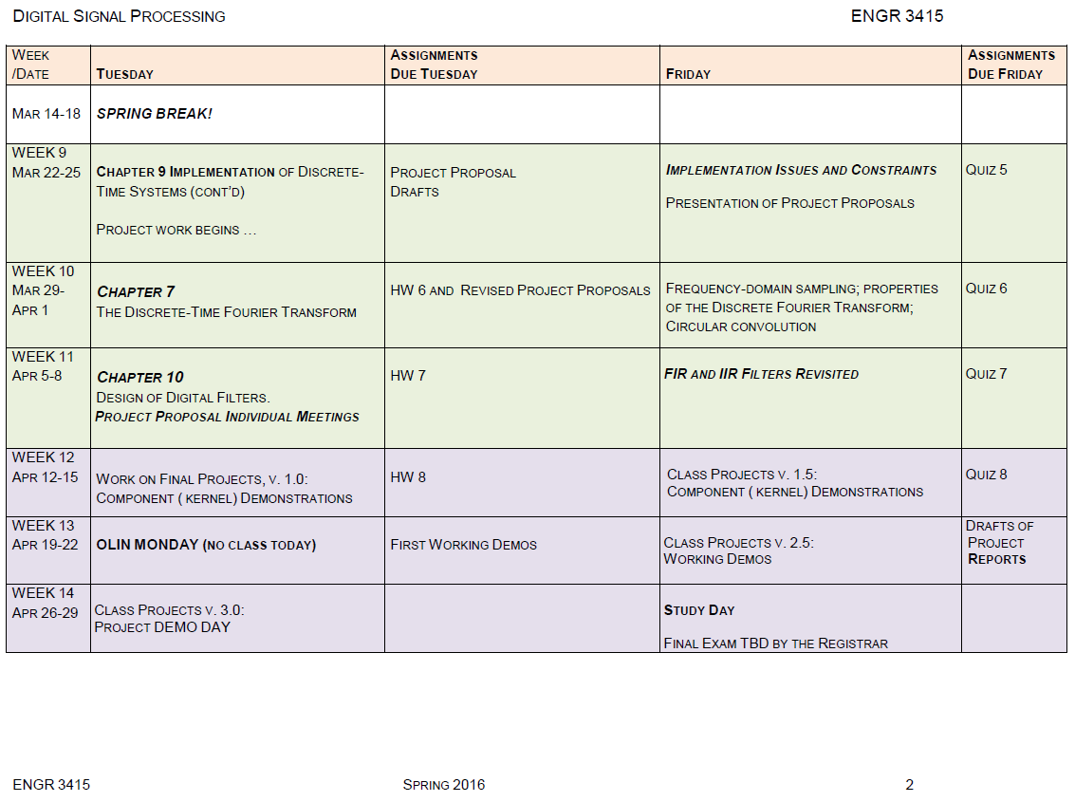

## Supplementary Materials II-B-1b: DSP Example of Developed Course Material

“Properties of Linear Phase (LP) FIR filters” motivates the four types of LP FIR filters. Linear phase FIR filters have constant group delay which means that all passed frequencies experience the same delay, thus avoiding phase dispersion, e.g., ‘smeared’ attack transients in percussive sounds. When the cases of symmetry and anti-symmetry are combined with even and odd filter order M, we get four types of linear phase FIR filters. Examples are given for each type, and space is provided for students to graph the resulting frequency responses. In so doing, they see that frequency responses for each of these types have particular characteristics and shapes. Causal FIR filters are always stable because their poles are located at z = 0 in the complex plane. Therefore, it’s the location of their zeros that differentiate the 4 types. Constraints on the zeros imposed by each type limit the kinds of frequency responses that can be achieved, a significant finding for designing LP FIR filters. Handwritten derivations of the Type 1 and Type 2 frequency response formulas, as well as derivations of Eqn. 1 and Eqn. 2, accompanied the handout.

**Properties of Linear Phase (LP) FIR filters**

NOTE: L = length of the FIR filter impulse response h[n], and M = L-1 = order of the FIR filter.

The frequency response of the FIR filter is given by . Recall the system function  🡪 M poles at the origin and M zeros located anywhere in the z-plane.

We will see that linear phase imposes constraints on the locations of the M zeros.

We have two possible cases for linear phase (LP) filters:

Case A: h[n] symmetric so that, where α = constant group delay= $\frac{M}{2}$, the index (or center) of symmetry for h[n]. The constant α also gives the group delay of H(ω). Why?

Case B: h[n] anti-symmetric so that . Here, the group delay is also constant since, a constant group delay. As in Case A, α= $\frac{M}{2}$ is also known as the index (or center) of symmetry for h[n]. .

The group delay offers another graphical representation conveying useful information about the frequency response of a filter, specifically about the phase of H(ω).

The group delay  gives the delay, in samples, introduced by the system to a sinusoid of frequency ω.

The MATLAB command: [Gd,w] = GRPDELAY(b,a,N) returns length N vectors Gd and w containing the group delay and the frequencies (in radians) at which it is evaluated. The frequency response is evaluated at N points equally spaced around the upper half of the unit circle. If you don't specify N, it defaults to 512.

**Causal FIR filters with Linear Phase**

If h[n] is causal and symmetric, i.e., if , then

, where Ae(ω) is a real, even, periodic function of ω. Eqn. (*)

Similarly, if h[n] is causal and anti-symmetric, i.e., if , then , where Ao(ω) is a real, odd, periodic function of ω. Eqn. (**)

L = length of h[n] = M+1 samples in both cases.

When the cases of symmetry and anti-symmetry are combined with even and odd M, we get four types of linear phase FIR filters. Frequency responses for each of these types have particular characteristics and shapes!

**Type I FIR Linear Phase Systems (causal h[n] symmetric, M even)**

Symmetry condition: h[n] = h[M-n], 0 ≤ n ≤ M with M even integer. Time delay M/2 is also an integer.

FIR Frequency response:  Eqn. (***)

Apply symmetry condition to Eqn. (***) to get the Type I LP FIR frequency response: , where

a[0] = h[M/2],

a[k] = 2h[(M/2)-k], k = 1,2, … , M/2. Thus we see that H(ω) has the form of Eqn. (*) given above, where

.

**EX 1**: h[n] = {**1**,1,1,1,1}. What is the center of symmetry?

**EX 2**: h[n] = {**1**, 1, 1}. Find H(ω). Graph |H(ω)| and  H(ω) .

**Type II FIR Linear Phase Systems (causal h[n] symmetric, M odd)**

Symmetry condition: h[n] = h[M-n], 0 ≤ n ≤ M, with M odd integer. Time delay M/2 is an integer plus one-half.

Apply symmetry condition to Eqn. (***) to get the Type II LP FIR frequency response: , where

b[k] = 2h[(M+1)/2 - k], k = 1,2, … , (M+1)/2. Again, we see that H(ω) has the form of Eqn. (*) given above.

**EX 3**: h[n] = {**1**,1,1,1,1,1}. Find the center of symmetry.

**EX 4**: h[n] = {**1**, 1}. Find H(ω). Graph |H(ω)| and  H(ω) .

**Type III FIR Linear Phase Systems (causal anti-symmetric h[n], M even)**

Anti-symmetry condition: h[n] = -h[M-n], 0 ≤ n ≤ M with M even integer. Time delay M/2 is an integer.

Apply anti-symmetry condition to Eqn. (***) to get the Type III LP FIR frequency response: , where

c[k] = 2h[(M/2)-k], k = 1,2, … , M/2. Thus we see that H(ω) has the form of Eqn. (**).

**EX 5**: h[n] = {**1**,0,-1}. Center of symmetry = ___________. Find H(ω). Graph |H(ω)| and  H(ω) .

**Type IV FIR Linear Phase Systems (causal anti-symmetric h[n], M odd)**

Anti-symmetry condition: h[n] = -h[M-n], 0 ≤ n ≤ M with M odd integer. Time delay M/2 is an integer plus one-half.

Apply anti-symmetry condition to Eqn. (***) to get the Type IV LP FIR frequency response: , where

d[k] = 2h[(M+1)/2 - k], k = 1,2, … , (M+1)/2. Again, we see that H(ω) has the form of Eqn. (**) given above.

**EX 6**: {**1**,-1}. Determine the center of symmetry: _______. Find H(ω). Graph |H(ω)| and  H(ω) .

**Locations of Zeros for FIR LP Systems**

Types I and II

System function H(z) for causal FIR filters: . For symmetric cases (types I and II), use to express H(z) as

. **Eqn. (1)** Symmetric h[n]: for FIR types I and II

Deduce from Eqn. (1):

a. If z0 is a zero of H(z), then . This implies that:

i. If is a zero of H(z), then  is also a zero of H(z).

b. When h[n] is real and z0 is a zero of H(z), then will also be a zero of H(z), and due to part a(i), will also be a zero of H(z).

c. Therefore, when h[n] real, each complex zero NOT on the unit circle will be part of a set of four conjugate reciprocal zeros of the form .

d. If a zero of H(z) is on the unit circle, i.e., , then . Therefore, zeros on the unit circle come in pairs of the form .

e. If a zero of H(z) is real and not on the unit circle, the reciprocal will also be a zero of H(z), and H(z) will have factors of the form  or factors of the form .

f. The case of a zero at z = -1 needs to be examined, especially for Type II LP FIR filters. From Eqn. (1), H(-1) = (-1)M H(-1). If M is even (Type I), then get an identity. But if M is odd, H(-1) = -H(-1): the only solution is H(-1) must be zero. Therefore, for symmetric h[n] with M odd, the system function H(z) MUST have a zero at z = -1.

Types III and IV

If h[n] anti-symmetric (types III and IV), then can show that

. **Eqn. (2)** Anti-symmetric h[n]: FIR types III and IV.

Deduce from Eqn. (2):

a. The zeros of H(z) for the anti-symmetric case are constrained in the same way as the zeros for the symmetric case.

b. In the anti-symmetric case, however, both z = 1 and z = -1 hold special interest.

c. If z = 1, Eqn. (2) becomes H(1) = -H(1) 🡪 H(z) MUST have a zero at z = 1 for both M even and M odd.

d. If z = -1, Eqn. (2) gives H(-1) = (-1)-M+1 H(-1). If M is even, then H(-1) = -H(-1). Therefore, z = -1 MUST be a zero of H(z) if M is even (so what type of linear phase FIR filter would always have a zero at z = -1?).

These constraints on the zeros impose limitations on the types of frequency responses that can be achieved with FIR LP filters. As designers, we need to take into account these constraints. For example, if you are designing a filter with an anti-symmetric h[n] *that has to allow the highest frequencies for a given Fs*, would you choose M to be even or odd?

## Supplementary Materials II-B-1c: DSP Developed Course Materials’ Topics

Here is a complete listing of the 48 topics covered in my developed course materials for the DSP course, any of which are available on request.

**1.** Syllabus

**2.** Course schedule

**3.** Complex math diagnostic and solution

**4.** DSP student goals sheet

**5.** Bilinear transformation

**6.** Digital filter design

**7.** Guidelines for DSP Application presentations and reports

**8.** Matlab BLT, Butterworth, Chebyshev 1

**9.** 15 Complex facts of life

**10.** Intro to DSP and sampling

**11.** Matlab commands for complex numbers

**12.** Sampling in color

**13.** Sampling problem

**14.** DT signals, DT systems

**15.** Matlab signals

**16.** Matlab code for signals

**17.** Matlab convolution

**18.** Motivation for z-transform and why useful

**19.** Deconv, poly, residuez, freqz

**20.** Finding impulse response

**21.** Investigating region of convergence and ROC summary

**22.** Matlab code partial fraction expansions

**23.** Second order systems

**24.** Intro to frequency response

**25.** Frequency response of second order FIR filter

**26.** z-transform for review

**27.** Frequency domain analysis of LTI systems – for review

**28.** LTI benefits

**29.** Table 3.1 Example signals and their ROCs

**30.** Table 3.2 z-transform properties

**31.** Table 3.3 z-transform pairs

**32.** Final project proposal guidelines

**33.** DF I, DF I practice

**34.** Filter implementation

**35.** IIR parallel realization

**36.** IIR filter implementation

**37.** FIR filter structures

**38.** Guidelines for DSP Final Project Written Report and Presentation

**39.** Matlab code for IIR cascade and parallel realizations

**40.** Round-off noise in IIR filters

**41.** Connecting the DFT to the DTFT

**42.** Finding tne 4-point DFT, IDFT

**43.** Why do we need circular conv for the DFT

**44.** A return to the BLT

**45.** Analog2digital Butterworth filter example using the BLT

**46.** LPF design using Matlab

**47.** Proof for FIR types 1, 2 system functions

**48.** Properties of LP FIR filters

## Supplementary Materials II-B-2a: Signals and Systems Course Schedule, Spring 2019

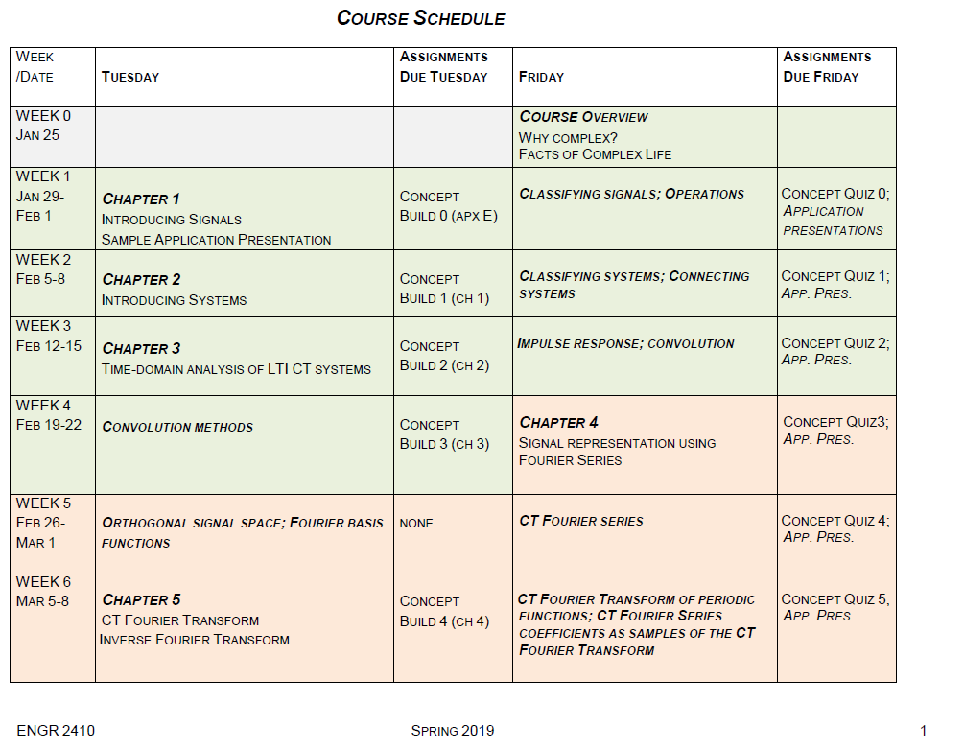

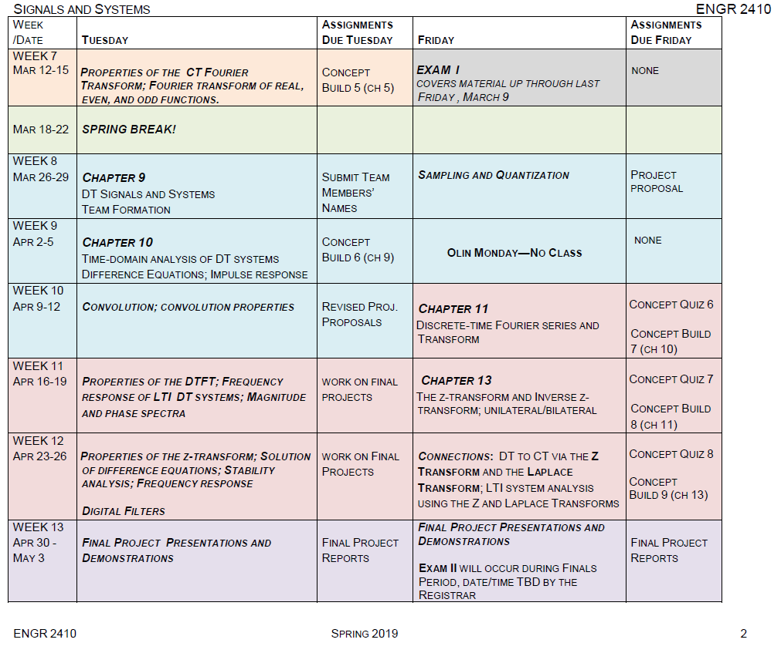

## Supplementary Materials II-B-2b: Signals and Systems Example of Developed Course Material, Spring 2019

The following developed course material example, “**2019-04-30 Transient vs. Steady-state response; Connecting pole-zero plots, the system function H(z) and frequency response H(Ω); 3-dB width; Sinusoidal steady state response; Matlab verification**”, explains how to discern the transient response from the steady-state response, starting with the input/output difference equation, then finding its z domain equivalent, and finally using the inverse Z-transform to deduce the output in the discrete-time domain, at which point the transient and steady-state components become evident. Spaces are left in the handout so students can figure out the answers to questions posed.

The handout goes on to connect pole-zero plots, system functions, and frequency response. It concludes with a discussion of the 3-dB bandwidth and sinusoidal steady state response. A follow-up handout provides the Matlab verification for the calculations done by the students.

**2019-04-30 Transient vs. Steady-state response; Connecting pole-zero plots, the system function H(z) and frequency response H(Ω); 3-dB width; Sinusoidal steady state response; Matlab verification**

**Transient vs. Steady-state response**

Recall the system given in EX 1 from Friday’s handout (April 26) on “Solving difference equations”:

.

If this system has an input x[k] = u[k], what is the output y[k]?



Solving for the constants of the partial fraction expansion gives us: A = -4, B = 2/3, and C = 16/3.

Taking the inverse ZT of Y(z) gives us the output .

What is the transient response, i.e., the part of the output that quickly dies away?

What is the steady-state response, i.e., the part of the output that goes on for a long time?

**Pole-zero plots, system function H(z), and Frequency Response H(Ω)**

Goal: Connecting the pole-zero plot of H(z) to the shape of the frequency response H(Ω)

**EX 2**. Consider the difference equation describing an IIR (infinite impulse response) filter:



What is the order of the filter?

How will you find the system function H(z)?

. Now find an expression for the frequency response H(Ω):

Find the poles and zeros of H(z).

First convert  into an expression in terms of z: _______________________

Zeros: ___________

Poles: _____________

Graph the poles and zeros: 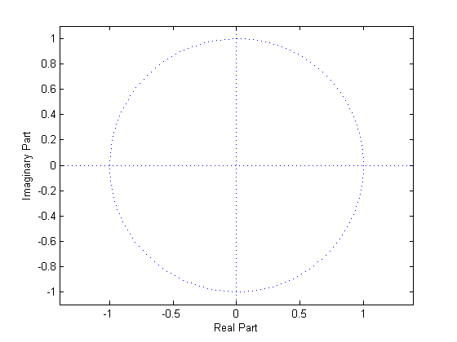

NOTE the property of real polynomials. A polynomial of degree N has N roots. If all the coefficients of the polynomia are real, the roots either must be real or must occur in complex conjugate pairs.

Claim: From the pole-zero plot you can make a rough sketch of the magnitude of the frequency response |H(Ω)|:

_______________________________________________________________

At what frequencies do the zeros occur? Ω = _____________________

How will the zeros affect the rough sketch of |H(Ω)|?

A zero at a given frequency will eliminate that frequency from the response.

How will poles affect |H(Ω)|?

Our poles occur at . Remember that frequency response H(Ω) is defined for 

Where is on the z-plane?

Where is on the z-plane?

Recall that H(Ω) is often notated as to reinforce the fact that frequency response is restricted to the unit circle. This is why we have the phrase ‘take a walk around the unit circle’ to get insight into what the frequency response might be. Taking this walk is especially appropriate when we have a pole-zero plot. The pole-zero plot allows us to see which frequencies Ω on the unit circle are boosted and which are damped or eliminated.

Where do we look in the z-plane for the frequencies?



In our example, the two poles at affect the frequency response = H(Ω) near which frequencies?

Since H(z) blows up at , the nearby points on the u.c. (at ) must have large values 🡪 H(pi/3) large cf. to H(Ω) at other frequencies.

Show that |H(Ω) | = 0 when Ω = 0, when Ω = π, and when Ω = -π: 

Now let’s see what happens to |H(Ω)| near a pole. Where should we look, i.e., what might be the frequencies of interest?

Now complete your rough sketch of |H(Ω)| on p. 2 ...

Calculate |H(Ω)| for Ω = pi/3.

Find  = 10.52. This value of the frequency response is a good approximation to the true maximum value which actually occurs at Ω = 0.3334π.

**3-dB width**

Locate the 3-dB width. The 3-dB width is a common measure of the width of the peak of |H(Ω)|.

How to calculate the 3-dB width:

* Step 1. Determine the peak value of |H(Ω)|.
* Step 2. Find the nearest frequency on each side of the peak where the value of the frequency response is .
* Step 3. The 3-dB width is the difference between these two frequencies.

Step 1. The true peak value is 10.526 at Ω = 0.3334π. Can find the peak value from a Matlab plot.

Step 2. Look for points where 

From the Matlab plot, we can determine the frequencies at which |H| = 7.442 are Ω= 0.302π =.9488 and Ω =0.369π = 1.1592.

Step 3. Therefore, = 0.067π.

**Sinusoidal steady-state**

If the input to the system is , calculate the output y[k] of the system.

What is the form of the output y[k] for the sinusoidal input ?

Recall .

 = _______________________

 = ________________________

Therefore, y[k] = _________________________________________

**Matlab verification of our calculations**

Find the pfe for EX 1 where 

.

Use [r,p,k] = residuez(b,a). Note that residuez uses the coefficients in the order of ascending powers of z-1.

-------------

Find the poles and zeros of .

Use [z,p,k] = tf2zp(b,a). Use coefficients in the order of descending powers of z.

------------

Graph the pole-zero plot. Use zplane(z,p).

-------------

Now calculate H(z) from the poles and zeros of your plot. Verify that it is the same as .

Use [b, a] = zp2tf(z,p,k)

-----------------------

Graph the magnitude of the frequency response .

Use [h,w] = freqz(b,a,n,'whole').

See if you can locate the 3-dB width.

________________

Graph the phase of the frequency response .

-----------------------------

Use subplot to graph both the magnitude and phase of .

Locate  and  on the graph in order to verify your calculation for the output y[k], given a sinusoidal input .

**Reminders:**

Project presentations will occur on Friday, May 3, 1240 – 310pm. Attendance is required. Guidelines for the Final Project Reports and Final Project Presentations were handed out in class last Friday. They can also be found on Canvas.

Our second midterm will occur on Thursday, May 9, from 4-7pm in AC304. The 2nd midterm will cover the material since the first midterm, i.e., chapters 5, 9, 10, 11, and 13, including material covered today, April 30. Concentrate on the topics we covered in class, your concept builds, concept quizzes, and the handouts I’ve made.

**Matlab Verification Code for “Transient, stst, ZT cf. DTFT, ML verification” Handout**

b = [2];

a = [1 -7/4 7/8 -1/8];

[r, p, k] = residuez(b,a)

b = [1 0 -1];

a = [1 -.9 .81];

[z,p,k] = tf2zp(b,a)

zplane(z,p)

[b,a] = zp2tf(z,p,k)

clf

[H, w] = freqz(b,a,512,'whole');

magH = abs(H);

subplot(211);plot(w,magH);grid

phaseH=angle(H);

subplot(212);plot(w,phaseH)

clf

[H, w] = freqz(b,a,512,'whole');

subplot(211)

plot(w,magH); grid

subplot(212);plot(w,phaseH);grid

**Figures**

Pole-zero plot

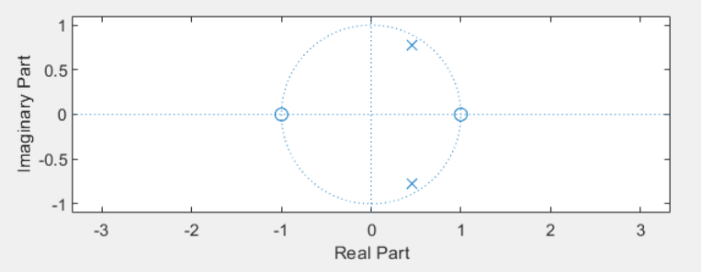

Frequency Response plotted from 0 to 2pi (Note the symmetry)

Magnitude of H(Ω) (top); Angle of H(Ω) (bottom)

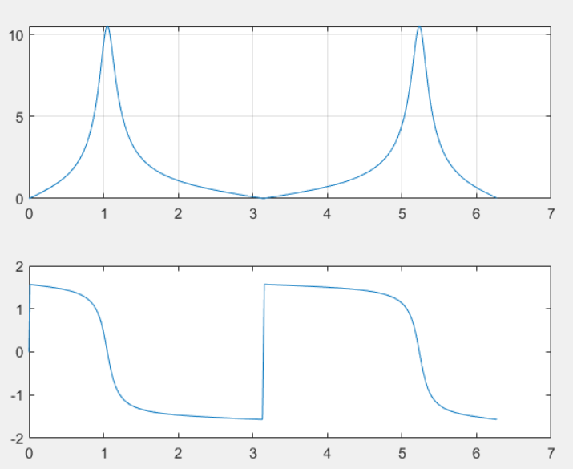

**Another way of interpreting the Frequency Response, by graphing the response from –pi to pi.**

w = -pi:0.005:pi;

h = freqz([1 -1],[1 -.9 .81],w);

plot(w,abs(h));

plot(w,angle(h));

clf

subplot(211)

plot(w,abs(h));

subplot(212);

plot(w,angle(h));

Frequency Response plotted from -pi to pi

Magnitude of H(Ω) (top); Angle of H(Ω) (bottom)

**Note the symmetry, i.e., |H| is even, angle H is odd.**

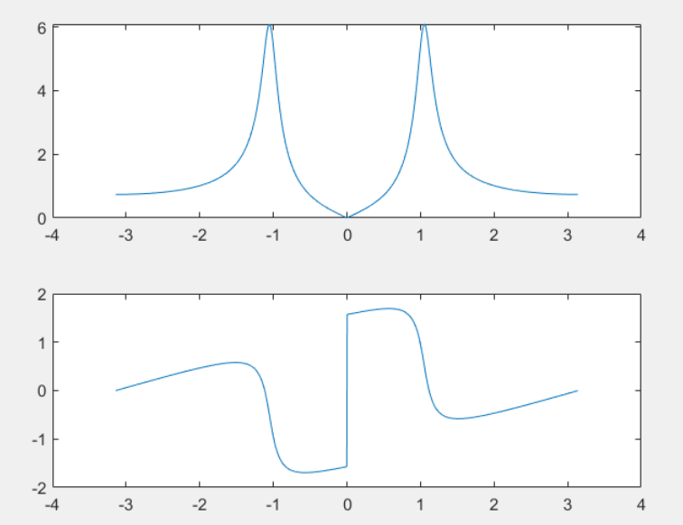

## Supplementary Materials II-B-2c: Signals and Systems Developed Course Materials’ Topics, Spring 2019

Here is a complete listing of the 41 topics covered by my developed course materials for the Signals & Systems course, any of which are available on request.

**1.** Course schedule

**2.** Course syllabus

**3.** Complex math work sheet

**4.** Guidelines for Application presentations and reports

**5.** Intro to signals

**6.** Classification of signals

**7.** CT and DT periodicity

**8.** CT impulse function

**9.** Linear or NL, TI or TV examples

**10.** Linearity, time invariance

**11.** Intro to systems: concepts, illustrations, examples

**12.** BIBO stability

**13.** Love that convolution

**14.** Concept build 2, pb 2 soln – convolving a truncated triangle wave with a rectangular function

**15.** Convolution properties, convolution with impulse functions

**16.** Convolution worksheet II – for studio class

**17.** Why is the derivative of a step fn a delta fn?

**18.** From orthogonal signal space to Fourier basis functions

**19.** Orthogonal signal space

**20.** Exponential CTFS

**21.** CTFS properties; complex exponential in, cx expon out; CTFT

**22.** Using the CTFT

**23.** LTI bonuses with proofs

**24.** Final project proposal guildelines

**25.** Sampling

**26.** Instructions for final project written report and presentation

**27.** Sampling process in t domain and f domain

**28.** Sampling and aliasing

**29.** Matlab conv and signal practice

**30.** Conv worksheet with infinite sequences plus Matlab conv – also with soln+derivations

**31.** DT convolution

**32.** Properties of the DTFT – also with soln

**33.** Complex exponential in, complex exponential out – also with soln

**34.** Matlab example plots – rectangular and sinc DTFT – soln

**35.** Rectangular and sinc DTFT – also with soln

**36.** z-transform and the region of convergence – also with soln

**37.** Properties of the z-transform – also with soln

**38.** Solving difference eqns, P-Z plots, stability – also with soln

**39.** Matlab verification for transient, steady state, z-transform cf. DTFT

**40.** Relationship between the Laplace transform and z-transform – also with soln

**41.** Transient, steady state, z-transform cf. DTFT, Matlab verification – also with soln

## Supplementary Materials II-C-3: Engineering the Orchestra, part II—Composition Example

Supplemental Materials II-C-3 gives a final project composition from this course. The performance shows a student combining flute, clarinet, guitar, and trumpet—an unusual instrumentation that combines four non-homogeneous instruments.

Engineering the Orchestra, part II, Final Project Composition <https://youtu.be/g4wS3piRKHw>

## Supplementary Materials II-D: “Creating the Renaissance Engineer”, a white paper presenting a vision for our new college, January 2001

My white paper, “Creating the Renaissance Engineer”, written in January 2001, helped define Olin College:

Engineering, Entrepreneurship, the Arts

What we do that no one else does

**Franklin W. Olin College of Engineering –Creating the Renaissance Engineer**

**Scientifically Astute,**

**Artistic,**

**Entrepreneurial**

A place where LdV might like to drop by

*Olin’s mission does not stop after a student graduates. Rather it is carried forward, an integral part of each graduate, into creative endeavors far and wide. What assures the creativity?*

*A mind able to triangulate its corners.*

The Renaissance, a time of fluid boundaries between science and art, produced feats of engineering design, artistic mastery, and an entrepreneurial spirit that continue to inspire and motivate humankind. At FWO, our students learn to speak the languages of engineering, science, mathematics, the arts, and business—not as separate subjects—but all together. We emphasize this essentially trilingual approach (engineering/science/math, arts, entrepreneurship) because we believe that a mind able to reach all its corners becomes a fully functioning intelligence capable of reaping the kind of “breakthrough” thinking that moves the human condition further.

Olin students create in many fields while at the College—in engineering, mathematics, science, art/music/film/video/writing/theater/performance, and business—just as they will after graduating. We believe that pursuing projects and knowledge in all of these concentrations fuels an individual’s creativity, as does the ability to communicate these pursuits to a larger audience. It is this synergistic creativity that is ultimately Olin’s goal—to produce and enhance the resilient, resourceful, artistic, intelligent, and technically astute individual who will take these gifts and basically go out and change the world in some way. This catalyst for change touches another of Olin’s core values: that change be beneficial to human kind. Philanthropy, ethics, and communication figure prominently in the FWO worldview. Towards that end, our faculty includes social scientists with specialties in past and current ethical and historical issues, as well as experts in communication so that our students have the skills to reach others with their ideas.

Given the emphasis on creating in multiple fields which, by its very nature, often necessitates “going out on a limb”, students’ participation and ever-increasing fluency in EEA (Engineering, Entrepreneurship, the Arts) helps them become more confident in their abilities. Ultimately—after an undergraduate education steeped in “doing” and “thinking” both singly and collaboratively—they find themselves comfortable with risk, having spent part of their undergraduate years becoming acquainted with it. A high comfort level with risk provides a key character trait of the entrepreneur, where entrepreneur is defined broadly as an independent, active, self-sufficient individual who can articulate a vision and bring it to fruition [sschiffman]. Risk-tolerance enables graduates to pursue business opportunities, inventions, innovative projects, not to mention dreams, new theories, and ideas from which others may shrink or cast as impossible. Of course, history is awash with great ventures that were so summarily dismissed. Olin graduates are not shrinking violets and they do not take no for an answer! They are a little bit uppity (though respectfully so).

With FWO’s faculty embodying engineering, science, mathematics, the arts, and business (in cooperation with Babson College), as well as in specialty areas such as professional ethics, technological history, communication, and educational psychology, the College’s essentially multidisciplinary approach encourages close connections with other nearby institutions. FWO exists within the BBOW community—Brandeis, Babson, Olin, Wellesley. Babson College, ranked no. 1 for its programs in entrepreneurship, offers a rich array of business-oriented classes. Brandeis and Wellesley enjoy solid reputations for their liberal arts curricula. Professors from these schools (and other Boston area campuses such as MIT, BU, Boston College, Harvard, etc.) can be asked to teach courses on the Olin campus that they successfully teach on their home campuses. Teaching well-developed courses at FWO may be a particularly attractive offer for sabbaticals. Olin can also start a series of FWO “Guggenheims” to bring in various scholars on a visiting basis. Professors that are brought in from other schools can provide a steady input of more humanities offerings, as well as a wider array of technical courses not offered at FWO. In this way, our college can offer additional studies in the humanities, math, science, and engineering through its partnership in BBOW, Olin “Guggenheims”, and invited guest lecturers from Boston area colleges and universities who are asked to teach a particular course for which they are “famous” and “revered” on their own campus.

At Olin we cultivate a student who invents, pursues entrepreneurial activities, engages in innovative projects not only in engineering/science/math but also in the arts and business. Professional ethics, historical context, communicative ability, and a philanthropic bent inform all they undertake.

Graduates are fluent in art, science, and entrepreneurship—three disciplines whose legacies have perhaps most affected the human condition. By speaking these languages, students cannot help but make the analogies, leaps of faith, and mental discourse that spurs invention. Each of these languages is powerful in its own right, presenting a richness of fundamental thought and expertise that models practically everything they might undertake in life. The innate entrepreneurial/scientific/artistic streak in each of them develops through a well-designed FWO curriculum, a rich array of entrepreneurial studies available at Babson College, as well as contact with peers, faculty, the FWO and Boston area communities. With a mind able to navigate its full space, the Olin graduate bursts forth with a kind of synergistic creativity that, coupled with the ability to apply fundamentals, IS the Renaissance Engineer—entrepreneurial, artistic, enlightened, and scientifically astute.

In creating the Renaissance Engineer, FWO builds a readily identifiable image such as those associated with other institutions, e.g., the University of Chicago (great books), Harvard (elective system), William and Mary (colonial college). Conveying breadth and depth, art, science, and the individual’s ability to carry a vision forward (entrepreneurship), the Renaissance Engineer embodies a highly marketable image to all of our constituencies (students, parents, industry, academia, faculty, administration, alumni—at home and abroad). The “*Renaissance Engineer—Entrepreneurial, Scientific, with a flare for the Arts*” gives us an institutional identity that is at once marketable and memorable. It exudes longevity, allowing an admissions interpretation with virtually endless variations.

**How the “Renaissance Engineer” might benefit FWO**

A Possible solution for some issues we are wrestling with:

**AP credit** – What do we do about students who enter with enough AP credits to basically skip their first year of college? We might build a curriculum which now challenges them to think about these fields in an entirely new way, in conjunction with engineering/science/math, entrepreneurship and the arts. For example, a student entering with AP physics might find at FWO not the standard Mechanics class, but rather Mechanics and Sculpture, Mechanics with Applications to Civil Engineering, Mechanics and the Human Body, and/or Mechanics Applied to Architecture. Similarly, a student with AP chemistry might find that Olin’s core course in chemistry is linked with environmental concerns. Ditto for the AP biology student, who might find not “standard-issue” biology, but rather “The Science and Business of Biology” or “Biology and Art”.

**The Great Leveler** --- How do we handle students who are already walking encyclopedias in certain fields, e.g., a student who knows calculus like the back of her hand? Here are two possible approaches:

1. “What’s so great about Calculus” addresses all the mathematical fundamentals but with a worldly twist: students figure out how to apply what they are learning to everyday life.
2. “Variation in Science and Art” focuses on systems that vary with time, i.e., dynamical systems, and the differential equations that model them. Students learn all about the usefulness of diffeqs and simultaneously are exposed to the concept of variation in art, music, and science.
3. “Calculus and the Newtonian World” exposes students to all the concepts and fundamentals of calculus in tandem with a history of the cultural and scientific world that Newton inhabited.

**A Project Differentiator** --- What might distinguish FWO’s approach to project-based learning from that of Harvey Mudd, MIT, Aalborg, and others? At Olin, projects are undertaken where the number of tapped fields keeps increasing as the undergraduate calendar progresses to graduation day. So, for example, a possible plan might be:

Year 1: engineering and math/science (physics/chemistry/biology)

Year 2: engineering, math/science, business

Year 3: engineering, math/science, business, visual arts

Year 4: engineering, math/science, business, visual arts, music

**Possible Suggestions for a Graduation Requirement:**

a technical capstone experience and an artistic capstone experience

a technical capstone experience and a business capstone experience

a technical capstone project and a project that combines art and science

a technical capstone project and another that combines engineering and business

a technical capstone project and another that combines science/math and business

a technical capstone project and another that combines the arts and business

a technical capstone project and another that combines any relevant field and business

a technical capstone project and a multidisciplinary project

**Benefits for the Student**

Active use of multiple areas of the mind

Fluency in multiple languages (engineering/science/math, the arts, and business)

Strong grasp of ethical, historical, and professional issues in engineering and science

Communication skills

Philanthropic education

A catalyst for agility, versatility, resourcefulness

Climate for invention

Real heroes: artists, scientists, and engineers have moved culture throughout the ages

Synergistic creativity

**Benefits for the Faculty**

The Renaissance model is multidisciplinary

Everyday communication across a broad spectrum of fields

Exposure to visiting faculty

Ongoing invention and development

Imaginative environment because of the unusual confluence of EEA (Engn, Entrep, the Arts)

Students whose skill set, grasp of fundamentals across disciplines, inventiveness, and insight increase from year-to-year

Resourceful, confident, agile group of alumni with whom further ties can be productive

**Benefits for the FWO community**

Multiple languages spoken

A core mission that encompasses many of the passions/interests of staff, students, and faculty

Emphasis on accessing all of a mind’s potential

An environment that nurtures and encourages exploration

Synergistic creativity

Enterprising intellectual community as a result of that creativity

Stimulating an original, distinctive mission unlike that of any other institution yet one that many aspire to and have tried to implement

Inspiration and motivation

**Benefits for FWO’s continued ability to thrive and pursue its mission with excellence**

The boon to creativity provided by access to more of the mind carries graduates into many facets of world society where their influence is felt in both large and small ways

This creativity engenders new theories, ideas, inventions, business opportunities for Olin, its grads, and the communities they live in

FWO could become linked in the minds of many with Leonardo, motivating gifted students, faculty and staff to work here

FWO’s Renaissance model of science with art and business is associated with the depth that the term “Renaissance” connotes, engaging parents in its mission

FWO’s incorporation of business and entrepreneurship (broadly defined) assures parents and students that graduates will be prepared for some of challenges and practicalities of life

FWO’s emphasis on philanthropic, ethical, and historical issues inspires and motivates good works, including some that assure Olin’s future

Agile, inventive, resourceful group of alumni with whom FWO maintains close, “affectionate” ties

**Probable Longevity of the “Renaissance Engineer”**

Olin may enjoy preeminence in “creating the Renaissance Engineer” for quite some time—perhaps always, since we will have been the first to do so. Unlikely to be challenged by existing schools due to high departmental walls, Olin’s Renaissance approach might take seed in a new college adopting all or part of our model. Or it might inspire something similar within an existing institution (e.g., an experimental college within a university setting). Any of these spin-offs would be great. Part of our mission is to export what we accomplish. Many schools have tried to build bridges between their engineering and arts departments. These tend to take on the appearance of some art applied to engineering or engineering applied to art. No college or university has been able to successfully put in place a program that produces the Renaissance engineer. Yet so many are wrestling with this concept. They want it. But with many departments and faculty involved (each with its, her, and his own agenda), that consensus often waters down to a bit of this and a squirt of that.

**What separates the science and art focus of Olin from other universities that have programs in place that incorporate art with engineering, e.g., the electronic arts option at Renssalaer?**

For starters, we define entrepreneurial activity broadly enough to ensure its timeliness for years to come, and shield FWO from association with a hot item that could at some point not enjoy its current popularity.) Secondly, we emphasize the Renaissance model which places a high premium on fluency in both science and art, not bits of science and a bit of art, but an in-depth understanding of the fundamental principles presented from various angles.

## Supplementary Materials III-E: Publication in *Science*: “Creating Musical Variation”, April 4, 2008



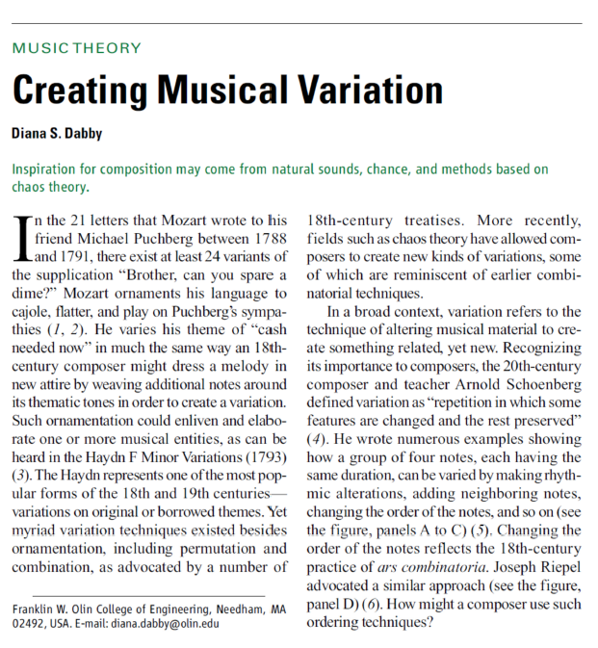

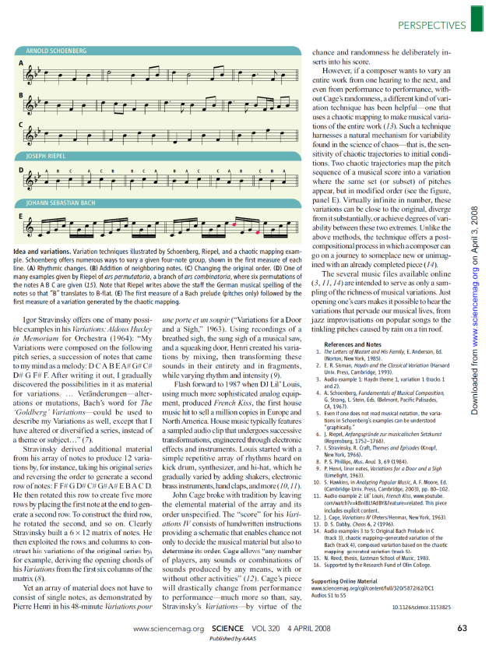

## Supplementary Materials III-F. Recent Patents and Trademarks Issued by the United States Patent and Trademark Office (USPTO)

Supplementary Materials III-F includes two patents granted 2016 and two trademarks registered 2015 and 2014, respectively.

The patents underlie CantoVario’s technology. A third patent (pending) underpins the mashup variations on [www.cantovario.com](http://www.cantovario.com).

Dabby, D.S. (2016). Method and Apparatus for Computer-aided Variation of Music and other Sequences, including Variation by Chaotic Mapping. US 9286877 United States Patent and Trademark Office, 15 March 2016. Continuation in Part to cover applications, filed April 2014. <http://patft.uspto.gov/netacgi/nph-Parser?Sect1=PTO1&Sect2=HITOFF&d=PALL&p=1&u=%2Fnetahtml%2FPTO%2Fsrchnum.htm&r=1&f=G&l=50&s1=9286877.PN.&OS=PN/9286877&RS=PN/9286877>

Dabby, D.S. (2016). Method and Apparatus for Computer-aided Variation of Music and other Sequences, including Variation by Chaotic Mapping. US 9286876 United States Patent and Trademark Office, 15 March 2016. Provisional filed July 2010, Utility and updated Provisional filed July 2011. Preliminary amendment filed January 2012. <http://patft.uspto.gov/netacgi/nph-Parser?Sect1=PTO1&Sect2=HITOFF&d=PALL&p=1&u=%2Fnetahtml%2FPTO%2Fsrchnum.htm&r=1&f=G&l=50&s1=9286876.PN.&OS=PN/9286876&RS=PN/9286876>

Dabby, D.S. (2015). EnginArtTM. Computer software for processing digital music files; computer software for creating and editing music and sounds; music-composition software. Registration No. 4698653 United States Patent and Trademark Office, 10 March 2015. <http://tmsearch.uspto.gov/bin/showfield?f=doc&state=4807:hplqv5.3.1>

Dabby, D.S. (2014). CantoVarioTM. Computer software for processing digital music files; computer software for creating and editing music and sounds; music-composition software. Registration No. 4656199 United States Patent and Trademark Office, 16 December, 2014. <http://tmsearch.uspto.gov/bin/showfield?f=doc&state=4807:hplqv5.4.1>

## Supplementary Materials III-G: YouTube Videos of Recent Compositions

Scores for the below works can be found in **Appendix III-G**.

***September Quartet.*** Recorded live on the Tenth Anniversary of 9/11, this YouTube video captures the performance from the middle of the “93” movement to the “End.” <https://www.youtube.com/watch?v=UQj2EmfFgAg> [In the process of establishing this new link, the previous 500 views and comments were lost.]

Performers: Ashley Addington, flute; Jennifer Slowik, oboe; Ray Jackendoff, clarinet; Philipp Staeudlin, alto saxophone; Dana Russian, trumpet soloist; Dana Oakes, trumpet; Jeffrey Means, percussion; Jonathan Hess, percussion; Matt Sharrock, percussion; John McDonald, piano; Jae Young Lee, violinTufts chamber Singers; and Jamie Kirsch, conductor.

***Tre Studi di Colore.*** YouTube videos of *Tre Studi di Colore* recorded by pianist Jongsun Lee at Mozart Hall, Seoul, Korea, in December 2013.

Violetto: <https://www.youtube.com/watch?v=mRrJhR4OmEQ> Rosso: <https://www.youtube.com/watch?v=j1mWqnuUkA8> Azzurro <https://www.youtube.com/watch?v=yH5X84zePjw>

***Fuente y Variación.*** A YouTube video of *Fuente y Variación* recorded by pianist Jongsun Lee at Mozart Hall, Seoul, Korea, Dec. 9, 2013. *Variación* <https://www.youtube.com/watch?v=3vVeYwW1VNY> *Fuente* <https://www.youtube.com/watch?v=KSA6kJN1iyA>

**TEDx talk at Seoul National University** “Two are better than one: composers and performers in music.” Pianist Jongsun Lee presented her work bringing *Fuente y Variación* and *Tre Studi di Colore* from score to finished performance, Nov. 16, 2013. <https://www.youtube.com/watch?v=0i3wkr7G1O4>

***Who was Wissam Eid?*** YouTube video of *Who was Wissam Eid?* recorded April 17, 2017 <https://youtu.be/Ra_AoA8SUsY>

Performers: Gabriella Diaz, violin; David Russell, cello; and Lois Shapiro, piano.

***Parallel Lives—Distant Mirrors.*** YouTube video of *Parallel Lives—Distant Mirrors*, recorded live in Houghton Chapel as part of the Wellesley College Concert Series <https://www.youtube.com/watch?v=xSqE22X4I8U>

Performers: Yong Su Clark, flute; P. Lucy McVeigh, mezzo-soprano; and Jongsun Lee, piano.

## Supplementary Materials IV-H-1: CantoVario’s MIT VMS Demo Day presentation

CantoVario’s Demo Day five-minute presentation video, given April 30, 2014 at MIT: <https://youtu.be/ookPBjK0iaA>

## Supplementary Materials IV-H-2: NSF I-Corps “Lessons Learned” Video

CantoVario’s “Lessons Learned” video can be accessed at <https://drive.google.com/open?id=1O4EcHjHHpA_kC4Kch0OLn1VbLrbY9ymL>

## Supplementary Materials IV-H-3: CantoVario and NSF I-Corps Backstory

In Fall 2018, Cantovario participated in the MIT I-Corps node’s SPARK Program, conducting 32 interviews with students (ages 12-22). Results revealed that 88% or more listen to music daily, access streaming services, share music, and experiment with music. Furthermore, they highly value music as part of daily life, and if given the chance to **directly interact with music**, they would. These interviews gave credence to a science museum exhibit prototype that features **direct interaction with music** via variation, chaos theory, and the sound-focusing technology of CantoVario’s Industry Partner—Brown Innovations.

CantoVario then submitted an application to the NSF Innovation Corps (I-Corps) National Teams Program and was awarded a 50K grant for customer discovery.

As the entrepreneurial lead for the CantoVario team, I completed 170 face-to-face interviews in 6½ weeks, May 6 – June 13, 2019. These interviews yielded context as well as gain/pain points, focusing mainly on musician-producers: aspiring, student, and professional.

The interviewees covet an artistic state of complete immersion in the current experience such that time ceases to exist. They highly value this gain point because their creativity flows effortlessly; they get “swept away.” But when not in that artistic state, i.e., when their creativity feels blocked, they experience pain. This pain—palpably expressed by voice and visual countenance during interviews—results in “stress, anxiety, and self-doubt.”

Though professionals can get stuck, they’ve developed strategies for moving past these pain points, having experienced numerous creative projects over many years. Yet the vast majority of amateur and student musician-producers do not have their skills. However, they too have a job to be done, and that job is creating music, often under time constraints. CantoVario addresses the pain points of stress, anxiety, and self-doubt, by 1) reducing the barrier to enter—and stay in—an artistic state, 2) igniting ideas, thus diminishing stuck time, and 3) decreasing the time to go from idea to final result.

The Director of The Bridge, a Knight Foundation funded incubator for musician-producers in Miami, FL, offered The Bridge as an interview site for CantoVario’s I-Corps interviews in Miami. A month later, she wrote: “CantoVario does for the musician, the very thing we all need when we’re stuck. It simply nudges us a bit and gets the wheels turning again but in a new direction. It creates a change of perspective on a synaptic level. CantoVario doesn’t distract us from our goal or scrap the whole thing for a fresh start. It takes what we’ve done and re-packages it for us in a way that we might not have come up with on our own. This can be like a breath of fresh air for a stuck composer. Our very own idea looking right back at us but now with an interesting twist that we’re free to take or leave. The value is not in what the program produces musically. The value is in freeing the creative process from this spiraling rut.”

## Supplementary Materials IV-H-4: CantoVario’s Three Current Projects

**Project 1: Musical Variation Engines**

**Engine A. CantoVario Musical Variation Engine: Variations of Multiple Pitched and Non-pitched MIDI Instruments.** During the NSF I-Corps Teams program, 27 aspiring musician-producers were asked, “Do you ever make versions of your songs?” 22/27 make versions of their songs, suggesting an openness to variation. They were also asked to define “version.” Responses ranged from “different varieties” and “modification”, to the “the soul stays the same, despite changes.” CantoVario was designed to make variations of music according to the style of the musical input. The creator of that input can then decide whether to produce variations close to the original or farther away. If desired, the variations can mutate, producing a completely different song, far removed from the original. Finally, CantoVario creates a virtually infinite set of variations, which can be both blessing and curse. Several interviewees spoke of being “overwhelmed” by the sheer number of options offered by music production software. As a result, CantoVario will likely offer two Musical Variation Engine options: ‘lite’ and ‘full.’ (cantovario.com provides a short explanatory video on its home page, the first part of which demonstrates a CantoVario-generated variation which alters the pitch and rhythm of a Gershwin Prelude. More variations available on request.)

***Evidence:*** Engine A has been implemented as both a standalone application and a demo web app that is currently available at: <http://cantovario.com/summer2019/>  for beta testing. A 2017 Olin Summer Innovation and Research Grant funded an Olin student (Justin Kunimune ‘19) to code this web app (updated Summer 2019), as well as a CantoVario MIDI Standalone App that would incorporate all my algorithms that vary MIDI songs (as specified in my 2016 patents). His work was excellent. The summers were incredibly productive—and fun! CantoVario proposals were also awarded funds for a student programmer in 2015-2016. These summer research grants enabled me to move forward with implementing CantoVario MIDI and audio algorithms 2006-09 and 2014 – 2017.

**Engine B. CantoVario Variation Engine: Audio Mashup/Hybridization of Songs.** Increasingly today, artists are collaborating on songs, e.g., “Drop it Like it’s Hot” (2004) was an early example. CantoVario proposes moving the needle farther on collaboration by offering artists a platform to deliberately commingle their songs or blend an array of different ideas. This technology (disclosed in a 2017 provisional and 2018 utility patent, pending) harnesses chaos theory as a ‘behind the scenes’ actor to introduce more contrapuntal complexity in today’s songs, including the element of surprise. The concept of “expectation and surprise” is a time-honored tradition in classical music where the great composers led an audience forward with expected guide posts, only to turn the tables on their expectation with surprise. A simple, but effective, example is the deceptive cadence: here the audience is set up to expect the authentic cadence, i.e., dominant to tonic chords (V – I), but hears instead the deceptive V – VI cadence. Examples abound in Haydn piano sonatas. Significantly, as a result of interviewing listeners as part of the NSF I-Corps program, I found that they value musical surprise over predictability. One telling piece of evidence is their preference for shuffle mode when listening to personal playlists.

Professional musician-producers lamented during interviews that streaming services are reducing listeners’ attention spans, while acknowledging that the services have the clout to do so. The streaming revenue model encourages single song listening, not album listening. The emotional hook (the part of the song people remember best) or the chorus (the repeated section that captures the song’s message) are now coming earlier. Thus in order to capture and sustain a listener’s attention, artists feel the need to address the musical point more quickly.[13] “It's survival-of-the-fittest: Songs that manage to grab and sustain listeners' attention get played and others get skipped. There's always another song. If people can skip so easily and at no cost, you have to do something to grab their attention.”[14]

CantoVario is meeting this challenge with technology that helps artists collaborate and produce songs that offer something unexpected: musical variation that invites attentive listening.

***Evidence:*** An example mashup variation (“Evacuate the Dance Floor” by Cascada mashed with “Set Fire to the Rain” by Adele) can be heard at <http://test.cantovario.com/listen?mu_id=59070a37155185139b24a0a5>. 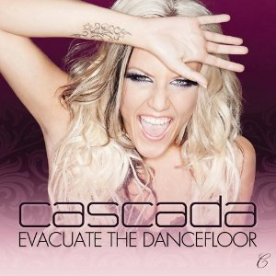 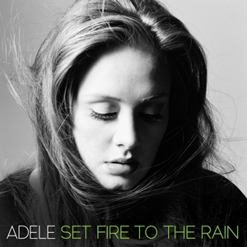 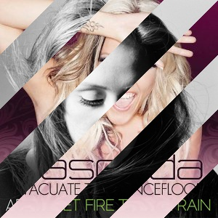

Figure 18. Album art for “Evacuate the Dance Floor”, “Set Fire to the Rain”, and the CantoVario mashup.

More demo mashup variations, in fact 160 of them, are at [www.cantovario.com](http://www.cantovario.com)

**Project 2: *Music via Chaos Theory* Exhibit for a science museum**. CantoVario not only seeks to create positive change in the music industry through its engineering technology, it also seeks to scientifically motivate kids, teens, and their families through an exhibit that unites music and engineering. A quick 1-minute video description can be found at <https://www.youtube.com/watch?v=kU5Mx9mY02Y> CantoVario Science Museum Demo

Additional evidence for the viability of a chaos/music science museum exhibit came from a CantoVario keynote given for the 2018 Academy of Applied Science Northeast Regional Young Inventors’ Program Convention. The Academy of Applied Science's Young Inventors' Program (YIP) is a K-12 project-based learning program that provides hands-on STEAM (Science, Technology, Engineering, Arts, Math) educational enrichment opportunities to budding youth inventors. The Young Inventors' Program delivers YIP Kits, i.e., invention kits for classrooms, to help schools introduce a fun invention curriculum to their students in the form of a teachable unit, or via a club or afterschool program, that culminates in a school Invention Convention event.

I presented an interactive demo for 700 attendees (K-12 students, teachers, and families) at Southern New Hampshire University in March 2018. The interactive CantoVario Mashup demo received 416 plays in 10-minutes; 304 of the plays were rated 4 or 5 stars out of 5. According to Google Analytics, there were 204 users. These results gave us significant data from a large sample size in which none of the participants had prior exposure to CantoVario, thus providing additional support for a CantoVario chaos/music science museum exhibit.

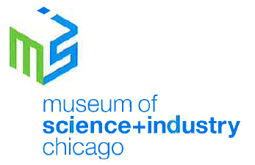

The Museum of Science and Industry (MSI) in Chicago would like to work with CantoVario and Brown Innovations (CantoVario’s industry partner) by providing guidance and feedback to inform the project. The Director of Science Exhibitions and Partnerships at MSI wrote that the chaos/music museum prototype “aligns well with our mission (to inspire the inventive genius in everyone) since the core technologies behind the project are current inventions that could inspire others.” Her conclusion: “we enthusiastically support development of the Music/Chaos Exhibit Prototype and would like to see it grow into an exhibit at MSI, space permitting, as well as contribute to its export to other museums of science.” MSI is the largest science center in the Western Hemisphere.

Since the exhibit has an audible component, sound-focusing technology is necessary to direct the audio to different listeners, so that each listener has a set of controls to make their own song variations. To ensure focused audio, CantoVario plans to work with Brown Innovations, whose founder, president, and chief engineer is Kevin Brown. Brown Innovations has provided revolutionary sound focusing technologies since 1993, ranging from museum displays at the Rock and Roll Hall of Fame to audio installations at Sao Paolo's Art Biennial; from outdoor information kiosks in Helsinki to quiet library and gallery settings.

**Project 3: A Concert of “Variations and Shadows.”** As an outgrowth of the musical variations project, a Variation Concert prototype presents a new kind of live performance: seat location determines which variation path the audience hears through a given piece. During the past year, performances occurred at two different venues. The first occurred in July 2018 as a beta test. In November 2018, we presented a variation concert at Houghton Chapel as part of the Wellesley College Concert Series for a large audience.

***Evidence*:** The Variation Concert piece produced for the Wellesley College Concert Series (*Parallel Lives—Distant Mirrors*) can be experienced in the final movement of <https://www.youtube.com/watch?v=xSqE22X4I8U> .

*Parallel Lives—Distant Mirrors* explores parallel universes in Iraq and the United States over a period of five movements:  Ignition, The Last Minutes of Baghdad TV, An Iraqi Mother’s Lament, Quranic Verses 16:111-114, and Catharsis.  The culminating movement (Catharsis) includes a soundtrack composed of Associated Press recordings from the 2003 bombardment of Iraq, the last minutes of Iraqi TV, and recorded American and Iraqi voices, among others.  Movements 2, 3, and 4, each focus on one of the Arabic voice recordings heard in the soundtrack, but in translation.

Scored for solo piano + soundtrack, Catharsis offers the audience a new listening experience, a “Variation Concert” where **seat location determines which variation path one hears through the soundtrack.**  Everyone hears the live piano, but the Left side of the audience hears one path through the soundtrack, while the Right side hears a different path.  Midway through the piece, the paths switch: much of the material heard by the Left side during the first half of the piece is now heard by the Right side, and vice versa.  A sung Introduction opens the movement, followed by a 3-part structure comprising Mashup, Macchina (Machine), and Tristezza (Sadness) that repeats but with variations. The Introduction and Coda are each heard by the entire audience. The soundtrack comprises the following audio material:

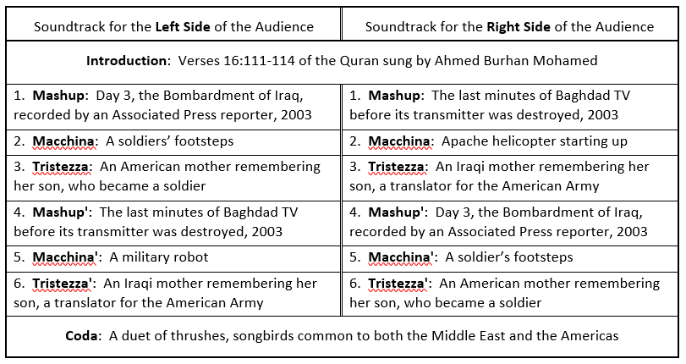

I’ve talked about a “variation concert” since the 1994 inception of my musical variations project, both in public lectures and informal conversations. A fellow MIT alum, Kevin Brown, built a company (Brown Innovations) around sound-focusing technology. Over the years, we discussed producing a variation concert. *Parallel Lives—Distant Mirrors* was the first one.

## Supplementary Materials IV-J-1: Results of a Four-Year Study on the Effectiveness of OCO for Building Leadership, Teamwork, and Communication Skills

Here are the results of a four-year study on the effectiveness of the Olin Conductorless Orchestra for building student understanding and development of professional skills: leadership, teamwork, and effective communication.

In April 2015 I devised an anonymous questionnaire (administered May 1, 2015) to assess whether OCO had made a difference for our students with respect to leadership, teamwork, and communication.

Six questions comprised the questionnaire, each of which started with the contextual clause “From the time you started OCO till the present time …” :

1A) has OCO made a difference for your **understanding of leadership**?

1B) has OCO helped you **develop your own leadership skills**?

2A) has OCO made a difference for your **understanding of teamwork**?

2B) has OCO helped you **develop your own teamwork skills**?

3A) has OCO made a difference for your **understanding of effective communication**?

3B) has OCO helped you **develop your own communication skills**?

Students answered each question by selecting from five possible responses:

1. Not at all
2. A bit
3. Moderately
4. Yes
5. Significantly

The percentage results given below represent the number of responses marked “Moderately”, “Yes”, or “Significantly”, divided by the number of respondents, where the number of respondents ranged from 14 to 19, depending on the given year. The students in OCO typically include first-years, sophomores, juniors, and seniors.

For the Spring 2015 orchestra, the tabulated responses were as follows:

* + Regarding **teamwork**, 79% of students indicated that OCO made a difference in their understanding of teamwork and 84% indicated that OCO helped them develop their own teamwork skills.
  + Regarding **communication**, 84% indicated that OCO made a difference in their understanding of effective communication and 79% indicated that OCO helped them develop their own communication skills.
  + Regarding **leadership**, 74% indicated that OCO made a difference in their understanding of leadership and 47% indicated that OCO helped them develop their own leadership skills.

In short, students benefited from OCO in terms of teamwork and communication, and less with respect to leadership. This made sense since the students had to work as a team in a conductorless orchestra without a de facto leader. To do a good job, these students had to get better at teaming and communicating with one another. Since OCO helped grow their understanding and personal development of teamwork and effective communication—two widely acknowledged traits of skilled leadership—it’s telling that in written comments, eight of the 19 students expressed “we are all leaders”, or a close parallel.

The same survey was then administered over the next three academic years. Table 1 captures those findings.

Table 1

|  |  |  |  |
| --- | --- | --- | --- |
| **Question #** | **Spring 2016** | **Spring 2017** | **Spring 2018** |
| 1A: … understanding of leadership | 83% | 86% | 88% |
| 1B: … develop [my] own leadership skills | 77% | 79% | 82% |
| 2A: … understanding of teamwork | 78% | 86% | 81% |
| 2B: … develop [my] own teamwork skills | 78% | 79% | 88% |
| 3A: … understanding of effective communication | 83% | 86% | 100% |
| 3B: … develop [my] own communication skills | 78% | 93% | 88% |

These results show growth in student understanding of leadership, development of their own leadership skills, and student understanding of effective communication. Student development of their own communication skills grew from Spring 2016 to Spring 2017, and still reached a comparably high percentage (88%) in Spring 2018.

Though the percentages for the “understanding of teamwork” questions remained respectably high, they were somewhat lower than the “understanding of leadership and communication” evaluations for Spring 2015, Spring 2016, Spring 2017, and Spring 2018. Two possible reasons for this result are:

1. Students at Olin work in teams for a number of required courses throughout their undergraduate years, and
2. Teaming strategies have increasingly infused courses since Spring 2015, when the study began.

These reasons suggest students did not ascribe as much understanding of teamwork to OCO. A corollary to this remark would be that OCO students brought the teaming skills they had learned in other courses to bear on their conduct in OCO rehearsals, practice groups, and performances.

## Supplementary Materials IV-J-2: The Engineers’ Conductorless Orchestra website Hub

Funding for this website hub came from Olin’s Integrated Project Fund. Thanks to encouragement from Prof. Mark Somerville (Interim Provost and Dean of the Faculty), I submitted a grant proposal to the Fund which was awarded.

I then worked with Luis Zuniga ’21 to build the website hub—a complex project with many moving parts and substantial content. This project was Luis’ first foray into web design using HTML, CSS and JavaScript, languages with which he had no prior experience. With a passing familiarity of functionalities that he had seen implemented on other websites, he knew more or less what features could be implemented for the ECO hub, but was continuously learning how they should be implemented. By the end of this project, he gained a better understating of common web design principles and became confident in his understanding of the abilities and limitations of the HTML and CSS markup languages, as well as the JavaScript programming language.

The ECO Hub can be found at <https://pages.olin.edu/eco-summer2019>

## Supplementary Materials IV-J-3: Example Performances by the Olin Conductorless Orchestra (2008 – 2019)

1. Haydn *Sinfonia No. 48 in C Major*, “Maria Theresia”: first movement (Allegro), Spring 2008. <https://youtu.be/knulC0k1r5M>
2. Composite video excerpts (Holst: Jupiter from *The Planets* and Lee Jisu: *Arirang Rhapsody*), Spring 2011 <http://www.youtube.com/watch?v=ZFd453aYudU&feature=mfu_in_order&list=UL>
3. Arturo Marquez *Danzon No. 2*, Spring 2013

<https://youtu.be/yyzEQ6n6OYA>

1. Beethoven *Creatures of Prometheus*, Fall 2015

<https://www.youtube.com/watch?v=VlkAZG106ek>

1. Saint-Saens *Danse Bacchanale*, Fall 2015

<https://youtu.be/zix7IweadvM>

1. Dvorak *Symphony No. 9 in E minor*: fourth movement (Allegro con fuoco)—Spring 2016

<http://bit.ly/OCO_Dvorak9th>

1. Gershwin *An American in Paris*: Spring 2017

<https://www.youtube.com/watch?v=BA5F48usRIo>

1. Mozart *Serenade in Bb for 13 Winds*, K. 361: Finale—Spring 2019

<https://www.youtube.com/watch?v=hTNUGRU4Pl8>

1. Berlioz “Marche Hongroise” from *La Damnation de Faust*: Spring 2019

<https://www.youtube.com/watch?v=a9IkNITe1fE>

## Supplementary Materials IV-L-1: A Recipe for Making Music or How to Bake a Music Program from Scratch (Fall 2001 – Spring 2009)

A Recipe for Making Music

Or how to bake a music program from scratch

(Fall 2001 – Spring 2009)

**Years 1-5**

**Ingredients:**

**Year 1 (2000-01).** Find and purchase pianos [no students yet on campus]

**Year 2 (2001-02).** Chamber ensembles, music stands, chairs, practice rooms, BSO student concert tickets [30 students on campus]

**Year 3 (2002-03).** 75 students on campus. Locate and purchase musical scores, books, CDs, BSO student concert tickets, more practice rooms, a concert piano, humidifiers, de-humidifiers, talented student performers and composers in two performance/composition seminars (Music Performance, Music Composition; Musical Aesthetics and Design), weekly performances for the Olin and Needham communities, OCO—the Olin Conductorless Orchestra (audition required) consisting of violin, cello, oboe, clarinet, bassoon, trumpet, percussion, piano. Master classes at Olin, master classes at Juilliard, performances of music by Beethoven (Gantz ’06; Dillon ‘06), Poulenc (Wieczorek ’06), Mozart (OCO), Tansman (Tsai ’06), Cabezas ‘06, Shannon ‘06, Donaldson ‘06, Graham ’06, Cave ’06, and Tsai ’06; performances for two Candidates’ Weekends (to attract top engineering students who are also excellent musicians); 5 passionate pursuits in music; performances for ‘Olin Rising’, the inauguration of Richard Miller as Olin’s first President.

**Year 4 (2003-04).** 150 enrolled students, 10% of whom pass the audition and enroll in the Olin Conductorless Orchestra (OCO); another 10% enroll in a music/orchestration seminar—The Wired Ensemble[15]—dedicated to the live performance of original student compositions for orchestral instruments and voices; 6 passionate pursuits in music; performances for Family Day, Admissions Open House, two Candidates’ Weekends; four concerts of student works, and orchestral works for the end-of-term Olin Exposition; BSO student concert tickets; New England Conservatory student opera tickets. Find and purchase timpani.

**Year 5** **(2004-05).** 225 enrolled students with 40 students on junior term away. 14 students in OCO (junior semester abroad claims 4). 17 students in Wired Ensemble, 11 of whom choose their work in Wired Ensemble as their choice for presentation during Olin’s required Fall Exposition.[16] More practice rooms, a repaired Steinway A, additional humidifiers, Wenger musician chairs, 5 more music stands, a set of triangles, one xylophone, and a music club (the Olin Jammers).

**Mix in:** one professor with a lot of help from staff, administration and faculty (Abby Adair, Manny Amaral, Dave Anderson, Holly Bennett, Linda Canavan, Ellen Cooney, Rod Crafts, Terri Dunphy, Mary Fitzpatrick, Joe Hunter, Susan Johanson, Carol Kelley, Chris Kelly, David Kerns, Sherra Kerns, Leslie Larocca, Dee Magnoni, Joe McDonald, Rick Miller, Mike Moody, Andy Moutinho, Duncan Murdoch, Charlie Nolan, Jay Patten, Pedro Perez, Carole Perrin, Gill Pratt, Janey Pratt, Margie Quinlan, Tony Rivera, Ann Schaffner, Steve Schiffman, Steve Sherrick, Scott Slaboden, Rob Stewart, Brian Storey, Nancy Sullivan, Karen Stone, Cara Szeghy, Jennifer Thomas, Melissa Trotta, Rachel Weinstock), 2 anonymous donors, the 1000 Committee (3 students, two faculty) to decide how to spend the donors’ gifts, and (at one time or another) virtually every Olin student.

**Add:** a term teaching in the graduate studies division at Juilliard during Spring 2002; resources at New England Conservatory and Juilliard

**Create:** the only college conductorless orchestra in the country

**Find:** a concert hall(way).

**Schedule and organize:** rehearsals, dress rehearsals, and performances for approximately 15-20 events per year.

**Oversee and check:** instruments, piano tunings, repairs, humidity levels

**Locate:** orchestral parts for OCO and various ensembles

**Supervise:** 11 passionate pursuits in music performance, 3 independent studies in music composition and theory

**List:** teachers (at least 2-3 per instrument/voice so that students can find a good fit and choose accordingly) for 22 vocal and instrumental students

**Monitor and help solve:** plunging humidity levels, overcrowded practice rooms, instrument tuning and repair

**Use:** the piano to bridge the different instrumental palettes within a small orchestra and fill in missing parts (as needed)

**Arrange:** Mozart’s c minor concerto for 1 oboe, 2 clarinets, 1 bassoon, 1 violin, 1 viola, 1 cello, and piano

**Write:** piano cadenza for Mozart’s c minor concerto

**Arrange:** Rhapsody in Blue for 1 oboe, 2 clarinets, 1 bassoon, 1 trumpet, drum set, timpani, 1 violin, 1 cello, and piano

**Arrange:** Rhapsody on a Theme of Paganini for 1 oboe, 2 clarinets, 1 alto sax, 1 bassoon, 1 trumpet, 3 trombones, percussion, 1 violin, 1 viola, 1 cello, and piano

**Arrange:** Bartok’s Transylvania Dances for 1 oboe, 2 clarinets, 1 alto sax, 1 bassoon, 1 trumpet, 3 trombones, percussion, 1 violin, 1 viola, 1 cello, and piano

**Arrange:** Britten’s Diversions for 2 clarinets, 2 alto saxes, 1 tenor sax, 1 bassoon, 1 trumpet, 3 trombones, xylophone, 1 violin, 1 viola, 1 cello, and piano

**Arrange:** Stravinsky’s orchestral Suite No. 2 for 2 clarinets, 2 alto saxes, 1 tenor sax, 1 bassoon, 1 trumpet, 3 trombones, xylophone, 1 violin, 1 viola, 1 cello, and piano.

**Arrange:** Stravinsky’s Ebony Concerto for 3 clarinets, 2 alto saxes, 1 tenor sax, 1 bassoon, 1 trumpet, euphonium, 3 trombones, percussion, 1 violin, 1 viola, 2 celli, piano.

**Re-arrange:** Gershwin, Rachmaninoff, Stravinsky for performances when various players are sick or out-of-town for job interviews, etc.

**Perform:** piano parts to all of the above for 22 concerts (Nov 2002 – Dec 2004), in addition to concerts given by students in the *Music Performance, Music Composition* class (coach and pianist for Poulenc clarinet/piano sonata, Beethoven G major violin/piano sonata op. 30 no. 3, Beethoven g minor cello/piano sonata, op. 5 no. 2), the *Musical Design and Aesthetics* course (coach and pianist for Shostakovich cello/piano sonata and Tansman Sonatine for bassoon and piano), the *Wired Ensemble* (23 student compositions in concerts), *Independent Studies* (2 student compositions in concert) and the *Passionate Pursuit* program (coach and pianist for Handel Sonata no. 3 in G for flute/piano and the Weber Concerto for clarinet/orchestra (piano reduction)).

**Field:** myriad questions from prospective and admitted students (including their parents) wanting to continue music at Olin

**Select and purchase:** ~$10,000 worth of CDs, books, and scores for the Olin Library

**Order:** all music for 3 courses[17] plus the conductorless orchestra (scores, books, CDs)

**Baking philosophy:** Music enlivens the atmosphere of Olin. It permeates walls. Day or night—someone, somewhere is making music on campus. Often what you hear will inspire a reverie. At other times you may be its muse. The college gives students opportunities to perform, compose, realize individual projects, collaborate with others in chamber ensembles, including the Wired Ensemble and the Olin Conductorless Orchestra—the only conductorless orchestra of its kind at an American college. Courses encompass composition, performance, instrumentation, musical variation, and spoken word. A number of experiential projects accompany each class. Students have traveled to New York to participate in master classes at Juilliard, heard the Boston Symphony Orchestra at Symphony Hall, and produced the performances and compositions featured at a number of Olin events, including Candidates’ Weekends and the Inauguration of Olin’s first President, Rick Miller.

**Years 6 - 9**

**Ingredients:**

**Year 6 (2005-2006).** 300 students enrolled at Olin, half of whom ‘do’ music. **Wired Ensemble performances** for the Olin and Needham communities: Family Day, Admissions Open House, Fall Expo, both Candidate Weekends, Spring Expo, and North Hill Retirement Community. **Olin Conductorless Orchestra (OCO) performances** for the Olin and Needham communities: Family Day, Admissions Open House, Fall Expo, Candidate Weekends, Spring Expo, Senior AHS Capstone concert, Commencement, and North Hill Retirement Community. **First AHS Capstone in Music projects** **and concerts** (Grant Hutchins, Katie Rivard, Amanda Blackwood, Steve Shannon, Janet Tsai, Jake Graham, Jay Gantz, and Ben Donaldson.) **Passionate Pursuit performances** at Fall and Spring Expos by the Olin String Quartet, vocalists, and instrumentalists. Additional musical scores, books, and CDs for the Olin Library. Boston Symphony Orchestra (**BSO**) student concert tickets. Wired Ensemble trips to **Jordan Hall**, **Juilliard**, and the **Brooklyn Academy of Music** to hear classic and contemporary works. Olin acquires an upright Baldwin piano for AC 318 donated by Jack Ma in memory of Maryann King Ma.

**Year 7 (2006-2007).** Concert of **18 World Premières** by the Wired Ensemble (Family Weekend). Additional Wired Ensemble performances for Admissions Open House, Fall Expo, and Candidate Weekends. **OCO gives its first full-length concert** (Glavin Chapel, April 21, 2007), as well as performances for Admissions Open House, Fall Expo, and both Candidate Weekends. First Wired Ensemble trip to the **Metropolitan Opera** to hear Puccini’s *Tosca*, as well as local trips to Jordan Hall at New England Conservatory to hear the Cantata Singers with orchestra. The **Steinway A** gets an overhaul. More CDs, musical books and scores for the Olin Library. **2007 AHS Capstone in Music projects and concerts** (Kristin Dorsey, Matthew Tesch, Laura Stupin, and Kat Kim). **Passionate pursuit performances** at Fall and Spring Expos by eight instrumentalists and vocalists, with a separate concert each semester for a larger group of vocalists (12 students Fall 06 and 7 students Spring 07). **BSO** concert trips to Symphony Hall and **Boston Chamber Music Society** concerts at Jordan Hall. Additional music stands and musician chairs needed. **Two new practice rooms** allocated in East Hall.

**Year 8 (2007-2008).** Two new courses added to the Olin curriculum—Engineering the Orchestra I: Acoustics, Waves, and Vibration (Lee and Dabby) and Engineering the Orchestra II: Orchestration, Theory, Composition (Dabby). **Wired Ensemble Event** performed for Fall Expo. **Engineering the Orchestra demonstration and performance** at both Candidate Weekends. **OCO gives its own Fall and Spring concerts,** in addition to performances for Admissions Open House, Fall Expo, and both Candidates’ Weekends. OCO becomes too large for the Olin Concert Hallway, so the **Milas Hall Mezzanine** becomes the favored performance venue for the orchestra. **OCO holds its first Recording Session** on May 1, 2008, the last day of classes for Spring 2008. Its recording of the first movement of Haydn’s *Symphony no. 48 in C* goes online and is now available at <https://youtu.be/knulC0k1r5M>

**Passionate Pursuit Concerts** for Fall and Spring Expos plus additional concerts each semester for a larger group of vocalists (7 students Fall 07 and 6 students Spring 08). Wired Ensemble trips to Boston’s Jordan Hall and to the **New York City Opera at Lincoln Center**. OCO trip to Jordan Hall to hear the **Cantata Singers** perform Orff’s *Carmina Burana*. Trips to hear the **BSO** at Symphony Hall.

**Year 9 (2008-2009).** A **new Jam Room** is built in the Campus Center. CC310 also allocated for musicians’ practice. **Wired Ensemble** trips to hear the **Fauré *Requiem*** in Boston and the **New York Philharmonic at Avery Fisher Hall** in New York. The Wired Ensemble writes, composes music for, and stages *Sir Falsalot* for Fall Expo. Wired Ensemble pieces featured during both Candidates’ Weekends, in addition to work from the **Engineering the Orchestra II**. **OCO holds its first video taping/recording session** and creates its first DVD. The orchestra is asked to perform a concert for the Trustees/President’s Council May 11 meeting. The **Trustees/Presidents’ Council Concert** features 35 minutes of music by Mussorgsky, Beethoven, and Saint-Saёns. In addition to its annual Fall Expo performance, OCO performs for Admissions Open House, the Jessica Herman ‘10 Memorial Service, and both Candidates’ Weekends. **Passionate pursuit performances** at separate, dedicated concerts at both Fall and Spring Expos. “Olin does the **BSO**” continues as a co-curricular.

**Mix in:** one professor with a lot of help from staff, administration and faculty (Manny Amaral, Bruce Andruskiewicz, Allison Bahme, Holly Bennett, Alison Black, George Butler, Linda Canavan, Rebecca Christianson, Caitlin Clark, Paul Coveney, Rod Crafts, Andy DeMelia, Elaine Drobnis, Terri Dunphy, Steve Durfee, Ozgur Eris, Noel Espinal, Mary Fitzpatrick, Alyson Goodrow, Siddhartan Govindasamy, Steve Hannabury, Kurt Hirschenhofer, Joe Hunter, Zhiaopeng Ji, Susan Johanson, Carol Kelley, Chris Kelly, David Kerns, Sherra Kerns, Joanne Kossuth, Chris Lee, Caitrin Lynch, Dee Magnoni, Deb Manzelli, Joe McDonald, Linda Miller, Rick Miller, Mike Moody, Emily Moscol, Duncan Murdoch, Oscar Mur-Miranda, Charlie Nolan, Carole Perrin, Gill Pratt, Stephanie Rizzitano, Courtney Sampson, Ann Schaffner, Steve Schiffman, Scott Slaboden, Brian Storey, Nancy Sullivan, Nick Tatar, David Ware, Lydia Zeglarsky, and (at one time or another) virtually every Olin student.

**Find:** a new concert venue (Milas Hall Mezzanine) due to a larger orchestra

**Schedule, organize, and coach:** rehearsals, dress rehearsals, and performances for approximately 10-14 events per year.

**Recommend:** student instrumentalists and vocalists for Needham and Wellesley musical performances/events

**Oversee and check:** instruments, piano tunings, repairs, humidity levels

**Supervise:** 35 individual passionate pursuits in music; 8 group (51 students involved) passionate pursuits in music; 9 individual independent studies in music composition and theory + 1 group independent study (5 students)

**Locate:** teachers (at least 2-3 per instrument/voice so that students can find a good fit and choose accordingly) for vocal and instrumental students

**Monitor and help solve:** humidity levels, overcrowded practice rooms, instrument tunings and repairs—resolved with a new Jam Room Fall 2008

**Solicit and give feedback:** Academic Program and Facilities’ design for the new Jam Room

**Perform:** Wired Ensemble and OCO Concerts (2005 – 2006) and subsequently, as needed.

**Field:** questions from prospective and admitted students (including their parents) wanting to continue music at Olin

**Select and purchase:** CDs, books, and scores for the Olin Library

**Bring in:** five external guests/year to provide direct feedback to OCO and to the Music Program at Olin, in general

**Arrange, arrange, arrange:** Due to the small size of Olin’s student body, it soon became apparent that the Olin Conductorless Orchestra might never achieve a full string section, not to mention complete wind and brass sections. So I opened auditions to any instrumentalist who could pass the audition requirement. Thus saxophones (typically associated with jazz bands), euphoniums (found in wind bands), and other nontraditional orchestral instruments entered the orchestra. Yet the students in OCO were choosing pieces by Tchaikovsky, Bartok, Elgar, Schubert, Haydn, Beethoven, Smetana, Bernstein, and Saint-Saens—none of which utilized saxophones, guitars, or euphoniums, and many of which required large 50-90 piece orchestras. (Our orchestra has typically numbered 15-17 players.) As a result, I began re-orchestrating repertoire to suit OCO’s nontraditional instrumentation and unbalanced wind, brass, and string sections. From Fall 2005 to Spring 2009, I made 36 of these re-orchestrations, each of which took anywhere from 10 – 75 hours to create. There are several reasons why this is such a labor-intensive, yet nuanced process. Numerous design constraints exist, some in conflict with others: 1) OCO’s eclectic instrumentation, 2) differing musical abilities among the students, 3) instrumental, sectional, and orchestral voice leading, 4) contrapuntal and harmonic intent of the composer, 5) reduction from original scores requiring 90 players to ~16-player arrangements, or an increase in forces, e.g., from a small woodwind section in the original orchestral work to a large wind section in the OCO arrangement, 6) complaints by winds that the strings get all the good parts, and so on.

**Baking philosophy**

**The Short Story**

* Provide orchestration, composition, theory, and performance skills towards all facets of the program.
* Organize, coach, and rehearse concerts for Olin events and programs (10-14 events/year).
* Ensure year-to-year continuous improvement and innovation.

**A Longer Story (the nuts and bolts) …**

* Select music, schedule rehearsal times, coach composers/ensembles, and serve as pianist-on-call for musical programs featured at Family Weekend, Fall Admissions Open House, Fall Expo, Spring Expo, Candidates’ Weekends (4-6 performances over 10 days), Graduation, corporate requests, and Olin requests.
* Address difficult spots with student musicians on an individual basis to improve performance.
* Review student compositions on an individual basis for upcoming performances.
* Supervise 1-3 independent studies in music per year.
* Advise 12-18 passionate pursuits in music per year.
* Meet with and field questions from prospective Olin students regarding music at Olin.
* Answer questions about music from Olin students and their parents regarding teachers, instruments, instrument storage, the jam room, practice rooms.
* Advise piano tuners and technicians about what needs to be repaired on the Olin pianos.
* Purchase CDs, musical scores, books for the Olin library.
* Monitor and check out pianos/timpani/humidity levels in Studio 305/Res Hall practice rooms/Jam Room.
* Answer student questions regarding homework assigned in BBOW (Brandeis, Babson, Olin, Wellesley) music courses.
* Schedule, coordinate, purchase tickets, and arrange transportation for students to hear Boston Symphony Orchestra concerts in Symphony Hall during the school year, as well as concerts at New England Conservatory’s Jordan Hall.
* (Am I forgetting something :)

Ah yes … additional program work includes

* Helping students find ‘good fit’ private teachers on their instruments
* Providing musical opportunities for students to create and perform
* Instrument repair and maintenance instructions (written and oral) for Facilities and other members of the Olin community
* Fall meetings with incoming frosh interested in pursuing music at Olin
* Consultations with students regarding tuning and maintenance of Steinway A in East Hall
* Meetings with administration and students regarding the Jam Room, CC 310, and the East Hall practice rooms
* Meetings with external constituents in Needham community
* Providing musicians at request of external constituents in the Needham community, e.g., Friends of Music at Needham High School Benefit Concerts and weekly Sunday services at the Presbyterian Church of Needham

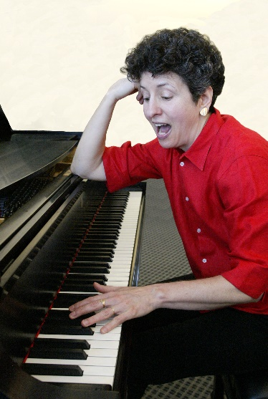The above recipe continues to this day. Olin has a thriving music program. Over the next ten years (2009 – 2019), each year included class trips to the Metropolitan Opera in New York City, class trips into Boston to hear Handel and Haydn Society concerts, Boston Lyric Opera, the Cantata Singers, and more, AHS Capstones in Music, Candidates Weekends concerts, my co-curricular “Olin Does the BSO”, “Family Night at the Opera” (our advising family makes a spring pilgrimage into Boston for dinner and a night at the opera), passionate pursuits in music, Admissions Fall Open House, the Olin Fall and Spring Exposition concerts, performances outside of Olin for OCO, Wired Ensemble, and other groups—all take place on a yearly basis!

So what did happen next?

## Supplementary Materials IV-L-2: What happened next—stories from ‘behind the scenes’ (Development of the Music Program, Fall 2009 – Spring 2019)

Stories from ‘behind the scenes’

Development of the Music Program, Fall 2009 – Spring 2019

|  |
| --- |
| 2009-10 |

Olin’s music groups have become an integral part of the College. As the Music Program grew over the years, it increasingly became associated with various offices and departments at the College. The Music Program now responds to nine Olin community constituencies: Admissions, Development, President’s Council, Office of Student Life, Council of Olin Representatives, Alumni Relations, Olin Families, current students/staff/faculty, and the town of Needham.

Part of my job is to ensure the vitality and health of all the music groups at Olin, thus enabling year-to-year improvement and innovation for this successful program which includes course ensembles (Wired Ensemble, OCO) as well as club ensembles such as the PowerChords (an a cappella group requiring an audition), the Cheerios (a cappella group not requiring an audition), and various chamber music groups. Yet Olin has less than 300 students compared to the far larger enrollments of our college and university neighbors.

As a result, our student musical groups depend on a small coterie of musicians, many of them already in one or more groups at Olin. As is well-known, engineering students have very little time: for our musicians, it’s an even tighter schedule. So we faced a challenge when Wellesley’s then department chair wanted to directly solicit our vocalists and instrumentalists for their various choral, instrumental, and orchestral ensembles. In May 2010, I wrote the following to the then chair:

Dear [ ____ ] – thank you for contacting me about the desire to invite Olin students to audition for the [music groups].  Over the past years quite a few Olin students have joined Wellesley music groups and enjoyed them very much!  Our students have pursued music, math, science, arts, humanities, business, and social sciences at Babson, Wellesley, Brandeis and elsewhere.  With access to the web and all it offers, they (like all students today) can find virtually any scholarly or passionate pursuit they wish to undertake.

I’m writing to assure you that Olin wants its students to enjoy access to all that your Department offers.   An open atmosphere has always prevailed on our campus:  there is nothing that prevents a student from pursuing all that Wellesley, Brandeis, and Babson have to offer.   This has been nicely evident in the past, and I expect our students to continue such pursuits in the future.

As you may be aware, there are several vocal groups on our campus.  Ditto for instrumental groups.  Olin’s music groups have become an integral part of the College.  A little bit of background:  As the Music Program grew over the years, it increasingly became associated with various offices at the College.  At the present time, the Music Program responds to nine Olin community constituencies:  Admissions, Development, President’s Council, Office of Student Life, Council of Olin Representatives, Alumni Relations, Olin Families, current students/staff/faculty, and the town of Needham.

Yet we have less than 300 students compared to the far larger enrollments of our college and university neighbors.  As a result, our student musical groups depend on a small coterie of musicians, many of them already in one or more groups at Olin.  As is well-known, engineering students have very little time:  for our musicians, it’s an even tighter schedule.

Part of my job is to insure the vitality and health of the music groups at Olin.   With only 300 students compared to our BBOW neighbors’ thousands, we do not have a large pool that can perform in myriad groups.  If [ your groups ] issue a special invitation to our students, it’s only fair that other school and community musical organizations have direct access to our limited numbers of students, all of whom already have time-management issues.

Our students are very aware of what’s available at neighboring colleges/universities.  I would like to continue leaving that in their hands, without additional solicitations.

At some point, Olin is going to grow the size of its student body.  That will be a win-win for all of us!

Kind regards to you and also to [ ____ ] –

Diana

Innovations included adjustments to the AHS Capstone Syllabus written by Caitrin Lynch and Rob Martello to suit the Music Capstone. We implemented weekly performances by students during the last six weeks of the AHS Capstone course, regardless of whether class was scheduled to meet or not, in addition to class and instructor constructive commentary on weekly performances, audio recordings of weekly performances so each performer could re-visit the performance to make improvements for next week, “just-in-time” tutorials on musical analysis at the piano, and individual sessions on student creative work that I scheduled outside of class meeting times.

OCO reached another milestone at the end of the Spring 2010 semester. Since the formation of OCO in the Fall of 2002, the orchestra has consistently risen to a higher level each year. Yet at the end of the Spring 2010 semester, I felt the only way to further improve OCO was to introduce major changes to the orchestra. I spent the summer of 2010 thinking about it and met personally with all OCO students on campus during summer 2010 to solicit direct feedback in 30-minute meetings. The resulting innovations impacted the 10-11 academic year.

|  |
| --- |
| 2010-11 |

OCO made a number of changes that took effect in the Fall 2010 semester: a clear cut attendance policy, “creative injections” (surprise musical activities produced by two different students each week), biweekly string sectional coaching, biweekly wind sectional coaching, and optional coached chamber music. After OCO’s first concert at the end of October, I cleared a day and checked in with each member of the orchestra for 20- to 40-minute individual feedback sessions in order to gauge their response to the changes we had implemented. The results were affirming: Students supported the changes and suggested a few more, e.g., “can we include weekly sight reading?” On December 20, 2010 (the Olin Fall Exposition), OCO gave its best concert to date before a packed Milas Hall mezzanine/balcony audience. This performance was videotaped by Joe Hunter.

The Wired Ensemble also reached a high point this year. On December 20, 2010, the class performed a concert of 13 original student compositions which was the best collective class concert we have had in this course. Working with these students from the class of 2014 is a joy—they’re creative, open, and responsive. I was able to connect the arts of writing text and writing music to a much fuller degree this year by making explicit analogies between musical composition tools/concepts and those associated with writing. For instance, linking the end of a musical phrase with the beginning of another is analogous to transitioning from one paragraph to the next.

Because Olin is a tight-knit community and since I know most of the musicians, I was finding it difficult to turn down students who wanted to join OCO on the basis of an audition, so I started the practice of inviting a professional orchestral musician to hear OCO fall and spring auditions with me. We heard 9.5 hours of auditions in the Fall and 4.5 hours in the Spring.

The Spring 2011 semester included six Candidate Weekends (CWs) concerts, a joint concert with BOW music groups in the Sorenson Performing Arts Center, and a Spring Expo concert. A week before the first Candidates Weekend (CW1) performances, I got an email late at night from an OCO student: “Hey Diana, I have some pretty bad news... I just hurt my finger and had to go to the emergency room.  There were small chunks of wood that went into my thumb and they had to cut a part of my skin to open up the area to extract the foreign objects.  […].”  This resulted in a mad scramble to re-arrange parts and find another player who luckily was available.

Then one hour before the same CW1 concert, I got an email from another player: “Diana, I am sorry but I can’t come to the concert tonight. One of my friends just committed suicide.” With this news, I found myself doing two things at once: quickly re-scoring some of the player’s key parts to avoid any holes in the two pieces OCO would be performing and thinking about the suicide. I knew that life has to go on; we want to go with it and do what needs to be done. On the other hand, a young life was lost and it almost felt like a sacrilege to carry on as if nothing had happened.

On an uplifting note, after that performance, the mother of one of the candidates saw me at dinner and later wrote an email for the orchestra :

Dear Professor Dabby--It was very lovely to talk to you at candidate's weekend. My son and I had a wonderful time, and we both found Olin College to be a very special place.

I had expected to get a feel for the curriculum, students, physical plant, which I did, but I never imagined how much impact the performance of the Olin Conductorless Orchestra would have on my experience; it seemed to offer a beautiful symbolic representation of what the school is all about. I was moved to tears by the performance. I hope the members of the Orchestra know how truly amazing and transporting it is to hear music played collaboratively, without a conductor. From my perspective, the unique quality of the sound seemed to emerge from both the musicians' capacity to be intuitive about each other, modulating tonality and volume to achieve a balance, and a shared intense focus on the nuances of the pieces. I thought about how the qualities needed to achieve such a beautiful performance are what every good leader needs to cultivate.

I tried to articulate something of what I felt to one of the orchestra members, but I think was embarrassingly way too choked up to be clear--after all, I am a nervous mother with her first child going off to college! The musical performance was like no other that I have ever experienced. I hope that you will share my reflections with these wonderful musicians.

Sincerely,

Laura Crain

Here is the OCO videotape from CW 3 (March 4, 2011) that Laura Crain attended: <http://www.youtube.com/watch?v=ZFd453aYudU&feature=mfu_in_order&list=UL>

The Wired Ensemble was also showcased for all three CWs, performing four compositions I selected from the Wired Ensemble Event concert of December 2010. They were good pieces, and audiences of the candidates and their parents seemed quite taken with what the students had composed. In any case, it was ‘standing room only’ for the three CWs Wired Ensemble showcases which was exciting for the student composers. On the other hand, it was a crazy quilt of performers that I put together for these performances. Twelve performers were needed and not all of them could make each of the three CW concerts so there was a lot of searching for additional performers, shuffling and extra rehearsals to make it all work. And thankfully it did!

Candidates’ Weekends ended on March 5. By then OCO had selected new repertoire, including the Dvorak Ninth Symphony (4th movement). Everyone wanted to do the piece so we got started on it—in preparation for the next concert, to take place on April 10. OCO had been invited to play in a concert at the Sorenson Center for the Arts, along with two musical groups from Wellesley and another musical group from Babson. This was a big deal. And two weeks before the concert, the Dvorak was in miserable shape. Further proof of this hit me when the string section coach, a professional violinist, said, “It’s not going to make it.” Unfortunately, I couldn’t accept this, believing we didn’t have that option. So I scheduled more rehearsals and brought in pizza. The extra practice helped and things started to look up. But there was still one problem: Sorenson Theater does not have ‘live’ acoustics (it’s excellent for spoken voice and theater) which meant that the Dvorak needed to be beefed up. I had already re-orchestrated the piece with that in mind. But three days before the concert, I felt it needed more heft in the bass (we had only one cello but an excellent one). So I did something I’d never done before with the OCO re-orchestrations: I added another low E timpani part and doubled it wherever possible with the trombone. I took a chance that even in the trombone’s low register (really, its lowest note E – often kind of fuzzy and unfocused), the trombone would help underpin the bass line; I banked on its fuzziness being covered up by the low timpani. Then the cello line would be able to focus the sound as best it could. It was a gamble and it worked. A violinist Paula Zeitlin (string faculty at Wellesley) wrote Michele Oshima, the Director of the Sorenson Center: “[…]  thank you so much for all the work organizing this!  My students are definitely interested in performing again.  It was wonderful to hear all the groups AND finally meet Diana--whose orchestrations for OCO (especially the Dvorak) were just AMAZING!  […]” The orchestra played last on the program and really did a fine job. So it ended well. OCO found it exciting to have their backs to the wall but all of us agreed, “Never again.”

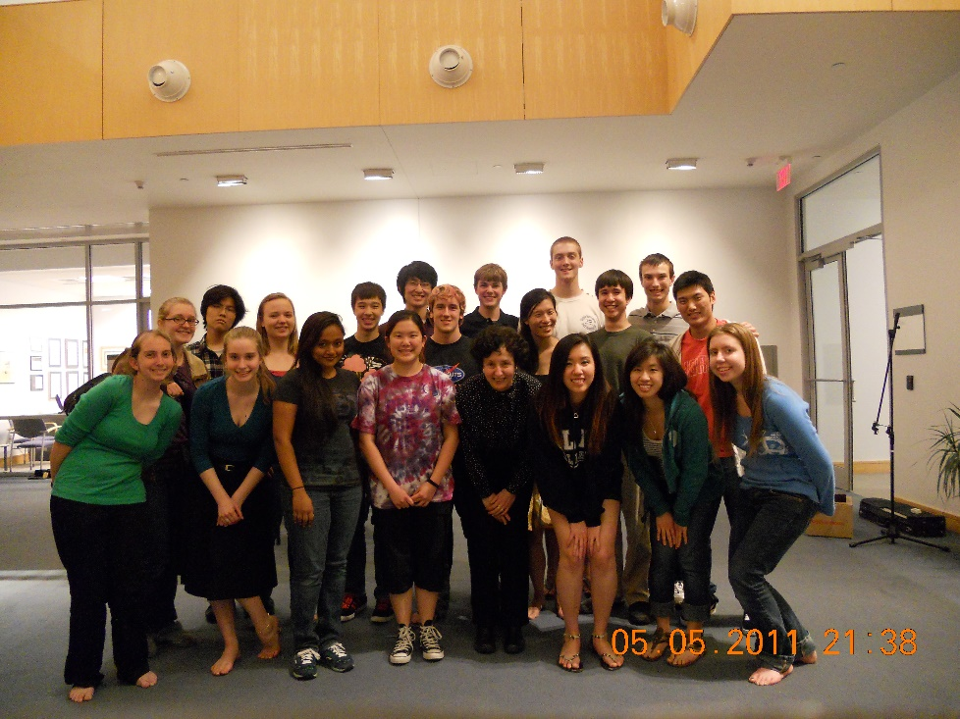

Figure 19. The 2010-11 OCO in the Milas Hall Mezzanine after our 3-hour Final Exam Rehearsal

(preparation for the upcoming 2011 Spring Expo concert)

|  |
| --- |
| 2011-12 |

Well, ‘never again’ didn’t last very long. In Fall 2011 OCO had an opportunity to perform at the Great Hall of Cooper Union in New York City. Five weeks before the concert, the orchestra chose a new piece: the Waltz Finale and Apotheosis from Tchaikovsky’s *Nutcracker*. I re-orchestrated it, again facing the issues of creating a big romantic sound (think lots of strings) with an orchestra that numbered 22 players, only 9 of whom were string players. All the players got their parts before Thanksgiving and each promised to have his/her part down by our first sectionals/rehearsal slated for the week after TG break. I happened to attend the wind sectional to get a sense of how the re-orchestration was working with the players. They started the Tchaikovsky and it sounded horrible. So to find out where the problems were, I asked each of the players to individually play their parts. Three players did not know their parts at all. It was demoralizing and embarrassing. Yet the students who didn’t know their parts rallied, and by the next sectional their playing had improved. The OCO tour to NYC was a first for the orchestra. It happened because so many people pitched in: The offices of Facilities, Admissions, External Relations, Development, Family and Alumni Relations worked together seamlessly. A real pleasure to work with all of them, and fun too!

Still, a few issues surfaced: I found myself taking heat for having “a perfectionist musician streak” and was urged to “Stop emphasizing always ‘reaching a higher level’”, according to two students’ feedback taken by the OCO Board. It seemed that some of what were considered innovations/improvements to OCO during Spring 2011 and Fall 2011 had not pleased all the students. I implemented these innovations/improvements because of feedback from the Spring 2010 OCO so again met with students to hear their thoughts about what they’d like to see happen for OCO this semester. I’ve also made some changes, though I’m not sure I can abandon ‘reaching for a higher level’. Progressing to a higher level means imagining something better and realizing it—in other words, a very creative process.

|  |
| --- |
| 2012-13 |

OCO made a total turn-around this year. By the end of the Spring 2012 semester, personality conflicts had undermined the group dynamic. In fact, these conflicts were present during the past two years as well, but they really became apparent last spring. So in May 2012, a committed group of OCO musicians and I met over a period of two weeks. At one point I asked them: “who do you want to play with” and all of a sudden it hit us – we needed something similar to the Admissions ‘group interview’ at CWs. Thus the idea that new players would have to pass both an individual audition as well as a group audition was born. The purpose of the group audition was to ensure everyone accepted into OCO would be on the same page. We drafted an ‘OCO Action Plan’ and re-invented the orchestra.

Yet despite our new Action Plan, only three string players chose to audition in September. The core group of OCO players tried hard to recruit additional strings. For my part, I kept thinking how to re-orchestrate pieces for a group that had only three strings. During the night of the September auditions, we were all trying to keep our spirits up; still, there was tangible concern in the air. Finally, as yet another string player said no, we decided to turn the page and rally behind what we did have: a great, committed group of 12 players. My closing thoughts that night: maybe we’ll look back on this day and find a blessing in disguise. And amazingly, that’s exactly what happened.

The students chose Beethoven’s Marcia alla Turca from the *Ruins of Athens*, op. 113, and Stravinsky’s *Suite No. 2* as their first pieces. Beethoven wrote his March for piccolo, 2 oboes, two clarinets, 2 bassoons, contrabassoon, 2 horns, 2 trumpets, and ~ 40 strings. But OCO only had a violin, viola, cello, 2 flutes, tenor sax, 2 trumpets, French horn, piano, and percussion. To arrange the music from 54 to 12 players, I altered the texture of the original piece. For example, I wrote an introductory bass drum line to introduce the March, as if from afar, then had only the tenor sax—rather than the original piccolo + oboes + clarinets + bassoons—enter ‘pianissimo’ with the main theme. Gradually I added other instruments, all entering ‘piano’ so that the texture and dynamics built up with each entrance until the last statement of the main theme. Then I thinned the texture again, adding a glockenspiel for touches of color, along with ‘subito piano+crescendo’ expressions applied to an ever increasing number of instruments to create the illusion of a climactic larger ensemble. I continued using the addition and absence of instruments, including quite a few that Beethoven didn’t use. Beethoven wrote extensive parts for triangle, cymbal, and bass drum which play together from start to finish on every eighth and/or quarter beat. I felt these would be overbearing for our ensemble, so I altered them, stressing their ‘color’ attributes, while adding new parts for snare drum, bass drum, and timpani.

I re-scored the Stravinsky *Suite no. 2* as well, writing additional parts for marimba and xylophone, timpani, and more, in order to suit OCO’s instrumentation and create a coherent ensemble sound. OCO performances of the Beethoven and Stravinsky were featured for Olin’s *Decade One Celebration* in October 2012.

The students then selected a third piece. Several works were nominated, one of which was *Danzon No. 2* by Arturo Marquez. There is a splendid recording of this 10-minute piece with Gustavo Dudamel conducting a ~150-piece orchestra on YouTube. I loved the piece but was hoping the students wouldn’t select it. Sure enough, they loved it too and selected Danzon. My job was to then score it from 150 down to 12 players. In retrospect, it turned out to be an engaging challenge. I created a new ensemble sound for the piece, manipulating instrumentation and dynamics that the composer didn’t write in order to create something exciting for 12 players. Danzon was a hit with the students and with the Fall Expo audience. As a result, two excellent cellists asked if they could audition for Spring 2013 OCO. The orchestra had really turned a corner. I had too. Though I worked just as hard with OCO as in past years, I found myself enjoying the rehearsals and board meetings as never before. We had two excellent navigators this year—Philicia Chow and David Pudlo—who both helped move OCO into its next, re-vitalized incarnation. During the fall term, the three of us met twice a week for about 1.5 hours to plan the rehearsal agendas, performances, and to keep everyone on track. This ‘behind the scenes’ work was key to our success. Though I’ve always done a lot of work for OCO and the Music Program ‘behind the scenes’, working with such team players has been a pleasure—and an inspiration! A spring 2013 performance is captured here: <http://youtu.be/8uHrZku3V8I>

As always, it was a joy to teach Wired Ensemble. It’s different every year—new projects, new students, added material, performance classes. And this year I managed to take Wired Ensemble to the Metropolitan Opera in New York. It was a great trip, and I still have a suspenseful memory of all of us running 10 blocks through Chinatown two weeks after Hurricane Sandy and noticing ‘business-as-usual’ in what had been flooded Chinatown. We ran those 10 blocks to catch the Fung Wah bus—and made it!

I also started preparing for OCO’s upcoming April 12 Sorenson Center concert with three Wellesley groups (BlueJazz Strings, BlueJazz Combo, BlueJazz Ensemble), the Babson-Olin Jazz Ensemble, and the Olin Cheerios singers. As has been the case for the past two Sorenson concerts, there was some drama before the concert. At the OCO rehearsal the night before, the students played through *Danse Macabre* by Saint-Saens. It was in poor shape. I went to one of the co-navigators and said, “I don’t think we should do this piece tomorrow. For one thing, Sorenson has now limited each group’s performance to less than 15 minutes.” I felt we’d be hogs if we did *Danse Macabre* (10’), in addition to our other repertoire (10’), especially if *Danse Macabre* were poorly played. The group had mixed feelings about whether we could get it by the next evening’s performance. So we started to work on it. Everyone pitched in, and the rehearsal became even more collaborative. The musicians quickly put into practice some additions/changes I made to the re-orchestration to ease things and provide instant fixes to togetherness issues, e.g., additional dynamics for the opening fanfare (typically taken by the violin soloist but re-orchestrated for two trumpets); taking the opening celli pizzicatos in the re-orchestration as ‘call and answer’ between the 2 cellists (rather than synchronizing the pizzicati); and adding timpani beats to a chromatic climactic run so that the entire orchestra would be together.

The concert was very good. All the groups played well. And the set lengths were just right. OCO played *Danse Macabre* better than the night before by orders of magnitude. OCO’s second piece was incredible (Arturo Marquez’ *Danzon No. 2*). The Wellesley directors and I talked after the concert. They were so impressed with OCO, the students, and the arrangements: a total success for all of us.

It was also a success fora SERV-sponsored event (“_______ for life”) to raise funds for the American Cancer Society. The OCO Board and I worked with Jessica Sutantio, SERV, and the Wellesley-Babson faculty involved in the April 12 Sorenson Concert to bring “_____for life” into the concert hall. Voluntary donations for the American Cancer Society were collected at the door.

Another fundraiser involving musical groups occurred a month later but was first discussed in November 2012 with Mike Sullivan, Program Director for the Needham Lions Club, who wanted OCO to join PowerChords for an event to raise money for their charities. I worked with Mike and students in OCO and PowerChords to bring the concert to fruition (May 10, 2013). This fundraiser featuring PowerChords and OCO continued for the next five years (through Spring 2017).

Though on developmental leave for Spring 2013, I came in every Thursday evening for the OCO course. The changes we made to OCO for Fall 2012 (including a new Action Plan, Group Auditions, and bonding activities) led to greater cohesion among the players. So it was no surprise that OCO performed its finest concert since inception at the Olin Spring 2013 Expo. The opening cello solo in *Danzon No. 2* was cited as ‘setting the stage’ for a transcendent performance. This sentiment was captured in post-concert feedback, here summarized by a student:

In between pieces before Danzon, I remember thinking about how much I had played already and wondering if I had enough left in me for Danzon. But as soon as Abe started in on his solo, all of those thoughts went away and I was engrossed in the music all the way through the big ending.

**The New Steinway B:** We’ve been aware of the need for the Milas Hall (MH) Mezzanine Steinway for a while. For years, any concerts taking place in the MH Mezzanine—our largest performance venue on campus—have had to use an electric piano. So on Saturday, April 6, I made a round trip to Stamford, CT, to check out a Steinway B being sold by a private party.  It’s an excellent instrument and was bought new from the Steinway showroom in Manhattan in 1998.   I wrote a proposal and sent it to key people (Provost/Dean of Faculty Vin Manno, Exec. VP Steve Hannabury, VP Joanne Kossuth, and VP Tom Krimmel). Then we discussed via email and in meetings. I wrote up answers to questions from all concerned, found a good piano technician in Connecticut to evaluate the Steinway prior to purchase, followed up with emails, phone calls and meetings with the piano technician, the seller, and Olin Facilities regarding placement of Steinway once it arrived. I ordered a piano dolly from Steinert Pianos in Boston, and communicated with Olin’s piano technician to do voicing, string leveling, tuning, and regulation of the piano.

A new Steinway B costs $80,000+.   The seller asked for $40K.  At P/DoF (Provost/Dean of Faculty) Vin Manno’s suggestion, the price came down to $35K. We incurred $5k of expenses for moving, repair/maintenance, and piano dolly. We started raising enough money to make the Steinway Fund of $50K a reality. To start things off, a group of faculty and staff contributed the first $5K.

A concert piano permanently residing in the Mezzanine makes a strong statement about our college, serving as a tangible, powerful symbol of the multiple intelligences that we often talk about. The piano opens up opportunities for students, staff, and faculty, in their roles as musicians, listeners, and educators. It can also be used for Development/Presidential receptions, gatherings, not to mention a future concert series that would be welcome not only by the Olin community but by those in our external community, e.g., residents of the town of Needham, residents of North Hill, and the list goes on.   It will be a huge plus for the college and may yield a big return on our investment that we haven’t yet foreseen.

|  |
| --- |
| 2013-14 |

OCO attracted additional instrumentalists for Fall 2013, including first-years, an excellent clarinetist from Babson College, and Olin seniors. After individual and group auditions involving 12 potential players, OCO selected eight. OCO grew to 20 musicians, including four percussionists and two pianists.

On Sunday of Columbus weekend I spent 2.5 hours playing/testing the new Milas Hall Mezzanine piano (a real pleasure) to assess its current state for Olin’s piano technician. He then did the voicing, string leveling, tuning, and regulation on Columbus Day. I arranged to take the seller of the Steinway (Louise Harris) and her guest to the Metropolitan Opera with the Wired Ensemble and then out for pizza with the students. She was very generous with us regarding the Steinway and we wanted to respond in kind. She loved interacting with the students and they really enjoyed talking with her too. It was a perfect day!

Discussions with VP Tom Krimmel, VP Charles Nolan, Development Officer Sindy Wayne, and others during Spring, Summer, and Fall 2013 helped with funding the new Steinway, including an initial funding solicitation, e.g., Asst. VP (AVP) Joe Hunter and I met immediately after OCO’s Fall Expo concert (Dec. 20, 2013) to select a short clip from their performance which used the piano.

Now that Olin had a concert Steinway in the Milas Mezzanine, opportunities opened up for student concerts in the MH Mezzanine, e.g., AHS Capstone projects involving performance and composition. I also worked with the Olin piano technician and CORe (Council of Olin Representatives) to get the East Hall Steinway A fixed and on a sustainable maintenance schedule. Since we needed additional instrument storage space, Facilities built another music instrument closet on the third floor of the Academic Center (AC) and expanded the AC318 closet with double doors so we can easily move timpani without damaging them.

To help bring more music-related activities to Olin students, Director of Post-graduate Planning Sally Phelps and I worked with Lee Zamir, and Darius Mobed of Bose Corporation to bring the Bose Speaker Workshop to Olin, enabling students to build their own Bose speakers.

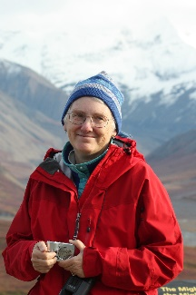In Spring 2014, we started the Ann Schaffner Concert Series at Olin with a generous grant from the Schaffner family. On June 19, 2013, the Olin community learned that Ann Schaffner had passed away. Ann was Olin’s first Director of Institutional Research from 2001 – 2011. I last saw her when she sang with the vocal group Boston Harmony on April 27, 2013 in Cambridge. It was a great concert. I looked for Ann afterwards. Asst. to the Dean of Admission Susan Johanson and AVP Joe Hunter happened to be there as well. When Ann saw me, she said in the most excited voice, “Did you hear me sing? Did you hear me sing?” Her husband Stu and son David were with her at the concert. The evening was poignant. Susan and I rode the subway back to our respective destinations and talked about Ann – how she radiated her love for music and interacted with us over the years. Susan remembered Ann’s words to the Olin community at her retirement reception in Dec. 2011, “And there’s one more thing I’d like to say—be kind to one another.”

I thought back to all that Ann had done for Olin, the numerous late nights I had seen her working in her office, the support she gave the music program and me personally. She was always thoughtful and reflective.  As I mentioned to her son at the April concert, I felt her goodness each semester for 10+ years at Olin.   I believed her position was critical, especially in the early days of the college.   Before Ann became head of assessment at Olin, there were many avenues that process could have taken.  Some might have turned the position into a more regimented procedure with the person in charge of assessment functioning as a kind of drill sergeant.  But Ann got things done with gentle persuasion.  I can’t tell you how many times she gave me a little extra time to get material to her. That extra time made the difference between stress and ease.  She could have wielded her power in a heavy way, but didn’t.  I admired her for her core and who she was as a human being.   Ann came to virtually every music performance at Olin.  I always looked for her; her presence gave a boost of encouragement.

In September 2013, VP Tom Krimmel told me that Ann and her husband had donated $25K to create the ‘Diana Dabby Music Fund’ at Olin. I asked Tom whether this shouldn’t really be called the Ann Schaffner Music Fund and he told me that Ann was adamant about the name. Yet I wanted Ann to be remembered and directly associated with music at Olin. In talking with VP Charles Nolan, we came up with a concert series in her name—the Ann Schaffner Concert Series. Stu Schaffner agreed with the new details and signed a revised Fund Agreement to that effect: “I am OK with “The Ann Schaffner Concert Series”, since many other activities at Olin have sponsor names attached.  I would rather you not include my name.  I am rewarded enough by knowing how pleased Ann would be to see all of this activity in the Olin music community that she loved so much.”

 The series was initiated Spring 2014. During discussions about endowed fund logistics in late February 2014, Exec. VP Steve Hannabury suggested the series start in Spring 2014 rather than wait till Fall 2014. By a fortunate coincidence, Korean pianist Jongsun Lee had recently won a piano competition and would be playing a ‘winners’ concert in New York on April 20. Realizing Steve’s preference for a Spring 2014 inaugural concert, I asked her if she’d like to perform at Olin. The answer was yes and we set the Olin concert for April 25. She decided to program the same pieces she had recently played in New York and Seoul. People still talk about how remarkable her playing was. Though the Schaffner family was unable to attend, they were pleased that we had started the series so quickly. The Ann Schaffner Concert Series live recording links:

<https://www.youtube.com/watch?v=UTgI_DgaUtU> (Ann Schaffner Inaugural concert, 2014: Jongsun Lee, piano)

<https://www.youtube.com/watch?v=qNTt0YAs7Pk> (Ann Schaffner Concert, 2015: John McDonald, piano)

<https://www.youtube.com/watch?v=l9d2hCmwL-M> (Ann Schaffner Concert, 2016: Longwood Symphony Orchestra String Quartet)

<https://www.youtube.com/watch?v=xWwoi_lmHU8&t=1s> (Ann Schaffner Concert, 2017: Mix and Stir Babson, Olin, Wellesley Faculty concert)

<https://www.youtube.com/watch?v=r7slKmLAawk&t=2950s> (Ann Schaffner Concert, 2018: Jongsun Lee and Hyunjung Kim, 1 piano-4 hands)

<https://youtu.be/G3dKQv_hf6A> (Ann Schaffner Concert, 2019: Olin Conductorless Orchestra in a repeat of its concert for the 2019 ASEE Zone I International Conference in Niagara Falls, NY)

During August, I started preparing for both Wired Ensemble and OCO, as well as ramping up the Music Program, e.g., helping the new frosh musicians get acclimated to college life and its musical opportunities—both in the Boston area and at our neighboring BOW schools, including Brandeis—all of which involves a lot of emails, phone calls, and individual meetings. Every year Wired and OCO are different because of changing repertoire, whether written by students (Wired) or selected by students (OCO). Thus, the work is stimulating and engaging. The 2013 Wired Ensemble course was the best ever. Here is a Wired Ensemble 2014 CW2 performance clip of compositions from the 2013 class: <https://youtu.be/sj_0mKg01ng>

On the other hand, the Fall 2013 OCO had some problems with new students not knowing their parts as well as expected. This upset other members. But discussions led to ways for addressing the practice issue that we plan to implement. During Fall 2013, I continued to bring in ‘external guests’—musicians in the Boston area—to provide external feedback and participate in the OCO collaborative mix. Though resisted back in 2006 when I first proposed ‘external guests’ to OCO students, the guest concept has become popular. Every year I try to identify guests the students will enjoy working with and also try to keep the guests involved by inviting them back. OCO’s Spring Expo on May12, 2014 can be heard here: <https://www.youtube.com/watch?v=BWjYPrRno9M>

The orchestra was again asked to perform in tandem with Wellesley and Babson groups in Sorenson Theater at Babson (together they gave a Spring 2014 concert) which can be heard at this link: <https://video.search.yahoo.com/yhs/search?fr=yhs-itm-001&hsimp=yhs-001&hspart=itm&p=appalachian+spring+olin+conductorless+orchestra#id=2&vid=1bd337d260fe7f185c4dffea7f8fef87&action=click>

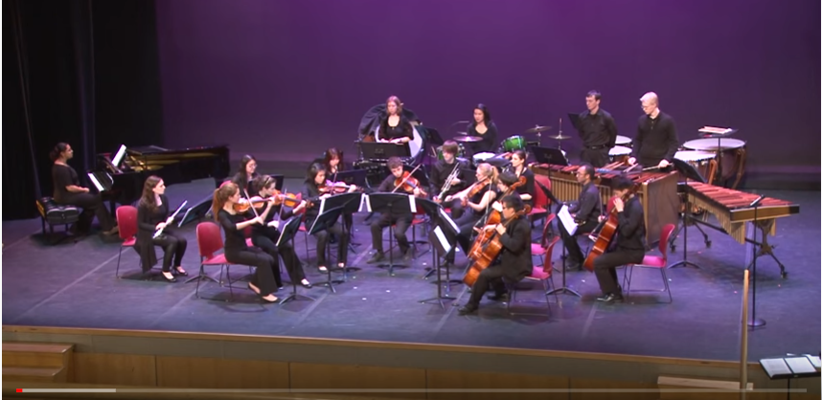

Figure 20. OCO performs at Babson’s Sorenson Theater on April 4, 2014.

In Spring 14, I continued work with CORE president Larissa Little and Olin piano technician Mark Whitlock to finish repairing the Steinway A in the East Hall Student Residence (including new key tops, back checks replacement/adjustment, damper regulation, and voicing). We were able to put the Steinway A on a sustainable maintenance schedule. I also worked with Joe Hunter to make recordings available on the Olin YouTube channel.

|  |
| --- |
| 2014-15 |

OCO attracted additional instrumentalists for Fall 2014, including another bass clarinet, a flutist, oboist, bass trombone, two cellists, and a percussionist. After individual and group auditions involving ten potential players, OCO selected eight. We also developed a toolkit of 20 rehearsal strategies. Here is an OCO performance clip from the May 11, 2015 Spring Expo—Two Symphonic Dances from Bernstein’s *West Side Story*: <https://www.youtube.com/watch?v=6LxaVDT1dCI>

The new Steinway B in the Milas Hall Mezzanine opened up opportunities for individual student performances, e.g., music for the February 2014 Board of Trustees. Working with IT, particularly Mary Fitzpatrick, we made the music notation program Sibelius 7 available to all Olin students which helped the music club groups like PowerChords, the Olin Rock Orchestra, and others.

While all the above was happening, I revised 28 handouts for Wired Ensemble to further strengthen our Composers’ Toolkit.In tandem with the OCO Board and students, I implemented rehearsal strategies to motivate more musical aspects of performance and continued to re-orchestrate pieces selected by OCO for upcoming concerts.

AVP Joe Hunter produced videotapes of both OCO and Wired Candidates Weekend performances, e.g., <https://www.youtube.com/watch?v=1q54qB3AiOU> Prokofiev's “Dance of the Knights” from “Romeo and Juliet,” op. 64ter, during the second Candidates Weekend, Feb 27, 2015, as well as the Wired Ensemble Candidates Weekend 2015 performance <https://youtu.be/rVRSSNKqG8A> (But sadly, for the past two years we’ve been unable to record hi-fidelity performances of Wired Ensemble during Candidate Weekends’ due to sound carrying from events in the library.) <https://www.youtube.com/watch?v=Sb0YbqIR7fs> SAME perf as above but shorter

For the Spring 2015 Ann Schaffner concert, I asked Prof. John McDonald (pianist, composer, and Tufts University professor) if he’d like to perform at Olin. Like Jongsun Lee the year before, he accepted right away. It was January 2015 and he thought April would work well for him. He then said, “I want to play a piece of yours.” So I sent him *A Fire’s Tale*. It’s a dramatic piece and he’s a dramatic pianist. Like the first Ann Schaffner Concert, this second concert was greatly appreciated by the audience. Admin. Asst. Paul Coveney designed smart programs for each, as well as for the Fall 2014 and Spring 2015 Expo performances, and AVP Joe Hunter made excellent videos. The 2015 Ann Schaffner Concert videotape can be found at <https://www.youtube.com/watch?v=qNTt0YAs7Pk>

The Music Program continued to build relationships with external organizations (e.g., Needham Lions Club, Needham Rotary Club, Wellesley Square Merchants Association, and the Musary), institutions (Wellesley, Babson, and New England Conservatory), and individuals (BOW faculty in music, NEC faculty, and Boston Conservatory faculty).I also worked with Marketing, Olin students and alumni to produce a photo exhibit in the Milas Hall Mezzanine (to address student requests regarding the backlog of photos, shot by Michael Maloney, of Olin musicians in action).

In closing out this year, I felt like the coach of a football team whose players inspire high expectations among themselves and fans. What counts for all is excellence: the art and consistent work of creating performances that everyone can be proud of and enjoy.

|  |
| --- |
| 2015-16 |

Since starting in Fall 2002, the Olin Conductorless Orchestra (OCO) has performed for prospective students and their families at the Fall Open House sponsored by Admissions. Here they perform the overture to Beethoven’s ballet, the *Creatures of Prometheus* on October 25, 2015. This was the best Family Day concert since 2002. <https://www.youtube.com/watch?v=VlkAZG106ek> Later that fall, OCO performed *Danse Bacchanale* by Saint-Saens to close out Olin’s December Exposition. <https://youtu.be/zix7IweadvM>

Music Program Assistant Ryan Eggert ’16 and I archived musical recordings and videos of student performances in Wired Ensemble, OCO, AHS Capstone, PowerChords, and the Olin Rock Orchestra, for the Music Program Sound Domes Project. We have two ‘localizer sound domes’ on the 3rd floor of the Academic Center (AC). Invented and patented by Brown Innovations, their hemispherical design provides a focused audio listening experience, but without headphones. Olin visitors and prospective students can step under either sound dome, activate the iPads (attached with wall mounts), and hear/see ‘live’ recordings of student musical performances.

OCO gave its best performance to date at a concert for the Lions Club Fundraiser in May 2016. It was caught in a great audio recording, but the student videographer failed to show up so there was no videotape. AVP Joe Hunter came to the rescue and created a photo montage video composed of myriad OCO photos shot by photographer Michael Maloney during the 15-16 academic year. Concert recording links: <http://bit.ly/OCO_Dvorak9th> (OCO plays Dvorak 9th, spring 2016)

The saga of the student Steinway A continued so I worked with CORE president Ian Hill and Olin’s piano technician to put the Steinway A on a more sustainable maintenance schedule.

I also met with Wellesley music faculty and jazz artist Maria Schneider (Maria Schneider Orchestra) as part of 2016 BOW Innovation Grant supporting the Maria Schneider Orchestra visit and arranged for eight Olin students to attend the sold-out concert, courtesy of the Babson College Sorenson Center box office and music professor Sandy Graham. And finally, the April 2016 Ann Schaffner Concert featured the String Quartet of the Longwood Symphony (a doctors’ orchestra) that embodies the twin passions shared by many of our students—music and engineering/science/math.

|  |
| --- |
| 2016-17 |

Wired Ensemble continued to attend the Metropolitan Opera at Lincoln Center in New York. This year we heard *Guillaume Tell* by Rossini, or at least most of it. During the fourth act, the mechanical ship malfunctioned and the audience was informed the opera would have to stop. As a result, the Met gave Wired Ensemble free tickets for the 2017 class to attend the *Les Contes d’Hoffmann* by Jacques Offenbach!

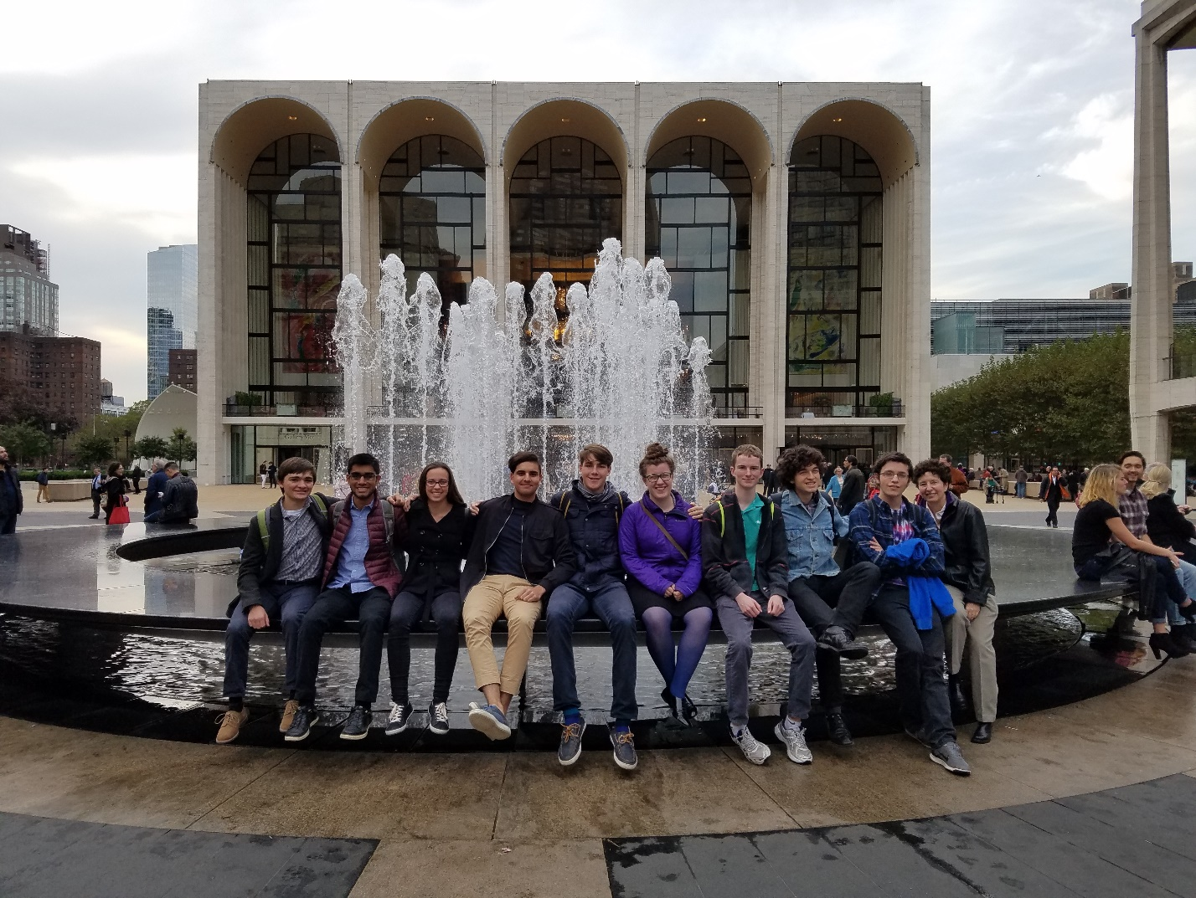

Figure 21. The 2016 Wired Ensemble class at the Met. This was the fourteenth Wired trip to New York.

The highlight of the Fall 2016 OCO was the concert Joe Hunter (Assistant Vice President and Director of Communication), External Relations, and Marcom (Marketing and Communications) sponsored in Dec. 2016 at Powers Hall, an excellent concert venue in Needham, also used for Handel & Haydn Society concerts. Joe wanted to give the OCO performance as a gift to the people of Needham. We featured solos and duos performed by OCO musicians during the first half of the concert. The students performed so well, and the audience responded in kind. On a wintry mix of a day, 250 people showed up for the evening concert. The orchestra performed Shostakovich, Mozart, and the first ten minutes of *An American in Paris*. I wrote an ending to *American* so the piece would sound conclusive. The audience loved OCO, giving the players a standing ovation. That took us all by surprise.

For Fall 2016, the OCO co-navigators, students, and I revised the rehearsal structure to include Rehearsal Groups (weekend rehearsal sessions to address targeted practice spots) and Rehearsal Leaders (each student signs up for 2 weekly rehearsals/semester, helps devise the week’s rehearsal agenda, and then works with all to keep rehearsals on track with the plan). We also wanted to find opportunities for OCO to perform at professional venues outside of Olin, so P/DoF Vin Manno granted us the funds for a short OCO tour 2016-2017. I then found a venue (the Great Hall at Cooper Union where Lincoln once spoke), a New York hotel, and helped prepare the orchestra for concert logistics by working with Admin. Asst. Paul Coveney and Joe Hunter on media relations, reception, program, and travel arrangements.

Cooper Union donated the hall gratis.  Because the performance occurred on a holiday weekend, the Great Hall was officially closed, yet the Director of Public Programs opened it for us, stayed throughout the concert, and afterwards said he’d like OCO to return next year or anytime.  Playing in a New York concert hall, journeying there and back, eating meals together gave all of us an uplifting musical and bonding experience.

Yet it was down to the wire in many unexpected ways. For starters, our instrumentation changed from Fall 2016. The changes posed challenges for the big 20-minute piece on the program: *An American in Paris*, originally scored for 24 wind and brass instruments, with full string and percussion sections. The wind and brass are critical for Gershwin’s jazz writing, especially the clarinets, oboes, trumpets, and horns. OCO had 1 oboe and a pocket trumpet. But we did have 3 flutes (one doubling on piccolo), 2 bass clarinets and 2 trombones—for a total of 9 wind/brass. There were a lot of constraints with these instruments; I wasn’t even sure a good arrangement was possible with what we had, the range limitations, and technical concerns. In short, creating the re-orchestration (arrangement) felt like navigating an obstacle course, albeit an artistic one. It challenged me.

Though the students had selected *American*, they were often torn between the practice time needed for such an ambitious piece and a semester that was already stressing them out. OCO meets only one night a week, so every rehearsal is important. But February weather caused problems. For instance, we called an extra rehearsal for Sunday, Feb 9. I drove out to Olin, but on the way home, the storm intensified, and at that point I noticed my car was the only one on Route 2 for the entire commute.

Up until the Great Hall performance, I was re-writing parts to make things easier/better for the instrumentalists, based on what I heard in OCO’s playing at each succeeding rehearsal. Some parts would probably make it, but others caused concern. Thinking this process would continue, I brought music paper, scissors, and scotch tape to my hotel room and made additional parts for a few players to help boost the playing/confidence of others. It was incredible that the players with the extra parts stayed cool and calm throughout.

About 250-300 people attended OCO’s New York concert.  (We ran out of programs.)  OCO received a standing ovation for its Great Hall concert, something none of us expected. Though the performance had flaws, the orchestra managed to connect with a New York audience on an emotional, gut level. There weren’t many Olin people there, and the response to the group was enthusiastic. I actually cried. There had been so many hurdles and everything had come out in the end, at least communicatively. On a personal note: during the standing ovation, a New York concert violinist came running down the aisle and took my hands, saying “What you did with those pieces was amazing. Those arrangements were brilliant.”

After a spirited reception, we all checked into a midtown New York hotel and met up at Angelo’s pizza, occupying four big tables. I believe that dinner was the best pizza ever. Spirits were high, the antics uproarious. I’ve included photos below to capture some of the evening. The entire trip provided something this ensemble really appreciated—bonding. Also, the concert gave opportunities to spread Olin’s message. For example, a young Wall Street businessman was so intrigued by what the orchestra represented that he said, “This was the best use of my time today.” He wanted to hire Olin students. Another wanted to write a grant to bring the orchestra back next year.

Because parts of *American* required more rehearsal, we continued to work on it for the rest of the semester. I’m happy to say that the May 8 Expo performance of *American* was the best ever for OCO since inception. In the early years of OCO, I could only put about a minute or less of any given performance out for the public. Last spring, it was 10 minutes. In Spring 2017 it was 20 minutes: all of *An American in Paris*.

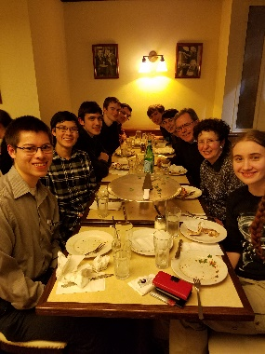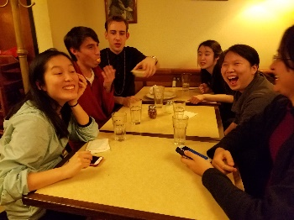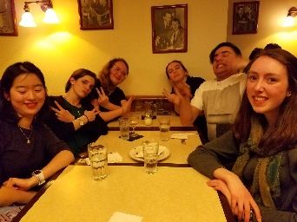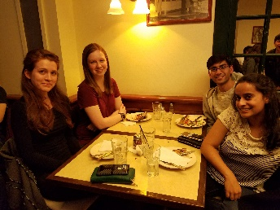

Figure 22. Dinner at Angelo’s Pizza on 57th street in New York after the OCO concert at the Great Hall of the Cooper Union.

Throughout this year, our talented student musicians had performance opportunities (solo, duo, and ensemble) at Olin and in professional concert halls. At the same time, the Music Program continued to build relationships with external organizations, e.g., Needham Lions Club, Needham Rotary Club, Roger’s Pianos (who donated the grand piano for OCO’s Powers Hall concert), institutions (Wellesley, Babson, and New England Conservatory), and individuals (faculty at BOW, NEC, Boston Conservatory, and Berklee).

At this point**,** I’d like to thank Director of Marketing Michele Davis, AVP Joe Hunter, Admin. Asst. Paul Coveney, and Dean of Student Affairs Rae-Anne Butera for their help with the New York OCO tour. Michele helped find drivers for the vans which took a big concern off my plate. Joe drove one of the rental minivans to and from NYC (we were a caravan of five). His can-do spirit, media expertise, and calm personality were wonderful assets on this trip.  He brought two video cameras and videotaped everything.  He also coordinated the rental van pickups and drop-offs with the student drivers. This trip couldn’t have happened without him.

Paul has an amazing ability to see the large picture and still manage the details.  For example, he spotted 10 student bios where the information was no longer current and fixed them; he set up and managed the EventBrite, answering questions; he set up, managed, and updated all the rental vans, hotel rooms, and excel budget.  There is no way we could have had this tour without his help.

|  |
| --- |
| 2017-18 |

During Fall 2017, the Music Program expanded its ties with Babson and Wellesley by working with Isabel Fine (Concert Manager at Wellesley) and Leslie Chiu (General Manager of Babson’s Sorenson Center) on a Babson, Olin, Wellesley (BOW) Presidential Innovation Grant to help fund a Bandaloop residency at Wellesley. Bandaloop is a dance troop that performs vertically, mixing climbing with movement. Isabel created and managed a vibrant array of performances to celebrate the opening of Pendleton Hall, a new addition to the Music Department.

The results of a BOW Presidential Innovation grant (Mix and Stir: musicians, composers, and poets in concert) that I wrote in 2014 also occurred in 2017 as well. The purpose of Mix and Stir was to introduce the BOW community, and its neighbors, to a new concert venue and a new concert series at Olin, through two cross-disciplinary events. In doing so, Mix and Stir provided access, opportunity, and creative channels for those who work, teach, and learn at Babson, Olin, and Wellesley.

The first concert took place in April 2017 and featured Performers Gabriela Diaz (violin), David Russell (cello), and Lois Shapiro (piano) performing four trios: Ravel’s *Piano Trio in A Minor* (1914), Jenny Olivia Johnson’s *Asleep All Day*(2017) and Diana Dabby’s *Who was Wissam Eid?* (2017). Johnson’s work was based on a poem by Mary Pinard ("Grief, for a long time sound"), professor of English at Babson College.  Ravel’s trio took inspiration from a Malayan poetic form (the pantoum). A *New York Times Magazine* article, “The Hezbollah Connection” by Ronen Bergman, motivated my piece. We were able to get the word out to Olin’s neighboring communities and attendance was excellent. AVP Joe Hunter was very helpful in attracting a larger audience, and Admin. Asst. Paul Coveney set up an EventBrite and designed the program and flyers. The full concert (part of the Ann Schaffner Concert Series) can be heard at: <https://www.youtube.com/watch?v=xWwoi_lmHU8>

The second concert took place December 5, 2017, and again brought a Wellesley College faculty trio (Gabriella Diaz, violin; David Russell, cello; and Lois Shapiro, piano) to Olin for a concert featuring the works of BOW students. Because Prof. Martin Brody’s piece was unable to be performed at the ‘faculty’ concert held in April 2017, his work was moved to this concert as well. The whole concert can be heard at:  <https://youtu.be/SjLNAKT0-qE>

The Fall 2017 Wired Ensemble consisted of many students with little musical background, yet I never had a class that started that far behind and went so far. There was also some drama, e.g., one of my students composed a beautiful melody for her Wired Ensemble Event piece but couldn’t get beyond it, despite help. Nothing materialized so the night before the concert, I wrote the middle and last sections of the piece and performed it at Expo in addition to eight other pieces that involved a piano part.

During the past decade, OCO has consistently had a pianist in the orchestra but rehearsals occurred using an electronic piano. During January 2018, I searched for and found a new Yamaha B3 48” Upright Piano on sale. Thanks to the unsolicited generosity of contributors to the Music Fund, we were able to purchase it, as well as a Dampp Chaser System to keep the soundboard humidified during winter.

The Fall 2017 OCO consisted of unbalanced string and brass sections as usual, but the killer was a decimated woodwind section: 3 flutes and a bass clarinet. How to arrange pieces like the Schumann First Symphony for an orchestra lacking oboes, clarinets, bassoons, and more? I decided to vary the flute-heavy timbre by adding bass and alto flutes. The flutists were up for switching instruments, so devising a few more acoustic ‘sleight-of-hands’, I managed to make re-orchestrations that produced a coherent group sound.

Though on leave during Spring 2018, I continued OCO as a project-based learning (PBL) class (guiding from the side, up front as needed), as well as re-orchestrating symphonic works selected by the orchestra. In early March, OCO performed at the Mount Pleasant Rest Home and received the following letter from a resident who knew one of our students.

March 6, 2018

Dear Diana,

I have never experienced such a remarkable afternoon than that of March 1st. Earlier when Emma inquired about having the Olin Orchestra play at Mount Pleasant, I was most interest[ed]. However, it wasn’t until that splendid musical event was nearly over that I realized what a privilege the whole opportunity had been. After all, your musicians are unique – all engineers playing in a conductorless orchestra! Then to learn that Olin had performed at the Great Hall last year, made me understand just how special this was!

I have shared the story of this wonderful afternoon and can only hope Olin’s talented young people are recognized in greater ways. They represent such a positive story of young people and their accomplishments.

It was indeed a pleasure! We would wholeheartedly welcome you back at any time.

With sincere gratitude,

Lynn Muller

617-522-7600 x133

[muller@mountpleasanthome.org](mailto:muller@mountpleasanthome.org)

|  |
| --- |
| 2018-19 |

For several years now, Wired Ensemble composers have not been able to include timpani in their Final Project pieces (performed during the Wired Ensemble Event at Olin’s Fall Expo) because we’re unable to move the timpani from the Academic Center to the Milas Hall Mezzanine in time for the OCO Expo dress rehearsal and performance. So in conjunction with Joseph Lee ’19, Admin. Asst. Paul Coveney, and Steve Weiss Music, we located and purchased 2 Ludwig timpani (26” and 29”).

It has always been a joy to teach Wired students and interact with them. Their feedback continues to be helpful and strong. One metric particularly stands out in the Olin Learning Objectives (OLOs) cited by both the Fall 17 and Fall 18 Wired classes: “Develop and Apply Creativity.” The course mean for students in Fall 17 was 3.9/4, and in Fall 18 it was a unanimous 4.0/4.

OCO started the year with our usual bonding activity over ice cream: Every fall I ask the incoming musicians their favorite ice cream flavor. Then I buy those flavors (and some perennial favorites) for our first rehearsal. 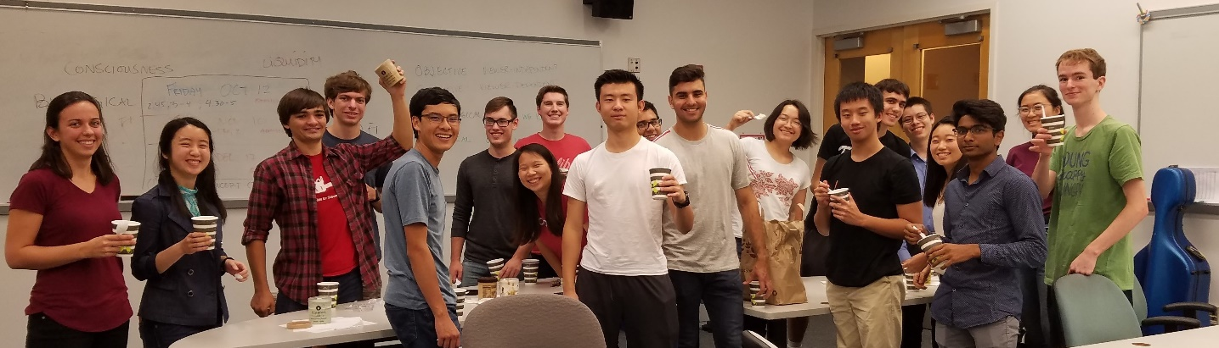

Figure 23. Who needs ice cream? OCO does!

I was hopeful that the Fall 2018 entering class would include at least a clarinet, anything other than a flute. But we ended up again having three flutes but now with an alto saxophone. Since our alto flute graduated with her owner, the Music Program purchased a black nickel Trevor James alto flute, which has a more incisive timbre than a silver alto flute, thus differentiating the alto flute from the two flute timbres (one of our graduating seniors wanted to play flute instead of bass or alto so two flutes were a given). Since I again managed to produce a coherent group sound, I also started working with the organizers of the ASEE Zone I International Conference to include an OCO performance in their program.

It became a reality. Provost and Dean of the Faculty Vincent Manno gave us a matching funds challenge so we ran a Fundit campaign with DFAR (Development, Family, and Alumni Relations). Adi Sudakhar ‘22 made the Fundit video (<https://fundit.olin.edu/project/14470>), Kyle Emmi ’21 worked out the trip logistics, Maggie Rosner ‘20 took care of getting the word out. Though the Fundit page shows us $1000 short, we made our goal due to the generosity of an anonymous donor who will forever be blessed.

Prof. Shane Rogers of Clarkson University, co-chair of the conference, was a prime mover on the ASEE side for helping us find a good acoustic venue, date, and time for the concert. Since we didn’t have enough room in the Olin van for our music stands, Shane assumed responsibility for locating stands. Amazingly, he went and bought 22 high quality, collapsible music stands, each of which could be packed in a player’s suitcase or backpack. His words to us: “now you can play anywhere and not have to worry about transporting music stands.” It was an incredible gift. Shane and all of the donors were credited in the ASEE OCO program, as well as in succeeding OCO programs, and thanked personally.

So we all boarded a Delta flight to Buffalo on April 12, arrived at the conference hotel, and checked in. While the students had free time to rest or explore, I went off to deliver a paper on “The Engineers’ Orchestra: a conductorless orchestra for developing 21st century professional skills” at a 2pm session, as well as invite the session attendees to the 5pm concert.

At our 330pm rehearsal, we got set up with the new music stands purchased by our ‘angel’ sponsor Prof. Shane Rogers. And then our only cellist Rachel Won snapped her A string. What ensued was an all-hands effort to fix the problem, but in the end, Rachel was the heroine, re-learning her solos and other parts for a ‘3-stringed’ cello. We all were most concerned about her opening solo for the last piece on the program (*Danzon No. 2* by Marquez). Just two weeks earlier, I had moved the latter part of the cello solo an octave lower to contrast a new string color (the D string) to the higher A string. But now she had to learn the first part of the solo on the D-string, playing it an octave lower. She totally pulled it off. This concert was the finest OCO performance from first piece to last in the orchestra’s 17-year history. The orchestra received a standing ovation. We were all so excited afterwards, eating, talking, laughing, and looking forward to hearing a great recording. It was not to be. There was a snafu with the video recorder and nothing was recorded. It was a huge loss for all of us. But the group decided we’d repeat the concert on May 10, 2019, as part of the Ann Schaffner concert series, especially since OCO had promised a recording of the ASEE concert to our Fundit backers.

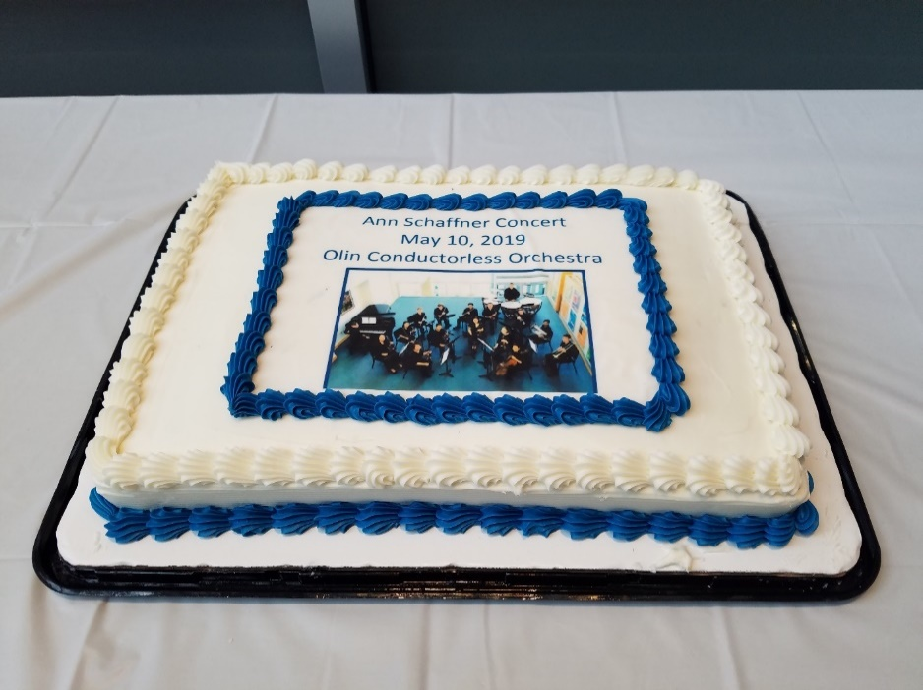

Figure 24. Admin. Asst. Paul Coveney’s great idea for the reception cake featuring a photo of the 2019 OCO.

***Evidence:*** The 2019 Ann Schaffner concert can be heard at YouTube link <https://youtu.be/G3dKQv_hf6A>

## Supplementary Materials IV-L-3: Short Videos conveying the Scope and Impact of the Music Program

Evidence of Music Program Impact, 2015 Candidates Weekend 3:  <https://youtu.be/uiryNONUTZA>

Origins of OCO, Candidates Weekends 2019: <https://youtu.be/i318wEnXnmw>

Origins of the Olin Concert Hallway Steinway B, Candidates Weekends 2019: <https://youtu.be/HwWwH3QSyqk>

Q&A on the Music Program, Candidates Weekends 2019: <https://youtu.be/5i-C5YXAJgM>

# VIII. Appendices: Evidence

## Appendix II-A-2. Examples of Wired Ensemble Assignments and Student Work

Appendix II-A-2 (“Student Work”) complements the above material with the following evidence:

1. “Mix and Stir”, part 2, final student scores.
2. Program created by Admin. Asst. Paul Coveney for the “Mix and Stir”, part 2, concert: Dec. 5, 2017
3. Example assignment for an original composition analysis. Students not only compose original music in Wired Ensemble, they also apply the Wired Ensemble Toolkit to analyze their own compositions. “Original Composition Analysis 1 (Woodwinds)” gives students a chance to analyze the work they just composed with respect to phrase structure. The student analysis also addresses Rehearsal Impact and Revision, two intimately tied processes in the Wired Ensemble.
4. Example analysis assignment. Students also use the Wired Ensemble Toolkit to analyze Beethoven’s revision process as shown in his 1803 Sketchbook. Having experienced the revision process by working on their own compositions during the first six weeks of the course, they now have a chance to examine how Beethoven progressed from initial idea to the final theme for the Funeral March of his “Eroica” Symphony.

Inserted PDFs start on the next page.

## Appendix II-B-1. DSP: Example Assignments, Labs, and Student Work

Appendix II-B-1 contains examples of DSP assignments and student work:

**1**“Guidelines for DSP Application Presentations and Written Reports.” These guidelines provide a lucid road map for the student’s presentation and written report. The goal is to help students produce clearly written reports (effective communication) that will be useful to other class members, some of whom might want to further explore a given application.

**2** “DSP Final Project—Guidelines for Project Written Reports and Presentations.” As with the “Application Guidelines”, the Final Project Guidelines stipulate the sections comprising the written report. Many of these section headings already appear in the Final Project *Proposal*, typically completed 4-5 weeks before the project is due. The Final Project *Proposal* receives written and oral feedback from the professor in individual meetings, after which the student revises and re-submits (revision). The instructor again provides written and oral feedback on the revision, at which point the student is more calibrated to produce the Final Project Demo and Final Project Report (application). That report will include much of the same Background, Significance, and Bibliographical material already completed for the Project Proposal, as well as much of the Project Description. This strong correlation between the Project Proposal and Final Report helps **motivate** students to write cogent *Proposals* that capture their best thinking and research to date.

**3**  Example of a DSP Final Project Written Report: M-synth. This student developed an interest in electronic music, including synthesizers and synthesis methods, as a result of her independent study in music production. Prior to this project, she found herself restricted to preset sounds provided by commercial synthesizers so she decided to build her own—one that would allow her to design her own sound palette. In doing so, she gained greater intuition on pole-zero plots and how they translate to various filters, as well as how different synthesis methods work, e.g., additive and subtractive synthesis. She designed her M-synth system to function as a subtractive synthesizer, an additive synthesizer, or both. It comprises six main sections: the oscillator, filter, envelope, amplifier, save, and play. She built a clean, elegant, and smart user interface.

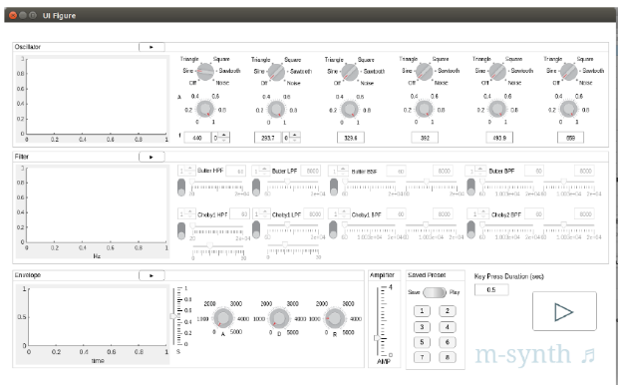

Figure 25. Graphical interface built for M-synth, a final project in DSP.

**4** Examples of labs developed for the course:

* FIR Filters and Frequency Response
* Filter Implementation and Coefficient Quantization
* Filter Structures

Inserted PDFs start on the following page.

## Appendix II-B-2. Signals and Systems: Example Assignments and Student Work

Appendix II-B-2 contains examples of the following:

**1** “Guidelines for Signals and Systems Application Presentations and Reports.” These guidelines give clear direction for the presentation and written report, providing the five required sections for both the presentation and report. Sections 3 and 4 are especially important. Section 3 “Explain one (small) part/facet of the App” encourages students to narrow the topic, something they will find useful when researching/building their Final Projects. Furthermore, it emphasizes the student role in presenting the application, i.e., the student is now the teacher (**lifelong learning**). Section 4 (“Significance of the App”) asks a critical question that points all students to the Final Project: “How might a student in our class employ one or more aspects of the App for a final project?”

**2** Sample student Application Report “Soundscape Ecology.” Soundscape ecology turned out to be a great interest for this student. She then devised a final project that allowed her to explore the topic in greater depth. The result successfully met the assignment’s focus on applications and written communication. It further provided preparation/scaffolding for the student’s final project deliverables, including a final project proposal, written final project report, and oral presentation.

**3** The “Guidelines for Signals and Systems Final Project Written Reports and Presentations” require students to include a small example as part of any explanation, thus encouraging student-initiated scaffolding. I got this idea from Professor Amar Bose. I taught recitations for his Acoustics course at MIT in 1989 and 1990. Each time he taught the course, he demonstrated the power of a small example.

**4** StudentFinal Project Report (“Soundscape Ecology as demonstrated by songbirds in Olin’s Parcel B”) shows a student clearly inspired (stimulation/impetus) to extend her exploration of Soundscape Ecology. She devised experiments, revised them in light of real world constraints, and expanded her analytical grasp of the spectral content.

PDFs begin on the next page.

## Appendix II-C-1. Uniting AHS with Engineering: Module linking music and engineering developed for a new course—“Engineering the Acoustical World”, Harvard School of Engineering and Applied Sciences (SEAS), led by Robert J. Wood, Harry Lewis and Marlyn McGrath Professor of Engineering and Applied Sciences

I prepared the following course materials (two 1.5 hour classes) for “Engineering the Acoustical World” on the topic “What’s so great about the overtone series?” Intentional spaces in the handouts allowed students to take notes or work out the answers to questions. Though answers didn’t appear in the handouts, they were provided to the students for later reference.

1. The overtone series pops out of the wave equation
2. The overtone series, standing waves, harmonics
3. A quick recap of our prior class
4. Pythagoras: scales based on proportional string lengths
5. From Pythagoras to Ptolemy to tempered tuning
6. Modal scales
7. Taking advantage of the overtone series for orchestration

PDFs of these materials start on the next page.

## Appendix III-G. Musical Scores of Commissions and World Premières

Appendix III-G contains PDF scores for the following works:

* *September Quartet* (2011) in five movements, for chorus, winds, brass, percussion, violin and piano

Beginning

77-175

93

11

End

* *Tre Studi di Colore* (2012) in three movements, for piano

Azzurro (right hand alone)

Rosso (left hand alone)

Violetto (hands together)

* *Fuente y Variación* (2013) in two movements, for piano

Fuente

Variación

* *Who was Wissam Eid* (2017) in three movements, for violin, cello, and piano

Ahmad Abu Adass

Rafik Hariri

Wissam Eid

* *Parallel Lives—Distant Mirrors* (2018) in five movements, for flute, mezzo-soprano, speaker, piano, and soundtrack

Ignition (solo piano)

The Last Minutes of Baghdad TV (bass and alto flutes + projection)

An Iraqi Mother’s Lament (voice and piano)

Quranic Verses 16:111 – 16:114 (speaker and alto flute)

Catharsis (piano + soundtrack)

PDF scores start on the next page.

## Appendix IV-H-1: Boston Sunday Globe Article on CantoVario (2013)

During Spring 2013, Carolyn Johnson, then lead science reporter for the *Boston Globe*, asked to meet with me about my work with chaos and musical variation. An article ensued in the “Ideas” section of the Sunday Boston Globe: “What a little chaos does for music.”

A PDF of her article starts on the following page.

## Appendix IV-H-2: *ArtScience* by David Edwards, Harvard University Press 2008: Chapter 2 (“Process”) on my Musical Variations Project

My musical variations project and its backstory comprise Chapter 2 (“Process”) of a 2008 Harvard University Press book by David Edwards: *ArtScience*: *Creativity in the Post-Google Generation*.

The PDF starts on the next page.

Edwards’ book was also reviewed in Nature: <https://www.nature.com/articles/451246a.pdf?origin=ppub>

## Appendix IV-H-3: NSF I-Corps Grant (funded 2019)

A PDF of CantoVario’s NSF grant entitled “I-Corps: Harnessing Chaotic System Variability” starts on the following page.

NSF Innovation Corps (I-Corps) Teams Award Date: April 4, 2019 Award No. (FAIN): 1924305 Proposal No.: 1924305 Managing Division Abbreviation: IIP. "I-Corps: Harnessing Chaotic System Variability." Diana Dabby, PI.

## Appendix IV-J-1: “The Engineers’ Orchestra”, published by Springer Nature

A PDF of the book chapter “The Engineers’ Orchestra: a conductorless orchestra for our time”, published by Springer Nature in *Creative Ways of Knowing in Engineering*, starts on the next page.

The below link to the Springer Nature site for the book chapter gives the abstract, references, and acknowledgments:

<https://link.springer.com/chapter/10.1007/978-3-319-49352-7_2>

## Appendix IV-J-2: “The Engineers’ Orchestra: a conductorless orchestra for developing 21st century professional skills.” Awarded *2020* *best paper* by the American Society for engineering education (ASEE),zone 1

A PDF of this paper, peer-reviewed and published in the Proceedings of the ASEE Zone I International Conference, Niagara Falls, NY, April 12-14, 2019, starts on the following page.

## Appendix IV-K-1: A Sampling of my Orchestral Arrangements

I’ll now give brief analyses for seven orchestral arrangements (with links to videos), each of which speaks to one or more aspects of my orchestral arrangements. Appendix IV-K-2 includes scores of the arrangements.

1. Haydn *Sinfonia No. 48 in C Major*, “Maria Theresia”: first movement (Allegro), Spring 2008.
2. Arturo Marquez *Danzon No. 2*: Spring 2013
3. Dvorak *Symphony No. 8 in G Major*, fourth movement (Allegro ma non troppo): Taking advantage of the overtone series for orchestration (Spring 2014)
4. Dvorak *Symphony No. 9 in E minor*: fourth movement (Allegro con fuoco)—Spring 2016
5. Gershwin *An American in Paris*: Spring 2017
6. Mozart *Serenade in Bb for 13 Winds*, K. 361: Finale—Spring 2019
7. Berlioz “Marche Hongroise” from *La Damnation de Faust*: Spring 2019

**Haydn Sinfonia No. 48 in C Major, “Maria Theresia”: first movement (Allegro), Spring 2008.**

During the Spring 2008 term, OCO had none of the instruments called for in Haydn’s 48th Symphony, with the exception of timpani and strings, the latter of which comprised an unbalanced section of three violins, viola, and three cellos. Haydn’s No. 48 calls for 2 oboes, bassoon, 2 horns, 2 trumpets, timpani, and strings. In this recording and arrangement, I re-scored the work for 2 flutes, 3 clarinets, tenor saxophone, trumpet, euphonium, timpani, and the above string section. When Haydn wrote this work (ca. 1769), clarinets and flutes, not to mention saxophones, were not standard instrumentation. But all the students wanted to play this piece, so to develop a coherent Haydn sonority, I doubled strings with winds in their lowest registers so the winds would blend chameleon-like with the strings, e.g., the violins with flutes in their lowest register where their sonority is less ‘flutey’, as occurs in mm. 7-11: two of the violins are doubled with flute2 in its lowest register and violin3 is doubled with clarinet in its chalumeau register. I also blended one of the three clarinets with trumpet to camouflage the preponderance of clarinets by situating it within a brass sonority (e.g., clarinet3 with trumpet in mm. 5-9), and generally assigned two of the clarinets to the oboe parts. But what to do with the tenor saxophone? I treated this instrument as either a brass or woodwind, depending on context. For example, by combining it with trumpet in mm. 1-4, the tenor sax took on the quality of a horn, but then I ‘hid’ it right afterwards by merging it with the strings in mm. 5-11 where its register blends better with the harmonic support provided by the cellos in conjunction with the pedal points I assigned to flute1, clarinet2, clarinet3, and trumpet. (Haydn assigns these same pedal points to two horns and two trumpets.) At other times, I treated the tenor saxophone as a woodwind by using it to punctuate the cello parts, much as a bassoon would in the classical orchestra, e.g., mm. 30-41.

To vary the tonal palette (and keep the listener from latching onto any particular sonority for too long), as well as to give more melodic parts to the wind instruments (since they were complaining that the strings got all the good parts), I transferred the melody to the first clarinet in mm. 12-17 instead of keeping it in the first violins, as in the original Haydn score. In mm. 22-23, I substituted double stops in the upper 2 violin parts for the triple stops, to ensure the two violins would execute them exactly together. To create the ‘wood’ sound for the winds, I used clarinet1 on top and flute1 on bottom for the oboe lines in mm. 22-29, contrary to how flute and clarinet are usually positioned.

I employed the ‘sleight of hand’ of the above examples throughout this arrangement. For example, where Haydn writes a forte section only for the strings in mm. 103-111, I varied the sonority and reinforced the material with our winds and trumpet so that the sudden piano on the upbeat to m. 112 offered more contrast. It also provided melodic parts for the brass and wind sections.

***Evidence****:* The OCO recording of my arrangement of the Haydn can be heard at <https://youtu.be/knulC0k1r5M>

**Arturo Marquez Danzon No. 2: Spring 2013**

Marquez composed Danzon for a huge contemporary orchestra. OCO only had 13 players (2 flutes, tenor sax, French horn, 2 trumpets, piano, violin, viola, 2 cellos, and 2 percussionists.) To create the strong climaxes in the piece, I often pared down the texture, in order to build it up again. For example, Marquez opens Danzon with a full string section accompanying a clarinet solo. He also adds piano and claves. The claves give the ‘latin’ character to the work, so they had to remain. But instead of including his full piano part, which would not blend well with just 3 strings doing pizzicatos, I doubled the pizzicato cello with marimba. I then re-worked the clarinet solo for the other cello.

*Danzon* is filled with local and maximal climaxes. To set up the big climactic moments, I thinned the orchestration by eliminating instruments that play in the original score, sometimes adding a subito piano in the process. For example, the first strong arrival point in *Danzon* occurs at the Con fuoco (literally, “with fire”) in m. 74. I set that up by reducing the instrumentation starting in m. 66 by obliterating all the winds and brass of the original except for two flutes and French horn, writing a new part for the piano with the French horn sustaining the piano’s bass line, and adding a subito piano to each of the parts on the second beat of m. 66. I delayed bringing in the two trumpets, tenor sax, and bass drum until two measures before the Con fuoco.

The next climactic moment occurs in m. 145, according to the Marquez score (marked fortissimo). But for our orchestra, I imagined even more emphasis at mm. 150-151. So I kept our instruments forte at m. 145, replaced the repetitive piano part in mm. 145-153 with a new part reflecting the violins of the original score, then allocated the original pizzicato viola part to our violin and viola (both arco), and gave each of our two trumpets, tenor sax, and French horn dual roles: Each covered the roles of two different instruments, thus capturing the harmony of the original four horns, as well as the forte punctuating chords played in the original by two trumpets and three trombones from mm. 145-149.

Measures 256-280 illustrate a third strategy for setting up the illusion of huge forces with a small orchestra. A local climax occurs in m. 256, followed by a huge arrival point at m. 280. On the upbeat to m. 249, Marquez brings in the entire woodwind section which plays until the big Con fuoco section at m. 280. But to give more contrast and the illusion of powerful forces at m. 256, and then again at m. 280, I pared his woodwinds down to just two flutes playing an octave lower than the flutes of the original score and treated the tenor sax as a brass instrument. Then on the upbeat to m. 256, I took both flutes an octave higher to give a burst of energy to the local climax at m. 256. In mm. 261-267, I took out all the woodwinds again and delayed adding our two flutes until the upbeat to m. 268 where I put them both on the same part. I again paired the tenor saxophone (OCO’s only other woodwind) with our brass instruments so it (like a chameleon) assumed the color of the trumpets and French horn.

We had an exceptional marimbist/percussionist (David Pudlo), so I used the marimba to create color and carry lines originally scored for standard orchestral instruments or I combined an instrument in the original score with marimba. For example, in mm. 318-328, I doubled the treble part of the piano with the marimba. Up to that point, i.e., from mm. 282-316, the piano sonority had been prominent. Adding the marimba changed the texture and color from a piano to a hybrid instrument, the ‘mariano’, a totally made-up name but it gets the point across.

***Evidence:***  My arrangement can be heard in the 2013 OCO YouTube video recording <https://youtu.be/yyzEQ6n6OYA> The pianist (Philicia Chow) is excellent, yet she had to perform her big part on an electronic piano. Her playing made it clear we had to find a concert piano for future OCO concerts, which thankfully we did!

**Dvorak Symphony No. 8 in G Major, fourth movement (Allegro ma non troppo): Taking advantage of the overtone series for orchestration (Spring 2014)**

The orchestra selected the fourth movement of Dvorak’sSymphony No. 8 in G major, op. 88 (Allegro, ma non troppo). Dvorak scored his symphony for 2 flutes, 2 oboes, 2 clarinets, 2 bassoons, 4 horns, 2 trumpets, 2 trombones, bass trombone, tuba, timpani, and strings (32 violins, 12 violas, 12 cellos, and 8 double basses).

I then re-orchestrated the symphony for OCO’s 18 players (2 flutes, clarinet, bass clarinet, trumpet, baritone, 3 violins, 2 violas, 3 cellos, piano, and 3 percussionists).

In the score below, Dvorak wrote a part for the first violin section that takes them ever higher. But OCO only had two first violins, rather than 17. Playing the stratospheric passage as written would have resulted in a thin (and barely audible) climax.

So for the ending of the Dvorak, I brought our two first violins and single second violin an octave down from the Dvorak score. Then I wrote a short part for the glockenspiel that would ping the desired climactic high notes, and doubled the violins at the octave with the marimba (mm. 452-470). I counted on the octave overtones occurring in the lowered violin parts to contribute a string resonance to the marimba and glockenspiel parts. (The glockenspiel is a high, bell-like instrument which sounds 2 octaves higher than written.)

Though Dvorak doesn’t use a glockenspiel anywhere in his Eighth Symphony, I’ve often found it effective for adding “color” and sonority to OCO’s instrumentation. Since we had a good player, I gave her extra parts throughout the work, including the momentous sprint to the end.

Here is the original Dvorak score showing the high first violin parts in the top staff below:

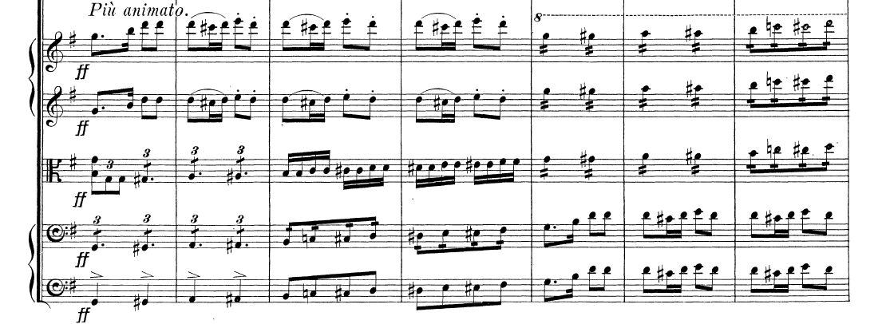

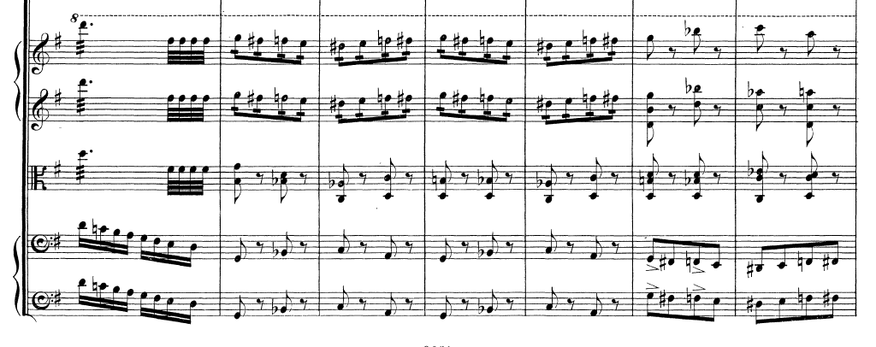

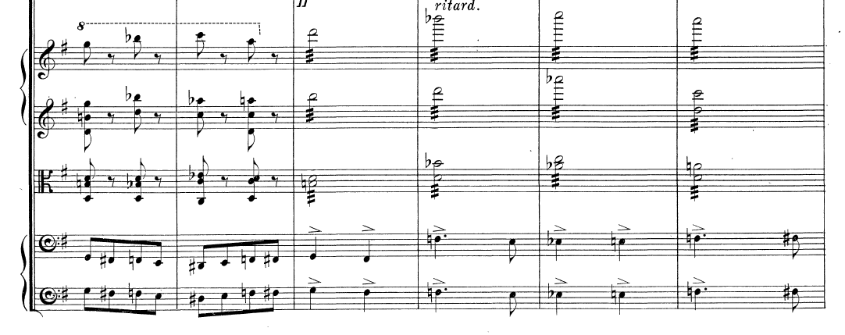

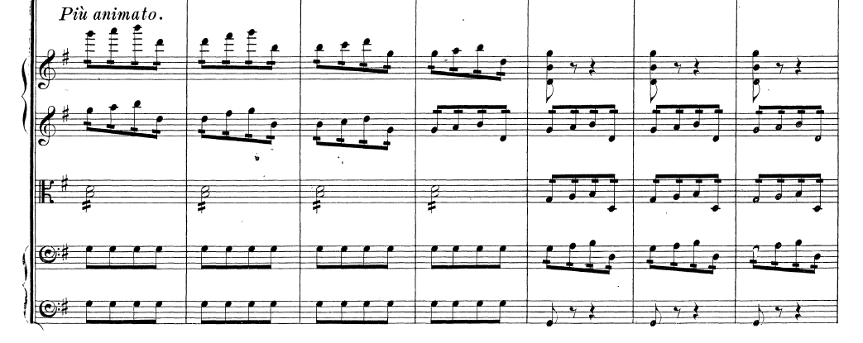

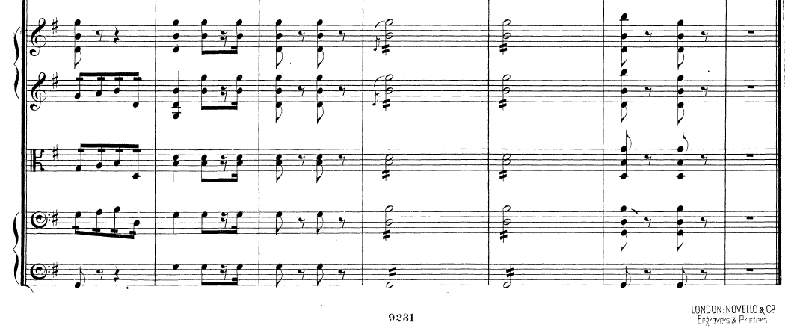

Here is my re-orchestration of the *Più animato* which brings all three violins an octave lower, starting in m. 450. The glockenspiel doubles the lowered violins at the octave so the violin overtones commingle with it. The marimba then doubles the glockenspiel, both of which double the lowered violins at the octave (mm. 452-461). From 462 to 465, it simulates the high tremolos of the first violins in Dvorak’s original scoring and continues to support the violins at the octave till m. 470. Finally, the glockenspiel ‘pings’ the last downbeat of the movement.

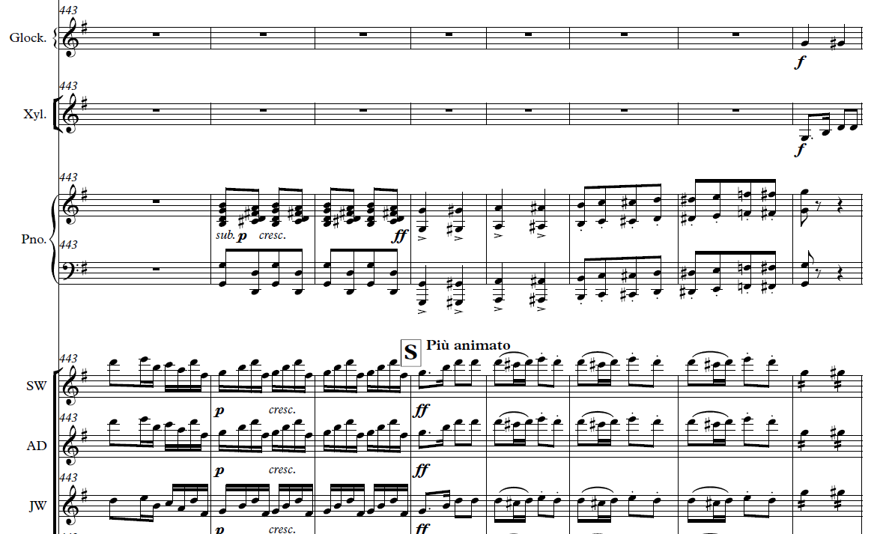

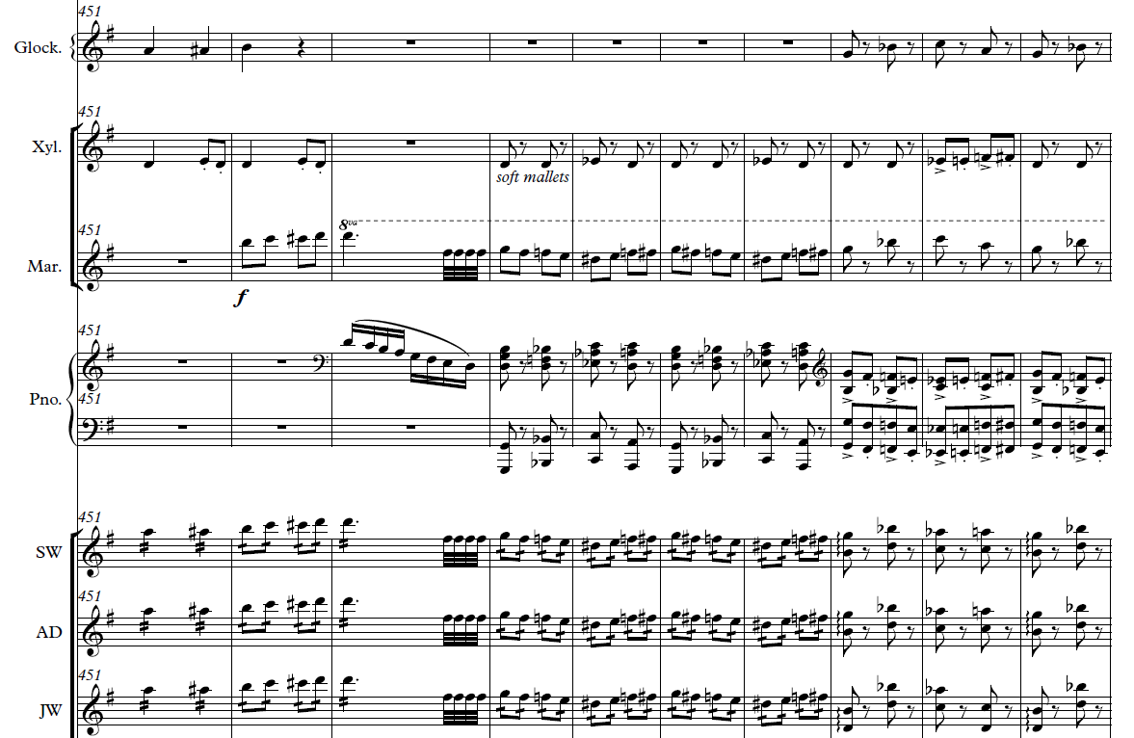

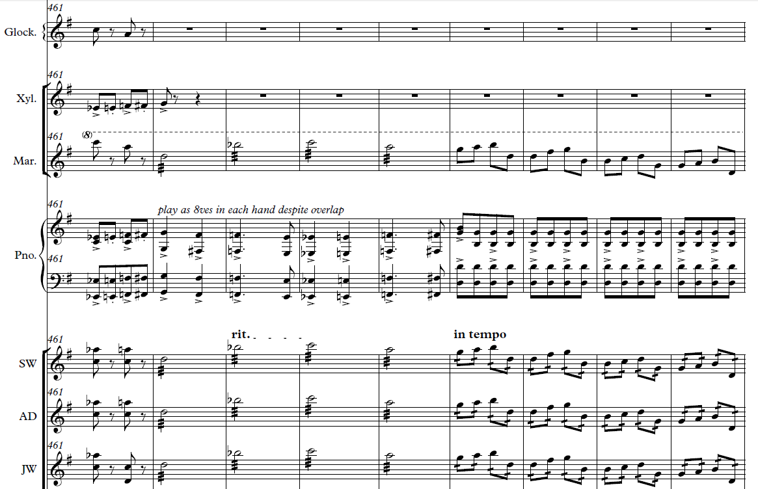

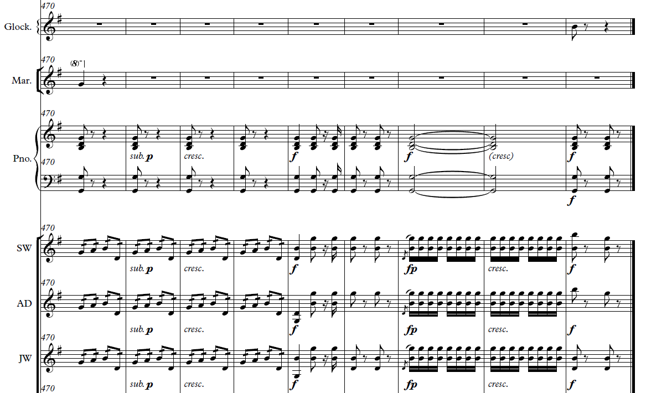

***Evidence****:*  My re-orchestration of the *Più animato* can be heard in the 2014 OCO YouTube video recording <http://bit.ly/OCO_Dvorak8>

**Dvorak Symphony No. 9 in e minor: fourth movement (Allegro con fuoco)—Spring 2016**

Dvorak scored his ninth symphony for 2 flutes, 2 oboes, 2 clarinets, 2 bassoons, 4 horns, 2 trumpets, 2 tenor trombones, bass trombone, timpani, percussion, and strings (34 violins, 14 violas, 12 cellos, and 8 double basses).

OCO had 2 flutes, 2 oboes, 2 clarinets, bass clarinet, trumpet, bass trombone, 6 violins, 2 violas, 3 cellos, harp, piano, and 2 percussionists.

In this symphony, Dvorak asks for 9 brass instruments. We only had two. But we had a pretty complete wind section. So I made myriad combinations of flutes, oboes, clarinets, and bass clarinet with trumpet and/or bass trombone to create the illusion of multiple differently-colored brass instruments. I used the piano to reinforce sections that needed more heft and added the harp when I could spare her on clarinet (she played both instruments).

Among other approaches, I used the glockenspiel and piano to not only ping but also buttress the violins where Dvorak sends them ever higher, as he did in the Eighth symphony. For example, in m. 39 he asks a large first violin section to reach for a B6, an octave and a fifth above the open E string. He doubles them with the first flute. But OCO had only two violins that could go for the high B. To create color, as well as a ‘wash’ over that note, I had the glockenspiel ‘ping’ it. Ditto for m. 182.

In mm. 201-213, Dvorak again writes an extremely high passage for the first violins. Though with practice, our violins could play this part, it would never sound as full as Dvorak intended. So I placed all six violins an octave lower and gave the pianist the same passage in right hand octaves and the glockenspiel the same passage in single notes. Then I told the glockenspiel player to “bang this out as loud as you can.” As with the Dvorak Eighth, I imagined the overtones of all six violins an octave lower would bathe the piano and glockenspiel parts with the string sonority, and that’s what happened. I used similar strategies in mm. 247-250, 277-280, 288-299, and 340-345.

***Evidence****:*  My arrangement can be heard in the 2016 OCO YouTube video recording <http://bit.ly/OCO_Dvorak9th> .

**Gershwin An American in Paris: Spring 2017**

The orchestration for *An American in Paris* calls for 24 woodwind and brass instruments. In Spring 2017 we only had nine. There are substantive parts in the original Gershwin for winds and brass, especially for clarinet and trumpet, including the memorable trumpet solos in the “Andante ma con ritmo deciso” section. We had no clarinet or trumpet, but we did have a pocket trumpet whose range was concert Bb3 to Eb5. The challenge was to convey the colors of a large brass section (eleven brass in the original Gershwin) with a woodwind section concentrated in the higher and lower ranges (comprising 3 flutes, oboe, and 2 bass clarinets) along with the 3 brass instruments we did have: trombone, bass trombone, and of course, the pocket trumpet.

This orchestration demanded much of the oboist. I did a first pass and then we met. He let me know where he needed to rest and what he could do given enough practice. On that basis, I made a revised arrangement which I continued to tweak according to what I heard during rehearsals. If we were close to a concert date, and I still heard players having difficulty, I revised passages and/or doubled them with other instrumments so that the passages came through more clearly and confidently.

To avoid too much of a particular timbre, I used instruments in their less identifiable registers, e.g., using the oboe in its poignant range for the beautiful melody starting between rehearsal marks 50 and 51 but also capturing the rhythmic countermelody by employing its lower register. (In the original Gershwin, the melody and countermelody are taken by two different instruments: the English horn and trumpet play the melody, whereas the oboe takes the countermelody.)

Producing a coherent group sound from this eclectic group of instruments was a challenge. Achieving balance was key. For example, I made a pizzicato part of Gershwin’s bassoon line at rehearsal 19, and dropped it an octave lower so the cello line could be clearly heard amidst the upper strings. The strings are a homogeneous family, i.e., they blend together well, so dropping the cello by an octave gave it a clearer voice.

Woodwinds, on the other hand, are not a homogeneous family of instruments. And because of that, they add distinctive color to an orchestration. But only having flute, oboe, and bass clarinet timbres challenged me to come up with combinations in just the right places at just the right times for audible color. For example, at rehearsal mark 20, I changed the color by giving all the original clarinet and bass clarinet parts to the piano, but then gave a woodwind hue to the piano part by doubling the left hand with one of our bass clarinets. Similarly, I added piano runs to rehearsal marks 38 and 39 not only to help out the winds and strings, especially with cohesion and technical concerns, but also to create timbral contrast. On the other hand, in the measure before rehearsal 41, I had no other option but to use the piano to capture the bassoon runs, but if I just put it there, the piano would stick out and not bring the passage to a blended conclusion. To remedy this, I added the piano timbre in the second and third measures before rehearsal 41 so it would be in the ‘mix’ or audible palette, i.e., combined with the flute and oboe runs, before emerging with its solo run in the measure before rehearsal 41.

*American* *in Paris* has no piano parts so I had to create one from scratch (since OCO had a good pianist), some of whose details I’ve discussed above. But there is a celeste part in *American* (rehearsal marks 42-45), and that’s an easy assignment to the piano. Still I made one change—prolonging the last chord at rehearsal mark 45 to match the held notes in the winds and strings (though the piano of course fades more quickly).

Whenever I came across a passage written for a single brass instrument, especially low brass, that I knew would demand too much individual practice from a player, I looked for ways to still achieve the line in the orchestration, often through re-distributing it. For instance, at rehearsal mark 22 in the original score, Gershwin gives a passage to the bass trombone filled with minor and major seventh jumps—a challenge for any player. Yet it was important for giving heft to the bass line. So I divided it between the bass trombone and trombone. It’s also fun and challenging for them because they have to play rhythmically in sync. I also re-distributed parts for the flutes, with dovetailing, e.g., two measures before rehearsal mark 66. In the original, these runs are taken by each flute in toto.

Sometimes I’ll re-distribute a line even if it’s easy for one instrument or section to play it. For instance, Gershwin writes a solo violin part in rehearsal 67 for just the concertmaster, but I could imagine the aural and visual effect of having each of three violins first pass it from one to another so I re-distributed the solo among them as a kind of musical relay.

Wherever possible, i.e., within the capacity of the pocket trumpet, I used it in combination with other instruments to create ‘hybrid’ timbres. For example, at rehearsal 70, I had the pocket trumpet bathe the oboe in its overtones by doubling it at the octave below. Similarly, I combined the oboe with flute to connote some of the ‘traffic’ sounds in *American* (originally scored for clarinet, as well as a special horn).

As I’ve done in many pieces, I used the glockenspiel to ping certain arrival points in the music, as well as contribute color, such as in rehearsal 28 where I created a glockenspiel line that floats above the others, from material originally given to the bass clarinet. In mm. 550-555, I used it for color and emphasis. Here, Gershwin writes an ‘open fifths’ passage reminiscent of the Beethoven Ninth that is doubled in all registers by the woodwinds (minus oboes and English horn), timpani, and strings. I added the glockenspiel, not at m. 550, but rather at m. 552 so the timbre of the passage changed midway during the repetitive passage, contributing emphasis as well.

***Evidence****:*  My arrangement can be heard in the 2017 OCO YouTube video recording <https://www.youtube.com/watch?v=BA5F48usRIo>

**Mozart Serenade in Bb for 13 Winds, K. 361: Finale—Spring 2019**

The Spring 19 woodwind section again comprised 3 flutes but now with an alto sax. The brass section included trumpet, tenor trombone, and euphonium. But we also had a pianist and timpanist. None of these instruments appear in Mozart’s Serenade. He scored it for 2 oboes, 2 clarinets, 2 basset horns, 4 horns, 2 bassoons, and double bass.

The first thing I did was expand the repeat signs: the Finale is in rondo form and each section of the rondo is repeated. By expanding the repeat signs, I was able to change instruments—and open the door for different dynamic markings—on the repeats. I made two versions of the Mozart. During Fall 2018, OCO had two trombones, one of whom studied away during Spring 2019. During the fall term, I switched the trombone parts on each repeat. During the spring term, I interchanged brass instruments on some repeats, e.g., trumpet and euphonium in mm. 65-80. I also paired the winds differently on the repeats, e.g., alto flute and alto saxophone in mm. 146-152, followed by flute2 and alto sax in mm. 153-160.

***Evidence****:*  My arrangement of the Spring 2019 Mozart can be heard in the 2019 OCO YouTube video recording <https://www.youtube.com/watch?v=hTNUGRU4Pl8>

**Berlioz “Marche Hongroise” from *La Damnation de Faust*: Spring 2019**

The challenge here was conveying a big, romantic bass line with only one cello (our Fall 2018 cellists were studying away during Spring 2019). Wherever possible, I doubled the cello at the octave with the alto sax, e.g., mm. 27-49, to give incision to the bass line (much as a bassoon would). At other times, I bolstered the cello line by doubling it with four violins at the octave, e.g., mm. 89-92 where the equally important counter line, heard in contrary motion, is buttressed by flutes, two violins, and right hand octaves in the piano. For the following measures, mm. 94-98, I took a different tack, doubling the cello with euphonium and alto sax.

The big, sustained climax of the Marche occurs in mm. 157-217, all marked fortissimo by Berlioz. The bass line melody starting at m. 157 has to be strong. I started by pairing the cello with the alto sax. so I kept the cello in a range that would also be strong in the alto sax. Next I added the trombone and euphonium, at first an octave apart, and then in unison (unison because the lowest, comfortable forte note for our euphonium player is E2), with the piano bass playing in octaves. To create dynamic contrast and excitement within these fortissimo measures, given a much smaller orchestra than that of Berlioz, I added two subito pianos, the first on the second beat of m. 166, and the second on the downbeat of m. 196. To avoid a thin texture in the violins for mm. 194-199, I dropped the top four violins an octave from what Berlioz had written and reinforced them with the flutes

***Evidence****:*  My arrangement of the Berlioz can be heard in the 2019 OCO YouTube video recording <https://www.youtube.com/watch?v=a9IkNITe1fE>

## Appendix IV-K-2: Scores of the Sample Orchestral Arrangements

PDF scores for the following orchestral arrangements discussed in **Appendix IV-K-1** start on the next page.

1. Haydn *Sinfonia No. 48 in C Major*, “Maria Theresia”: first movement (Allegro), Spring 2008.
2. Arturo Marquez *Danzon No. 2*, Spring 2013
3. Dvorak *Symphony No. 8 in G Major*, fourth movement (Allegro ma non troppo), Spring 2014

(N.B. Score example provided earlier as part of Appendix IV-K-1.)

1. Dvorak *Symphony No. 9 in e minor*: fourth movement (Allegro con fuoco), Spring 2016
2. Gershwin *An American in Paris*, Spring 2017
3. Mozart *Serenade in Bb for 13 Winds*, K. 361, seventh movement (Finale), Spring 2019
4. Berlioz “Marche Hongroise” from *La Damnation de Faust*, Spring 2019

## Appendix IV-K-3. Arrangements of Orchestral Works for 12-22 players

The below appendices—organized by academic year—give orchestral arrangements that can be accessed at The Engineers’ Conductorless Orchestra Hub <https://pages.olin.edu/eco-summer2019>, a website offering useful resources, videos, orchestral arrangements, and blueprints to help/encourage other engineering schools to start their own conductorless orchestras, as discussed in Section IV-K of this dossier.

Appendix IV-K-3: 18-19

Fall 2018. Four original orchestral arrangements for 19 players (**2** **flutes, alto flute, alto saxophone, euphonium, trumpet, 2 trombones, timpani, piano, 6 violins and 3 cellos**)

* Mozart *Wind Serenade in Bb Major*, K. 361 (Rondo). **Mozart** wrote his tenth serenade (aka *Gran Partita)* for 2 oboes, 2 clarinets, 2 basset horns, 4 horns, 2 bassoons, and double bass, none of which we had. So I arranged it for our wind/brass players, adding timpani and piano parts in the process.
* Tchaikovsky “Waltz” from the *Serenade for String* Orchestra, op. 48. **Tchaikovsky** composed his *Serenade* for full string orchestra (34 violins, 14 violas, 12 cellos, and 6 double basses), the larger the better according to him.
* Mozart overture to *Così fan tutte*, K. 588. **Mozart’s** overture calls for 2 flutes, 2 oboes, 2 clarinets, 2 bassoons, 2 horns, 2 trumpets, timpani, and strings (16 violins, 6 violas, 4 celli, 2 double basses).
* Berlioz “Marche Hongroise” from *La Damnation de Faust*. **Berlioz** scored his Hungarian March for piccolo, 2 flutes, 2 oboes, 2 clarinets, 2 bassoons, 4 horns, 2 trumpets, 2 cornets, 3 trombones, tuba, ophicleide, timpani, percussion, and strings (34 violins, 14 violas, 12 cellos, and 6 double basses.

Spring 2019. Created five orchestral arrangements for 16 players (**2** **flutes, alto flute, alto saxophone, euphonium, trumpet, trombone, timpani, piano, 6 violins and cello**)

* K. **Badelt**/T. **Ricketts** Medley from *Pirates of the Caribbean*. The **Badelt/Ricketts** *Pirates* medley was scored for 2 flutes, oboe, 2 clarinets, bass clarinet, bassoon, 3 trumpets, 4 horns, 2 trombones, bass trombone, tuba, timpani, percussion, piano, and strings.
* Mozart Rondo from the *Serenade for Winds*, K. 361. **Mozart** wrote the *Wind Serenade*, K. 361, for 2 oboes, 2 clarinets, 2 basset horns, 4 horns, 2 bassoons, and double bass, none of which we had.
* Berlioz Marche Hongroise from *La Damnation de Faust*. **Berlioz** composed the Hungarian March for piccolo, 2 flutes, 2 oboes, 2 clarinets, 2 bassoons, 4 horns, 2 trumpets, 2 cornets, 3 trombones, tuba, ophicleide, timpani, percussion, and strings (34 violins, 14 violas, 12 cellos, and 6 double basses.
* Tchaikovsky Waltz from the *Serenade for String Orchestra,* op. 48. Tchaikovsky wrote his Serenade for full string orchestra (26 violins, 10 violas, 8 cellos, and 6 double basses).
* Marquez *Danzon No. 2*. **Marquez** scored Danzon No. 2 for large contemporary orchestra consisting of 2 flutes, 2 oboes, 2 clarinets, 2 bassoons, 4 horns, 2 trumpets, 2 trombones, bass trombone, tuba, timpani, percussion, piano, and strings (38 violins, 14 violas, 12 cellos, and 8 double basses).

Appendix IV-K-3: 17-18

Fall 2017 and Spring 2018. Six original orchestral arrangements for 22 players (**flute, alto flute, bass flute, bass clarinet, French horn, trumpet, 2 trombones, bass trombone, timpani, glockenspiel, piano, 5 violins, 2 violas, and 3 cellos**)

* Dvorak *Serenáda in d minor, Op. 44 (Finale).* **Dvorak** wrote his Serenadefor 2 oboes, 2 clarinets, 2 bassoons, contrabassoon, 3 horns, cello and double bass. We had none of these instruments except for 1 horn so I re-scored the Finale for our wind/brass players, adding piano and timpani parts in the process.
* Elgar *Serenade for String Orchestra in e minor*, op. 20 (Allegro Piacevole and Allegretto). **Elgar** composed this early work for an orchestral string section (18 violins, 8 violas, 8 cellos, and 4 double basses).
* Mozart Overture to the *The Marriage of Figaro*, K. 492. **Mozart** wrote the overture for 2 flutes, 2 oboes, 2 clarinets, 2 bassoons, 2 horns, 2 trumpets, timpani, and strings (16 violins, 6 violas, 4 celli, 2 double basses).
* Schumann Symphony No. 1 in Bb Major, “Spring”, Op. 38 (Andante un poco maestoso—Allegro molto vivace). **Schumann** scored his first symphony for 2 flutes, 2 oboes, 2 clarinets, 2 bassoons, 4 horns, 2 trumpets, alto trombone, tenor trombone, bass trombone, timpani, triangle, and strings (24 violins, 8 violas, 8 celli, 4 double basses.
* Puccini *Preludio Sinfonico* in A Major. **Puccini** composed *Preludio Sinfonico* for 2 flutes, piccolo, 2 oboes, English horn, 2 clarinets, 2 bassoons, 4 French horns, 2 trumpets, 2 trombones, bass trombone, timpani, cymbals, bass drum, harp, and strings (34 violins, 14 violas, 12 celli, 6 double basses).
* Elmer Bernstein theme song from *The Magnificent Seven.* **Elmer Bernstein** wrote title track for 3 flutes, 2 oboes, English horn, 2 clarinets, bass clarinet, 2 bassoons, contrabassoon, 4 French horns, 4 trumpets, 2 trombones, 2 bass trombones, tuba, timpani, percussion, piano, and strings (25 violins, 7 violas, 8 celli, 6 double basses)

Appendix IV-K-3: 16-17

Fall 2016. Three original orchestral arrangements for 26 players (7 violins, viola, 5 cellos, 3 flutes, piccolo, 2 oboes, clarinet, 2 bass clarinets, 2 tenor trombones, bass trombone, piano, glockenspiel, timpani.)

* Shostakovich “Waltz No. 2” from the *Suite for Variety Orchestra*. **Shostakovich** scored this version of “Waltz 2” for 2 flutes, oboe, 3 clarinets, bass clarinet, alto saxophone, 2 horns, 3 trumpets, 2 trombones, timpani, glockenspiel, and strings.
* Mozart Overture to the *Magic Flute*. **Mozart** wrote the overture to his opera *The Magic Flute* for 2 flutes, 2 oboes, 2 clarinets, 2 bassoons, 2 horns, 2 trumpets, alto and tenor trombones, bass trombone, timpani, and strings (16 violins, 6 violas, 4 celli, 2 double basses).
* Gershwin ‘selections’ from *An American in Paris*. **An American in Paris** calls for 3 flutes, piccolo, 2 oboes, English horn, 2 clarinets, bass clarinet, 2 bassoons, 4 horns, 3 trumpets, 3 trombones, tuba, timpani, percussion, and strings (34 violins, 14 violas, 12 cellos, 8 double basses).  **NB:** I took the first half of *American*, created an ending before the Andante ma con ritmo deciso, so OCO could perform it during fall 16.

Spring 2017. Three original orchestral arrangements for 24 players (7 violins, viola, 4 cellos, 3 flutes, piccolo, oboe, 2 bass clarinets, 2 tenor trombones, bass trombone, piano, glockenspiel, woodblock, snare drum, timpani.)

* Louis Prima/Benny Goodman/O’Brien *Sing, Sing, Sing*. **Scored** for 2 flutes, 2 oboes, 2 clarinets, bass clarinet, bassoon, 4 horns, 3 trumpets, 2 trombones, bass trombone, tuba, timpani, drum kit, bongos, tambourine, xylophone, piano, electric guitar, bass guitar, and strings.
* Gershwin *An American in Paris* (complete).**Gershwin** scored *An American in Paris*for 3 flutes, piccolo, 2 oboes, English horn, 2 clarinets, bass clarinet, 2 bassoons, 4 hours, 3 trumpets, 2 trombones, bass trombone, tuba, timpani, percussion, and strings (34 violins, 14 violas, 12 cellos, 8 double basses).

**N.B.** Creating a good arrangement of *American* for OCO was especially challenging because OCO only had 1 oboe and a pocket trumpet to span the orchestral mid/upper range which the original Gershwin covers with another oboe, English horn, 2 clarinets, 3 trumpets, and 4 horns.

* J. Powell/S. O’Loughlin “This is Berk”from the movie *How to Tame Your Dragon*. ***This is Berk*** was scored for 2 flutes, oboe, 2 clarinets, bass clarinet, bassoon, 4 horns, 3 trumpets, 3 trombones, tuba, timpani, percussion, piano, and strings.

Appendix IV-K-3: 15-16

Fall 2015. Five original orchestral arrangements for 24 players (**2 flutes, 2 oboes, clarinet, 2 bass clarinets, trumpet, bass trombone, 6 violins, 2 violas, 3 cellos, harp, piano,** and **2 percussionists**)

* Dvorak *Serenáda in d minor, Op. 44 (Minuet in F).* **Dvorak** wrote his Serenadefor 2 oboes, 2 clarinets, 2 bassoons, contrabassoon, 3 horns, cello and double bass.
* Suk *Serenáda in Eb major, Op. 6 (Andante con moto)*. **Suk** composed this Serenade for orchestral strings (34 violins, 14 violas, 12 celli, 6 double basses).
* Beethoven Overture to the *Creatures of Prometheus*. **Beethoven** wrote the Prometheus Overture for 2 flutes, 2 oboes, 2 clarinets, 2 bassoons, 2 horns, 2 trumpets, timpani, and strings (18 violins, 6 violas, 4 celli, 2 double basses).
* Saint-Säens *Danse Bacchanale* from *Samson et Dalila*. **Saint-Säens** employed myriad instruments for the Danse Bacchanale: piccolo, 2 flutes, 2 oboes, English horn, 2 clarinets, bass clarinet, 2 bassoons, contrabassoon, 4 horns, 2 trumpets, cornet, 2 trombones, bass trombone, tuba, timpani, triangle, castanets, cymbal, bass drum, harp, and strings (26 violins, 10 violas, 8 cellos, and 6 double basses).
* A. Silvestri, G. Ballard, and J. Brubaker Suite from the *Polar Express*. **Suite from the *Polar Express***uses piccolo, 2 flutes, oboe, 2 clarinets, bass clarinet, 2 bassoons, 4 horns, 3 trumpets, 2 trombones, bass trombone, tuba, piano/synth, timpani, and myriad percussion.

Spring 2016. Five original orchestral arrangements for 23 players (**2 flutes, 2 oboes, 2 clarinets, bass clarinet, trumpet, bass trombone, 6 violins, 2 violas, 3 cellos, harp, piano,** and **2 percussionists**)

* Rimsky-Korsakov *Scheherazade* (The Sea and Sinbad’s Ship). **Rimsky-Korsakov** scored “The Sea and Sinbad’s Ship” for piccolo, 2 flutes, 2 oboes, 2 clarinets, 2 bassoons, 4 horns, 2 trumpets, 2 tenor trombones, bass trombone, tuba, timpani, harp, and strings (34 violins, 14 violas, 12 cellos, and 8 double basses).
* Dvorak *Symphony No. 9 in E minor* “From the New World”, Op. 95 (Allegro con fuoco). **Dvorak** scored the “Allegro con fuoco” movement for 2 flutes, 2 oboes, 2 clarinets, 2 bassoons, 4 horns, 2 trumpets, 2 tenor trombones, bass trombone, timpani, percussion, and strings (34 violins, 14 violas, 12 cellos, and 8 double basses).

Appendix IV-K-3: 14-15

Fall 2014. Five orchestral arrangements I created for 19 players (**flute, oboe, clarinet, tenor sax, 2 bass clarinets, trumpet, baritone, bass trombone, 4 violins, viola, 2 cellos, piano,** and **2 percussionists** on timpani, marimba, glockenspiel, snare drum, bass drum, tambourine, and triangle)

* Dvorak *Serenáda in d minor*, Op. 44 (Moderato, quasi marcia). Dvorak wrote his **Serenade Op. 44** for 2 oboes, 2 clarinets, 2 bassoons, contrabassoon, 3 horns, cello and double bass.
* Dvorak *Serenáda in E major*, Op. 22 (Moderato). Dvorak scored the **Serenade Op. 22** for orchestral strings (34 violins, 14 violas, 12 celli, 6 double basses).
* J.S. Bach/Holst *Fugue à la Gigue*. Bachoriginally wrote the **Fugue in G major**, BWV 577, for organ. Gustav Holst arranged it for 2 flutes, 2 oboes, 2 clarinets, 2 bassoons, 2 horns, 2 trumpets, 2 trombones, tuba, and strings (34 violins, 14 violas, 12 celli, 6 double basses).
* Ramin Djawadi Theme song from *Game of Thrones*. Djawadi scored the **Game of Thrones** theme song for alto, tenor, and bass winds, horn, trombone, bass trombone, tuba, harp, 2 toms, and strings.
* Wagner *Ride of the Valkyries*. Wagner composed **Ride of the Valkyries** for 2 piccolos, 2 flutes, 3 oboes, English horn, 3 clarinets, bass clarinet, 3 bassoons, 8 horns, 3 trumpets, 4 trombones, tuba, timpani, triangle, cymbal, snare drum, and strings (34 violins, 14 violas, 12 celli, 6 double basses).

Spring 2015. Two original orchestral arrangements for 19 players (**flute, oboe, clarinet, tenor sax, 2 bass clarinets, trumpet, bass trombone, 4 violins, viola, 3 cellos, piano,** and **2 percussionists** on timpani, marimba, glockenspiel, snare drum, bass drum, tambourine, and triangle for the Prokofiev and on timpani, marimba, glockenspiel, snare drum, 4 pitched toms, bass drum, cymbal, bongos, congas, timbales, tambourine, cowbell, and triangle )

* Prokofiev Montagus and Capulets (from *Romeo and Juliet*, op. 64ter). Prokofiev wrote his **Montagus and Capulets** for piccolo, 2 flutes, 2 oboes, English horn, 2 bassoons, contrabassoon, 2 trumpets, cornet, 4 horns, 3 trombones, tuba, timpani, and strings (38 violins, 14 violas, 12 cellos, and 8 double basses).
* Bernstein *Symphonic Dances* (Prologue and Somewhere). Bernstein based the **Symphonic** **Dances** on the score to his musical *West Side Story*. The **Prologue** is scored for 2 flutes, piccolo, 2 oboes, English horn, Eb clarinet, 2 Bb clarinets, bass clarinet, alto sax, 2 bassoons, contrabassoon, 4 horns, 3 trumpets, 3 trombones, tuba, xylophone, vibraphone, percussion, piano, harp, and strings (38 violins, 14 violas, 12 cellos, and 8 double basses. **Somewhere** uses a somewhat smaller orchestral palette consisting of flutes, oboes, clarinets, bass clarinet, bassoons, contrabassoon, horns, trumpets, trombones, tuba, timpani, vibraphone, percussion, piano, harp, and strings.

Appendix IV-K-3: 13-14

Fall 2013. Two orchestral arrangements for 20 instrumentalists, 4 of whom are percussionists and 2 are pianists. The remaining 14 instruments comprise 2 flutes, clarinet, tenor sax, bass clarinet, trumpet, baritone, 3 violins, 1 viola, and 3 cellos.

* Copland *Appalachian Spring* (in its entirety: 700 measures). **Copland** wrote *Appalachian Spring* for a 90+-piece orchestra consisting of 2 flutes, 2 oboes, 2 clarinets, 2 bassoons, 2 horns, 2 trumpets, 2 trombones, piano, harp, timpani, percussion, and strings (38 violins, 14 violas, 12 cellos, and 8 double basses).
* Copland *Appalachian Spring* (2/3 of the piece—471 measures—with a new ending I wrote for OCO’s Fall 2013 Expo performance)
* Debussy *Petite Suite*. **Debussy** wrote the *Petite Suite* for 1 piano, 4 hands. Henri Büsser, a colleague of Debussy’s, later scored it for orchestra comprising 2 flutes, piccolo, 2 oboes, English horn, 2 clarinets, 2 bassoons, 2 horns, 2 trumpets, timpani, percussion (cymbals, tambourine, triangle), harp, and strings (38 violins, 14 violas, 12 cellos, and 9 basses). I then re-orchestrated it for 2 flutes, clarinet, bass clarinet, tenor sax, trumpet, baritone, 3 violins, viola, 3 cellos, piano, marimba, xylophone, glockenspiel, and timpani (in addition to Büsser’s percussion of cymbals, tambourine, and triangle).

Spring 2014. Three original orchestral arrangements for 18 players (**2 flutes, clarinet, bass clarinet, trumpet, baritone, 3 violins, 2 violas, 3 cellos, piano,** and **3 percussionists**)

* Copland *Appalachian Spring.* **Copland** wrote *Appalachian* *Spring* for 2 flutes, 2 oboes, 2 clarinets, 2 bassoons, 2 horns, 2 trumpets, 2 trombones, piano, harp, timpani, percussion, and strings (32 violins, 12 violas, 10 cellos, and 6 double basses).
* Saint-Saens *Le Carnaval des Animaux*. The seniors in the orchestra chose Introduction et Marche Royale du Lion (Introduction and Royal March of the Lion), Le Cygne (the Swan), and Fossiles. **Saint-Saens’** original score calls for a 70-piece orchestra: piccolo, 2 flutes, 2 oboes, 2 clarinets, 2 bassoons, 4 horns, 2 trumpets, 2 trombones, bass trombone, tuba, timpani, percussion, and a full complement of strings, (i.e., 26 violins, 10 violas, 8 cellos, and 6 double basses).
* Dvorak *Symphony No. 8 in G major*, op. 88 (Allegro, ma non troppo). **Dvorak** composed his eighth symphony for 2 flutes, 2 oboes, 2 clarinets, 2 bassoons, 4 horns, 2 trumpets, 2 trombones, bass trombone, tuba, timpani, and strings (32 violins, 12 violas, 12 cellos, and 8 double basses).

Appendix IV-K-3: 12-13

Fall 2012. Three orchestral arrangements for 12 players (**2 flutes, tenor sax, 2 trumpets, French horn, 1 violin, 1 viola, 1 cello, piano,** and **2 percussionists).**

* Beethoven *March* *alla Turca*, op. 113. Scored for piccolo, oboe, clarinet, bassoon, contrabassoon, Bb bass horn, trumpet, percussions, and strings (24 violins, 8 violas, 6 cellos, and 4 double basses).
* Stravinsky *Suite No. 2* for small orchestra. Scored for 2 flutes, oboe, 2 clarinets, 2 bassoons, horn, trumpet, trombone, tuba, percussion, piano, and strings.
* Marquez Danzon No. 2. Marquez scored Danzon No. 2 for a large contemporary orchestra consisting of 2 flutes, 2 oboes, 2 clarinets, 2 bassoons, 4 horns, 2 trumpets, 2 trombones, bass trombone, tuba, timpani, percussion, piano, and strings (38 violins, 14 violas, 12 cellos, and 8 double basses).

Spring 2013. Four original orchestral arrangements for 13 instruments (**2 flutes, tenor sax, 2 trumpets, French horn, 1 violin, 1 viola, 2 cellos, piano,** and **2 percussionists**):

* 2 selections from Mussorgsky’s *Pictures at an Exhibition* (Promenade and Old Castle). The Mussorgsky *Pictures* was originally written for piano solo. I consulted the original and the Ravel arrangement for piccolo, 2 flutes, 3 oboes, 2 Bb clarinets, bass clarinet, 2 bassoons, contrabassoon, 4 horns, 3 trumpets, 2 trombones, bass trombone, tuba, percussion, timpani, harp, and strings (32 violins, 12 violas, 12 cellos, 10 double basses).
* Saint-Saens *Danse Macabre*. **Saint-Saens’** original score calls for a 70-piece orchestra: piccolo, 2 flutes, 2 oboes, 2 clarinets, 2 bassoons, 4 horns, 2 trumpets, 2 trombones, bass trombone, tuba, timpani, percussion, and a full complement of strings, (i.e., 26 violins, 10 violas, 8 cellos, and 6 double basses).
* Mozart *Wind Serenade in Bb, K. 361* ( **Mozart** scored his Wind Serenade for 2 oboes, 2 clarinets, 2 basset horns, 2 French horns, 2 bassoons, and contrabassoon.
* Arturo Marquez *Danzon No. 2*. **Marquez** scored Danzon No. 2 for a large contemporary orchestra consisting of 2 flutes, 2 oboes, 2 clarinets, 2 bassoons, 4 horns, 2 trumpets, 2 trombones, bass trombone, tuba, timpani, percussion, piano, and strings (38 violins, 14 violas, 12 cellos, and 8 double basses).

Appendix IV-K-3: 11-12

Fall 2011. Four orchestral arrangements for 22 OCO instrumentalists (flute, 2 oboes, 2 clarinets, tenor sax, trumpet, 2 French horns, percussion, timpani, electric piano, acoustic piano, 4 violins, 3 violas, and 2 cellos).

* Mozart *Symphony no. 35 in D major*, K. 385, “Haffner” (Allegro con spirito). **Mozart** scored the “Haffner” for 2 flutes, 2 oboes, 2 clarinets, 2 bassoons, 2 horns, trumpet, timpani, and strings (16 violins, 6 violas, 4 celli, and 2 double basses).
* Beethoven *Symphony no. 7 in A major*, Op. 92, 2nd mvt. (Allegretto). **Beethoven** scored the “Allegretto” for ~44-piece orchestra: 2 flutes, 2 oboes, 2 clarinets, 2 bassoons, 2 horns, 2 trumpets, 2 horns, timpani, and strings (18 violins, 6 violas, 4 celli, and 3 double basses).
* John Williams *Across the Stars* (from Star Wars Episode II “Attack of the Clones”). **Williams** scored “Stars” for large orchestra including 2 flutes, piccolo, oboe, English horn, 3 clarinets, 2 bassoons, contra bassoon, 4 horns, 2 trumpets, 3 trombones, tuba, timpani, percussion, harp, piano, and strings (38 violins, 14 violas, 12 celli, and 8 basses).
* Tchaikovsky “Waltz Finale and Apotheosis” from *The Nutcracker*. **Tchaikovsky** scored the conclusion to the “Nutcracker” for 3 flutes, piccolo, 2 oboes, English horn, 2 clarinets, bass clarinet, 2 bassoons, 4 horns, 2 trumpets, 3 trombones, tuba, timpani, percussion, celesta, 2 harps, and strings (38 violins, 14 violas, 12 celli, and 8 basses).

Spring 2012. Four orchestral arrangements for 14 OCO instrumentalists (2 oboes, 2 clarinets, tenor sax, trumpet, French horn, piano, percussion, timpani, 2 violins, viola, and cello).

* Haydn *Symphony no. 45 in f# minor*, Hob. I:4. Haydn wrote his “Farewell” symphony for 2 oboes, bassoon, 2 horns, and strings (14 violins, 6 violas, 2 cellos, and double bass).
* Mozart *Serenade* in Eb major, K. 375, 5th mvt. (Finale: Allegro). Scored for 2 oboes, 2 clarinets, 2 horns, and 2 bassoons.
* Piazzolla *Oblivion.* Originally scored for orchestra.
* John Williams Theme from *Jurassic Park*. Scored for large orchestra including 2 flutes, piccolo, oboe, English horn, 3 clarinets, 2 bassoons, contra bassoon, 4 horns, 2 trumpets, 3 trombones, tuba, timpani, percussion, harp, piano, and strings (38 violins, 14 violas, 12 celli, and 8 basses).

Appendix IV-K-3: 10-11

Fall 2010:

J.S. Bach *Orchestral Suite No. 4* (Overture). Bach scored the Overture to his *Orchestral Suite No. 4* for a small orchestra consisting of only 3 trumpets, 3 oboes, strings, and timpani.

* Re-orchestrated the Overture for 24 players: 2 flutes, oboe, 5 clarinets, trumpet, French horn, trombone, 5 violins, 4 violas, 3 cellos, and timpani.

Aaron Copland *Rodeo* (Hoe-down). Copland scored Hoe-down for an ~90-piece orchestra consisting of piccolo, 2 flutes, 2 oboes, English horn, 2 clarinets, bass clarinet, 2 bassoons, 4 horns, 2 trumpets, 2 tenor trombones, bass trombone, tuba, timpani, percussion, piano, and strings (38 violins, 14 violas, 12 cellos, 8 double basses).

* Re-orchestrated Hoe-down for 26 players: 2 flutes, oboe, 5 clarinets, trumpet, French horn, trombone, timpani, percussion, piano, 5 violins, 4 violas, and 3 cellos.

Gustav Holst “Jupiter” from *The Planets*. Holst scored Jupiter for an ~ 107-piece orchestra consisting of 2 piccolos, 2 flutes, 3 oboes, English horn, 3 clarinets, bass clarinet, 3 bassoons, contra bassoon, 6 horns, 4 trumpets, 2 tenor trombones, bass trombone, tenor tuba, bass tuba, 6 timpani, percussion, 2 harps, and strings (38 violins, 14 violas, 12 cellos, and 8 double basses).

* Re-orchestrated Jupiter for 25 players: 2 flutes, oboe, 4 clarinets, trumpet, French horn, trombone, timpani, percussion, piano, 5 violins, 4 violas, and 3 cellos.

Lee Jisu *Arirang Rhapsody*. Jisu scored *Arirang* for piano soloist with a small orchestra composed of piccolo, flute, oboe, horn, trumpet, timpani, bassoon, harp, percussion, and strings.

* Orchestrated the piano solo part, and re-orchestrated the accompanying ensemble, for 25 players: 2 flutes, oboe, 4 clarinets, trumpet, French horn, trombone, timpani, percussion, piano, 5 violins, 4 violas, and 3 cellos.

Spring 2011. Three orchestral arrangements for 20 OCO instrumentalists (2 flutes, oboe, 3 clarinets, trumpet, French horn, trombone, percussion, timpani, piano, 3 violins, 4 violas, and cello).

* Rimsky-Korsakov “The Sea and Sinbad’s Ship” from *Scheherazade*. Scored for piccolo, 2 flutes, 2 oboes, 2 clarinets, 2 bassoons, 4 horns, 2 trumpets, 2 tenor trombones, bass trombone, tuba, timpani, harp, and strings (34 violins, 14 violas, 12 cellos, and 8 double basses).
* Suk *Serenade in Eb for String Orchestra*, Op. 6. **Suk** scored the *Serenade* for full string orchestra (1892).
* Dvorak *Symphony No. 9 in e minor*, “From the New World”, (Allegro con fuoco). **Dvorák** wrote his ninth symphony in 1893, scoring the “Allegro con fuoco” movement for 2 flutes, 2 oboes, 2 clarinets, 2 bassoons, 4 horns, 2 trumpets, 2 tenor trombones, bass trombone, timpani, percussion, and strings (34 violins, 14 violas, 12 cellos, and 8 double basses).

Appendix IV-K-3: 09-10

Fall 2009:

Handel “Alla Hornpipe” from *Water Music*. Handel scored the Hornpipe for 2 trumpets, 2 horns, 2 oboes, bassoon, and strings.

* Re-orchestrated the Hornpipe for: 3 flutes, 3 clarinets, alto sax, trumpet, horn, 3 violins, viola, 2 cellos.

Mozart Overture to the *Marriage of Figaro*. Mozart scored Figaro for 2 flutes, 2 oboes, 2 clarinets, 2 bassoons, 2 horns, 2 trumpets, timpani, and strings (12 violins, 4 violas, 4 cellos, 2 double basses)

* Re-orchestrated the overture for: 3 flutes, 3 clarinets, alto sax, trumpet, horn, 3 violins, viola, 2 cellos.

Beethoven *Symphony No. 4 in Bb major* (Adagio-Allegro vivace). Beethoven scored his symphony for flute, 2 oboes, 2 clarinets, 2 bassoons, 2 horns, trumpet, timpani, and strings (18 violins, 6 violas, 4 cellos, and 2 double basses).

* Re-orchestrated the Beethoven for: 3 flutes, 3 clarinets, alto sax, trumpet, horn, 3 violins, viola, 2 cellos.

Schumann *Symphony No. 2 in C major* (Adagio espressivo). Schumann scored this movement for 2 flutes, 2 oboes, 2 clarinets, 2 bassoons, 2 horns, 2 trumpets, and strings (34 violins, 14 violas, 12 cellos, and 6 double basses).

* Re-orchestrated the Schumann for: 3 flutes, 3 clarinets, alto sax, trumpet, horn, 3 violins, viola, 2 cellos.

Spring 2010:

Arranged the following orchestral scores for OCO’s eclectic instrumental mix. Spring 2010 instrumentation included 19 players—3 flutes (2nd flute doubling on piccolo), 5 Bb clarinets, alto sax, French horn, trumpet, timpani, percussion, 4 violins, 1 viola, and 2 cellos. OCO’s Fall 2010 instrumentation consisted of 24-26 players—2 flutes, oboe, 4-5 clarinets, trumpet, French horn, trombone, timpani, percussion, piano, 5 violins, 4 violas, and 3 cellos. (Students in OCO select each semester’s repertoire.)

Smetana *The Moldau*. Smetana’s original score calls for an ~70-piece orchestra: piccolo, 2 flutes, 2 oboes, 2 clarinets, 2 bassoons, contra bassoon, 4 horns, 2 trumpets, timpani, percussion, and a full complement of strings, (i.e., 26 violins, 10 violas, 8 cellos, and 6 double basses).

* Re-orchestrated *Moldau* for 19 players: 3 flutes (2nd flute doubling piccolo), 5 Bb clarinets, alto sax, French horn, trumpet, timpani, percussion, 4 violins, 1 viola, and 2 cellos.

Modeste Mussorgsky *Night on Bald Mountain*. The Mussorgsky was originally scored for an ~90-piece orchestra: 2 flutes (2nd flute doubling piccolo), 2 oboes, 2 clarinets, 2 bassoons, 4 horns, 2 trumpets, 2 tenor trombones, bass trombone, tuba, timpani, percussion, and strings (32 violins, 12 violas, 12 cellos, 10 double basses).

* Re-orchestrated the Mussorgsky for 19 players: 3 flutes (2nd flute doubling piccolo), 5 Bb clarinets, alto sax, French horn, trumpet, timpani, percussion, 4 violins, 1 viola, and 2 cellos.

Appendix IV-K-3: 08-09

Fall 2008 and Spring 2009:

Saint-Saens *Danse Macabre*, chosen by the orchestra as the first piece for the Fall 08 semester and also as one of the two audition pieces for returning players.

The Saint-Saens was originally scored for a 70-piece orchestra: piccolo, 2 flutes, 2 oboes, 2 clarinets, 2 bassoons, 4 horns, 2 trumpets, 2 trombones, bass trombone, tuba, timpani, percussion, and a full complement of strings, (i.e., 26 violins, 10 violas, 8 cellos, and 6 double basses).

* Re-orchestrated *Danse Macabre* for 15 players: flute, Eb clarinet, 2 Bb clarinets, alto sax, trumpet, timpani, xylophone, triangles, 3 violins, and 4 cellos (initial Fall makeup of OCO as a result of the Fall auditions)
* Re-orchestrated *Danse Macabre* a second time: for flute, Eb clarinet, 2 Bb clarinets, alto sax, trumpet, timpani, xylophone, triangles, **4 violins**, and 4 cellos (**minus baritone sax** who broke his collar bone, and **plus another violin** who joined the orchestra—both occurring mid-semester)
* Re-orchestrated *Danse Macabre* a third time: for **2 flutes (2nd flute doubling piccolo)**, Eb clarinet, 2 Bb clarinets, alto sax, trumpet, timpani, xylophone, triangles, 3 violins, and 4 cellos

Beethoven *Symphony No. 7 in A major*, Opus 92 (Allegretto), chosen by the orchestra as the second piece for the Fall 08 semester and also as one of the two audition pieces for returning players. The Beethoven was originally scored for an approximately 44-piece orchestra: 2 flutes, 2 oboes, 2 clarinets, 2 bassoons, 2 horns, 2 trumpets, timpani, and strings (16 violins, 6 violas, 4 cellos, and 3 double basses).

* Arranged the 2nd movement for 15 players: flute, Eb clarinet, 2 Bb clarinets, alto sax, trumpet, timpani, 3 violins, and 4 cellos (initial Fall makeup of OCO as a result of the Fall auditions).
* Arranged the 2nd movement again, this time for flute, Eb clarinet, 2 Bb clarinets, alto sax, trumpet, timpani, **4 violins**, and 4 cellos (**minus baritone sax** who broke his collar bone, **plus another violin** who joined the orchestra—both occurring mid-semester).
* Arranged the 2nd movement for a smaller ensemble of 9 players: Eb clarinet, Bb clarinet, 3 violins, and 4 cellos.
* Another small ensemble arrangement for flute, Eb clarinet, Bb clarinet, **4 violins**, and 4 cellos (due to gaining another violin).
* Arranged the 2nd movement for a small ensemble of 11 players (with an abbreviated score, i.e., shorter time length to accommodate Jessica Herman’s Memorial Service on Nov. 12, 2008 in Milas Hall Auditorium) for **flute**, Eb clarinet, Bb clarinet, 4 violins, and 4 cellos (I added flute to adjust for the acoustics of Milas Hall Auditorium)

Mussorgsky-Ravel *Pictures at an Exhibition* (Selections). *Promenade I*, *Gnomus, Promenade II, Il vecchio castello, Promenade III, Tuileries, Limoges.* Ravel scored the Mussorgsky *Pictures* (originally written for piano solo) for 90+-piece orchestra including piccolo, 2 flutes, 3 oboes, 2 Bb clarinets, bass clarinet, 2 bassoons, contrabassoon, 4 horns, 3 trumpets, 2 trombones, bass trombone, tuba, percussion, timpani, harp, and strings (32 violins, 12 violas, 12 cellos, 10 double basses).

* *Promenade I* and *Gnomus*: Re-orchestrated for flute, Eb clarinet, 2 Bb clarinets, alto sax, trumpet, timpani, percussion, **4 violins**, and 4 cellos (**minus baritone sax** who broke his collar bone **+ another violin**) [Gnomus lost]
* *Promenade I*, *Gnomus, Promenade II, Il vecchio castello, Promenade III, Tuileries, Limoges*: Re-orchestrated for 2 flutes (2nd flute doubling on piccolo), Eb clarinet, 2 Bb clarinets, alto sax, trumpet, timpani, percussion, 3 violins, and 4 cellos.

Appendix IV-K-3: 07-08

Fall 2007 and Spring 2008:

Haydn *Symphony No. 48 in C major,* “Maria Theresa”, (Allegro), chosen by the orchestra as the first piece for the 07-08 academic year and also as the audition piece for returning players. The Haydn was originally scored for 2 oboes, 2 trumpets, 2 horns, timpani, and strings.

* Arranged for 3 flutes, Eb clarinet, 3 Bb clarinets, tenor sax, trumpet, French horn, euphonium, timpani, 4 violins, 1 viola, 3 cellos, and double bass (Audition piece). [Lost]
* Arranged for 3 flutes, Eb clarinet, 2 Bb clarinets, tenor sax, trumpet, euphonium, timpani, 4 violins, 1 viola, and 3 cellos (Final Fall makeup of OCO as a result of the Fall auditions).
* Arranged for 2 flutes, 3 Bb clarinets, tenor sax, trumpet, euphonium, timpani, 3 violins, 1 viola, and 3 cellos (Final Fall makeup of OCO as a result of the Spring auditions),

Beethoven *Symphony No. 8 in F, Op. 93* (Allegro vivace e con brio). Originally scored for 2 flutes, 2 oboes, 2 clarinets, 2 bassoons, 2 horns, 2 trumpets, timpani, and strings.

* Arranged for 3 flutes, Eb clarinet, 3 Bb clarinets, tenor sax, trumpet, euphonium, timpani, 4 violins, 1 viola, 3 cellos, as a result of Fall Auditions.
* Arranged for 2 flutes, 3 Bb clarinets, tenor sax, trumpet, euphonium, timpani, 3 violins, 1 viola, and 3 cellos, as a result of Spring Auditions

Beethoven *Symphony No. 8 in F, Op. 93* (Allegretto scherzando). Originally scored for 2 flutes, 2 oboes, 2 clarinets, 2 bassoons, 2 horns, 2 trumpets, and strings.

* Arranged for piccolo, 3 flutes, Eb clarinet, 3 Bb clarinets, tenor sax, trumpet, euphonium, timpani, 4 violins, 1 viola, 3 cellos, as a result of Fall Auditions

Bernstein Overture *to* *Candide.* Originally scored for piccolo, 2 flutes, 2 oboes, Eb clarinet, 2 Bb clarinets, bass clarinet, 2 bassoons, contrabassoon, 4 horns, 2 trumpets, 2 trombones, bass trombone, tuba, percussion, timpani, harp, and strings.

* Arranged for piccolo, 3 flutes, Eb clarinet, 3 Bb clarinets, tenor sax, trumpet, euphonium, timpani, 4 violins, 1 viola, 3 cellos, as a result of Fall Auditions.
* Arranged for 2 flutes, 3 Bb clarinets, tenor sax, trumpet, euphonium, timpani, 4 violins, 1 viola, 3 cellos, as a result of Spring Auditions

Smetana *Vltava* (symphonic poem the ‘Moldau’). Originally scored for piccolo, 2 flutes, 2 oboes, 2 clarinets, 2 bassoons, contra bassoon, 4 horns, 2 trumpets, timpani, percussion, and strings.

* Arranged for 4 flutes, 3 Bb clarinets, tenor sax, trumpet, euphonium, timpani, 4 violins, 1 viola, 3 cellos, to serve as Spring Audition piece. [Lost]
* Arranged for 2 flutes, 3 Bb clarinets, tenor sax, trumpet, euphonium, timpani, 4 violins, 1 viola, 3 cellos, as a result of Spring Auditions

Appendix IV-K-3: 06-07

Fall 2006 and Spring 2007. Re-orchestrations of the following orchestral works for OCO’s instrumentation involving at one time or another 2 flutes, Eb clarinet, 2 Bb clarinets, soprano sax, alto sax, tenor sax, baritone sax, trumpet, horn, tenor trombone, bass trombone, tuba, 4 violins, 3 violas, 1 cello, 1 double bass, xylophone, timpani, piano, and percussion. The shifting instrumentation of OCO necessitated orchestrating several different versions for Bartok’s *A Falu Tànca*, Tchaikovsky’s *Fatum Symphonic Poem*, and Elgar’s *Nimrod* variation.

* Bartok *A Falu Tánca* in two versions: with and without oboe. [Lost]
* Tchaikovsky *Fatum Symphonic Poem* in three versions: (1) with baritone sax [Lost]; (2) with a second French horn, without baritone sax; (3) two horns, soprano, alto, tenor, and baritone saxes, and tuba.
* Elgar *Nimrod* variation in three versions: (1) with baritone sax; (2) with a second French horn, without baritone sax [Lost]; (3) two horns, minus soprano, alto and baritone saxes, and minus tuba.
* Elgar *Theme*, *Variation 4* (W.M.B) and *Variation 5* (R.P.A.) for 2 flutes, Eb clarinet, 2 Bb clarinets, tenor sax, trumpet, 2 horns, tenor trombone, bass trombone, 3 violins, 2 violas, 1 cello, 1 double bass.
* Schubert *Symphony No. 8 in B minor*, D. 759, (“Unfinished”), *Allegro Moderato* for 2 flutes, Eb clarinet, 2 Bb clarinets, tenor sax, 1 trumpet, 2 horns, tenor trombone, bass trombone, 3 violins, 2 violas, 1 cello, 1 double bass.

N.B. 25 arrangements of works by Mozart, Gershwin, Rachmaninov, Britten, Stravinsky, Gorecki, Bartok, and Copland between 2002 and 2007 appear to be lost due to lack of an orchestral library for the arrangements (which has since been remedied).

## Appendix IV-L: Concerts at Olin (Fall 2002 - Spring 2019) that I Rehearsed and Produced

**Concerts 2002 – 2019 presented by Music Program Director, Wired Ensemble and OCO professor, Diana Dabby**

The 272 concerts given below are *in addition* to numerous others presented by clubs at Olin, such as the Olin Rock Orchestra, PowerChords, Cheerios, Olin Jazz Orchestra, and student ad hoc ensembles, as well as those presented by the Ann Schaffner Concert Series.

**02-03**

November 3: Needham Open House—performances by the Music Performance, Music Composition class. Coach and pianist for Poulenc clarinet/piano sonata, Beethoven G major violin/piano sonata op. 30 no. 3, Beethoven g minor cello/piano sonata, op. 5 no. 2. Two concerts.

November 9: Master Classes at Juilliard for students in the Music Performance, Music Composition course

November 16: Family Day—compositions and performances by the Music Performance, Music Composition class. Two concerts: coach and pianist for both.

November 17: Admissions Open House—performances by the Music Performance, Music Composition class. Coach and pianist for Poulenc clarinet/piano sonata, Beethoven G major violin/piano sonata op. 30 no. 3, Beethoven g minor cello/piano sonata, op. 5 no. 2. Two concerts.

December 13: the first Olin Fall Exposition—First performance by the Olin Conductorless Orchestra (OCO). Performances by the Music Performance, Music Composition class. Repeat performances of both at different times. Coach and pianist for each of the four concerts.

Weekly performances for students, staff, and faculty (Nov. – Dec. 2002)

Candidates Weekend, February 28 – March 1, 2002

* Performances by students in the *Musical Design and Aesthetics* class on February 28. Coach and pianist for Shostakovich cello/piano sonata and Tansman Sonatine for bassoon and piano. Two concerts.
* Performance by the Olin Conductorless Orchestra on March 1. Coach and pianist for Gershwin’s Rhapsody in Blue. Two concerts at staggered times.

Candidates Weekend, March 7-8, 2002

* March 7 performances by students in *Musical Design & Aesthetics.* Coach and pianist for Tansman Sonatine for bassoon and piano. Two concerts.
* Performance by the Olin Conductorless Orchestra on Mar. 8. Coach and pianist for Gershwin’s *Rhapsody in Blue*. Two concerts.

May 2: Inaugural Festivities for Inaugural of Olin’s First President: Rick Miller. (Coach and pianist for student performances.)

May 3: Olin Showcase Performances for Inauguration, featuring Olin student composers and performers, including OCO. Coach and pianist for two concerts.

May 14: Spring Expo—performances featuring Olin student composers and performers, including OCO. (Coach and pianist for student performances.)

May 15: Spring Expo—performances featuring Olin student composers and performers, including OCO. (Coach and pianist for student performances.)

**03-04**

Oct. 12: Family Day. Performances by the *Wired Ensemble* class, including original compositions, and the *Olin Conductorless Orchestra* (Rachmaninov’s *Rhapsody on a Theme of Paganini*). Pianist for the Wired Ensemble and Orchestra performances. Two concerts.

October 19: Admissions Open House performances by the *Wired Ensemble* class, including original compositions, and the *Olin Conductorless Orchestra* (Rachmaninov’s *Rhapsody on a Theme of Paganini*). Pianist for the Wired Ensemble and Orchestra performances. Two concerts.

Dec. 17: Wired Ensemble Event takes place across 3 buildings on campus with the audience moving with it.

Candidates Weekend, February 27 – February 28, 2004

* Performances by students from the Wired Ensemble and Conductorless Orchestra on February 27. Pianist for student compositions and performances.
* Performance by the Olin Conductorless Orchestra on February 28. Pianist for Gershwin’s Rhapsody in Blue.

Candidates Weekend, March 5-6, 2004

* Performances by students from the Wired Ensemble and Conductorless Orchestra on February 27. Pianist for student compositions and performances.
* Performance by the Olin Conductorless Orchestra on February 28. Pianist for Gershwin’s Rhapsody in Blue.

May 4: Sunset Concert in the Olin Concert Hallway. (Coach and pianist.)

May 5-6 Spring Expo Performances—OCO and passionate pursuits. (Coach and pianist.)

**04-05**

*The Wired Ensemble* gave 11 performances during the 2004 - 2005 academic year. Coach and pianist for the following:

* Oct. 17—Family Day
* October 24—Admissions Open House
* December 21—Fall Expo
* February 10—Hewlett-Packard
* February 26—Candidates Weekends (two performances)
* March 5—Candidates Weekends (two performances)
* April 26—Hewlett Packard/Wayne Johnson’s “Friends of Olin”
* May 5—North Hill Retirement Community, Needham, MA
* May 19—Olin Spring Expo

The *Olin Conductorless Orchestra* gave 9 performances during the 04 - 05 academic year. Coach and pianist for:

* Oct. 17—Family Day
* October 24—Admissions Open House
* December 21—Fall Expo
* February 10—Hewlett-Packard
* February 26—Candidates Weekends
* March 5—Candidates Weekends
* April 26—HP/Wayne Johnson for “Friends of Olin”
* May 5—North Hill Retirement Community, Needham, MA
* May 19—Olin Spring Expo

December 21 and May 19: Passionate Pursuit performances

**05-06**

The *Olin Conductorless Orchestra* gave 8 performances from October to May. Coach and pianist for:

* October 22—Family Weekend
* October 23—Admissions Open House
* December 20—Fall Expo
* February 25—Candidates Weekends
* March 4—Candidates Weekends
* May 16—Spring Expo
* May 18—North Hill Retirement Community
* May 21—Commencement

The *Wired Ensemble* gave 5 performances from October to May. Coach and pianist for:

* October 22—Family Weekend
* October 23—Admissions Open House
* December 20—Fall Expo—The Wired Ensemble Event
* February 24—Candidates Weekends. Pianist for student compositions and performances.
* March 3—Candidates Weekends. Pianist for student compositions and performances.

May 7—AHS Capstone bassoon performance, Janet Tsai (annotation + live performance of 5 works in Sorenson Theater, including two for bassoon and orchestra). Pianist for two works.

May—AHS Capstone percussion performance and composition, Steve Shannon (annotation + live performance of original compositions in Sorenson Theater for the Performing Arts + CD of 7 original ‘drum-featured’ pieces)

May 18—North Hill Retirement Community. Pianist for student compositions and performances

December 20 and May 16: Passionate Pursuit performances

**06-07**

The *Wired Ensemble* gave 4 performances during the academic year:

* October 14: Family Weekend – Concert of 18 World Premières composed and performed by students in the Wired Ensemble
* December 19: Olin Fall Expo—the Wired Ensemble Event
* February 23: Wired Ensemble Candidates Weekend—Performances of pieces composed by Olin students, ranging from solos, duos, and trios to a string quintet.
* March 2: Wired Ensemble Candidates Weekend—Performances of pieces composed by Olin students

AHS Capstone performances:

* Bass trombone performance (May 5 solo concert in the Glavin Chapel), Matthew Tesch
* “Jazz Singing and the Swing Era” (May 5 solo recital in the Glavin Chapel), Laura Stupin
* Viola performance (May 6 solo concert in the Glavin Chapel), Kat Kim

The *Olin Conductorless Orchestra*  elected to give 5 performances from October to May:

* October 29: Admissions Open House
* December 19: Fall Expo
* February 23: Candidates Weekends
* March 2: Candidates Weekends
* April 21: OCO’s first full-length concert (Glavin Chapel at Babson College)

December 19 and May 16: Passionate Pursuit performances

**07-08**

The *Olin Conductorless Orchestra*  elected to give 6 performances from October to May:

* October 28: Admissions Open House
* December 2: OCO’s full Fall Concert
* December 19: Fall Expo
* February 22: Candidates Weekends
* February 29: Candidates Weekends
* April 18: OCO’s full Spring Concert

December 19: The Wired Ensemble Event

February 22: Candidates Weekend—Performances of pieces composed by students from a new course (Engineers’ Orchestra) focusing on theory, orchestration, and composition

February 29: Candidates Weekend—Performances of pieces composed by students from a new course (Engineers’ Orchestra) focusing on theory, orchestration, and composition. [100th concert.]

December 20 and May 14: Passionate Pursuit performances

**08-09**

October 17 Family Weekend: Wired Ensemble student compositions

October 17 Family Weekend: OCO

October 26: Admissions Open House—Wired Ensemble

October 26: Admissions Open House—OCO

December 18: Fall Expo—The Wired Ensemble Event

December 18: Fall Expo—OCO

February 28: Candidates Weekends—OCO

February 28: Candidates Weekends—Wired Ensemble student compositions

March 6: Candidates Weekends—OCO

March 6: Candidates Weekends—Wired Ensemble student compositions

May 1: AHS Capstone Lecture/Performance Recital. Kevin Sihlanick “Chicago and Delta Blues”, Bonnie Charles “Religious Tradition in American Popular Song”, Kelly Butcher “Tango Research & Composition”

May 3: Sylvia Schwartz AHS Capstone “Theory as Performer’s Tool” lecture/recital

May 11: Board of Trustees and President’s Council—OCO full concert

December 13 and May 18: Passionate Pursuit performances

**09-10**

October 16: Family Weekend—student compositions from the Wired Ensemble

October 16: Family Weekend—OCO

October 25: Admissions Open House - OCO

December 21: Olin Fall Expo - OCO

Fall 09 Expo Performance of the Wired Ensemble Event: December 21, 2009

Candidates Weekend, February 19-20

1. Performance by the Olin Conductorless Orchestra (AHSE 0112) on February 19.
2. Performances of pieces composed by students from the Wired Ensemble (AHSE 1122) on February 20.

Candidates Weekend, February 26-27

1. Performance by the Olin Conductorless Orchestra on February 26.
2. Performances of pieces composed by students from the Wired Ensemble on February 27.

Candidates Weekend, March 5-6

5. Performance by the Olin Conductorless Orchestra on March 5.

6. Performances of pieces composed by students from the Wired Ensemble on March 6.

May 3: AHS Capstone Performance Recital. Erika Boeing “Violin Performance: Bach and Mendelssohn”, Ben Fisher “Music Composition based on Early Music Influences”

May 10: Olin Spring Expo - OCO

December 21 and May 12: Passionate Pursuit performances

**10-11**

October 15: Family Weekend—student compositions from the Wired Ensemble

October 15: Family Weekend—OCO

October 24: Admissions Open House—OCO

December 15: AHS Capstone Lecture/Performance Recital. Scott Carlson “Music Production: A Portfolio of Musical Works”

December 20: Olin Fall Expo—The Wired Ensemble Event

December 20: Olin Fall Expo—OCO

Candidates Weekend, February 18

1. Performance by the Olin Conductorless Orchestra (AHSE 0112)
2. Performances of pieces composed by students from the Wired Ensemble (AHSE 1122)

Candidates Weekend, February 25

1. Performance by the Olin Conductorless Orchestra
2. Performances of pieces composed by students from the Wired Ensemble

Candidates Weekend, March 4

5. Performance by the Olin Conductorless Orchestra

6. Performances of pieces composed by students from the Wired Ensemble

Sorenson Performing Arts Center at Babson College, April 10: Babson, Olin, Wellesley Ensembles Concert—Olin Conductorless Orchestra 20-minute performance

May 10: Olin Spring Expo - OCO

December 20 and May 10: Passionate Pursuit performances

**11-12**

October 14: Family Weekend—Wired Ensemble student compositions

October 14: Family Weekend—OCO

October 23: Admissions Open House—OCO

December 18: The Great Hall at Cooper Union, New York, NY—Full Concert by the Olin Conductorless Orchestra

December 19: Olin Fall Expo—The Wired Ensemble Event

December 19: Olin Fall Expo—OCO

Candidates Weekend, February 17

1. Performance by the Olin Conductorless Orchestra (AHSE 0112)
2. Performances of pieces composed by students from the Wired Ensemble (AHSE 1122)

Candidates Weekend, February 24

1. Performance by the Olin Conductorless Orchestra
2. Performances of pieces composed by students from the Wired Ensemble

Candidates Weekend, March 3

5. Performance by the Olin Conductorless Orchestra

6. Performances of pieces composed by students from the Wired Ensemble

Sorenson Performing Arts Center at Babson College, April 20: Olin Conductorless Orchestra and the Wired Ensemble Full Concert

May 10: May 1: AHS Capstone Performance. Jason Curtis “Vocal Percussion”

May 14: Olin Spring Expo - OCO

December 19 and May 14: Passionate Pursuit performances

**12-13**

October 21: Admissions Fall Open House—OCO

October 27: Decade I Celebration of Olin’s Tenth Anniversary Concert—OCO

December 7: AHS Capstone Recital. Elsa Culler “Approaches to Performing and Understanding Classical Music”

December 17: Olin Fall Expo—The Wired Ensemble Event

December 17: Olin Fall Expo—OCO

Candidates Weekend, February 15

1. Performance by the Olin Conductorless Orchestra (AHSE 0112)
2. Performances of pieces composed by students from the Wired Ensemble (AHSE 1122)

Candidates Weekend, February 22

1. Performance by the Olin Conductorless Orchestra
2. Performances of pieces composed by students from the Wired Ensemble

Candidates Weekend, March 1

5. Performance by the Olin Conductorless Orchestra

6. Performances of pieces composed by students from the Wired Ensemble

Sorenson Performing Arts Center at Babson College, April 12: Babson, Olin, Wellesley Ensembles Concert—Olin Conductorless Orchestra 20-minute performance

May 10: Lions Club Fundraiser—PowerChords (Olin’s A Cappella group) and OCO

May 13: Olin Spring Expo - OCO

December 17 and May 13: Passionate Pursuit performances

**13-14**

October 18: Family Weekend—OCO

October 27: Admissions Fall Open House—OCO

December 20: Olin Fall Expo—The Wired Ensemble Event

December 20: Olin Fall Expo—OCO

Candidates Weekend, February 14

1. Performance by the Olin Conductorless Orchestra (AHSE 0112)
2. Performances of pieces composed by students from the Wired Ensemble (AHSE 1122)

Candidates Weekend, February 21

1. Performance by the Olin Conductorless Orchestra
2. Performances of pieces composed by students from the Wired Ensemble

Candidates Weekend, February 28

5. Performance by the Olin Conductorless Orchestra

6. Performances of pieces composed by students from the Wired Ensemble

Sorenson Performing Arts Center at Babson College, April 4: Babson, Olin, Wellesley Ensembles Concert—Olin Conductorless Orchestra 20-minute performance

May 9: Lions Club Fundraiser— PowerChords (Olin’s A Cappella group) and OCO

May 12: Olin Spring Expo - OCO

December 20 and May 12: Passionate Pursuit performances

**14-15**

October 17: Family Weekend—OCO

October 26: Admissions Fall Open House—OCO

December 19: Olin Fall Expo—The Wired Ensemble Event

December 19: Olin Fall Expo—OCO

February 20: AHS Capstone Performance. Kevin O’Toole “Phoenix Flight”

Candidates Weekend, February 20

1. Performance by the Olin Conductorless Orchestra (AHSE 0112)
2. Performances of pieces composed by students from the Wired Ensemble (AHSE 1122)

Candidates Weekend, February 27

1. Performance by the Olin Conductorless Orchestra
2. Performances of pieces composed by students from the Wired Ensemble

Candidates Weekend, March 6

5. Performance by the Olin Conductorless Orchestra

6. Performances of pieces composed by students from the Wired Ensemble

May 8: Lions Club Fundraiser—PowerChords (Olin’s A Cappella group) and OCO

May 11: Olin Spring Expo - OCO

December 19 and May 11: Passionate Pursuit performances

**15-16**

October 16: Family Weekend—OCO

October 25: Admissions Fall Open House—OCO

December 21: Olin Fall Expo—The Wired Ensemble Event

December 21: Olin Fall Expo—OCO

Candidates Weekend, February 19

1. Performance by the Olin Conductorless Orchestra (AHSE 0112) [200th concert.]
2. Performances of pieces composed by students from the Wired Ensemble (AHSE 1122)

Candidates Weekend, February 26

1. Performance by the Olin Conductorless Orchestra
2. Performances of pieces composed by students from the Wired Ensemble

Candidates Weekend, March 5

5. Performance by the Olin Conductorless Orchestra

6. Performances of pieces composed by students from the Wired Ensemble

May 5: AHS Capstone Performance. Michael Resnick “Music Composition: EP (Extended Play collection of songs)

May 6: Lions Club Fundraiser— PowerChords (Olin’s A Cappella group) and OCO

May 9: Olin Spring Expo - OCO

December 21 and May 9: Passionate Pursuit performances

**16-17**

September 16: Tenth Anniversary Alumni Weekend—OCO

October 14: Family Weekend—OCO

November 12: Admissions Fall Open House—OCO

December 17: Powers Hall at the Needham Town Hall—Full Concert by the Olin Conductorless Orchestra

December 19: Olin Fall Expo—The Wired Ensemble Event

December 19: Olin Fall Expo—OCO

Candidates Weekend, February 17

1. Performance by the Olin Conductorless Orchestra (AHSE 0112)
2. Performances of pieces composed by students from the Wired Ensemble (AHSE 1122)

February 19: The Great Hall at Cooper Union, New York, NY—Full Concert by the Olin Conductorless Orchestra

Candidates Weekend, February 24

1. Performance by the Olin Conductorless Orchestra
2. Performances of pieces composed by students from the Wired Ensemble

Candidates Weekend, March 3

5. Performance by the Olin Conductorless Orchestra

6. Performances of pieces composed by students from the Wired Ensemble

May 5: Lions Club Fundraiser— PowerChords (Olin’s A Cappella group) and OCO

May 8: Olin Spring Expo - OCO

December 19 and May 8: Passionate Pursuit performances

**17-18**

October 13: Family Weekend—OCO

October 28: Admissions Fall Open House—OCO

December 16: Beethoven Birthday Concert at Powers Hall in Needham—Full Concert by the Olin Conductorless Orchestra

December 18: Olin Fall Expo—The Wired Ensemble Event. Coach and pianist for student compositions.

December 18: Olin Fall Expo—OCO

Candidates Weekend, February 16

1. Performance by the Olin Conductorless Orchestra
2. Performances of pieces composed by students from the Wired Ensemble (Coach and pianist.)

Candidates Weekend, February 23

1. Performance by the Olin Conductorless Orchestra
2. Performances of pieces composed by students from the Wired Ensemble (Coach and pianist.)

March 1: Mt. Pleasant Residential Home—Full Concert by the Olin Conductorless Orchestra

Candidates Weekend, March 2

5. Performance by the Olin Conductorless Orchestra

6. Performances of pieces composed by students from the Wired Ensemble (Coach and pianist.)

May 14: Olin Spring Expo - OCO

December 18 and May 14: Passionate Pursuit performances

**18-19**

October 12: Family Weekend—OCO

November 10: Admissions Fall Open House—OCO

December 17: Olin Fall Expo—The Wired Ensemble Event

December 17: Olin Fall Expo—OCO

Candidates Weekend, February 15

1. Performance by the Olin Conductorless Orchestra (AHSE 0112)
2. Performances of pieces composed by students from the Wired Ensemble (AHSE 1122)

Candidates Weekend, February 22

1. Performance by the Olin Conductorless Orchestra
2. Performances of pieces composed by students from the Wired Ensemble

Candidates Weekend, March 1

5. Performance by the Olin Conductorless Orchestra

6. Performances of pieces composed by students from the Wired Ensemble

April 12: ASEE (American Society for Engineering Education) Zone 1 International Conference in Niagara Falls Invited Performance—Full Concert by the Olin Conductorless Orchestra

May 10: Ann Schaffner Concert Series—Full Concert by the Olin Conductorless Orchestra

May 13: AHS Capstone Performance. Joseph Lee “Journey”

May 13: Olin Spring Expo - OCO

December 17 and May 13: Passionate Pursuit performances

1. A sampling of live recordings from my solo New York concerts can be heard in **Supplementary Materials: Executive Summary, part 1—A Sampling of Live Recordings from Diana Dabby’s New York Concerts**.
2. A live recording of *Islamorada* with the composer as piano soloist can be heard in **Supplementary Materials: Executive Summary, part 2—Live recording of Islamorada with the composer as pianist**.
3. Quoted with permission from Stella Joo [by email communication, Oct. 9, 2019].
4. Drath, W., & Palus, C. (1994). Making common sense: Leadership as meaning-making in a community *of practice.* Greensboro, NC: Center for Creative Leadership.
5. S.E. Kerns, R.K. Miller, D.V. Kerns. “Designing from a Blank Slate: The Development of the Initial Olin College Curriculum.” In: National Academy of Engineering 2005. *Educating the Engineer of 2020: Adapting Engineering Education to the New Century*. Washington, DC: The National Academies Press.
6. Reporting to the Provost, the MIT VMS “harnesses the knowledge and experience of volunteer alumni and other business leaders to help innovators and prospective entrepreneurs bring their ideas and inventions to market.” The MIT VMS supports projects of MIT faculty, staff, students, and alumni. In 2014, 203 startups and 174 mentors were affiliated with the program.
7. Established in 2011, the NSF I-Corps Program connects scientific research with the technological, entrepreneurial, and business communities to help create a stronger national ecosystem for innovation by coupling scientific discovery with technology development and societal needs.
8. Patel, A. (2003). Language, music, syntax and the brain. *Nature Neuroscience*, 6 (7), 674-681. Sammler, D., Koelsch, S., Ball., T., Brandt, A., Elger, C., Friederici, A., Grigutsch, M., Huppertz, H.-J., Knosche, T., Wellmer, J., Widman, G., & Schulze-Bonhage, A. (2009). Overlap of musical and linguistic syntax processing: intracranial ERP evidence. In *The Neurosciences and Music III: Disorders and Plasticity. Annals of the N.Y. Academy of Sciences*, 1169, 494–498.
9. Hutchinson, S., Lee, l., Gabb, N., & Schlaug, G. (2003). Cerebellar volume of musicians. *Cerebral Cortex,* 13, 943–949. Lee, D., Chen, Y., & Schlaug, G. (2003). Corpus callosum: musician and gender effects. *NeuroReport,* 14, 205-209.
10. Drath, W., & Palus, C. (1994). *Making common sense: Leadership as meaning-making in a community*

    *of practice*. Greensboro, NC: Center for Creative Leadership.
11. Patel, A. (2007). *Music, language, and the brain*. New York: Oxford University Press.
12. Gilboa, A., & Tal-Shmotkin, M. (2012). String quartets as self-managed teams: An interdisciplinary perspective. *Psychology of Music, 40*(1), 19–41.
13. Hubert Léveillé Gauvin, Doctoral Dissertation, The Ohio State University, 2018: On popular music and media: Analyzing changes in compositional practices and music listening choice behavior using attention economy principles. Dissertation Committee: David Huron, Advisor Eugenia Costa-Giomi Robert Bond.
14. [Ohio State News: Misti Crane]. (Apr 4, 2017). “Has music streaming killed the instrumental intro?” [Text File]. Retrieved from <https://phys.org/news/2017-04-music-streaming-instrumental-intro.htm> . June 30, 2019.
15. So-called because the students are ‘wired’, i.e., in a high energy state when it comes to their music.
16. All Olin students were required to choose one piece of work from any of their courses to present at Fall Expo 2004.
17. Music Performance, Music Composition; Musical Design and Aesthetics; The Wired Ensemble: Instruments, Voices, Players